Report of Bucking, Splitting, and Hauling Fire Wood from Balsam Glade Picnic Area

to the Mountain Christian Church Wood Ministry Wood Lot on June 30, 2021

Sam Beard

June 30, 2021

On Wednesday, June 30, 2021, nine volunteers bucked and split two pickup loads of donation wood for the Mountain Christian Church Wood Ministry. 1.6 cords of wood were hauled in Joe Meade’s pickup from Balsam Glade Picnic Area to a wood lot west of NM-14 and about a half-mile south of the intersection of NM-14 and NM-536. The Sandia Ranger District issued a permit for the wood to go to the church where it will be donated to needy families in the East Mountain area.

The volunteers, who worked in light rain, were Joe Meade, Jory Meade, Tami Jo Meade, Lou Romero, Jerry Carroll, Eric Russell, Dan Benton, Cliff Giles, and Sam Beard.

Project photographs are presented below with more narrative about the project.

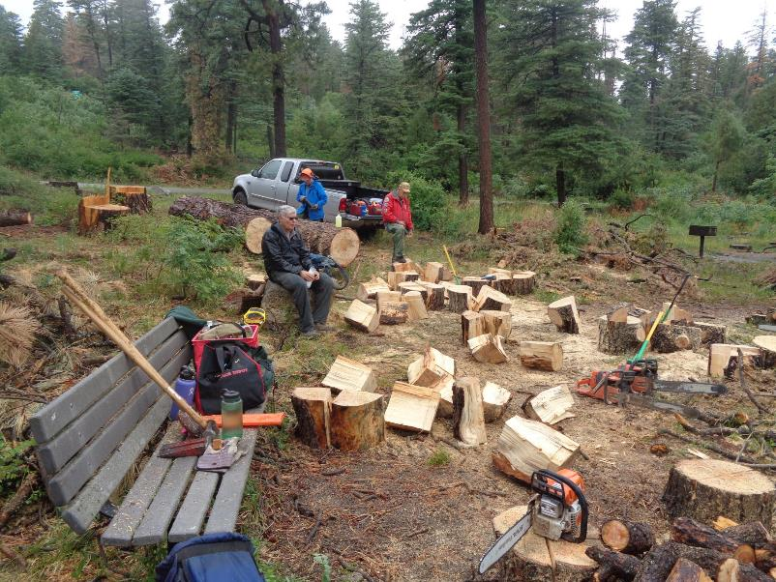

FOSM volunteers were working in light rain all morning at Balsam Glade Picnic Area. Kerry Wood, Cibola NF Trails and Wilderness

Manager, felled the 36-inch pine hazard tree a few weeks ago. Volunteers cut and manually split about a dozen large rounds

from the two trunks of the large pine. L to R: Cliff Giles, Eric Russell, and Jerry Carroll. All photos by Sam Beard.

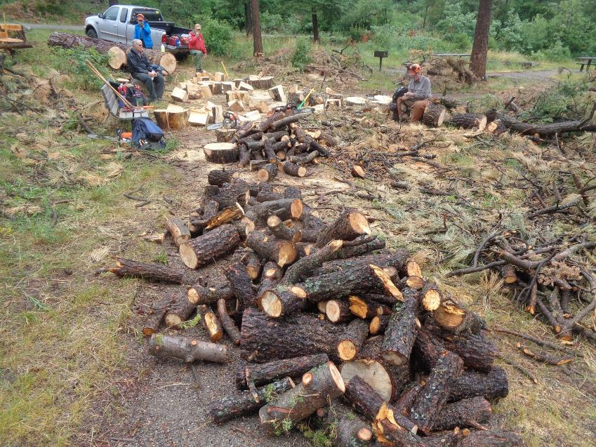

Limb wood was also bucked to a length of 12 inches. L to R: Cliff Giles, Eric Russell, Jerry Carroll, and Dan Benton.

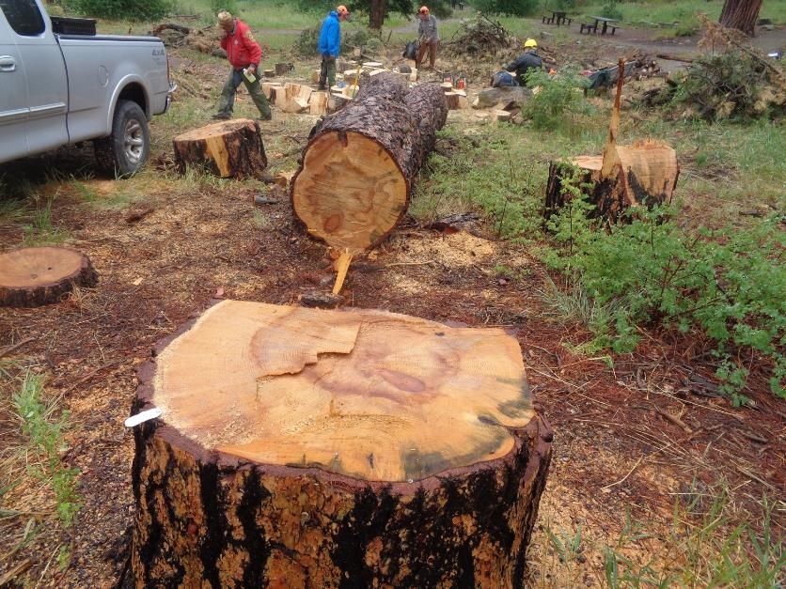

The 36-inch diameter stump of the large pine hazard tree that was felled by Kerry Wood. The low stump of a 12-inch fir

is shown on the left edge of the photograph. The fir tree was felled in order to have a clear lay for the pine tree.

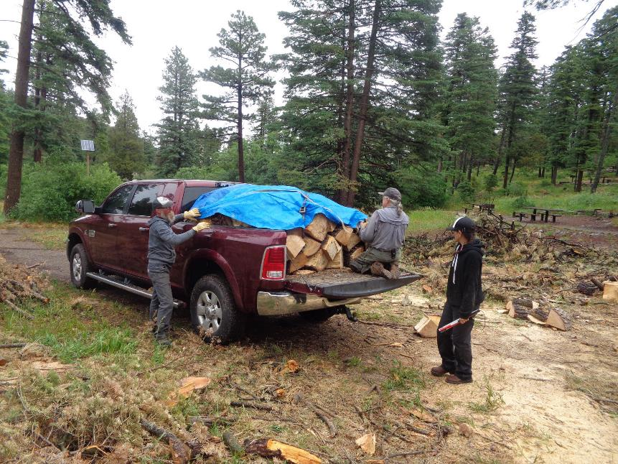

L to R: Jory Meade, Joe Meade, and Tami Jo Meade. Joe and Jory are securing the load of donation wood with a tarpaulin.

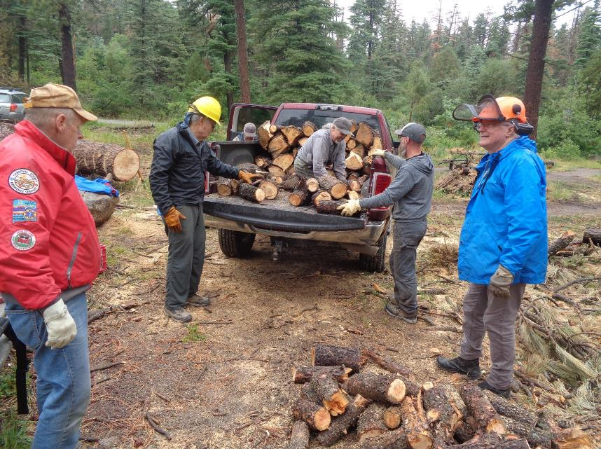

Stacking another load of wood in Joe’s pickup. L to R. Jerry Carroll, Cliff Giles, Joe Meade in the truck bed, Jory Meade, and Eric Russell.