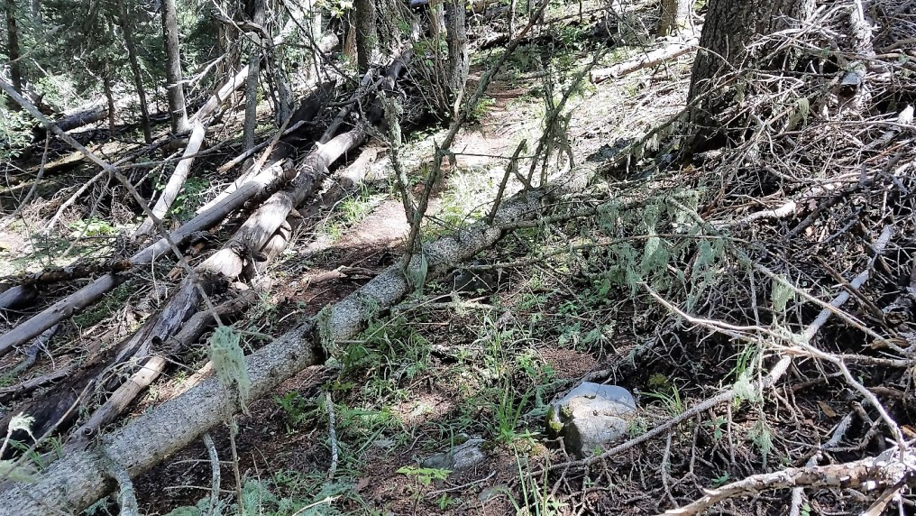
This six-inch diameter fallen fir was the first tree removed from Gravel Pit trail during yesterday’s hike. It was cut and moved off the trail.

(Photo by Stefan Martin)

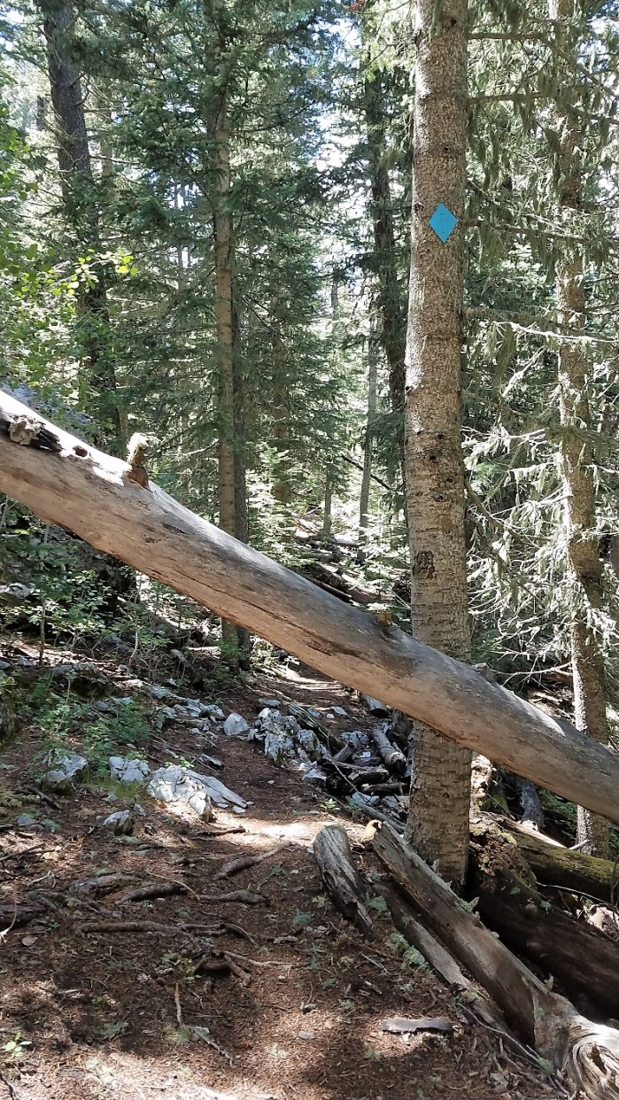
This 12-inch diameter “duck-under” fallen
tree on Gravel Pit appears to have come
down recently. It was removed. Photo taken
looking south.

(Photo by Stefan Martin)
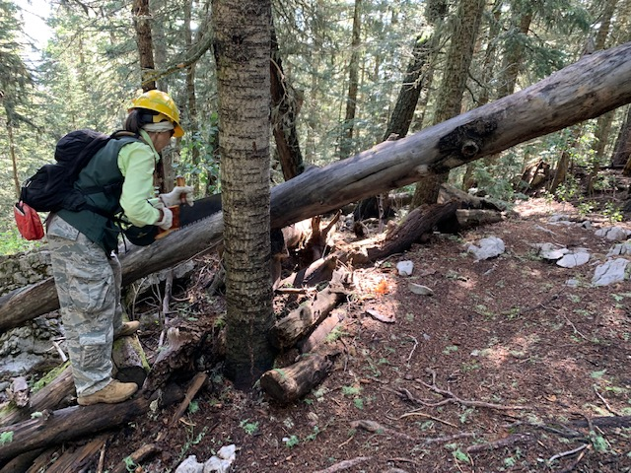
Rav is starting the cut on the fallen tree shown in the previous
photo. Photo taken looking north.

(Photo by Bob Lowder)
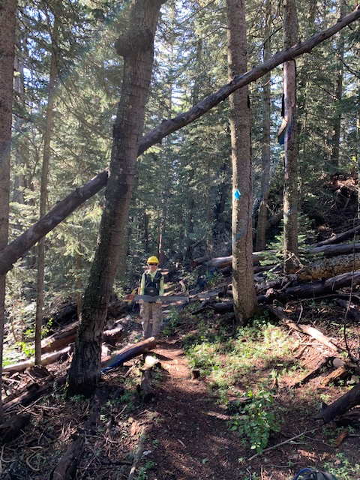
This lengthy six-inch diameter hangup has been
looming over Gravel Pit for quite some time. It
once had appeared to be well supported, but that
no longer seemed to be the case so it was removed.

(Photo by Bob Lowder)
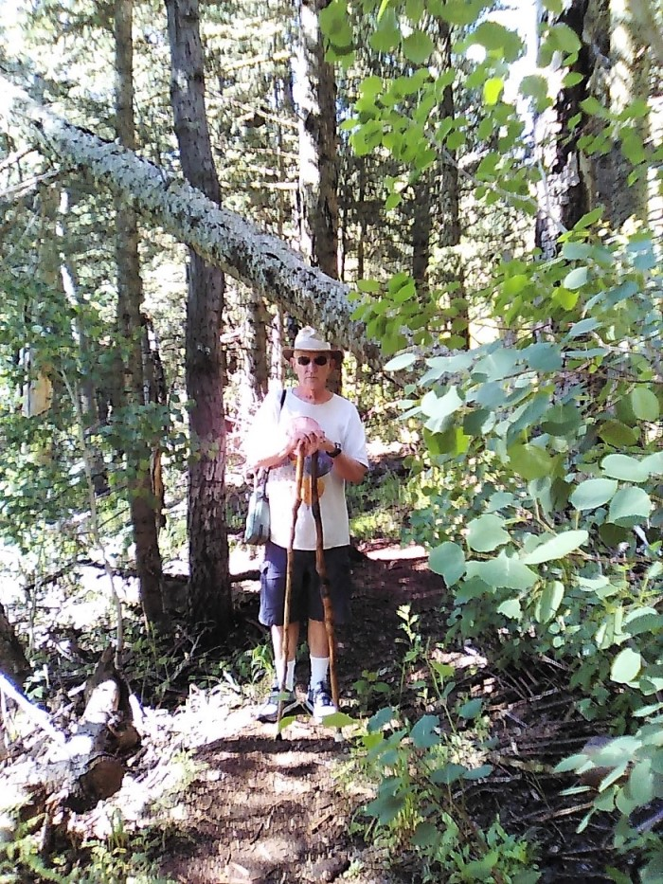
Yet another leaner in our Gravel Pit collection.
This one about 12-inches in diameter. Ken Nicholson
provides scale on a previous hike. This tree was
removed.

(Photo by Rav Nicholson)
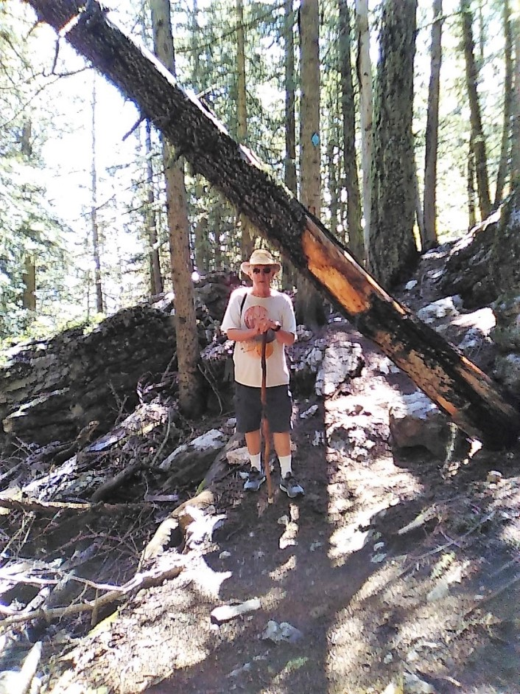
This was the last tree removed from Gravel Pit and
presented the biggest challenge. It was 15-inches in
diameter and supported by an aspen and two small fir
trees. While it had been leaning for some time, it
recently dropped down significantly.

(Photo by Rav Nicholson)
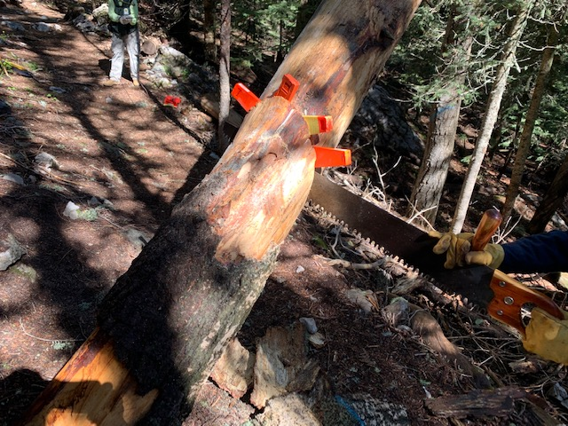
David is finishing the first cut on the 15-inch leaner. There was considerable top and side bind in the trunk requiring an array of wedges to keep the kerf open. The wood was quite hard
and much time was needed to complete the cuts.

(Photo by Bob Lowder)
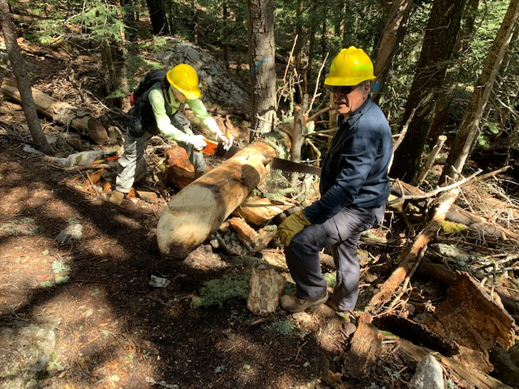
Once the tree was finally on the ground the base was protruding
slightly into the trail so a second cut was made to provide safe
passage. Rav cuts while David waits his turn. The remaining stump/root ball (not seen left of the photo) was chopped, pried up and rolled off the trail.

(Photo by Bob Lowder)
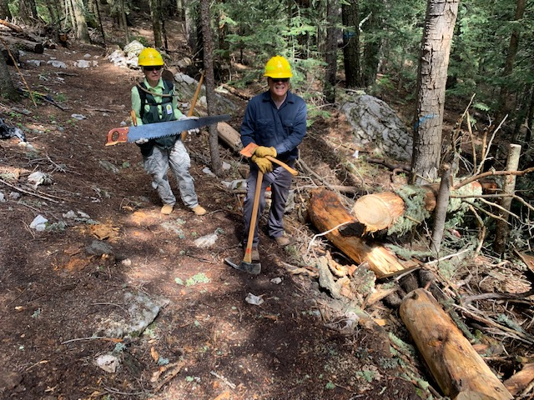
Mission accomplished – Gravel Pit trail cleared.

(Photo by Bob Lowder)

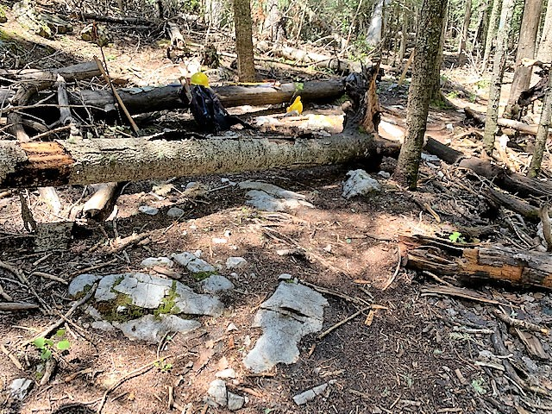
This dead 10-inch diameter cork bark fir had recently fallen along Switchback trail. Someone had tried to roll it off without much success. After a lunch break (the fallen tree in the background providing excellent seating) this tree was cut once and removed from the trail.

(Photo by Bob Lowder)
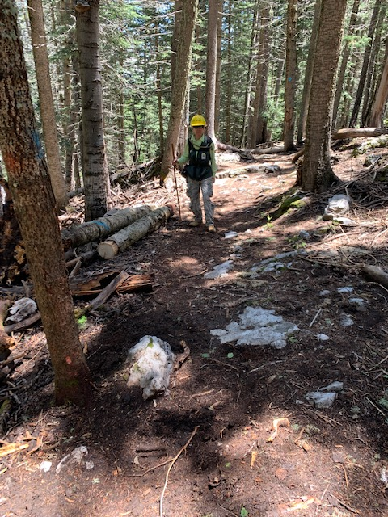
Fallen tree in previous photo has been cleared away
from Switchback trail.

(Photo by Bob Lowder)
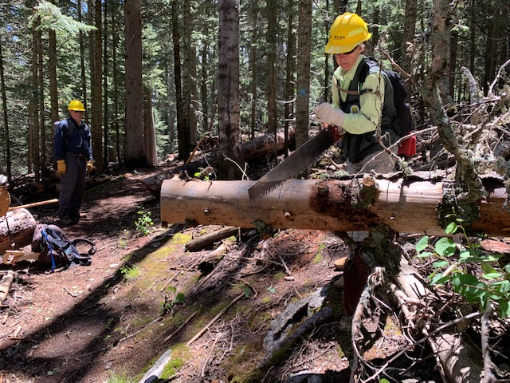
This previously cut tree, sticking out at just about head height near the trail margin, seemed to the crew that it might be of concern to someone passing by on a bike or horseback, so it was cut back. Rav has the honors.

(Photo by Bob Lowder)

