Report of Painting Oak Site North Restroom in the

Oak Flat Reservation Picnic Area on Thursday, July 8, 2021

Sam Beard, July 9, 2021

On Thursday, July 8, 2021, FOSM volunteers Anne Hickman, Silke Bletzer, Mike Madden, and Sam Beard painted the gable end exterior wooden fasciae, door frames, and an access door on the Oak site north restroom in the Oak Flat Reservation Picnic Area.

The structure had not been painted in many years, and much of the paint had flaked off of the wood. Steel wire brushes and scrapers were used to remove the loose pant before Behr USFS brown paint was applied. Project photos are presented below.

Also, the hasp and staple locking mechanism on the Oak site south restroom west door was repaired so that the hasp could be put over the staple easily.

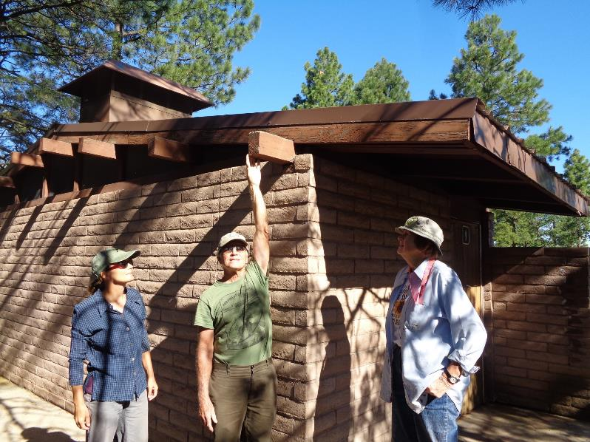

L to R: Silke Bletzer, Mike Madden, and Anne Hickman at the north restroom in the Oak site in the Oak

Flat Reservation Picnic Area. On Thursday our project was to paint all the wooden surfaces on

the gable end of the building – the fasciae and the decorative 4x6 beams.

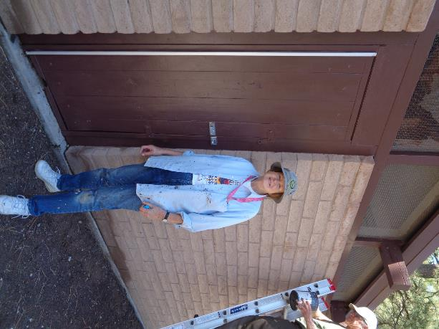

In addition to the gable end wood, Anne painted the access door shown here

and the two restroom door frames. All photos by Sam Beard unless noted otherwise.

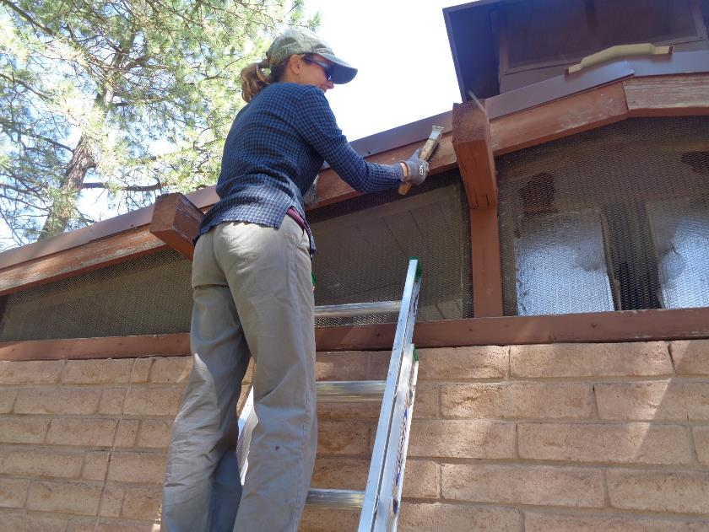

Silke using a steel wire brush to remove loose paint on the fascia.

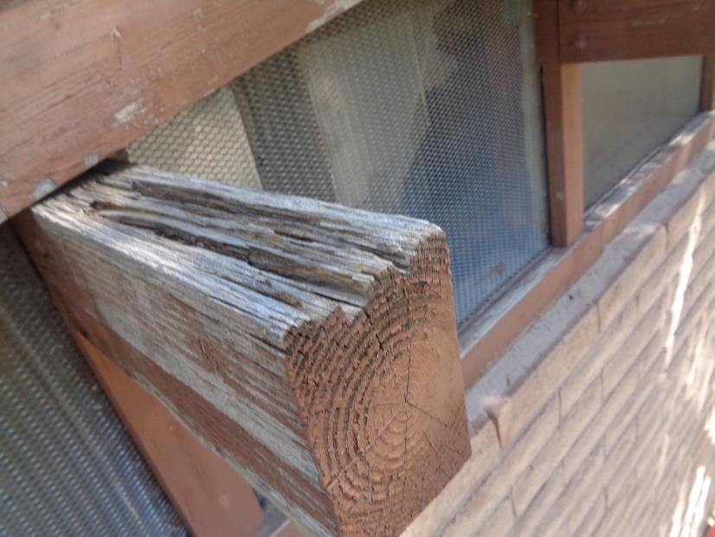

Severely damaged top of a beam due to a lack of paint and the weather. We are stabilizing the tops of the beams by applying a liquid epoxy that hardens the wood and an epoxy paste that fills the cracks and leaves a waterproof surface.

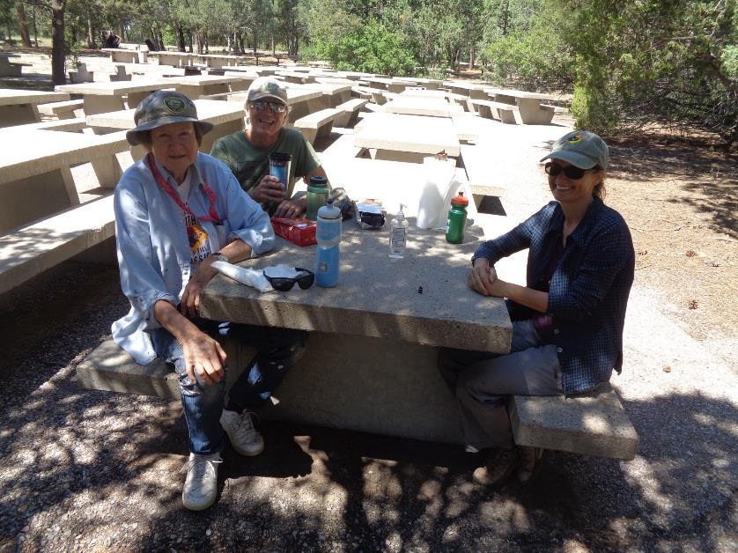

Our morning break at a picnic table in the shade.

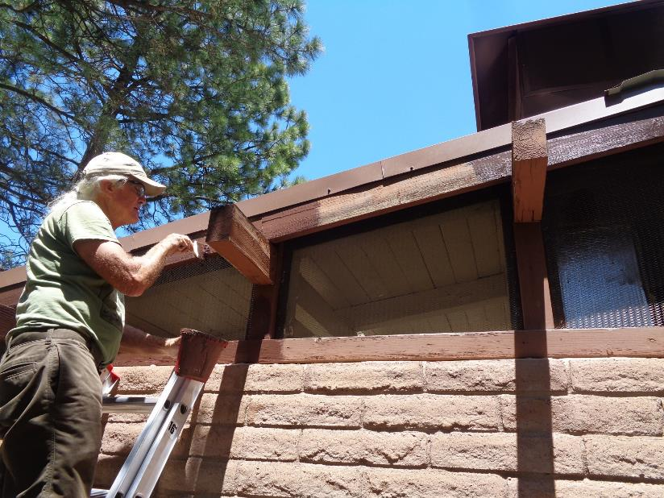

Mike painting the fascia with USFS brown paint. Note the difference between the weathered wood in the

center of the photo and the painted wood on both sides.

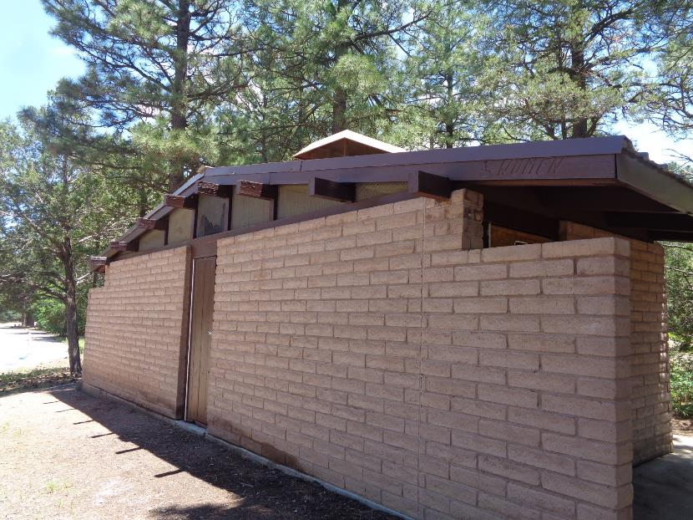

The painted west side of the restroom. The renovation of this building by FOSM included installing the metal

roof and painting the exterior wood.

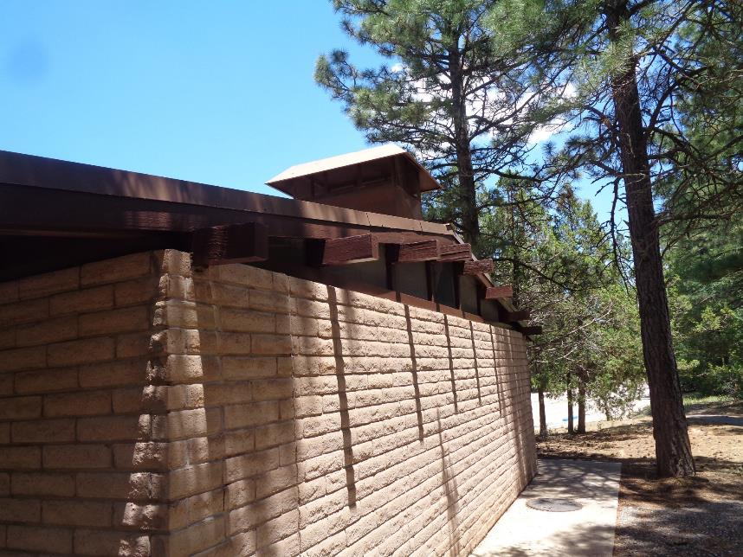

The painted wood on the east side of the restroom.

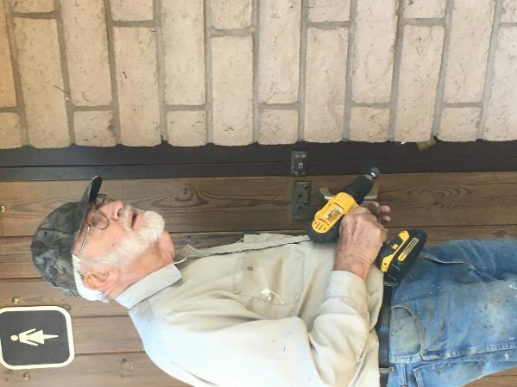

Sam Beard at the west door of the Oak site south restroom where we had noticed earlier that the

hasp was very difficult to close over the staple (the loop screwed to the door frame). The steel staple

extended too far to the right for the slot in the hasp to go over it. Photos by Silke Bletzer

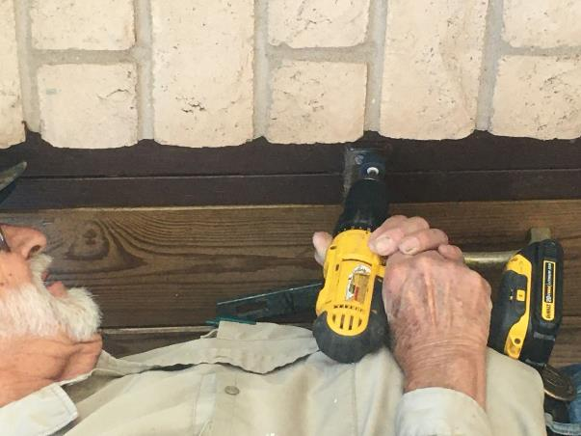

Sam is using a small cylindrical grinder in the battery-powered drill to grind off

some of the right side of the staple so that the hasp slot would go over the staple easily.

The shackle of a pad lock could then be put through the staple over the hasp to secure the door.