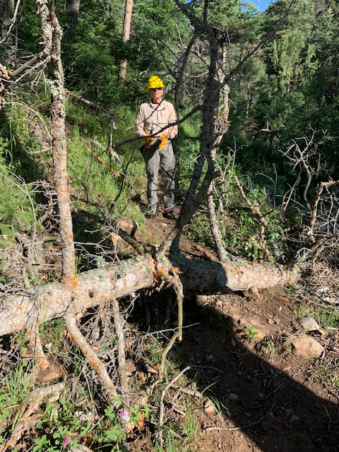
This dead ten-inch diameter fir was the first fallen
tree encountered by the crew. It was new as it was not
noted on a Cienega trail report dated the prior Thursday,
July 22nd. The tree was removed.

(Photo by Bob Lowder)

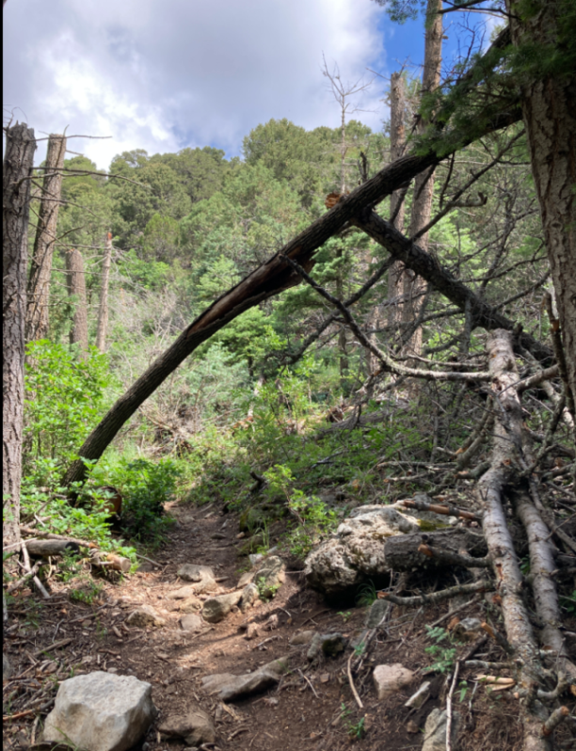
This hangup jumble was the next problem discovered as
the crew hiked uphill. It was primarily supported by
the eight-inch diameter dead oak that is bent over
the trail. Cutting the oak near its base brought the
whole mess down to the ground where the trees were cut
into sections and cleared away including the split top
of the dead fir.

(Photo by Jamey Browning on previous hike)

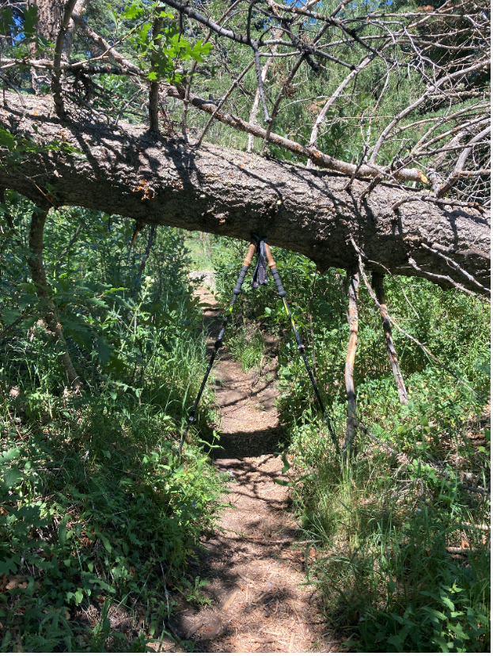
About 400 feet above the trees in the previous photo
was this large fallen dead fir suspended over the trail
at chest height. Photo is looking uphill.

(Photo by Jamey Browning on previous hike)
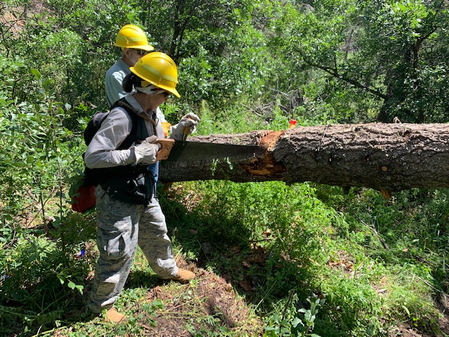
After limbs have been cut away, Rav is working on the first cut on the large fallen fir. The trail is downhill to the lower right of the photo.

(Photo by Bob Lowder)

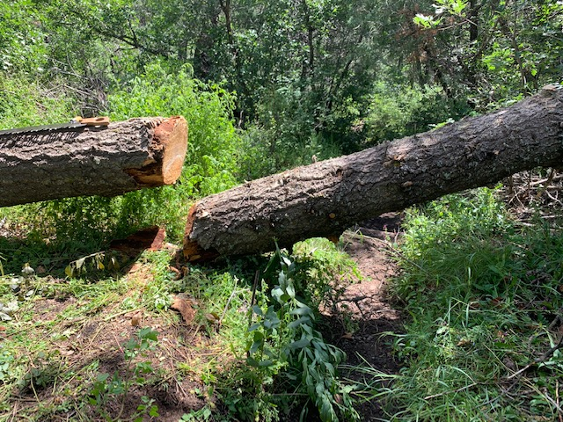
The first cut has been completed. Due to its large size and location, three cuts were needed to safely remove this tree from the trail, which drops downhill steeply below the tree. The cut end shown here was measured at just over 16-inches in diameter.

(Photo by Bob Lowder)
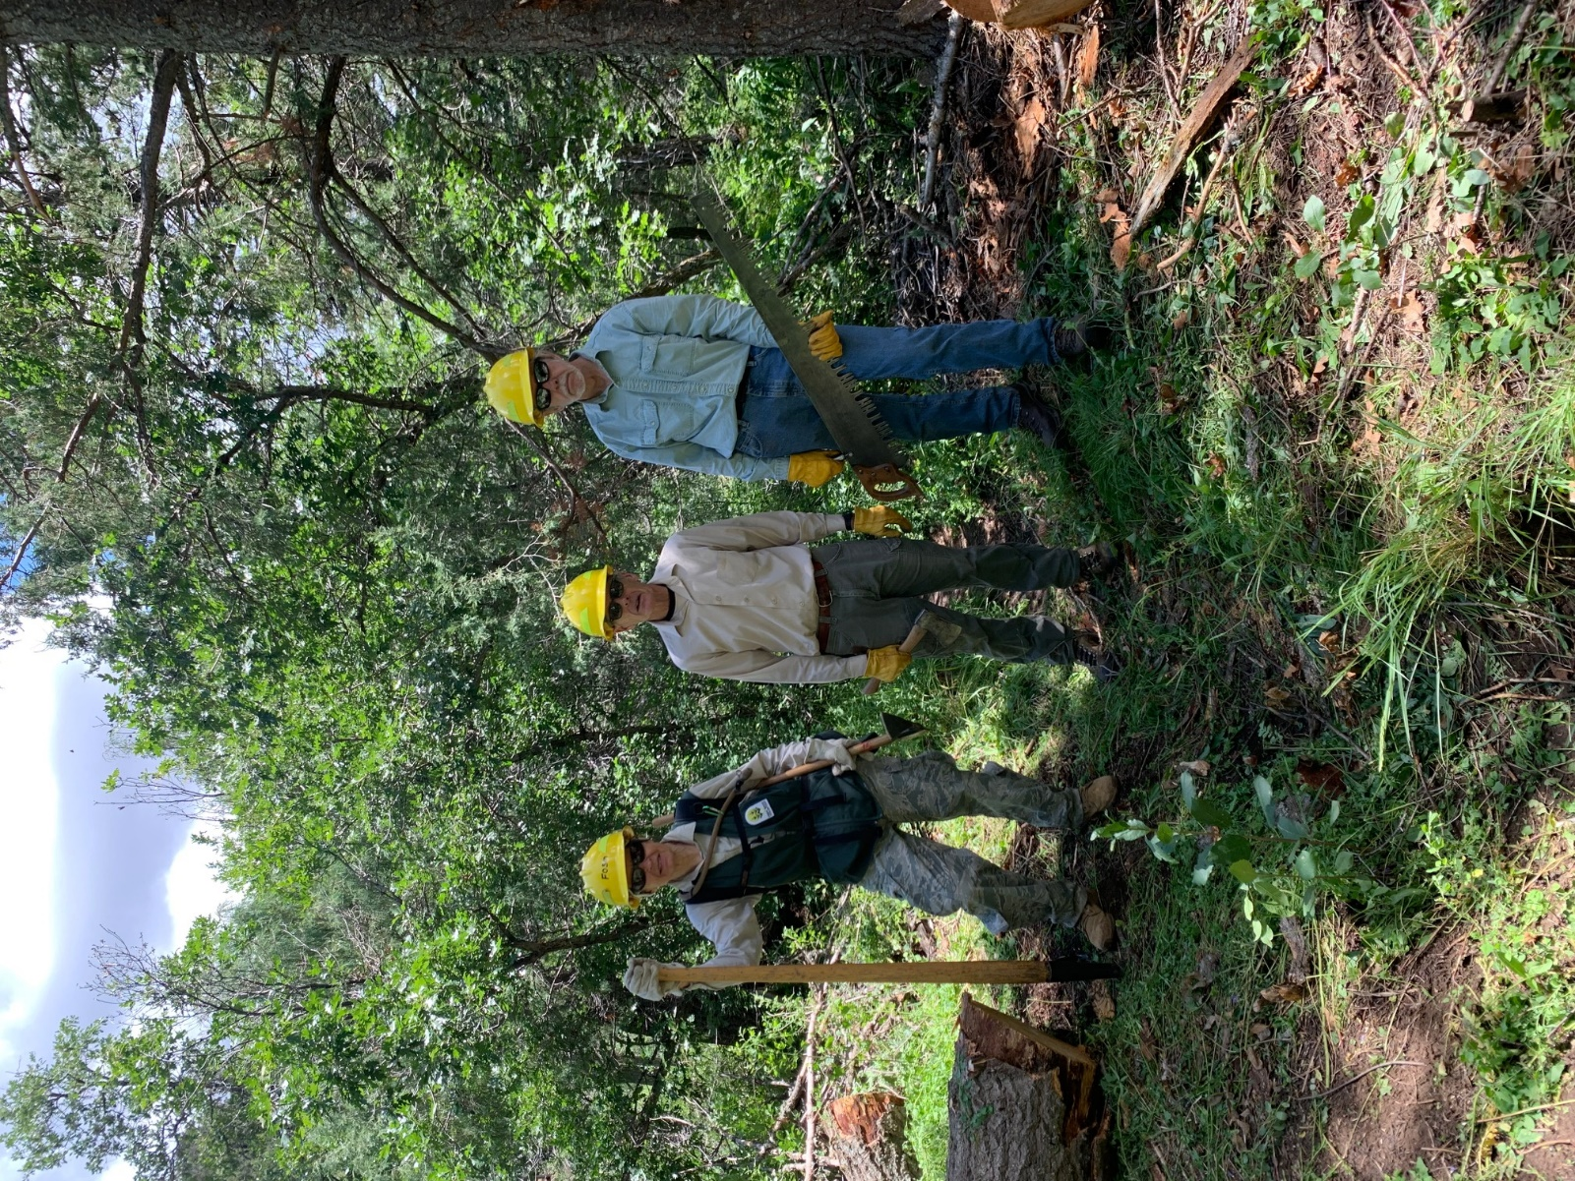
Done at last! After a morning of dealing with complicated
and difficult tasks, the crew is ready for a lunch break.

(Photo by Bob Lowder)

