FOSM Report on the Restoration of the Ridge Pole Ends on the CCC Picnic Shelter

in Doc Long Picnic Area in July 2021

Sam Beard and Mike Madden, July 31, 2021

**Introduction** -- The ends of the ridge pole of the CCC Picnic Shelter were restored using a procedure previously developed for the restoration of the ends of the large beams.

**History of Restoration of CCC Shelter Beams** -- The historic picnic shelter in Doc Long Picnic Area was constructed in 1936 by the Civilian Conservation Corps (CCC). During the 85 years since it was constructed the ends of four large horizontal beams and the ridge pole were damaged by exposure to the weather. Decay of these beams resulted in erosion of damaged wood from the tops of the beam ends. A few years ago, the four ends of the large beams were restored using a procedure develop by FOSM volunteer Bob Galloway. Bob used System Three liquid epoxy to stabilize the remaining wood to form a sound base for the installation of a wire mesh to which was applied a sprayed dense foam that was carved to the original shape of the beam. Epoxy putty was applied to the foam to obtain a tough outer surface that was weather resistant. Epoxy paste was used to fill cracks in the ends and sides of the beams. The resulting restored beam ends were painted with Forest Service brown paint.

The ends of the ridge pole were restored by FOSM volunteers in July 2021. The above procedure was used in the restoration of the ridge pole, but it was not necessary to use the wire mesh and foam on the smaller pole.

The following photographs show the steps in the restoration of the ridge pole ends.

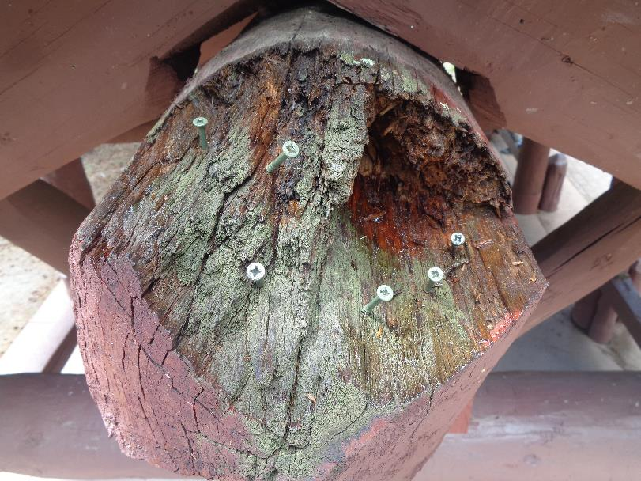

North end of ridge pole showing damage due to exposure to weather for 85 years. Screws provide anchors for epoxy putty

that will be placed on the beam to restore its original shape with three flat facets. Photo by Mike Madden

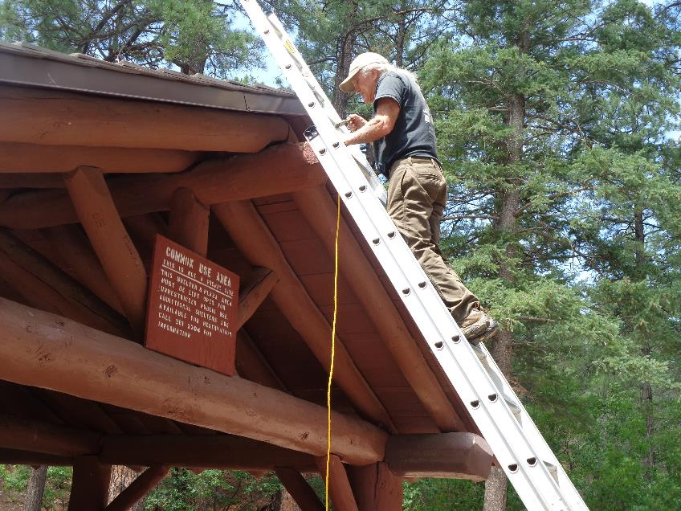

Mike Madden working on the restoration of the north end of the ridge pole. All photos by Sam Beard unless stated otherwise.

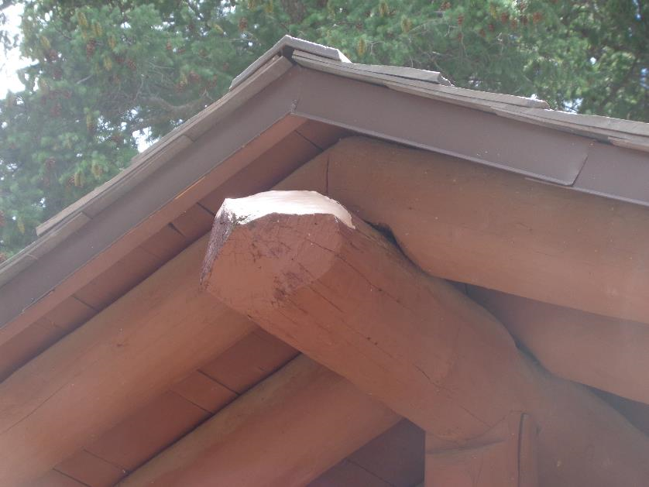

Epoxy putty on the north end of the pole to restore the original shape.

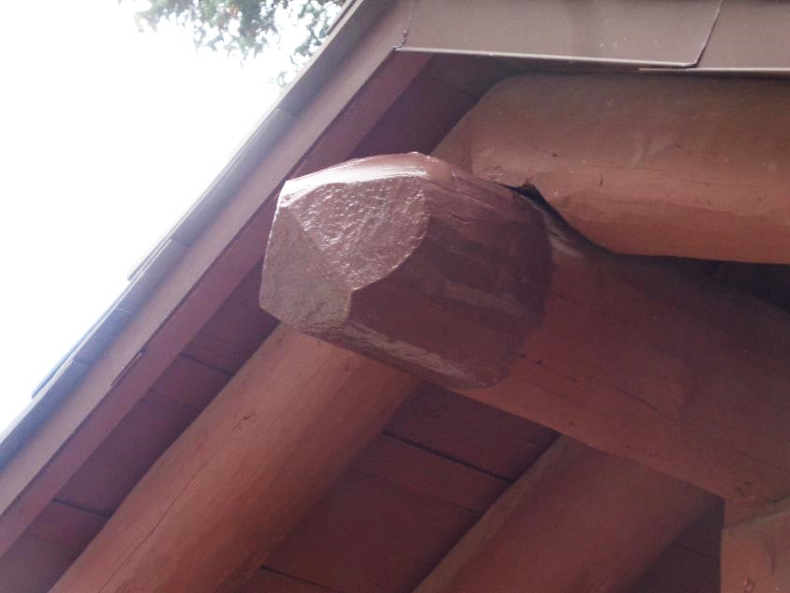

The restored north end of the pole has been painted with Forest Service brown paint.

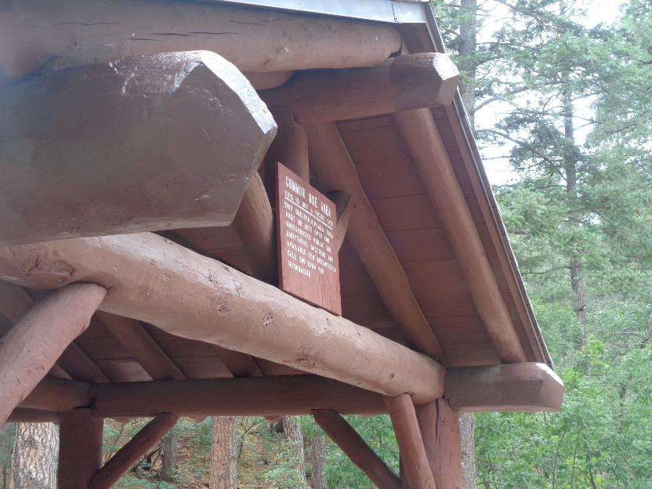

The north end of the CCC picnic shelter with the two large horizontal beams that were restored a few years ago and the

ridge pole that was recently restored.

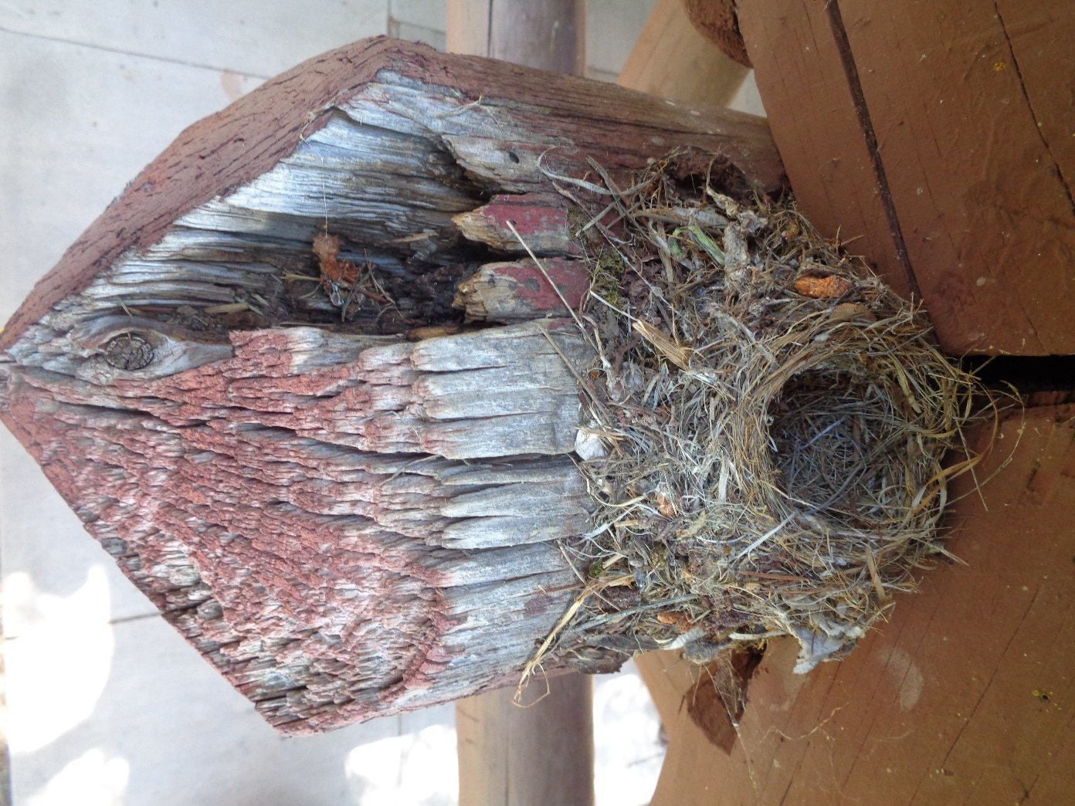

Damaged south end of the ridge pole with a small bird’s nest on it. The bird’s

nest was removed, because it was unoccupied and obviously abandoned after the nesting season.

Photo by Mike Madden

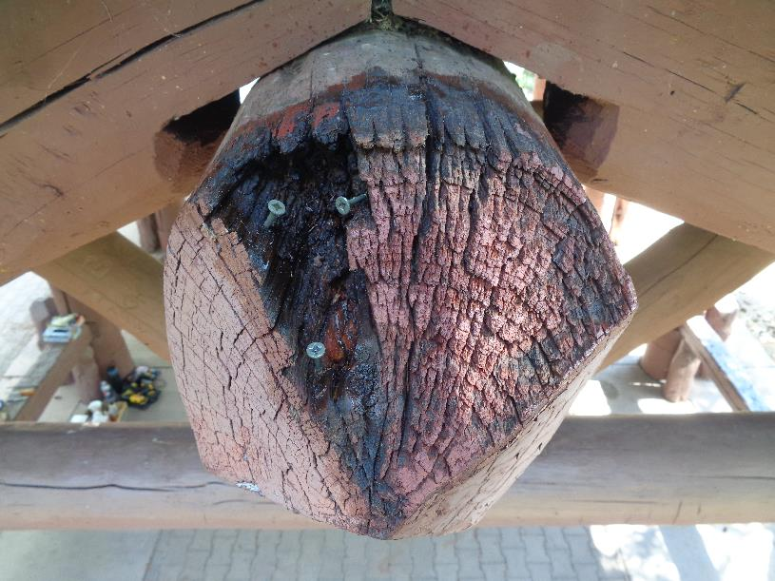

Liquid epoxy has been applied to the damaged area of the south pole to stabilize the wood, and screws have been installed as

anchors for the epoxy putty that will be placed in the damaged area. Photo by Mike Madden

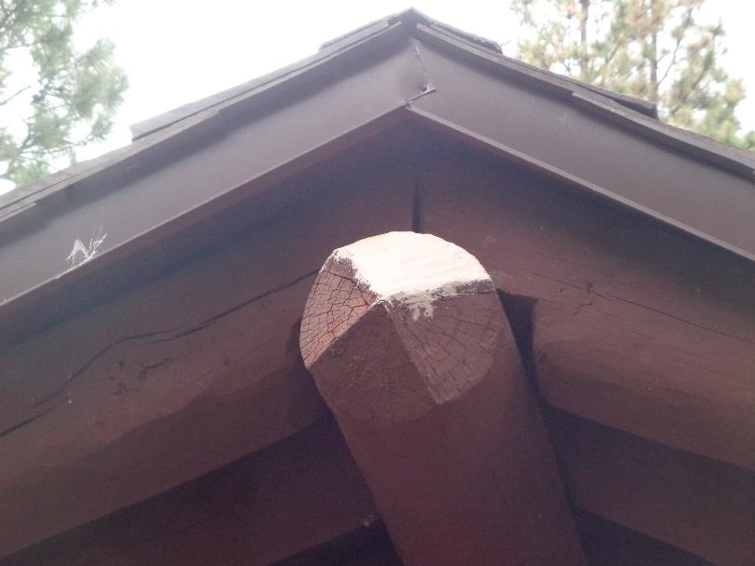

The original shape of the south end of the pole has been restored by the application of epoxy putty.

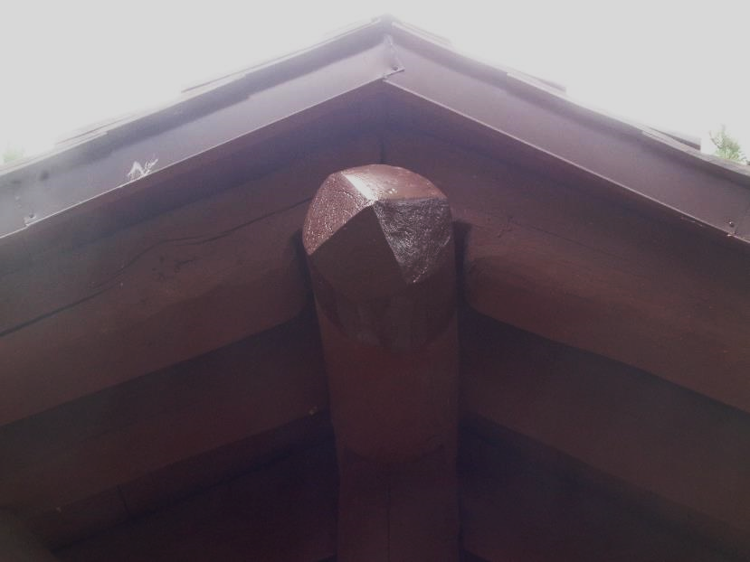

The restored south end of the pole has been painted with Forest Service brown paint.

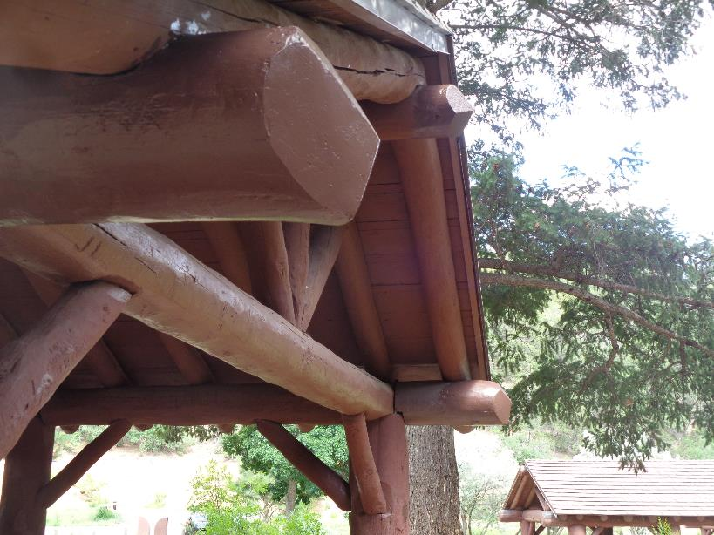

The south end of the shelter with three restored beams -- two large horizontal beams and the ridge pole.