**Report of FOSM Project to Paint Various Structures in Sulphur Canyon Picnic Area on Tuesday, August 3**

Anne Hickman and San Beard, August 5, 2021

 On Tuesday, August 3, the FOSM paint crew scraped and painted the large kiosk just past the second restroom in Sulphur Canyon Picnic Area, as well as the smaller kiosk near the two restrooms. Then we scraped and painted the white upright posts at both restrooms and swept away accumulated forest debris. Both restrooms are now more attractive and blend in with the environment.

While the other paint crew members were working at the upper end of the picnic area, Sam Beard was working at the large roofed kiosk at the second parking lot. As the photos below show, this kiosk is in a damp location due to the deep shade and lack of solar radiation. Green moss was growing on the fascia, and one end of the 2x6 fascia board is rotten. Sam scraped the fascia and painted it and the posts and horizontal timbers supporting the sign panel. He then moved down to the large 3-panel kiosk and scraped and painted the posts and beams.

Painters were Russ and Ellie Parker, Jane Harrison, Anne Hickman, and Sam Beard.   We will continue working in the lower part of Sulphur Canyon next week.

Photographs are presented below.

Anne Hickman and Sam Beard

FOSM Paint Crew

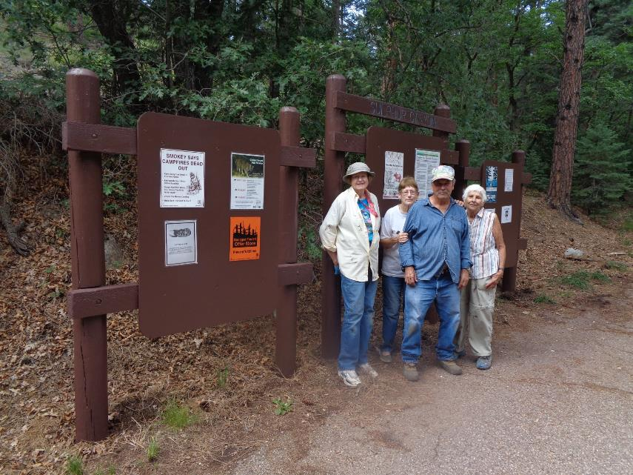

Paint crew at the large 3-panel kiosk that they painted in the upper part of Sulphur Canyon Picnic Area.

L to R: Anne Hickman, Ellie Parker, Russell Parker, and Jane Harrison. All photos by Sam Beard

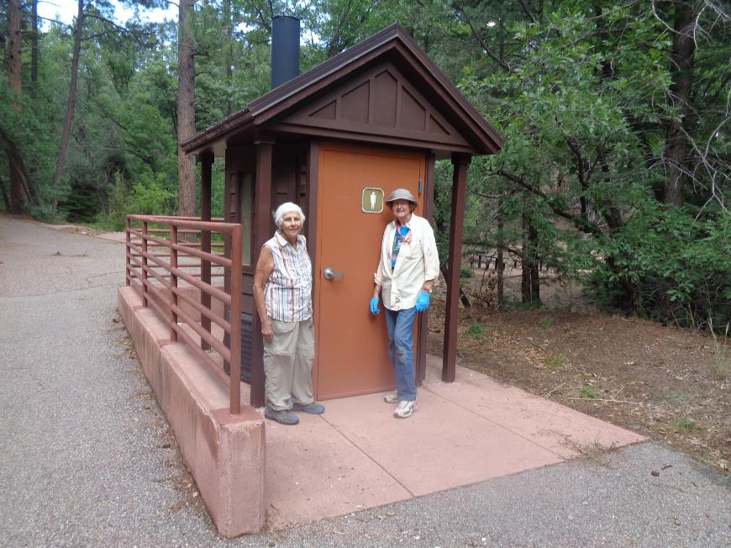

Jane and Anne at the restroom that the crew painted.

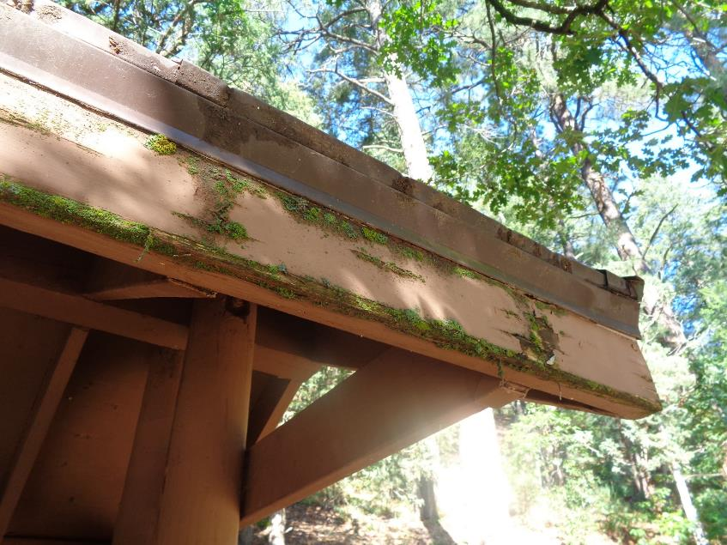

Green moss on fascia on large kiosk in lower part of Sulphur Canyon Picnic Area. The wood is damp, because the kiosk is in deep shade

and does not receive much direct solar heating that would dry the wood.

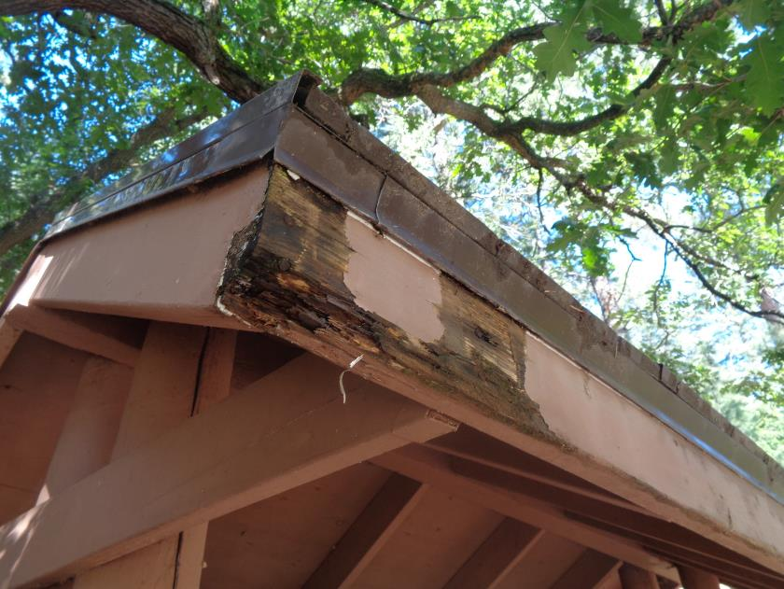

Rotten fascia due to the damp conditions at this kiosk. Also, due to the design of the roof edge, drip edge, and fascia, water flows directly

from the edge of the shingles onto the drip edge and then onto the fascia. If the shingles had been installed with the shingle edges

1 or 2 inches past the drip edge, rain would fall off the shingle edge without flowing directly over the drip edge and fascia.

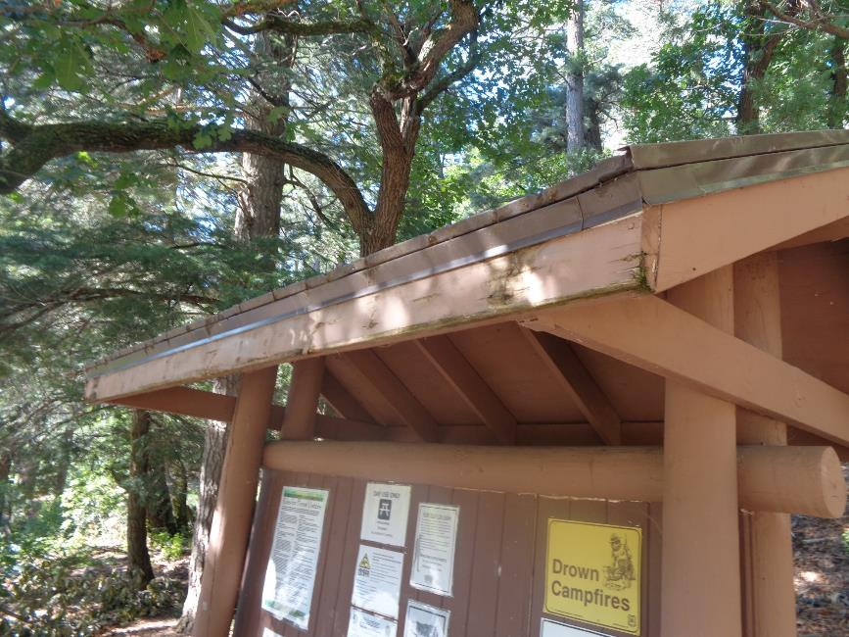

Fascia after I had used a steel brush to remove the moss in preparation for painting.

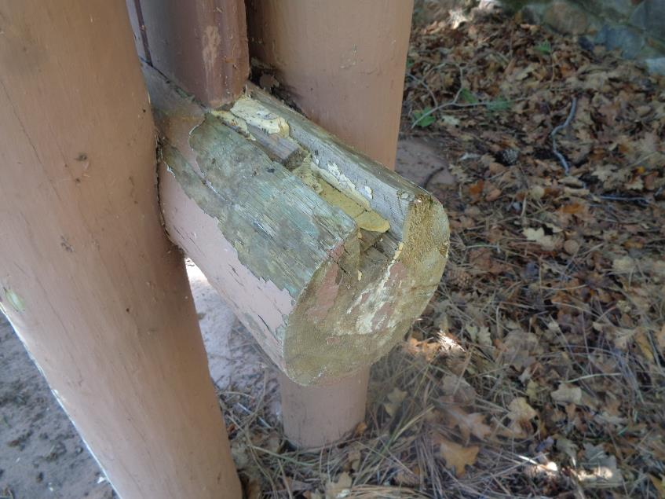

End of the bottom round beam that supports the sign panel. The groove in the top of the beam should be filled with

epoxy putty so that water will run off instead of into the beam.

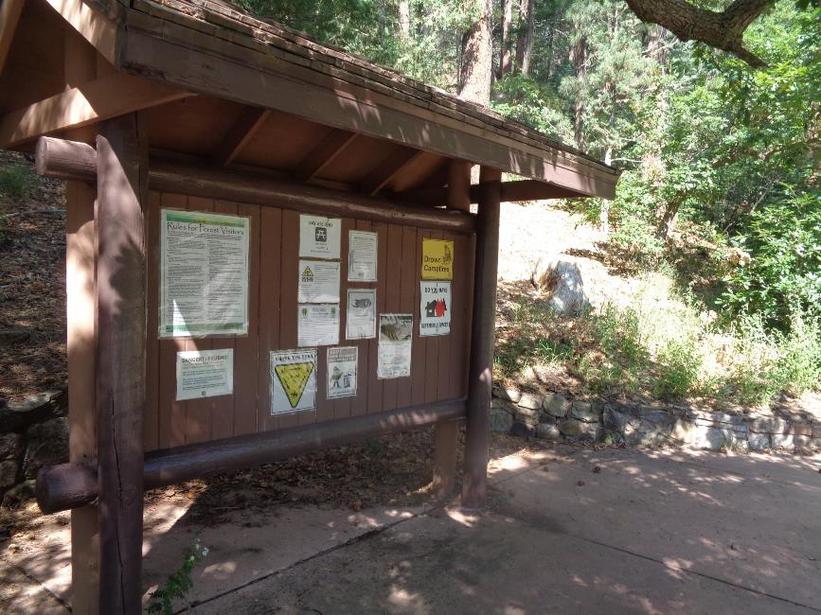

Kiosk after the fascia, posts, and beams had been painted.

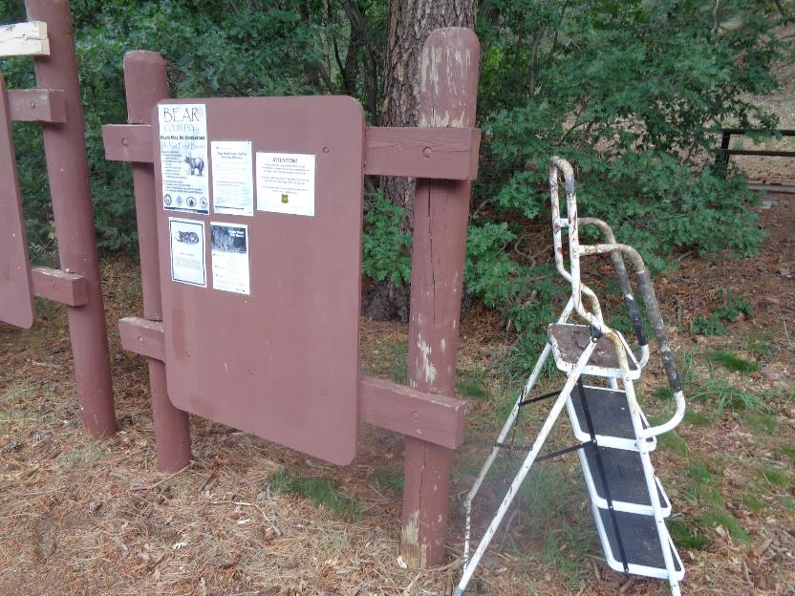

Large 3-panel kiosk at the second parking area in the Sulphur Canyon Picnic Area. Note the paint missing on the post.

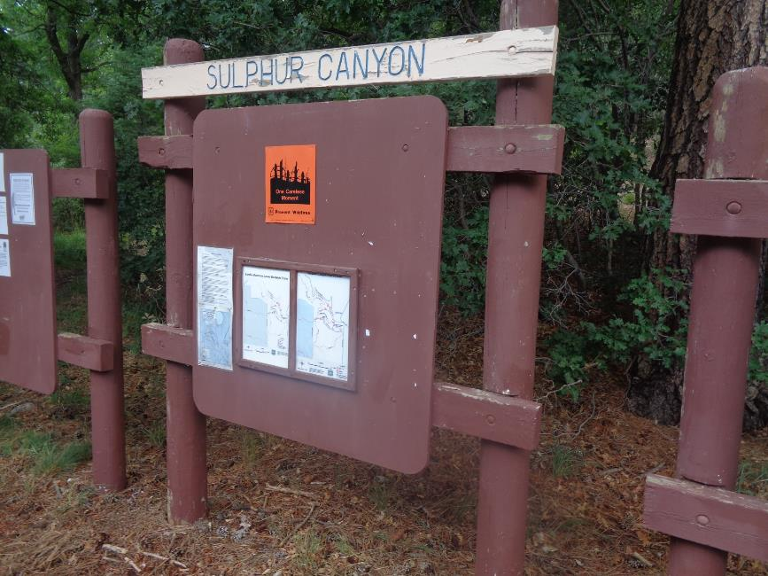

Paint is also missing from other parts of this sign.