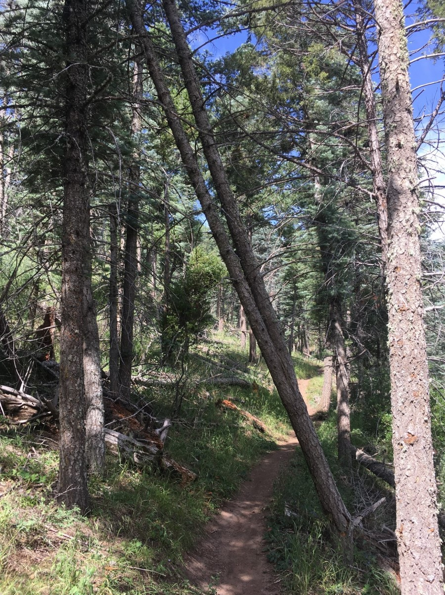
This double-trunk tree was leaning over Faulty trail.

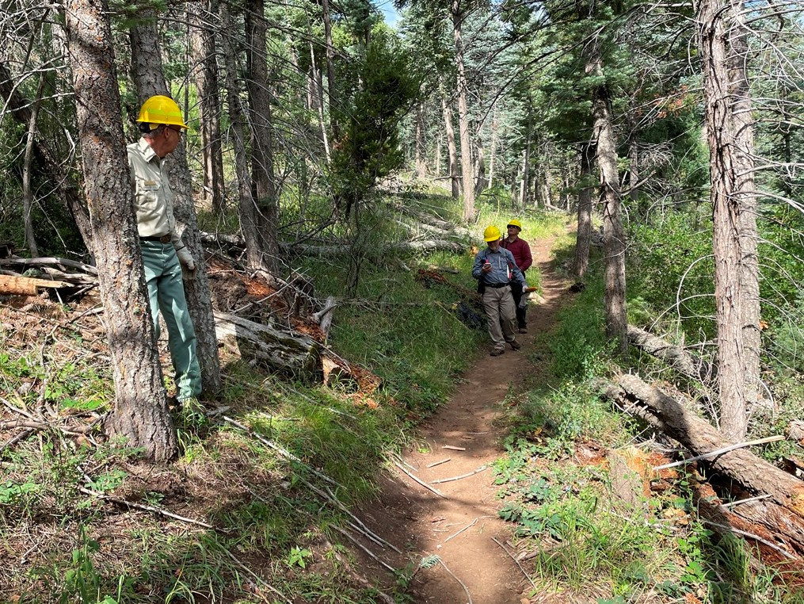
The double-trunk tree is no longer leaning over Faulty trail.

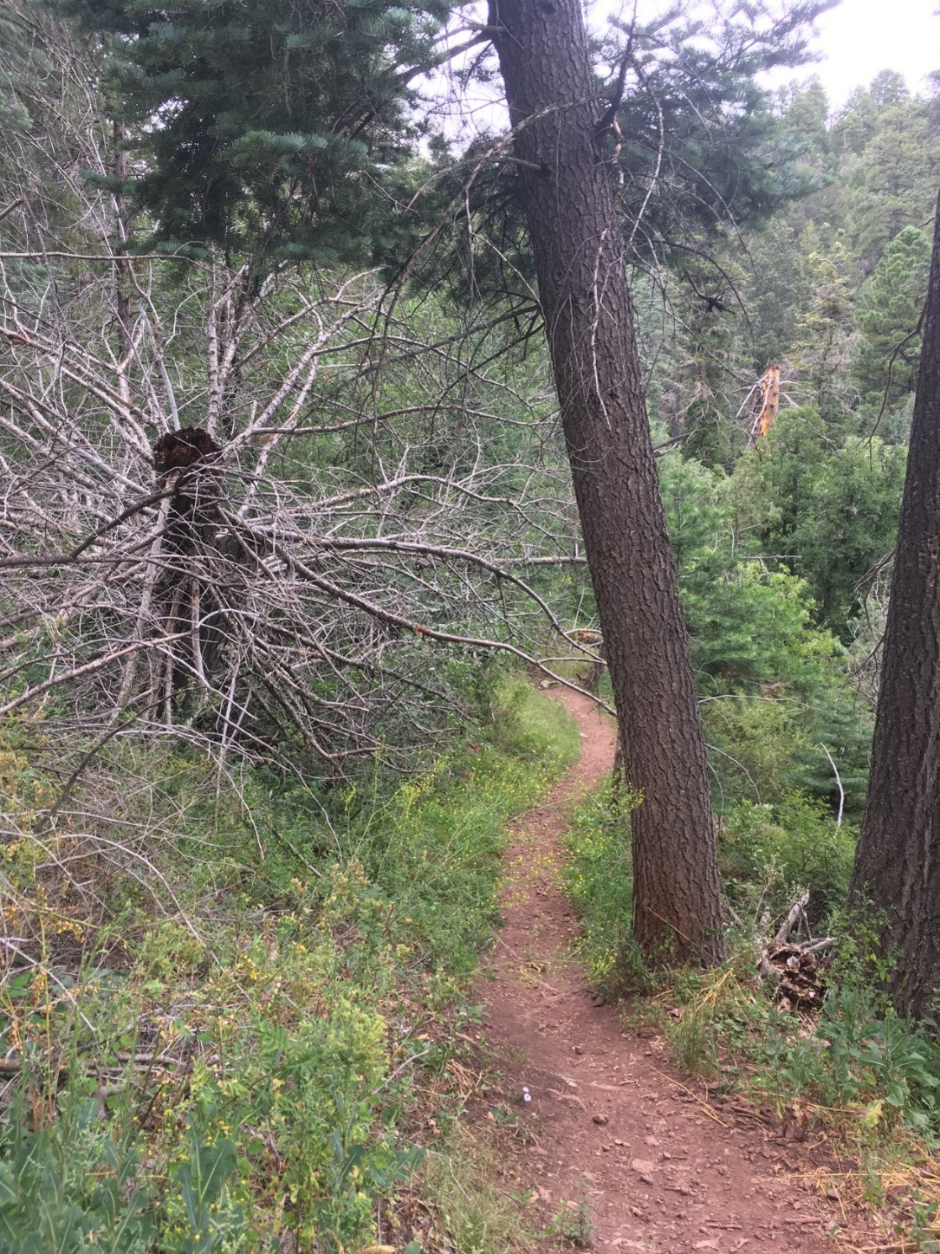
This large porcupine dead fir had fallen along Faulty
trail. Some of its branches were protruding into head
space and were cut away. It is well supported and not
likely to move downhill anytime soon.

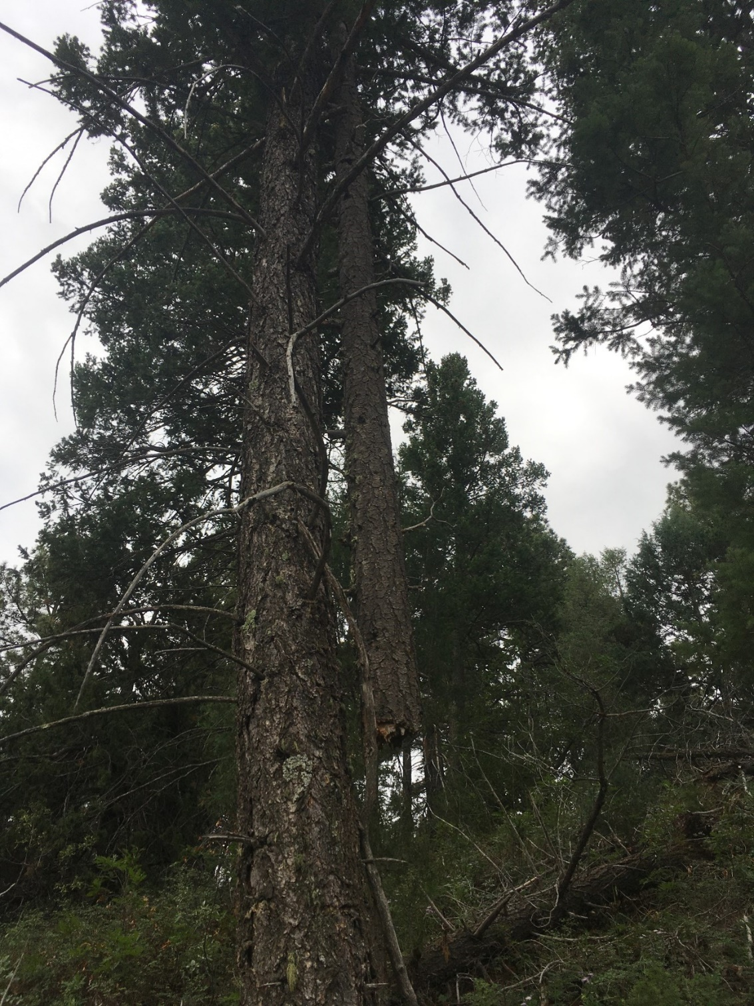
This nasty widow-maker was looming above the uphill
side of Faulty trail. It was pulled down from the uphill
side to the right using a very long rope. It broke into pieces when it hit the ground.
(Photo looking south)

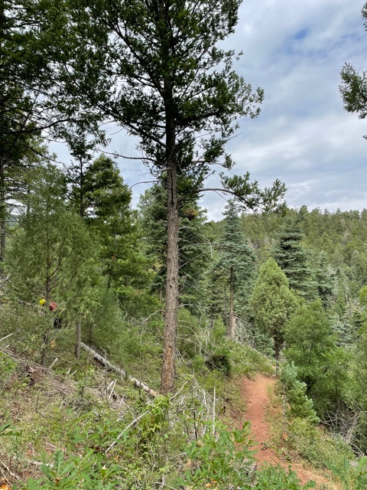
The widow-maker has been removed. Broken pieces are on
the ground left of the tree. (Photo looking north)

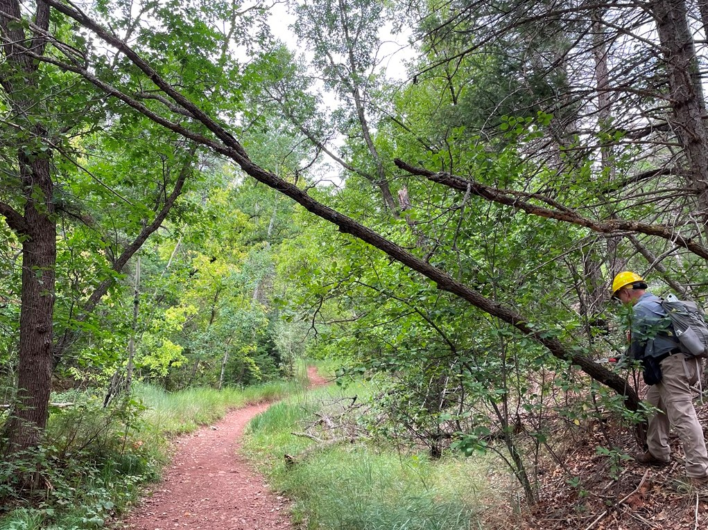
This dead oak had bent above its base and was leaning over Sulphur trail. It was cut away.
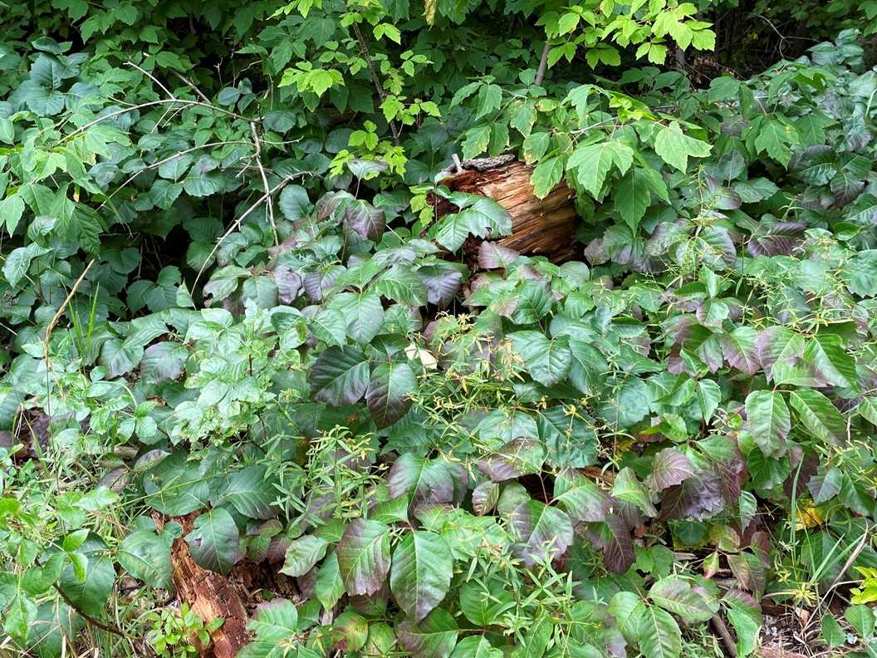
Poison Ivy along Sulphur trail.

