**Report of FOSM Volunteers Painting Two Three-Panel Kiosks**

**In Cienega Canyon Picnic Area on Tuesday, August 17, 2021**

On Tuesday, August 17, seven FOSM volunteers scraped, wire brushed, and painted two large three-panel kiosks in Cienega Canyon Picnic Area at the group reservation area and at the middle restroom. Posted announcements were removed to make it possible to paint the panels, and they were restapled to the panels after they were painted. The words “Cienega Canyon” will be painted with turquoise paint on the top board within a few weeks.

The volunteers were Russell Parker, Ellie Parker, Pauline Ho, Rick Buss, Anne Hickman, Jane Harrison, and Sam Beard.

Project photographs are presented below.

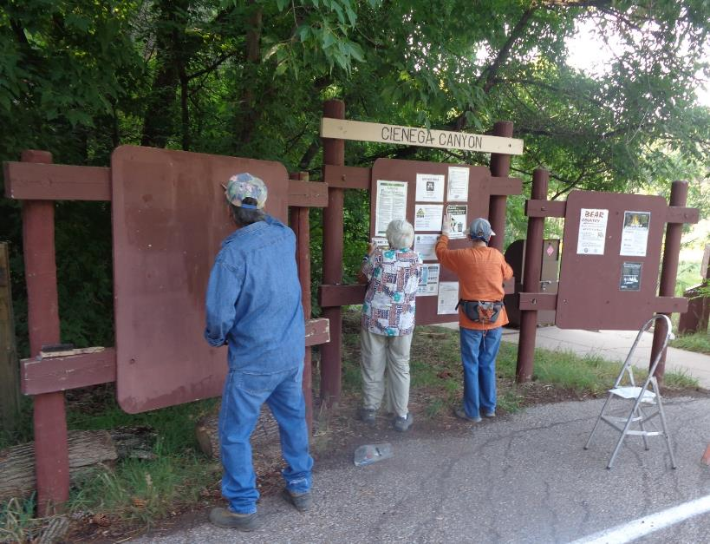

Removing signs and staples from this large kiosk in Cienega Group Reservation Area before repaint it. L to R: Russell Parker,

Jane Harrison, and Ellie Parker. All photos by Sam Beard

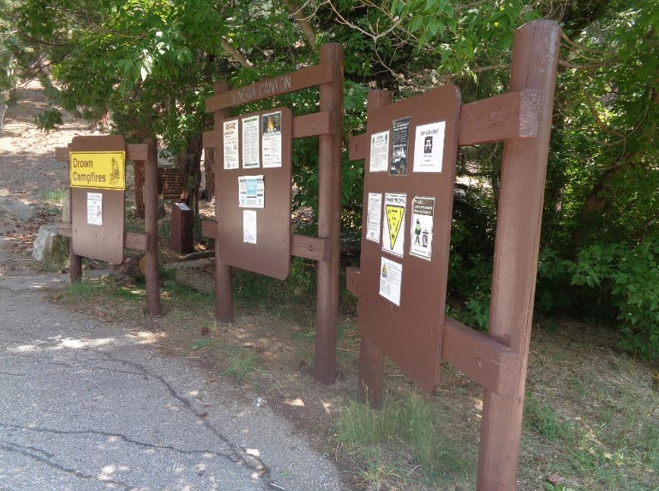

The Cienega Group Area kiosk after it was scraped, painted, and signs reinstalled.

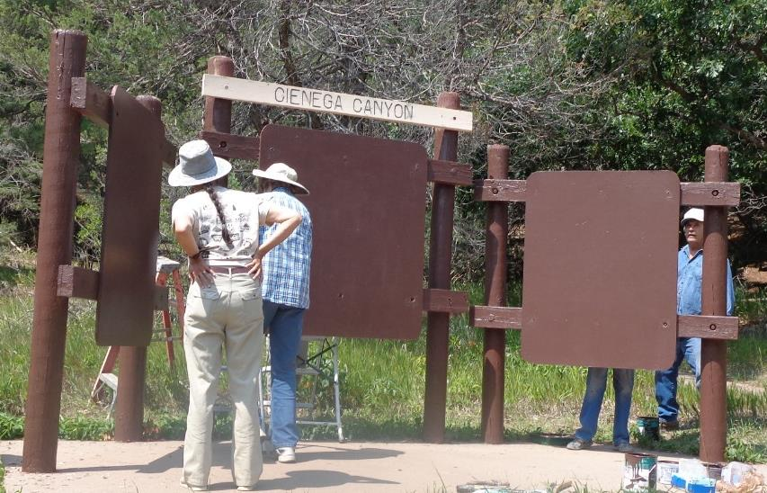

The large 3-panel kiosk at the middle restroom in Cienega Canyon Picnic Area before it was painted. L to R: Pauline Ho, Anne Hickman, and Russell Parker.

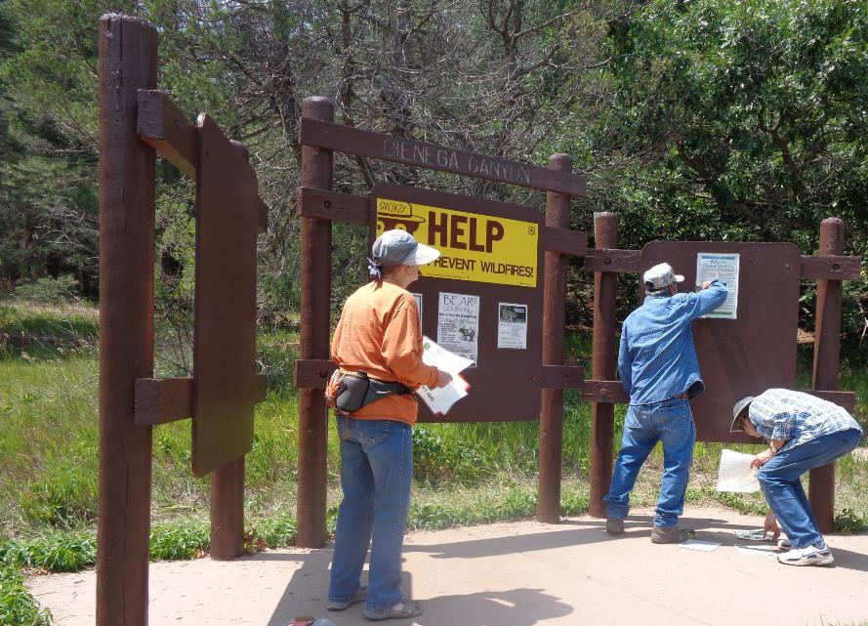

Ellie, Russell, and Anne are replacing signs after the above kiosk was painted.

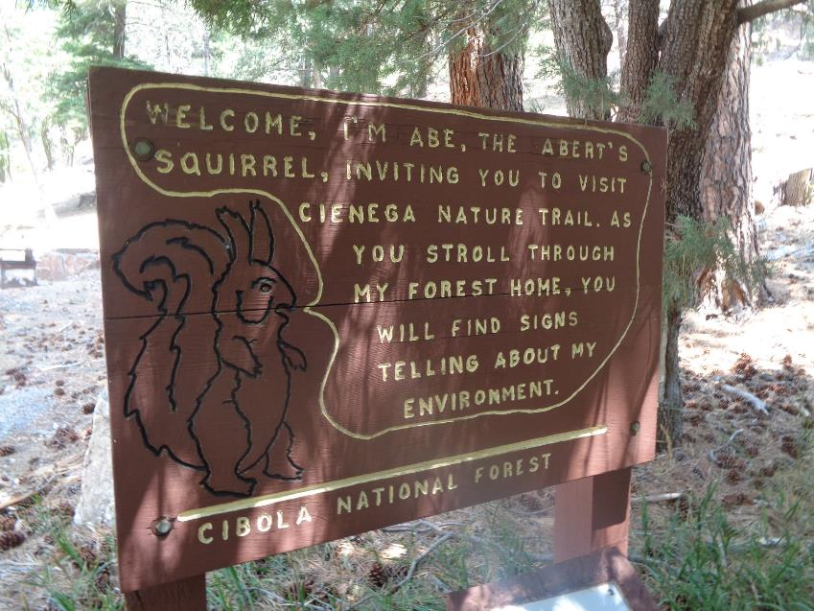

Interesting sign at the beginning of the Cienega Nature Trail.