**Report of FOSM Project to Replace Damaged Posts and Rails in Fences in Cienega, Sulphur, and Doc Long Picnic Areas on Wednesday, August 25, 2021**

Sam Beard, August 31, 2021

On Wednesday, August 25, eight FOSM volunteers replaced several damaged posts and poles in fences in Cienega, Sulphur, and Doc Long Picnic Areas. The posts had decayed near the ground surface, and poles were either broken or badly bent. Damaged rails were removed for the posts, and new rails were attached with steel threaded rods, washers, and nuts. The most difficult part of the process is digging the decayed part of the post out of the ground. At the entrance to Doc Long PA, a severely sagging rail was replaced.

After completing the rail installation, a group walked around Doc Long PA and found a total of seven broken posts that will be replaced on Wednesday, September 1.

The hard-working volunteers were Cliff Giles, Sim Cook, Dan Benton, Dennis Crowther, Eric Russell, Lorna Morrow, Jerry Carroll, and Sam Beard.

Project photographs are presented below.

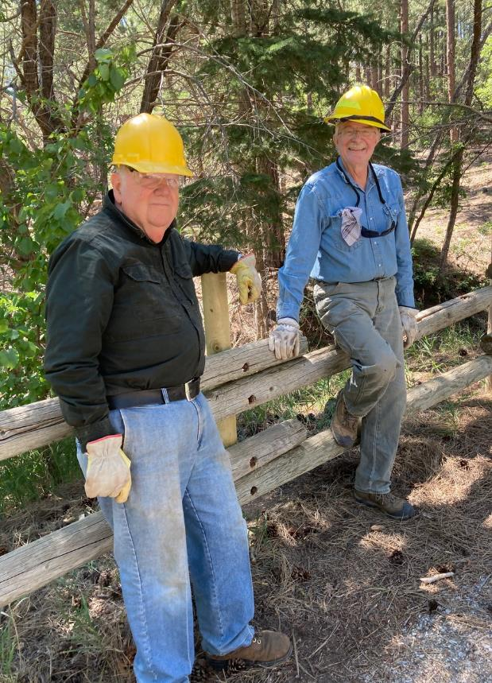

L to R: Dennis Crowther and Eric Russell at the post they installed at the Cienega Picnic Area

host site. All photos by Cliff Giles

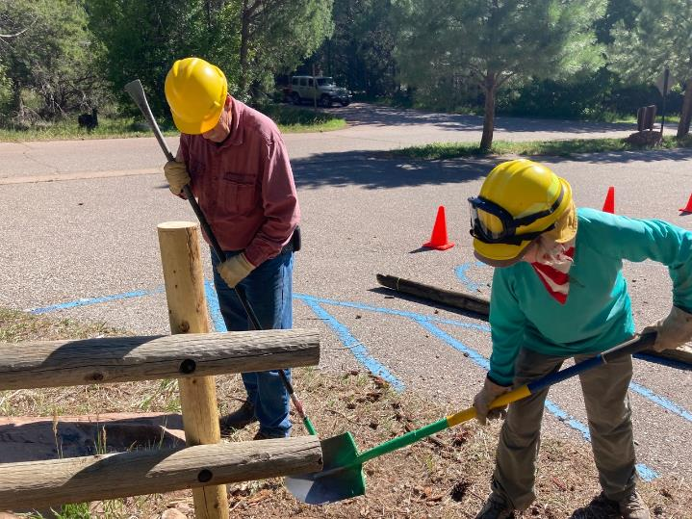

Jerry Carroll and Lorna Morrow back filling around a post they installed at the lowest parking lot

in Cienega Picnic Area.

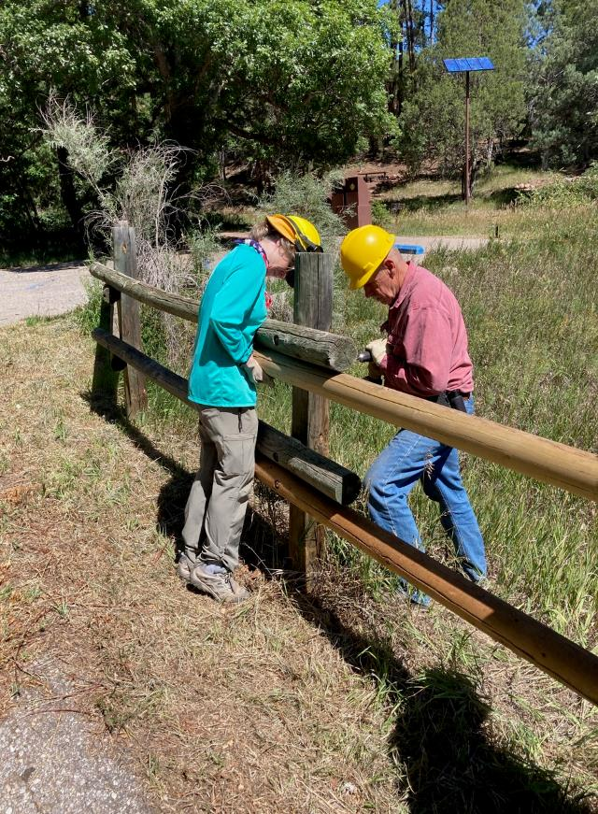

Lorna holding the pole while Jerry drills a hole for the threaded rod in Sulphur Canyon Picnic Area.

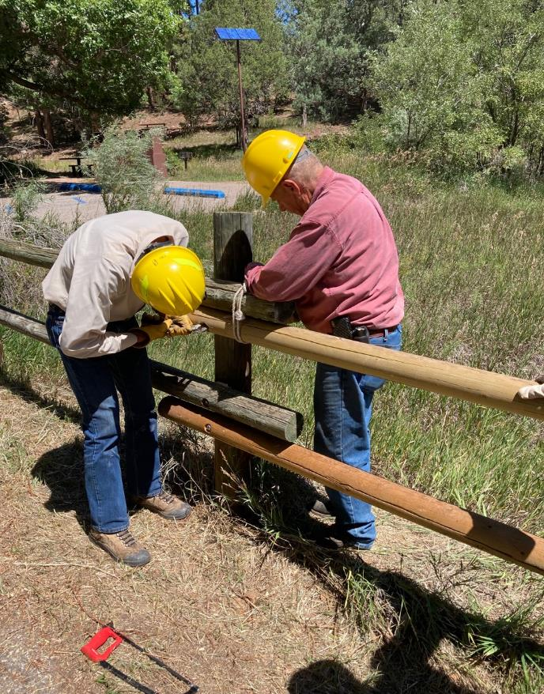

Sim Cook and Jerry Carroll working on replacing a pole in a Sulphur Picnic Area fence.

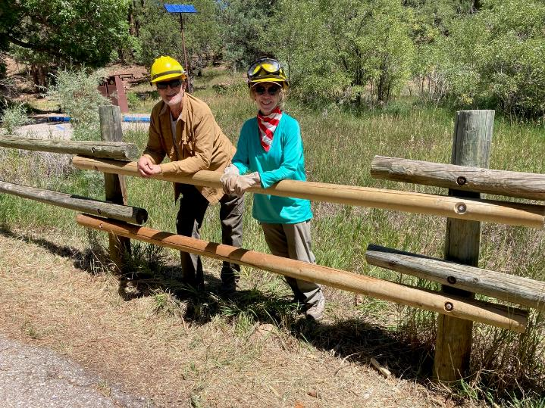

Dan Benton and Lorna Morrow at the installed rail in Sulphur Canyon PA.

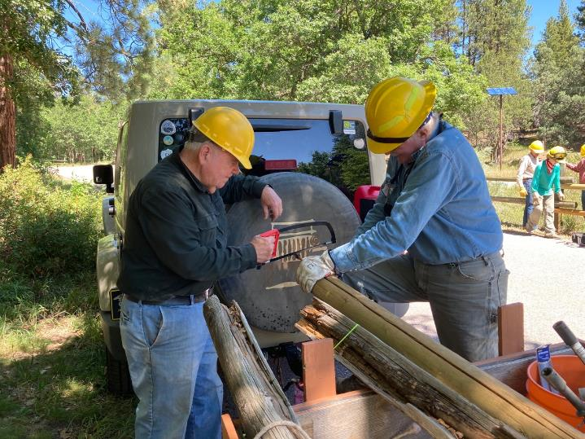

Dennis and Eric using a hack saw to restore threads in a piece of old threaded rod so that it can be used again.

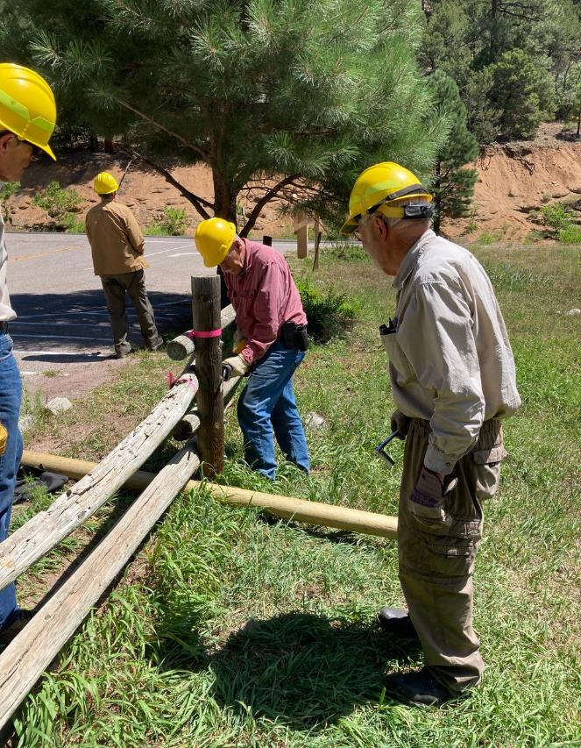

L to R: Sim Cook and Sam Beard observing Jerry Carroll working to remove a damaged pole in a fence

at the entrance to Doc Long PA. Dan Benton is in the background.

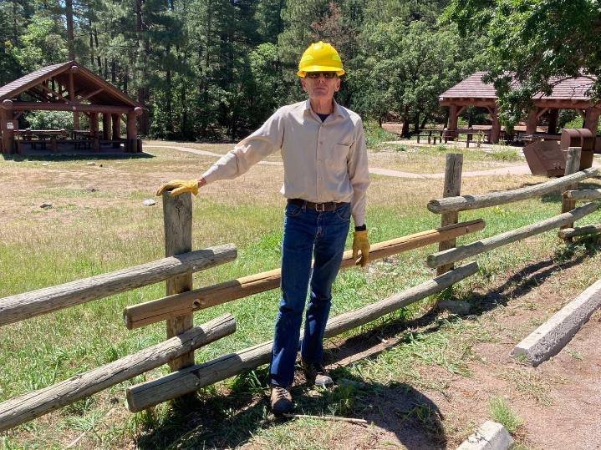

Sim at the new rail in Doc Long Picnic Area.