**Report of the FOSM Project to Install Six New Fence Posts**

**in Doc Long Picnic Area on Wednesday, September 1, 2021**

Sam Beard, September 3, 2021

On Wednesday, September 1, 2021, eight FOSM volunteers worked very hard installing six new posts in Doc Long Picnic Area where the old posts were completed decayed just below the surface. The posts were located at the picnic entrance, at the second gate, and at the upper restroom traffic circle. As one photo shows, Sim Cook was able to remove much of the buried part of one decayed post intact.

At the upper traffic circle, the old post had been set in concrete, probably because the former crew did not break up the solid rock they found at a depth of about 12 inches. Due to the difficulty of removing a large amount of buried concrete, the crew dug a new hole beside the old hole. In this hole, they found solid rock and had to use a rock bar to patiently chip away the rock until it was removed, and then the hole could be dug to a depth of 24 inches.

The work on Wednesday completed the replacement of numerous decayed posts in Doc Long, Sulphur Canyon, and Cienega Canyon Picnic areas.

The volunteers working on this project were Lou Romero, Sim Cook, Eric Russell, Cliff Giles, Dennis Crowther, Lorna Morrow, Jerry Carroll, and Sam Beard.

Project photos are presented below.

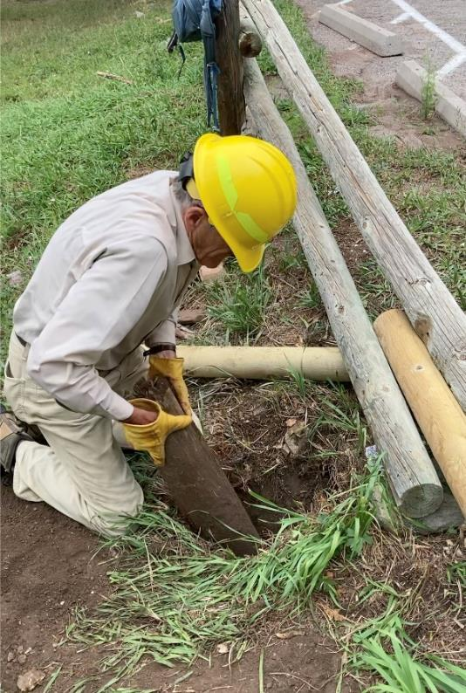

Sim Cook pulling the bottom part of a broken post from the hole after much work to loosen it

at the entrance to Doc Long Picnic Area. All photos by Cliff Giles

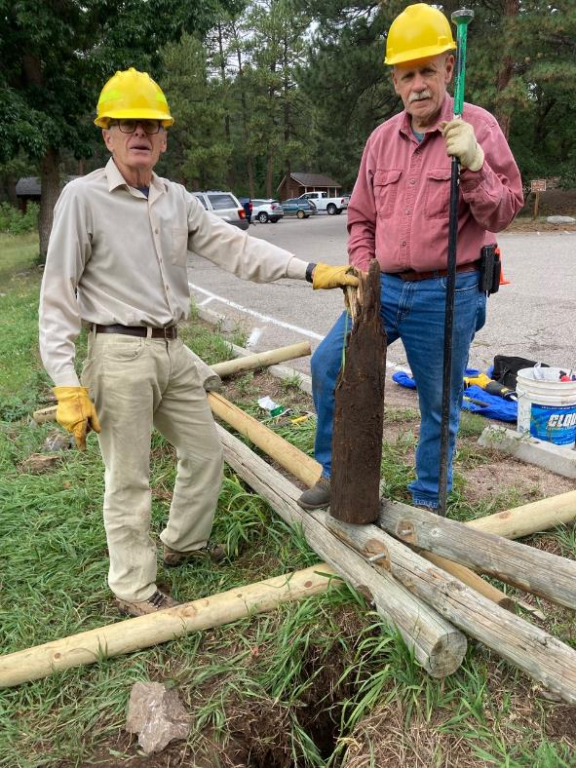

Sim Cook and Jerry Carroll showing the long buried part of the post that they have removed from the hole

in front of them.

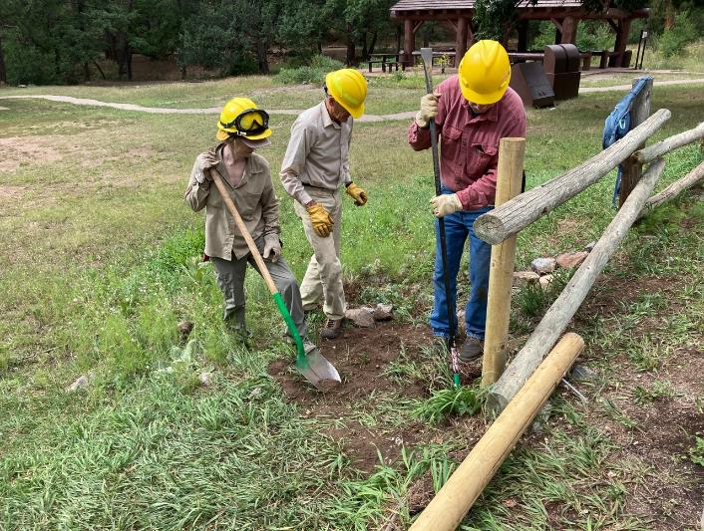

L to R: Lorna Morrow, Sim Cook, and Jerry Carroll finishing the installation of the new post.

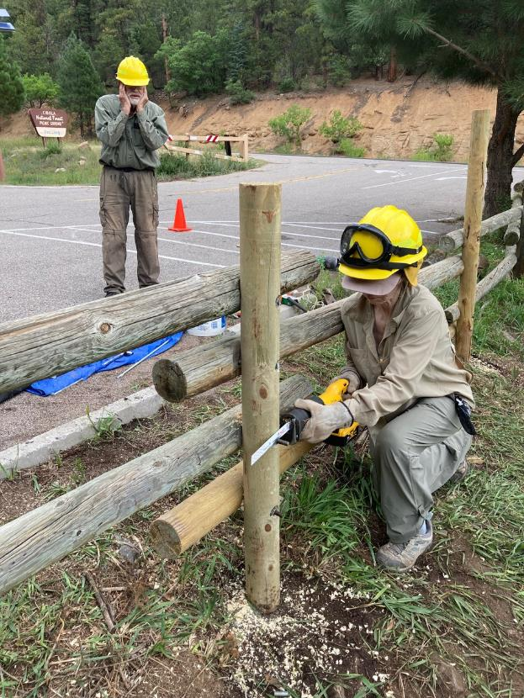

Lorna cutting off the excess threaded rod on the new post with the FOSM DeWalt

battery-powered reciprocating saw.

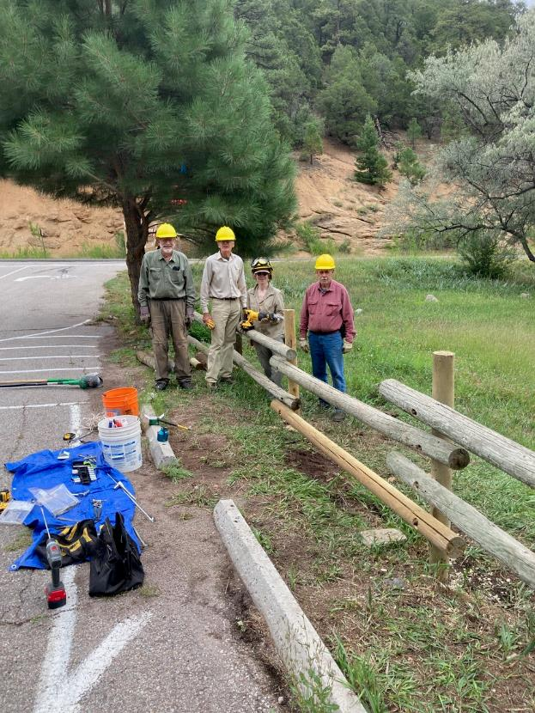

L to R: Sam Beard, Sim Cook, Lorna Morrow, and Jerry Carroll at the two new posts that

were installed at the picnic area entrance.

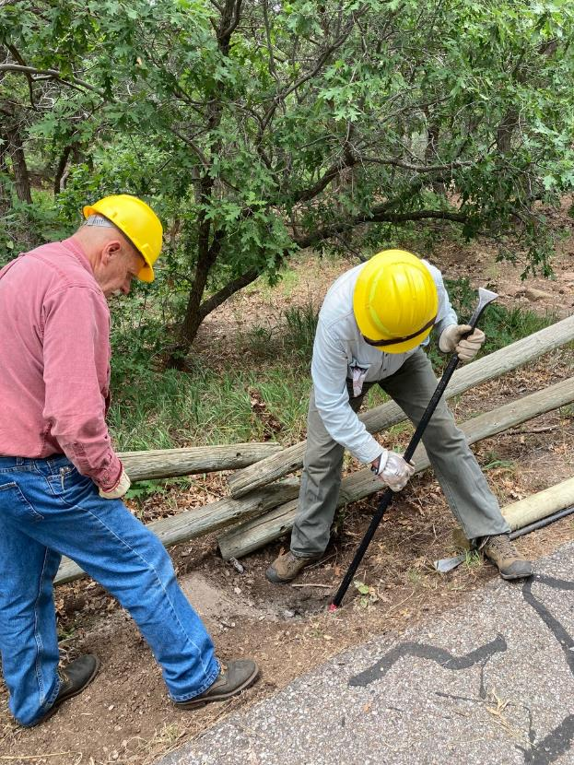

Jerry Carroll and Eric Russell removing rock particles from a new hole where concrete had been poured

around the old post. They used the rock bar to laboriously break up solid rock at the bottom of the hole.

This location was at the upper traffic circle in the picnic area.

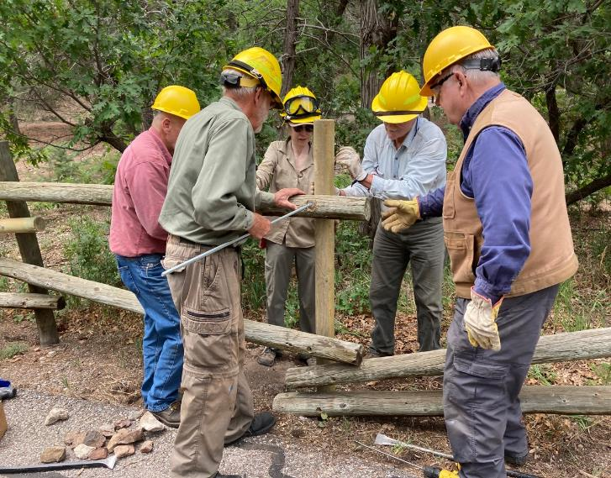

The post has been installed in the new hole, and threaded steel rod is being inserted in the hole to secure

the rail to the post. L to R: Jerry Carroll, Sam Beard, Lorna Morrow, Eric Russell, and Dennis Crowther.

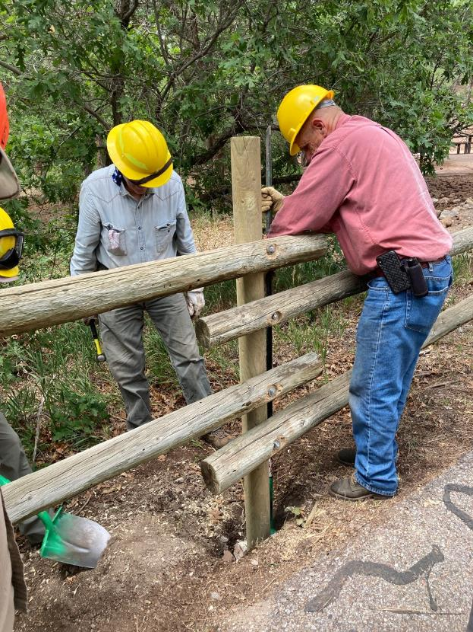

Jerry is using a dirt bar to tamp rocks around the new post.

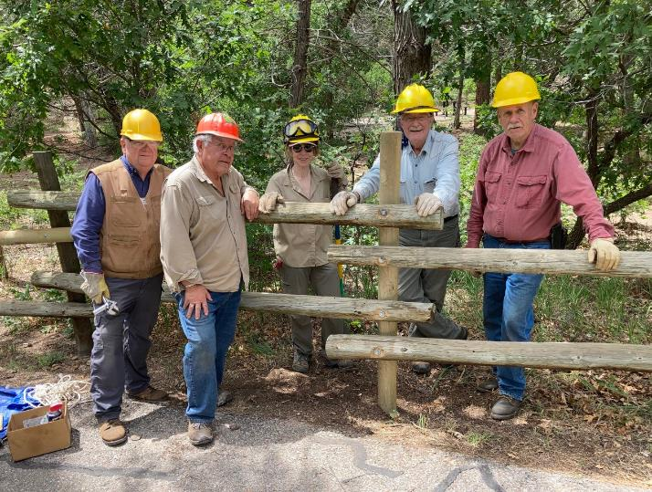

The crew who worked so hard to dig a new hole in solid rock and install the post at the upper restroom traffic

circle. L to R: Dennis, Lou Romero, Lorna, Eric, and Jerry.