**Report of the FOSM Paint Crew Projects on Tuesday, September 7, 2021**

Sam Beard and Anne Hickman, Sept. 8, 2021.

On Tuesday, September 7, the FOSM paint crew worked on projects at three sites:

1. **Crest Nature Trail** – The crew removed about two dozen relatively small graffiti patches from posts and signs along the Crest Nature Trail.
2. **Crest Parking Lot** – When we returned to the parking lot, we noticed that a sign board needed paint. We painted the front, back, and both posts.
3. **Restrooms at the Ranger Station Parking Lot** – Graffiti was found on the inside surface of both restrooms at the north parking lot. After applying the graffiti removal chemical, the residue and chemical was removed with water from the FOSM battery-powered low pressure washer.

The crew on Tuesday was Anne Hickman, Jane Harrison, Ellie and Russell Parker, Pauline Ho, Rick Buss, and Sam Beard.

Photos are presented below.

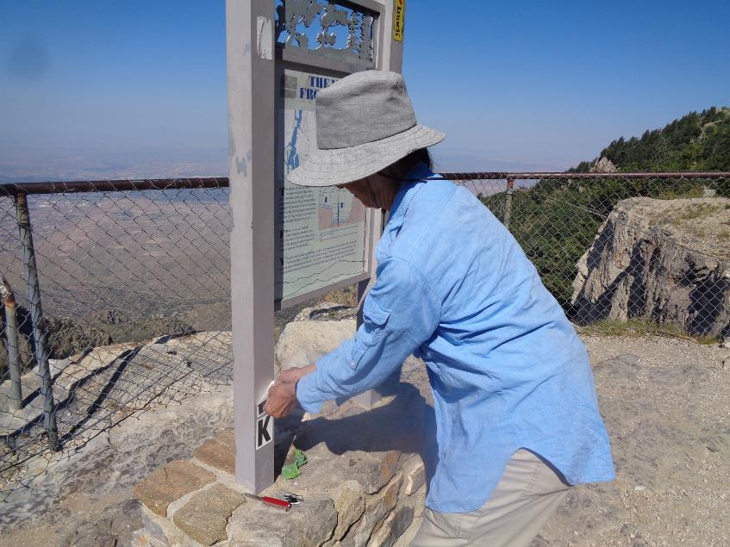

Pauline Ho patiently peaking off adhesive letters spelling WORK from a sign on the Crest Nature Trail. All photos by Sam Beard

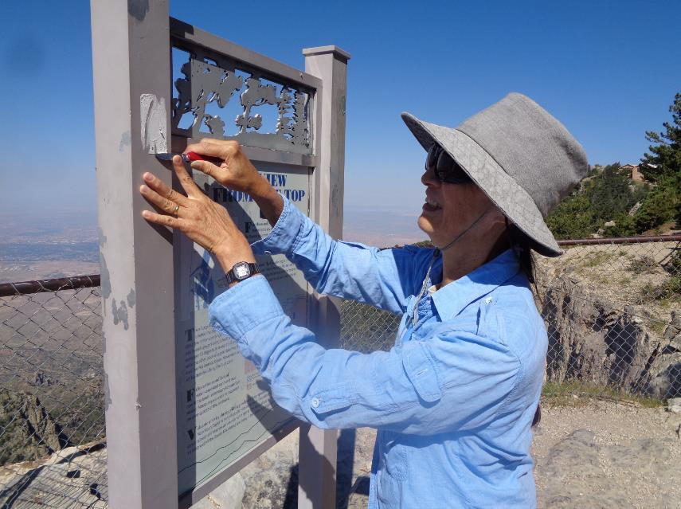

Pauline using a Swiss Army Knife to remove a label stuck on the post.

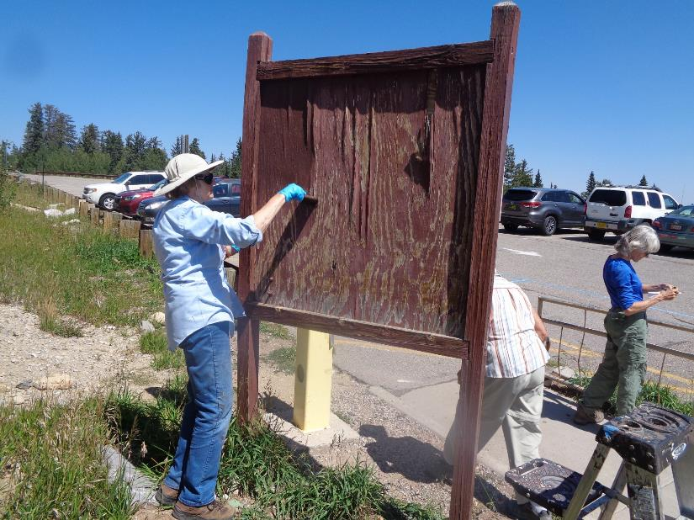

Anne Hickman painting the back of a sign board at the Crest parking lot. Note that the plywood needed paint and part of the plywood

had delaminated.

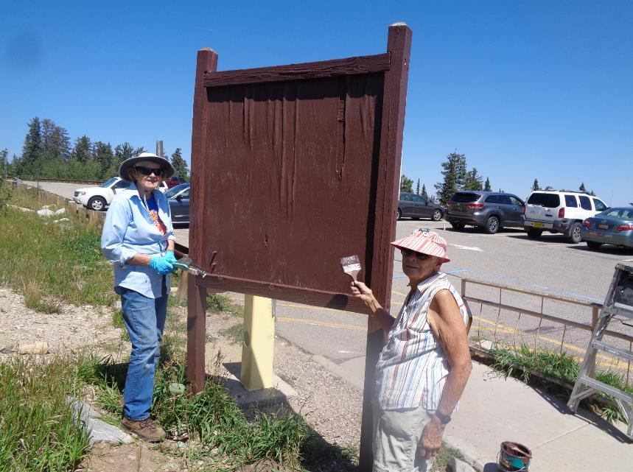

The back of the sign has been painted. The posts and front were also painted. L to R: Anne Hickman and Jane Harrison.

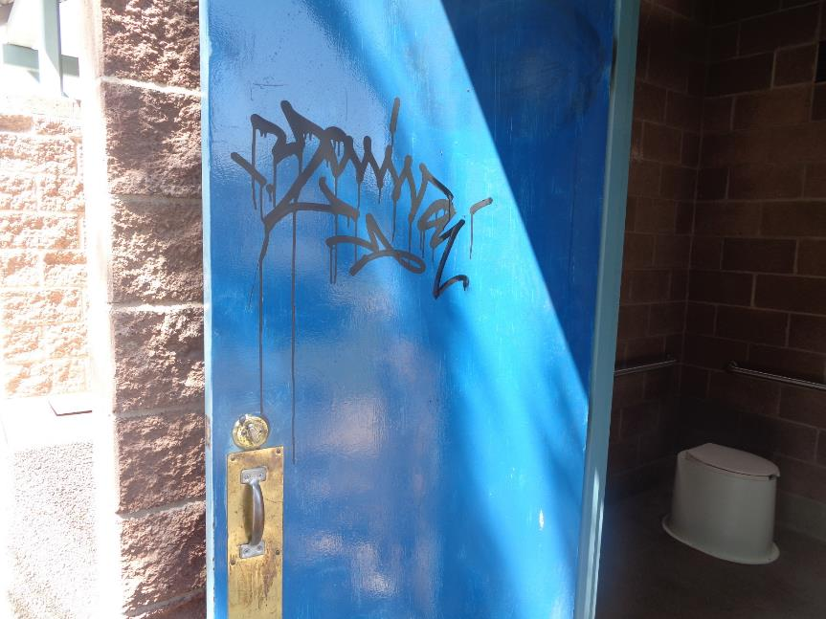

Graffiti on the inside surface of the door to the ladies’ restroom at the Ranger Station parking lot.

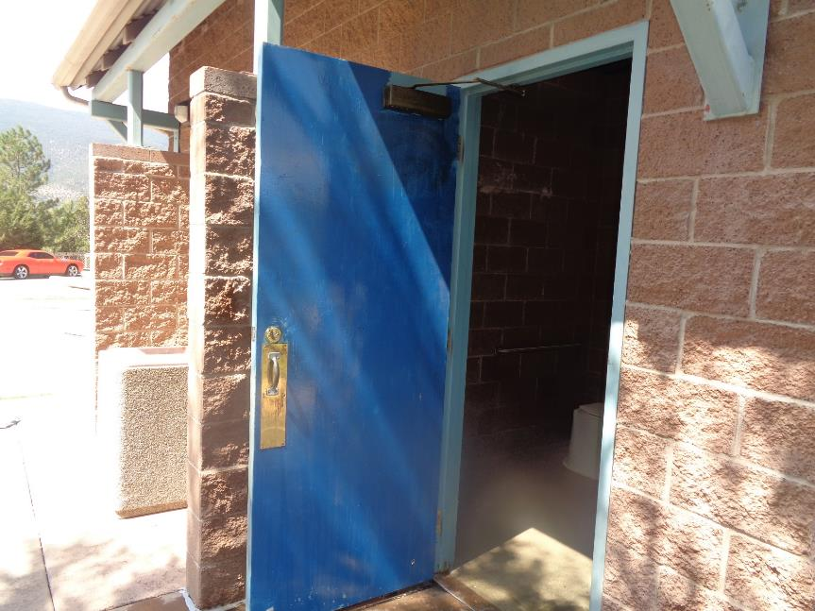

The new FOSM battery-powered low pressure washer was used to wash off the chemical used on the graffiti.

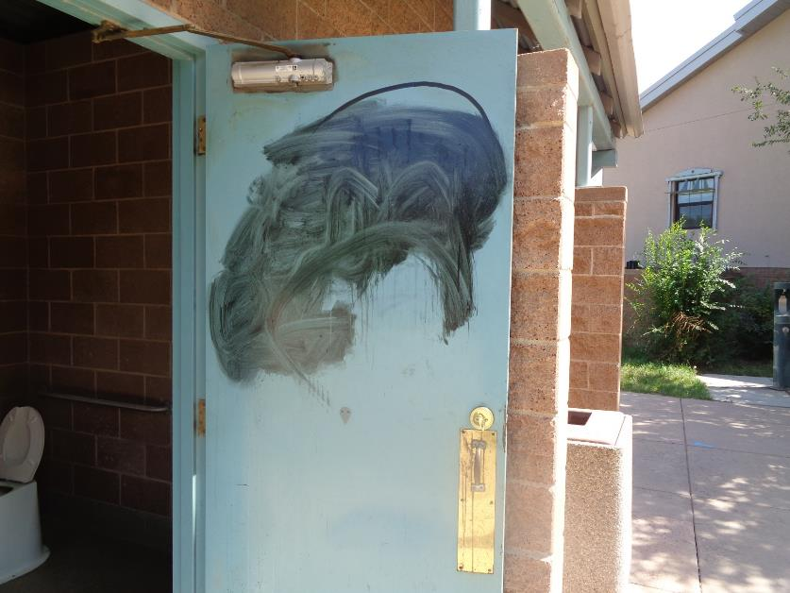

Graffiti removal chemical was applied on the graffiti on this door and then the area was rubbed with a wet rag after the

chemical had dissolved some of the graffiti.

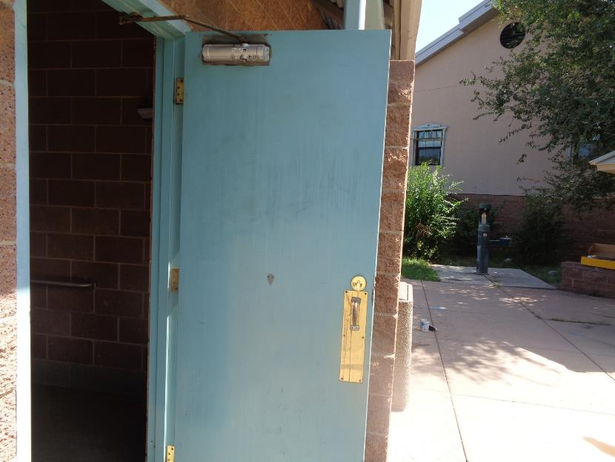

The FOSM pressure washer was also used on this door to wash off the partially dissolved graffiti and chemical.