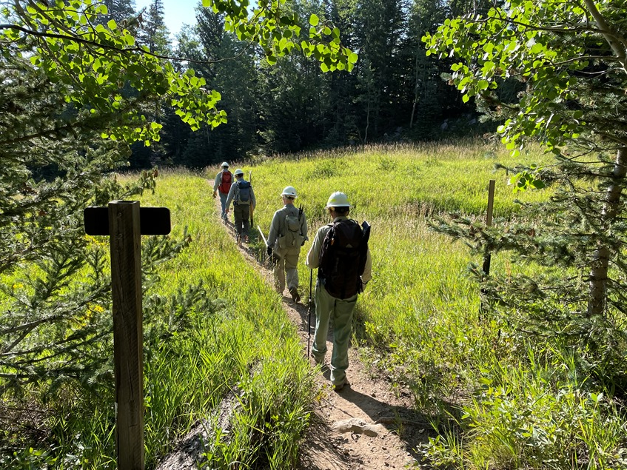
The crew crosses one of the runs at the Sandia Peak Ski Area on 10K South Trail while heading out for the day’s work.

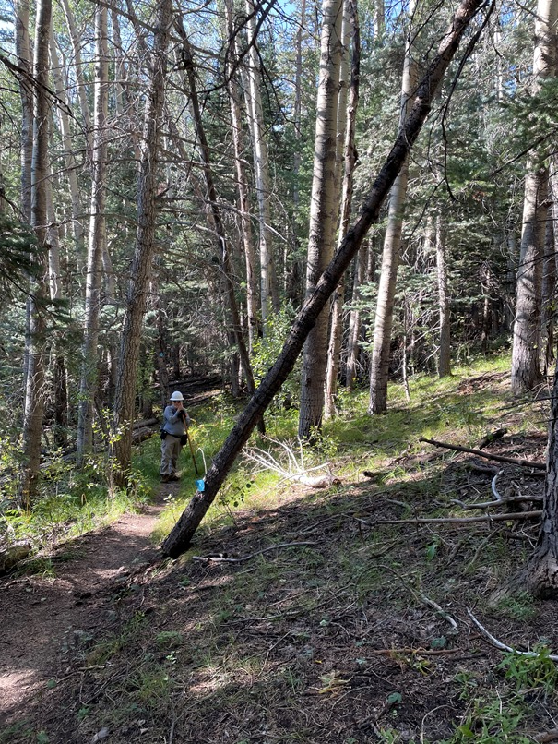
This strange leaner on 10K South appeared to have
been cut before based on the blue ski trail marker
which is usually high on the trunk. The lower end was
slowly sliding down into the tread. It was removed.
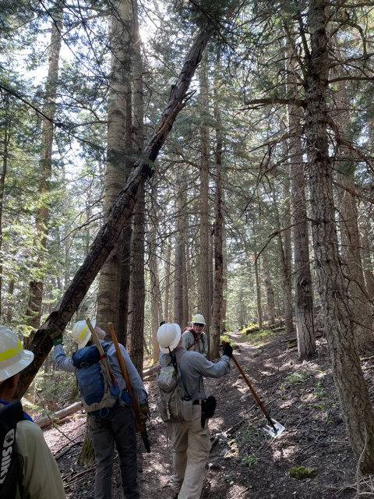
The crew stops to study this poorly supported tree
leaning over 10K South trail. It was removed.
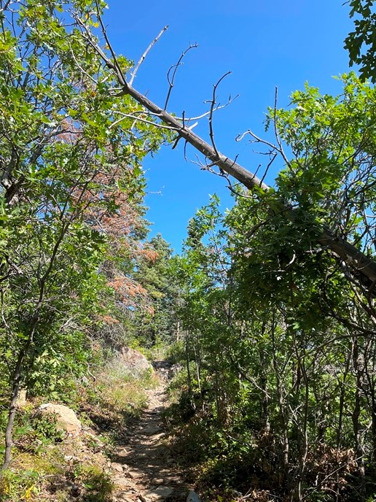
This old dead fallen treetop has been looming over
Crest Trail 130 a short distance south of the 130/Tree
Spring Junction for quite a while. It looms no more.

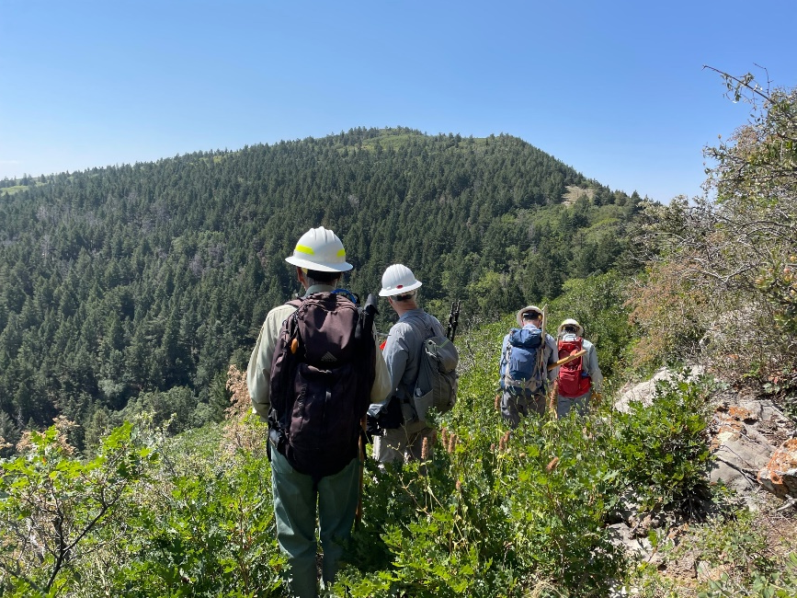
The crew stops to admire the view of Cienega Canyon a short distance before the Crest 130/Pino/Cienega trails junction.
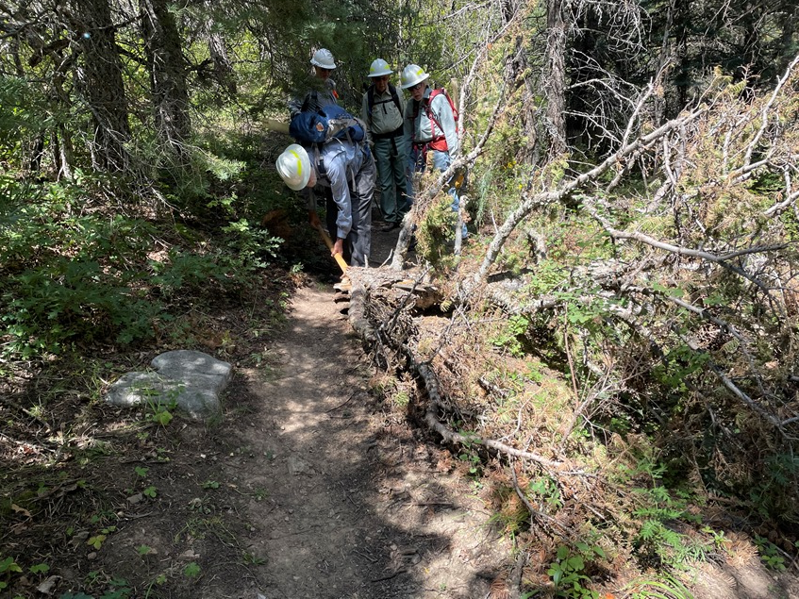
The crew had barely begun the hike down Cienega Canyon Trail before coming upon this large broken-off treetop that was partially blocking the trail. After some effort it was finally wrestled off.

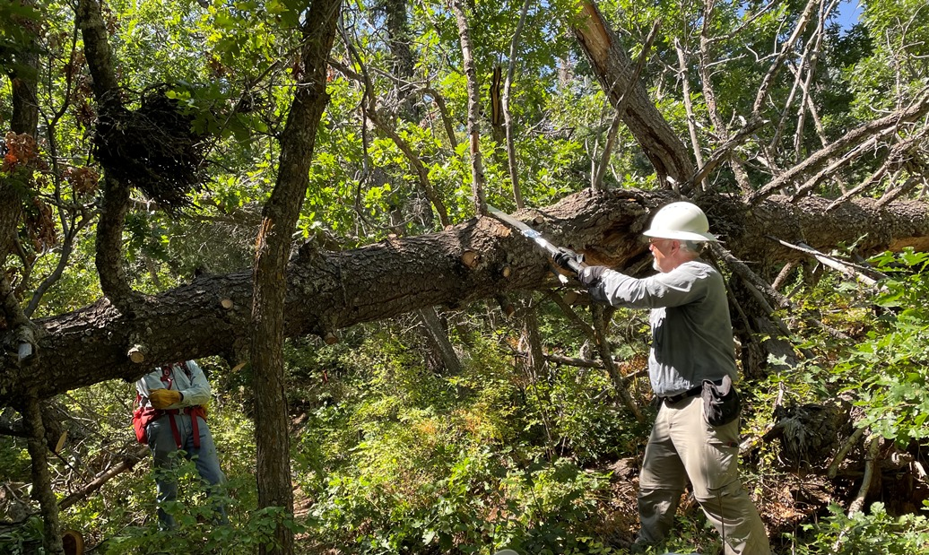
Cienega Canyon trail is always good for a few surprises for our crew. This 14-inch diameter fallen dead fir was found across the trail at head height. In porcupine tree fashion, it had branches sticking out in all directions that had to be cut away before the trunk could be cut. This was the top of a very large tree that continued some thirty feet uphill to the right of the photo. Towards its base, it was much larger than 14 inches in diameter. (Photo looking uphill)

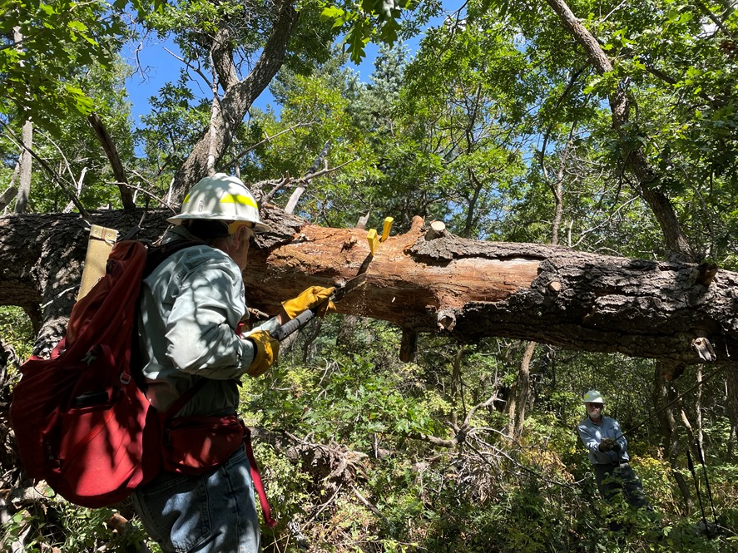
The second and final cut is being made to remove the middle section of the fallen tree. Byron is using the 21-inch Silky Katanaboy folding saw that Kerry Wood supplied to our crew for field testing. It performed in an excellent manner particularly in this situation that required some overhead cutting of branches. (Photo looking downhill)

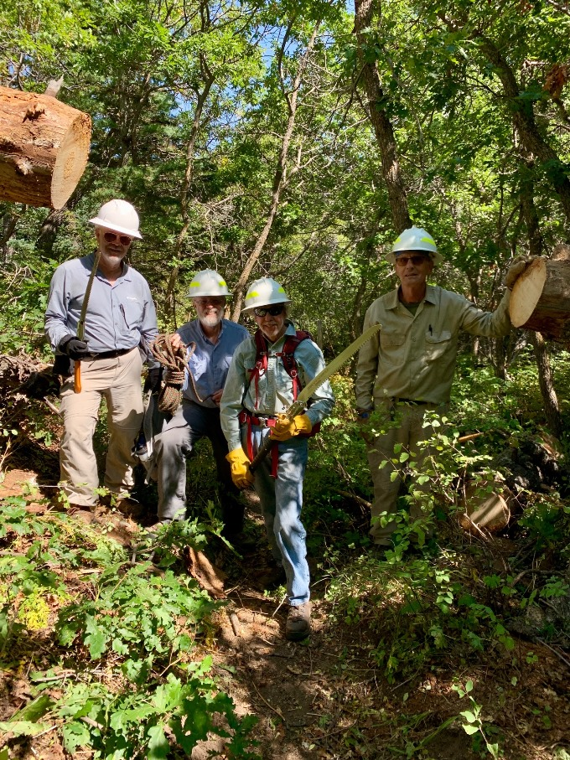
The trail is now open. The remaining ends of
the fallen tree are so long and so well supported
that they should remain as they stand for a very
long time.
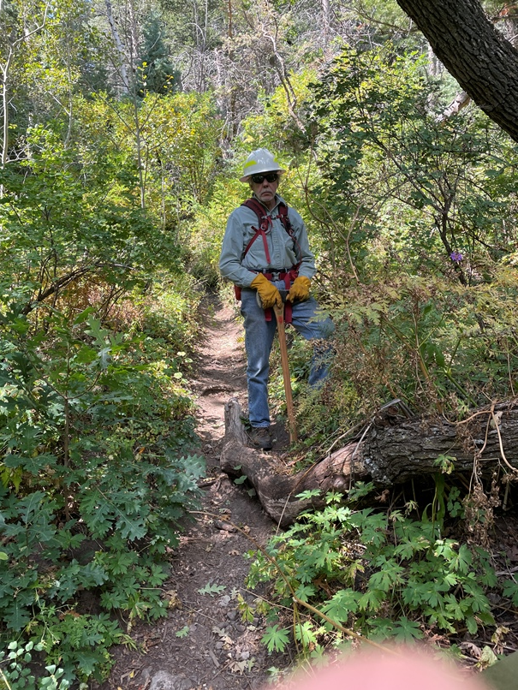
The top portion of a twisted dead oak tree which fell
into the tread was sticking up causing a serious
tripping hazard on Cienega Canyon Trail.

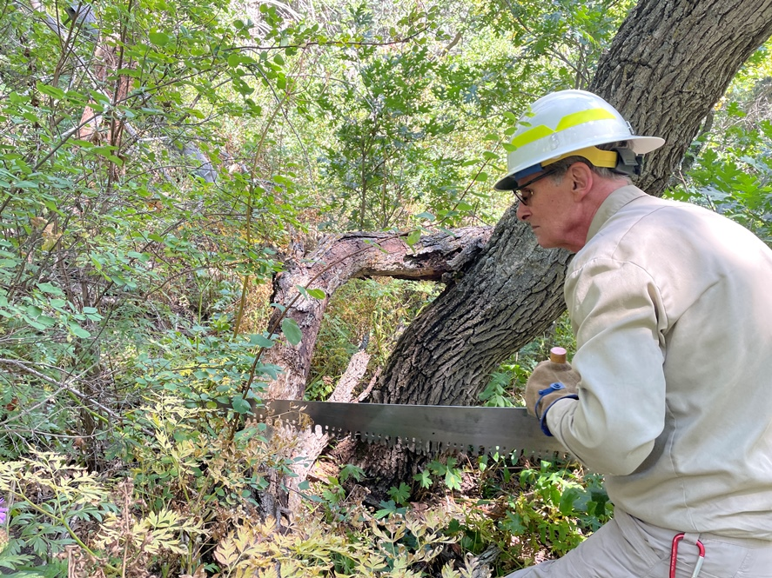
Bill is making a cut on the upper portion of the fallen oak tree
so that it can be moved off the trail.
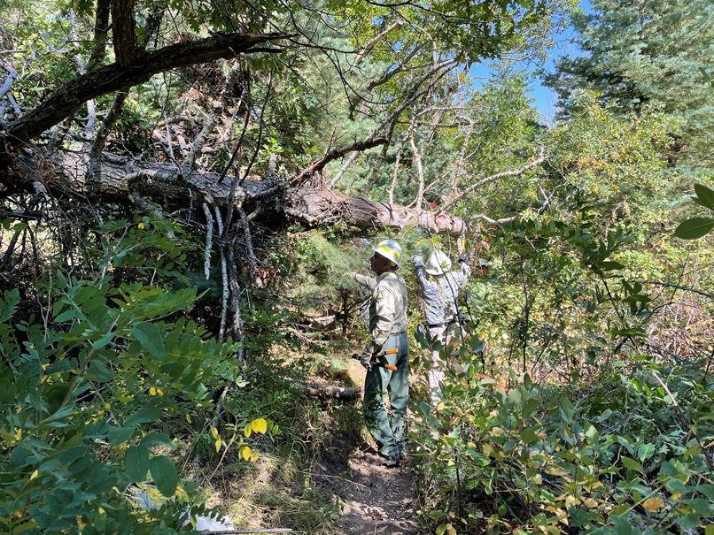
And yet another one was waiting for us. The broken-off top of this fallen tree was sticking out over the trail. The branches were removed and the tree was cut back away from the trail.

