**Report of Painting Yucca Site Restroom in Oak Flat Reservation Picnic Area**

**on Tuesday, September 14, 2021**

Sam Beard, Sept. 15, 2021

On Tuesday, September 14, the FOSM Paint Crew painted the exterior of the restroom in the Yucca Site at Oak Flat Reservation Picnic Area. They applied Behr FSS 20059 brown paint that is used on the Sandia Ranger District. FOSM volunteers had installed the metal roof a few years ago.

The volunteers were Russell and Ellie Parker, Jane Harrison, Anne Hickman, and Sam Beard.

Project photographs are presented below.

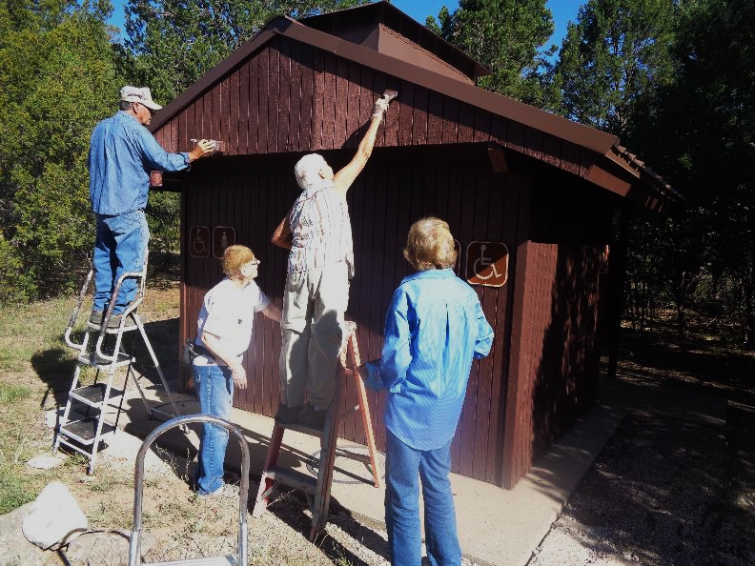

Painting gable end of restroom at Yucca site in Oak Flat Reservation Picnic Area. The light color

above Jane’s head is the weathered paint before the new USFS brown paint was applied.

L to R: Russell Parker, Ellie Parker, Jane Harrison, and Anne Hickman. Photos by Sam Beard

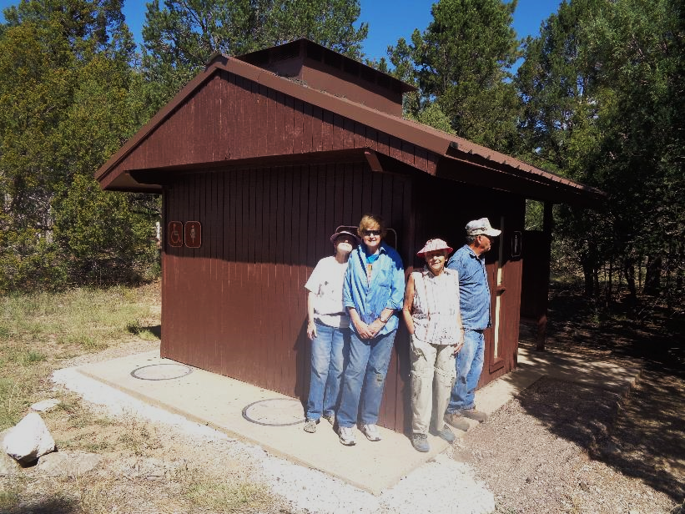

Ellie, Anne, Jane, and Russell standing beside painted restroom. The lower edge of the fir paneling

on the upper part of the gable end had separated from the framing, and Russell reattached it with screws and nails.