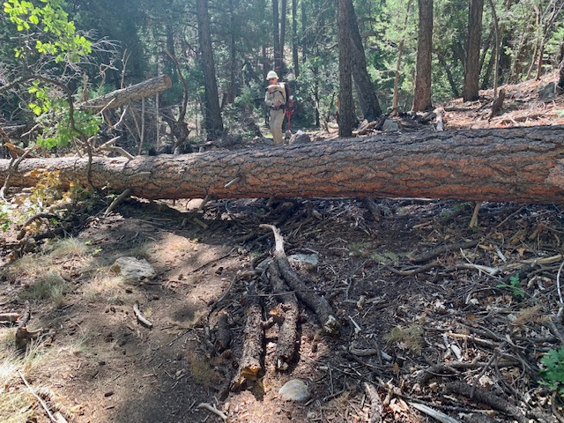
This 19½ in. diameter fallen Ponderosa was blocking Faulty Trail
about 1 mile south of the Bart’s Trail junction. The crew hiked nearly 4½ miles to reach this location. Safely removing an obstacle of this size can be a time-consuming operation.

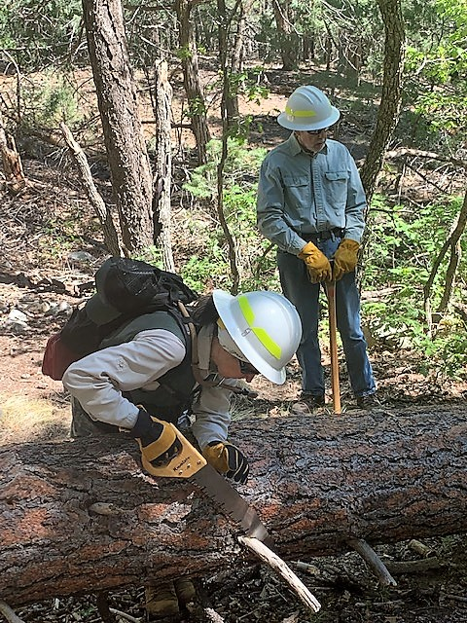
Rav is cutting away branches to provide safe space
for the sawyers to work and to facilitate rolling the
log off the trail after it is cut.
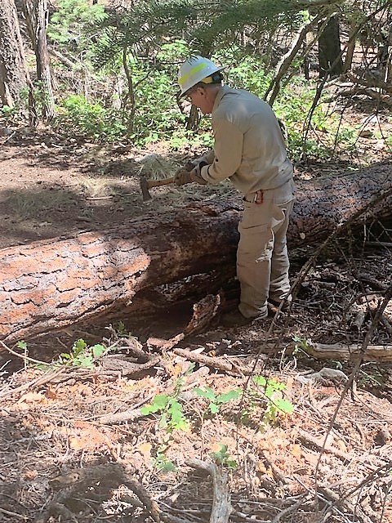
Bill is cutting away bark at the location of the first
cut. This is done because bark can contain blown in soil
which is abrasive and can dull the teeth of the crosscut saw.

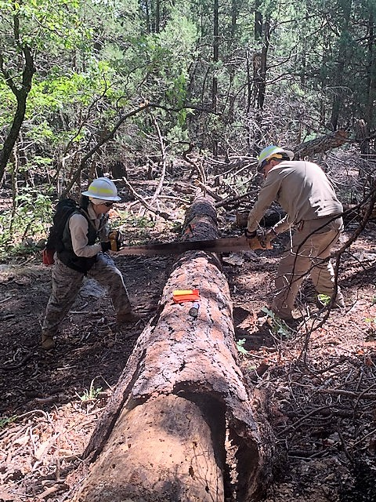
Rav and Bill begin the first cut.
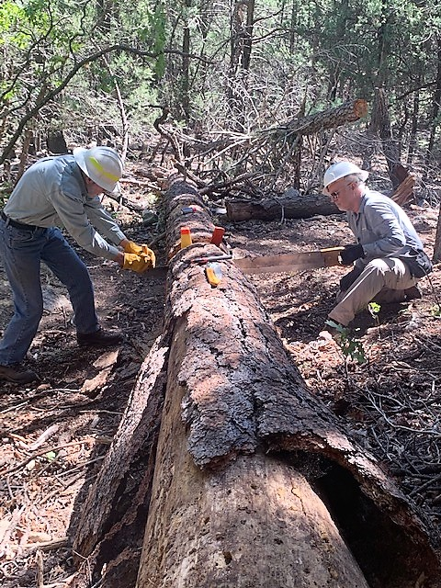
Byron and Jamey are close to finishing the first cut.
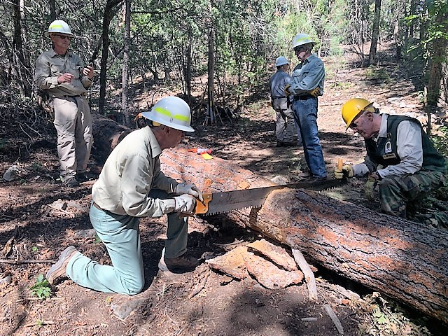
Bob and Ken starting the second cut.
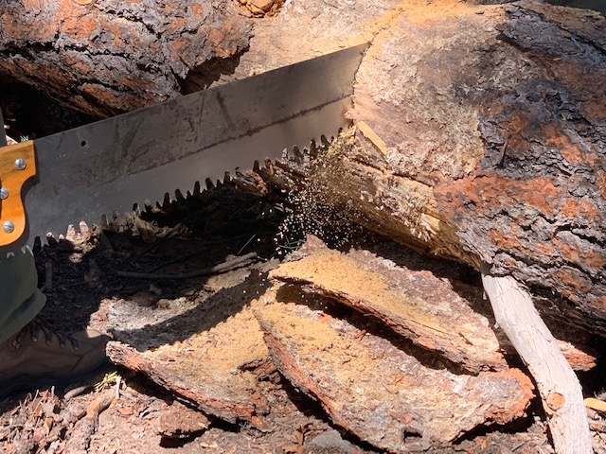
Sawdust cascading out of the kerf (cut opening) on the second cut.

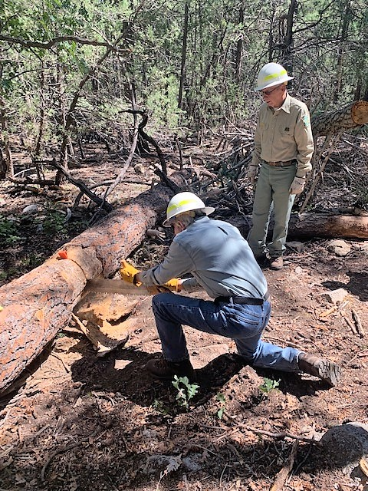
Byron finishes the second cut.
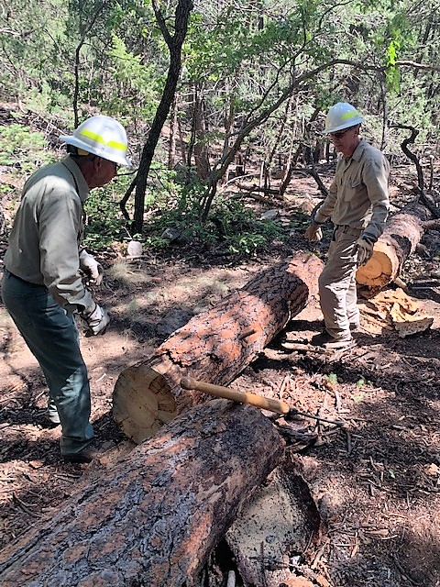
Bob and Bill have rolled the cut-away log onto a flat
rock in the trail located at the log’s center point.
The log was then rotated and rolled off the downhill
side of the trail.

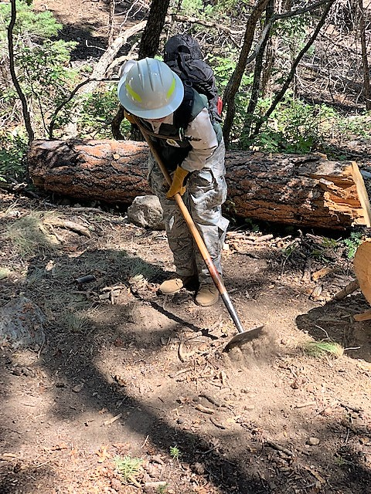
Rav is repairing the trail tread after the obstacle
was removed. The cut-away section is in the background.
A heavy wedge-shaped rock holds it securely in place.

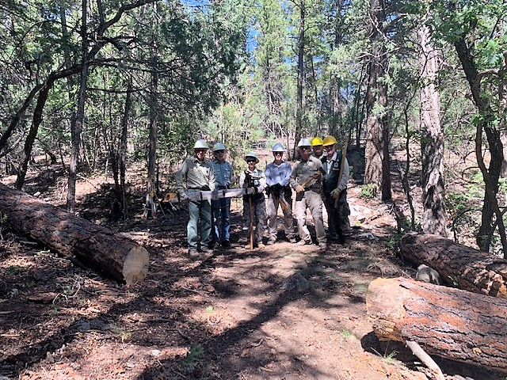
The trail is now clear. The crew, (left to right) Bob Lowder, Byron Garner, Rav Nicholson, Jamey Browning, Bill Savage, Sim Cook and Ken Nicholson. Not pictured, Sally Lowder.

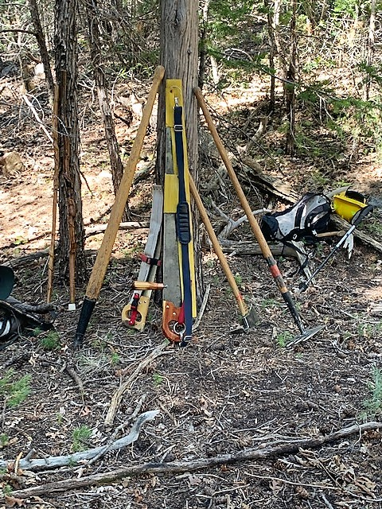
Some tools of the trade.

