Thursday, September 23, 2021, five of the elite “Thursday Trail Crew” continued hammering away at the Challenge Trail extension west of the old Dry Camp parking lot working towards the ski area.

We’ve progressed to the south facing slope ascending on the steep, powdery, rocky slope. Sounds like fun to me.

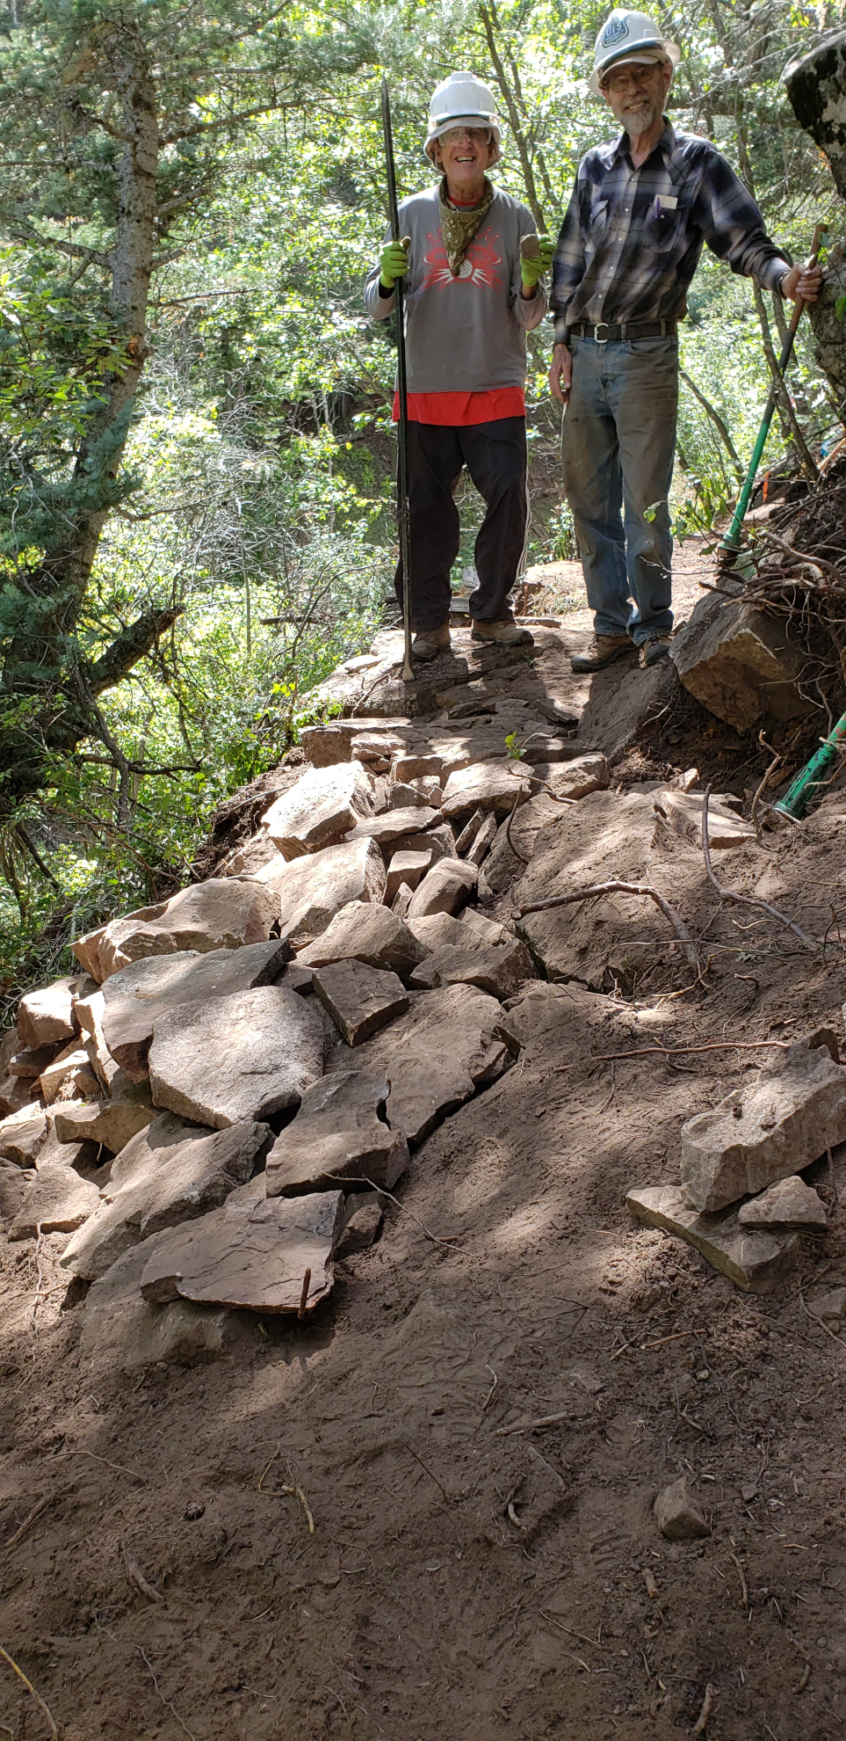
There we worked cutting new tread, improving cribbing rock work from last time, moving lots of rock, stabilizing trail, and widening the section of trail.

Volunteers were blessed with cool temps throughout the day. Although the trail is south facing there’s a lot of shade.

The volunteers were: Byron Garner, Bruce Hansche, Jim Houle, Richard Miller, and Eric Russell. Richard is a new guy with the crew and so far we haven’t been able to scare him away.

We’re about to make a left turn towards a small drainage so the work should be a lot easier there for a stretch next time.

Richard and Bruce worked all day on this stretch. Prying, pulling breaking, filling rocks. Note the bent rock bar. Covering with dirt remains.

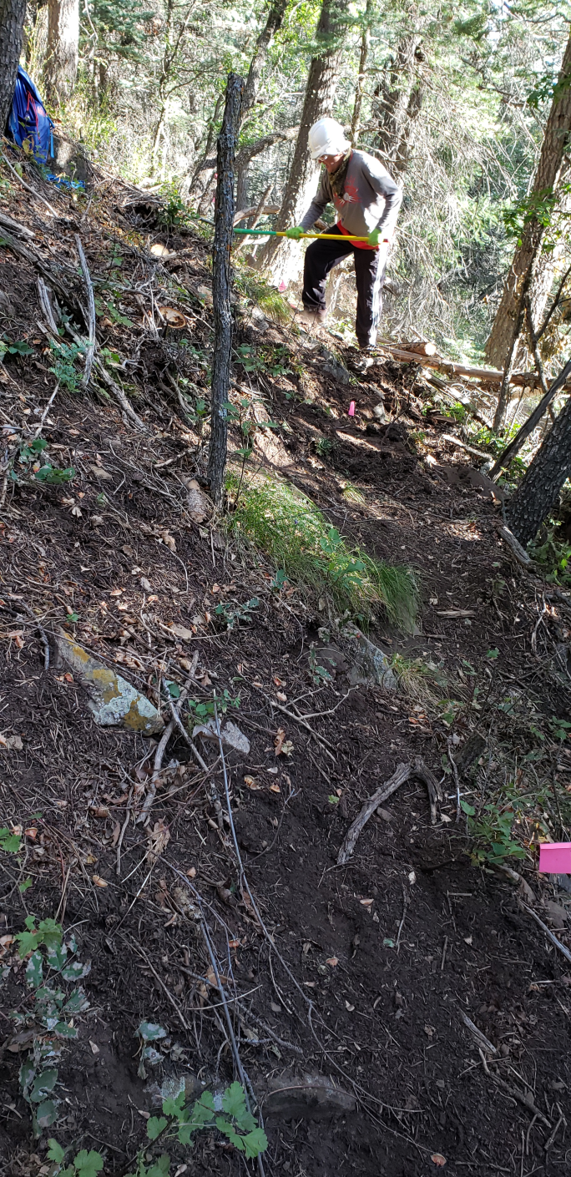
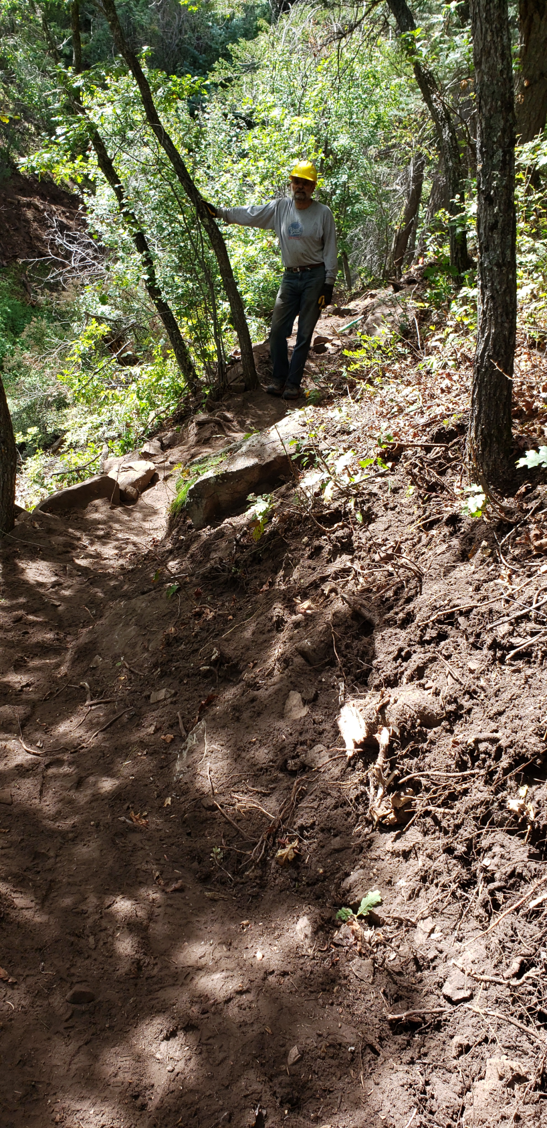
Jim surveying some of the After work. It’s actually very nice trail – just hard to see.
Rich working on the Before

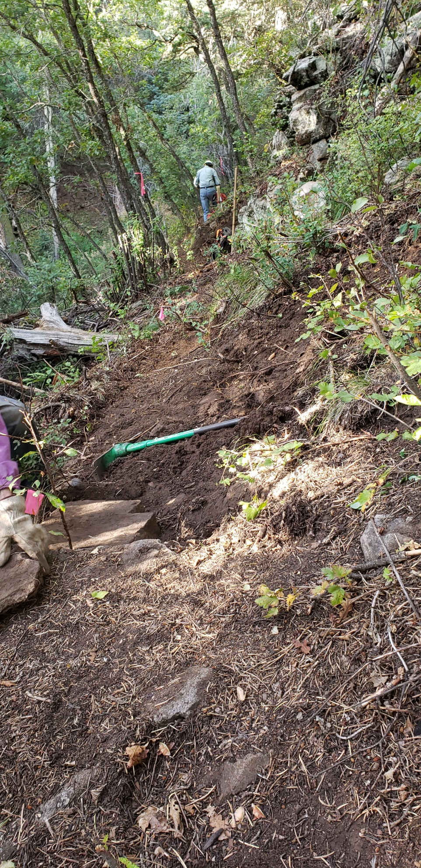
More Before – This is leading up to the rock fill section. Now completed. Byron working in the distance. Big Jenga rock pile above my pack just below Byron.

