**Friends of the Sandia Mountains**

**Annual Newsletter, September 2021**

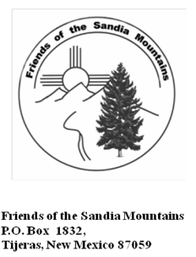

**From the President**

Like everything else, FY2020 was a lost year due to COVID. FOSM was able to host a Jan. 2020 Snowshoe Race, because it was pre-COVID. The virus restrictions began mid-March, so any thought of general meetings was absurd… not even a Board Meeting took place. Hosting a 2021 Snowshoe Race was taken off the table. Some ‘bubble’ weekly working crews persisted by invitation only. Sam did publish a FY2020 Annual Newsletter.

By FY2021 (Oct 1, 2020) elections, it was time for FOSM to get back on its feet again. When the election dust settled, one-third of the Board of 12 were newbies. I filled the Presidency seat for Bob Lowder, who had served for 16+ years. Cliff Giles took over VP from Lou Romero. Sim Cook and Byron Garner assumed At-Large positions.

With the transfer of office, Bob told me that FOSM basically runs itself, which is true… consider your own body and how many functions go on without even thinking about it. With new blood comes new ideas, so I formed a Strategic Planning Committee of four, half new and half old… Cliff and I, Lou and Sam. We spent the spring flushing out new ideas to take our great organization and make it even better. Zoom had become mainstream. Cliff took on the task of getting FOSM a Zoom account for our meetings, then booked presenters for the April-October meeting season! With COVID restrictions lifted, our weekly crews resumed in strong numbers.

Due to Lou Romero’s effort, OneABQ produced a 15-minute film of FOSM’s work on GOV TV. We were also filmed by KOB News.

We received an REI Grant due to Bob Galloway’s efforts. Cliff and Sim are managing the procurement of OHV signage on a NM Game & Fish Grant.

All the great work that was done by our volunteers over the past year is described by the respective leaders in the following pages. Please take the time to read it.

Julie Padilla, Sandia District Recreation Staff Officer, claims that FOSM annually logs 15,000 hours of volunteer service to the District! At the federal volunteer labor rate of $28.54/hr., we add a labor value to the District of $428,000.

In the near term, I’d like to see two things happen… PayPal buttons installed on our website for dues payment and donations… and a successful 2022 Snowshoe Race. Cliff is focused on the PayPal buttons. I’m focused on the Race.

As always, my sincere thanks go to all our dedicated volunteers for their hard work, serving in so many capacities on the District. Thanks also to the FOSM Officers and Board who make my job easier by taking on so many administrative tasks, and to the Sandia Ranger District staff whose partnership and appreciation are vital to us fulfilling our mission.

Respectfully,

Mike Madden, President

Friends of the Sandia Mountains

**Friends We Have Lost**

**Bill Geck** died on February 23. Bill was a long-time volunteer on the Sandia Ranger District. He and Don Carnicom removed fallen trees from trails for many years before FOSM started the Cibola Trail Rangers egroup and other members began helping remove trees.

**Larry Littlefield** died in the spring. He and Julie moved to Seattle a few years ago, and he was a volunteer at a botanical garden there. While a FOSM member, Larry was a chain saw operator, and sprayed herbicides on non-native and invasive species.

**Patricia Benton** died on September 3. Pat was an enthusiastic supporter of FOSM’s work, and frequently accompanied Dan to FOSM monthly meetings and other activities.

**Meadow Restoration by Thinning in Cedro CFRP**

In March and April of 2021, FOSM volunteers worked four days on the Cedro CFRP (Collaborative Forest Restoration Project) and thinned 7.9 acres in the western part of the 32-acre site. Earlier in the second year of the project, FOSM had thinned 6.5 acres; therefore, in the second year of the project, FOSM thinned 14.4 acres.

In late summer of this year, The Nature Conservative notified FOSM that the project was ending on September 30. In a Zoom meeting with other project organizations, Sam Beard presented a 10-minute Power Point summary of FOSM’s activities in the project with photographs of work at the site. In conclusion, FOSM thinned 12 acres in the first year and 14 acres in the second year, for a total of 26 acres thinned during the project. (Sam Beard)

**Restoration of Oak Flat Picnic Area Structures**

Volunteers completed the following projects in Oak Flat Reservation Picnic Area to extend the longevity of several structures and make them more attractive:

1. **Locust and Oak Sites**
2. **Metal Roofs Installed on Three Restrooms** – Dark brown steel roofs were installed on the three restrooms at these sites. After Manny Chavez, Sandia Ranger District Maintenance Supervisor, had removed the old shingles and felt, volunteers repaired the wooden sheathing and covered the roof with 30-lb black felt. Seven-inch wide custom-made steel drip edges were installed for good appearance and to protect the 2x6 fascia and cut ends of the 4x6 rafters. (See below for information about the rafters.) 16-foot by 3-foot steel R-panels were cut to length and screwed to the sheathing. In order to fit the panels around the 4-ft by 4-ft sky lights, three cuts had to be made in each of two panels. Special cuts were also required to fit the panels around the ventilation structure on the roof ridgeline. After four panels were installed on one side of the roof, steel gable trim pieces were screwed to the gable edges of the roof. The last roofing piece to be installed was the ridge cap that covered the upper ends of the panels. Black tar-like roofing cement was then applied around the 16-ft perimeter of the sky lights as a water seal. One crew could usually complete one-half of a roof in one day.
3. **Removal of Exposed Rafter Ends** – The design of these restrooms included four exposed 4x6 rafter ends along each eave to give a rustic appearance. Due to exposure to the weather, primarily rain running off the roof, no paint remained on these beams and some of the top surfaces were severely cracked with wood missing. In order to eliminate the need for future maintenance, the rafter ends were cut off with the FOSM battery-powered reciprocating saw. The ends of the cut rafters and the 2x6 fascia were covered with the custom-made 7-inch wide by 2-inch steel drip edges that provide an attractive trim to the eaves.
4. **Weather-proofing the Gable End 4x6 Exposed Beams** – The tops of 16 exposed 4x6 decorative wooden 12-inch beams on each restroom were weathered and cracked. To protect these beams, the top of each beam was coated with System Three Epoxy Paste that filled the cracks and provided a weather-proof surface that was then painted. Fasciae and other exposed wooden components on the gable ends of each restroom were painted with USFS brown latex paint.
5. **Penofin on Restroom Doors** – The two wooden doors on each restroom were coated with redwood Penofin, Penetrating Oil Finish. The door frames were painted brown.
6. **Painted Picnic Shelter Fascia** – The 2x6 fascia around the large picnic shelters at Pine, Locust, and Yucca sites were scraped and wire brushed before being painted with brown paint.
7. **Drip Edges Installed on Yucca Shelter** – A drip edge is a steel sheet that has been bent so that the upper 2 inches fits under the edge of the shingles or end of the metal panel. The vertical part of the drip edge covers the upper few inches of the fascia. The lower half-inch of the drip edge is bent out 45 degrees so that the rain can drip off and away from the wooden fascia. The Yucca picnic shelter was constructed without dip edges, and rain ran from the shingles onto the fascia. Fortunately, volunteers were able to tuck the upper part of the drip edge under the shingles. The drip edge and shingle edge were secured with 1.5-inch roofing screws with a water seal washer under the screw head.
8. **Painted Yucca Site Wooden Restroom** – The FOSM paint crew scraped, wire brushed, and painted the exterior fir paneling on the old restroom at Yucca site on September 14, 2021. (Sam Beard)

**Fence Construction at Tree Spring Trailhead**

In August volunteers constructed a 24-foot fence at the Tree Spring Trailhead to discourage hikers making a shortcut from the parking lot to the trail. It connected two fence segments constructed several years ago when a dense oak grove was between the two segments. Recently a route had been cut through the grove. The new fence was constructed in four zig-zag segments with 4-inch diameter pressure-treated 8-foot-long poles. Each 5-pole segment was about 6 feet in length along a line between the ends of the original fences. To avoid the need to dig post holes, three steel posts were driven into the ground to support crossed poles wired to the posts. The bottom pole rested on an 8-inch-high concrete block at each post so it was not in contact with the ground. The wire was two twisted strands of smooth galvanized steel similar to that used for barbed wire fences but without the barbs. A piece of approximately 24-inch wire was wrapped around the pole and post and twisted with fence pliers. Excess wire was cut off. (Sam Beard)

**Strategic Planning Committee**

The formation of a Strategic Planning Committee became something new for FOSM in the Spring of 2021. I chose Cliff, Lou and Sam to assist me in defining some major goals. We came up with the following four: 1) strengthen our relationship with SRD leadership, 2) broaden our community outreach (next generation members and stewards) education and development, 3) develop close relationships with other organizations and agencies, and 4) improve FOSM infrastructure to facilitate mission accomplishment. There are some tangible results this year. Sam and I can call or email Crystal, Julie, Antonio, Kerry, or Russell and get a quick response. It is understood that any special weekly project requires advanced notice and planning. We have partnered with Sandia Nordic Ski Club on seven Saturdays as an opportunity for our working membership to volunteer. We scheduled an outing with Albuquerque Digital Arts and Technology Academy. We also had Talking Talons youth participate in our weekly projects. In an effort to develop partnerships, we have had other organizations present at our monthly meetings and will continue to do so going forward. Thanks to Cliff, we are Zoom savvy and have only just begun to enhance our website with photographs and biographies of the current and past Officers and Board Members, our new 15-minute video, Sam Beard and Bob Lowder recognitions, FOSM 2018 National Award for Enduring Service, and much more.

With the new Board, we will strive to implement further improvements in FY2022. (Mike Madden)

**2021 FOSM Trail Construction Projects**

FOSM volunteers contributed to trail projects under the direction of Kerry Wood, Trails and Wilderness Program Manager, Cibola NF; and Russell Berman, Trails Foreman, SRD. The federal court injunction on timber management related to the Mexican Spotted Owl, along with COVID-19-related caution, put a halt to FOSM trail building projects between August 2020 and April 2021. Once projects resumed, over 30 trail sessions were coordinated with SRD from April through the end of September 2021.

**Cienega/Armijo Trails Improvement Project -** The big accomplishment of the FOSM trail building crews for FY2021 was the completion of the Cienega/Armijo Trails Improvement Project (CATIP), first begun in 2017. Congratulations are in order to all those who contributed to this project over the last four-plus years, most especially to Bob Galloway, who headed up the CATIP endeavor from the project’s inception! In addition to completing new trails This Way, That Way and Vista, the crews obliterated unsustainable user trails, cut trail corridor, removed deadfall, rerouted sections of Un Poquito Trail in Cold Canyon, and completed the installation, begun in 2019, of trail signs at the new trail junctions. This project has added over six miles of new sustainable trails to the SRD trail network.

**Sandia Trails Improvement Project -** The FOSM trail crew also contributed to the Sandia Trails Improvement Project (STIP), which focuses on improving the SRD trail network higher up on the mountain. One of the improvements is an extension to the Challenge Trail between Tree Spring and the ski area. A section north and west from Dry Camp/Tecolote Trailhead was started in summer 2021 by the Albuquerque Mountain Bike Association (AMBA) in partnership with the SRD. In August and September, FOSM crews worked to finish the section started by AMBA, then continued building new trail northwards towards the ski area. On two sessions they were joined by Youth Conservation Corps members who partnered with Talking Talons Youth Leadership. (Jenny Blackmore).

**Restoration of CCC Picnic Shelter**

**Large Beams and Ridge Pole in Doc Long Picnic Area**

The historic picnic shelter in Doc Long Picnic Area was constructed in 1936 by the Civilian Conservation Corps (CCC). During the 85 years since it was constructed, the ends of four large horizontal beams and the ridge pole were damaged by exposure to the weather. Decay of these beams resulted in erosion of damaged wood from the tops of the beam ends. The four ends of the large beams were restored using a procedure develop by FOSM member Bob Galloway. Bob used System Three liquid epoxy to stabilize the remaining wood to form a sound base for the installation of a wire mesh to which was applied a dense sprayed foam that was carved to the original shape of the beam. Epoxy putty was applied to the foam to obtain a tough outer surface that was weather resistant. Epoxy paste was used to fill cracks in the ends and sides of the beams. The resulting restored beam ends were painted with Forest Service brown paint.

The ends of the ridge pole were restored by FOSM volunteers in July 2021. The above procedure was also used in the restoration of the ridge pole, but it was not necessary to use the wire mesh and foam on the small pole. (Bob Galloway, Sam Beard and Mike Madden)

**Fence Maintenance in Doc Long, Sulphur, and Cienega Picnic Areas**

During the fall of 2020 and summer of 2021, FOSM crews worked 8 days on maintenance of the post-and-pole fences in Doc Long, Sulphur, and Cienega Picnic Areas. The following number of posts and poles were replaced in each picnic area: Doc Long, 6 posts and 5 poles; Sulphur, 5 poles; and Cienega, 16 posts and 5 poles.

Replacement of decayed or damaged posts and poles is difficult and time-consuming. The fences were assembled with ½-inch diameter threaded steel rods, washers, and nuts. The ends of most of the threaded rods were hit with hammers to damage the threads so that they could not be disassembled by vandals. It is necessary to cut the steel rods with a hack saw or a battery-powered reciprocating saw in order to remove the rusty nuts. An especially difficult and tedious task is digging out the sound 24-inch-long part of post that remained in the hole after the post broke at the surface due to decay. Steel digging or rock bars, pick mattocks, shovels, and post hole diggers are usually used to complete this task. Also, the 10-foot long 4-inch diameter poles are not available in the Albuquerque area, and it was necessary for FOSM to special order 50 poles at a cost of $23 each for a total expenditure of approximately $1200. (Sam Beard)

**Sandia Ranger District Signage Program**

The FOSM Signage Committee continued to keep an updated inventory of the interpretative education signs on the Ranger District. Many of the signs are concentrated in the Crest, Tram and Kiwanis Meadow areas. Others are scattered throughout the picnic areas and trail heads around the District. Maintenance, such as graffiti removal and complete sign replacement, was performed as required throughout the year.

The new CATIP trail complex in the Cienega, Sulphur, and Doc Long trails area was completed this year. Approximately 54 trail signs have been installed at trail intersections. Eventually official USFS trail maps will be posted around the complex, but in the meantime three temporary trail maps have been installed throughout the complex until permanent maps are available. (Don Carnicom)

**FOSM Records Retention**

Throughout the year we continued to get our corporate records collected and filed.  Now all electronic files and hard copy records are stored in a locked cabinet in the FOSM office at the Ranger Station.  The electronic files are stored on a flash drive that is updated about twice a year.  A duplicate set of files are kept on another flash drive and on a hard drive.  Any director issuing a document they wish to have retained can copy it to the email address, fosmrecords@friendsofthesandias.org, and it will end up on the flash drive. All new monthly Treasurer’s Reports were added during the year plus a few administrative memos. (Don Carnicom)

**FOSM Outreach**

**Talking Talons Youth Leader/Youth Conservation Corps Crew -** TTYL/NM YCC crew members Seth Castillo (Leader), Orion Francis, Rios Fernandez, Skyler Mund, and Blake Dimon worked with FOSM crews several days in September 2021. FOSM members enjoyed working with this crew of young men and appreciate their contributions to the projects. (Sam Beard)

**Celebrate Wildlife at Wildlife West --** The Celebrate Wildlife Event at Wildlife West Nature Park has been cancelled until further notice. (Don Carnicom)

**Outing of DATA Students and Teachers --** On June 3, 2021, a crew of 15: 4 DATA (Digital Arts & Tech Academy) teachers and 7 students invested 4 hours with USFS Southwest Retiree Amigos Rene Archer and Lou Romero (Co-Leaders) and 2 FOSM Instructors (Tribal Knowledge) Sam Beard and Cliff Giles.

We covered 2.1 miles of Oso Corredor Trail and used it as a learning laboratory to introduce the following subjects:

* The value and uses of the Sandia Mountains

* Caring for the Land and Serving People – Forest Service Mission, accomplishing Multiple Use Management with a focus on Recreation Uses in the Sandias

*Tree Mortality; Drought, Density, Insects...

* Tree and plant species recognition

* Prevention of soil erosion on trails

* Using Crosscut saw - Demonstration and practice with students

* GPS applications - facilitating FOSM's work - locating down trees; hazard trees and mapping thinned acreage at Cedro CFRP Project

* Fireline construction and what the News Media does not cover in TV news...the real "grunt" work up close and personal to the fire line...beyond the flames, helicopter water drops, airplane retardant drops, trucks and hoses we see in News coverage...

It was a productive, fun, informative and educational day for 15 of us: 4 teachers; 4 FOSM members and Amigos and 7 students. (Louis Romero)

**Felling Trees in Sandia Nordic Ski Club Groomed Trail System**

In cooperation with Kerry Wood, Cibola National Forest Trails and Wilderness Manager, and the Sandia Ranger District, the Sandia Nordic Ski Club (SNSC) is developing a system of groomed ski trails in the area between Ellis Trailhead and 10K South Trailhead. The total length of all the trails will be roughly 6.5 kilometers. At the request of SNSC, on six days in June and July FOSM sawyers and swampers and SNSC members felled and bucked approximately 100 trees to clear the trail corridors. The maximum diameter of the felled trees was 15 inches. FOSM members have also been helping support the development of these trails by joining Sandia Nordic members for their Saturday trail workdays, which have mostly involved using hand tools to finish the rough earth grading left by the SRD skid steer. These cross country ski trails will be groomed with equipment owned and operated by SNSC. While Sandia Nordic does not require a fee for the public to use these trails, the Club does encourage users to pay a nominal membership fee or make a donation to help support their operating expenses.

**SNSC Donated Chain Saw to FOSM** – The SNSC donated a battery-powered Husqvarna chain saw with a 16-inch bar to FOSM. The kit included two 36-volt 5.2 Ah batteries, a charger, a spare chain, and a bag. FOSM appreciates this donation very much, and this saw will be especially useful during State II fire restrictions when gasoline chain saw use is restricted. SNSC also paid to have the large FOSM brush cutter repaired. SNSC borrows the brush cutter each fall to cut grass on their trails. (Sam Beard and Scott Dietrich)

**Reports by Treasurer Tim Brown**

**Audits** - In January 2021 Sim Cook completed an audit of the FOSM financial records. He reported the records to be accurate and complete. Also, in October 2020 Tim Brown completed an audit of the FOSM physical assets.

**Field Guide to the Sandia Mountains** - UNM Press reports that the sales to date are approximately 13,500 copies. They are currently selling about 200 copies per year.

**Financial Report** - We began FY2021 on October 1, 2020 with a checking account balance of $25,122.76 and on September 1, 2021 the balance was $24,987.60. We also have two CDs which total $41,553.51. The largest expense was $8,308.99 for projects. The largest revenue was $6,200.38 from donations and a grant for a project and memberships of $2,345,00.

**Membership** - We now have 106 memberships compared with 109 at this time last year. New memberships are: Megan Gould, Robert Haggerty, John Haggerty, Ryan Delaware, Kathleen Dull, Griffin Hardy, Patrick Drummond, Michael Perry, Silke Bletzer, Charles Barrack, Claudia Arias, Daniel Briand, Richard Miller, Todd Hollister, Dick Danforth, Patty Danforth, Becky Schield, Cody Thompson and Leslie LaBry. Welcome Everyone!

**Expenditures in Support of the Sandia Ranger District** - Total expenditures through August 2021 were $8,680.54 broken down as follows: miscellaneous projects $8,308.99. In addition, $19,000.00 will be expended in September from New Mexico ORV and REI grants for signage.

**Hazard Tree Removal**

In FY2020, FOSM volunteers did not complete felling all the hazard trees selected by SRD personnel before September 25 when the FY2020 Annual Newsletter was published. Felling hazard trees was delayed due to Coronavirus and fire restrictions. On September 30, 2020, FOSM volunteers felled hazard trees in Cienega Picnic Area, and on October 7, they felled several dozen hazard trees in Las Huertas Picnic Area. Most of these trees were small oaks, but one 14-inch white fir was felled. On October 14, volunteers split and hauled one cord of wood to the hazmat building behind the ranger station for the church wood ministry.

In November, volunteers processed the wood in Cienega Picnic Area, at Ellis Trailhead, and in Capulin Picnic Area. In December, volunteers bucked a very large spruce across Kiwanis Meadow Road into 50 rounds.

In five days in April and May 2021, FOSM felled hazard trees and processed the wood in Cienega, Doc Long, Sulphur, Nine Mile, and Balsam Glade Picnic Areas and at the Ski Area Overflow Parking Area. On June 2 they split and hauled the 50 rounds on Kiwanis Meadow Road. And finally, on June 30, they bucked, split, and hauled wood from a 36-inch pine and a white fir felled by Kerry Wood in Balsam Glade Picnic Area.

The following list gives the total number of trees felled at each of the sites during the summer: Doc Long, 17; Sulphur, 24; Tree Spring, 1; Ski Area Overflow Parking Area, 6; Balsam Glade, 4; Capulin, 8; Snow Play Area, 16; Nine Mile, 6; and Ellis, 7. The total number of trees felled was 104, and the maximum diameter was 23 inches. (Sam Beard)

**FOSM Monthly Meeting Programs**

We canceled all monthly meetings in 2020 because of COVID, but we went virtual in 2021 using Zoom. Meetings began with updates from FOSM President Mike Madden, Projects leader Sam Beard, and Treasurer Tim Brown followed by informative and entertaining talks by invited speakers. Meeting dates, speakers, and topics are shown below:

|  |  |  |
| --- | --- | --- |
| **Date** | **Speaker** | **Topic** |
| May 4 | **Crystal Powell, District Ranger for the Sandia Ranger District** | **“Looking Back and Moving Forward: A pandemic, drought and continuing our work”** |
| June 1 | **Mike Madden, FOSM President** | **“The Sandia Collaborative – Preserving the Sandia Mountains for Current and Future Generations”** |
| **July 6** | **Pauline Ho and Rick Buss, FOSM members** | **“Australian Trails and Trains”** |
| **August 3** | **Sam Beard, FOSM co-founder** | **“Airplane Crashes in the Sandias”** |
| **September 7** | **Kerry Wood,** Trails Program Manager for the Cibola National Forest | **“Bikepacking the Oregon Timber Trail (OTT)”** |
| October 5 | **Mike Madden, FOSM President** | “2021-2022 Board of Directors election, FOSM Strategic Plan” |

(Cliff Giles)

**Maintenance of Kiwanis Cabin Roof**

After six trips by the FOSM crew to the Kiwanis Cabin on the Crest, the roof project is complete and ready for another 20 years of New Mexico weather. The first trip in early summer was to assess the need and determine the procedure. After some research, materials were selected and products procured. It took two visits to the cabin to repair with mortar and local rocks the 6 linear feet missing on a parapet corner. The Forest Service pressure washed the roof in preparation for rolling on the first coat of silicone roof coating. The last two trips in early September completed the final coat which was squeegeed on to adequately fill abraded concrete.

Incidental to the roof work, the crew also trimmed aspen which blocked the interpretive signage and cleaned steps leading to the cabin. A metal window frame from the cabin, apparently tossed over the cliff edge, was recovered for future repair and reinstall. Stone steps likely from the CCC era and a concrete-walled pit, similar to those at La Cueva and Juan Tabo, were also found.

The crew consisted of Michael Madden, Sam Beard, Joelle Hertel, and FS archeologist Sandra Combs. Masonry repair was done by Vandielen Tile. (Joelle Hertel)

**FOSM Website**

Pages were added for presenting short biographies and photographs for current officers and other members of the board of directors as well as for previous officers; for documenting monthly membership meetings; and for ease of contacting us. Planned additional enhancements include providing the ability to join, renew dues, or make donations using PayPal or credit card and pages illustrating the activities of and facilitating contact with our regular crews: Monday (trail maintenance), Tuesday (painting and graffiti removal), Wednesday (general projects), and Thursday (trail building). (Cliff Giles)

**FOSM’S Path to Celebrity**

A few years ago, I happened to attend the Annual Albuquerque Volunteers Recognition ceremony at the Convention Center. It was a fully sponsored luncheon with a large audience. The purpose was to honor organizations and a few individuals selected for their voluntary contributions to the well-being of the City. It was an impressive celebration. I remember thinking of our FOSM volunteers and our contributions.

It sparked the idea that I should nominate FOSM as an organization for recognition. I was now a Board member paying attention to both our contributions as an organization, and to individual FOSM members who consistently gave their time and talents and should be recognized by the Albuquerque community. I nominated FOSM for recognition in 2017. We were not selected, but at least I had learned the nomination process. The process had now changed to also select individuals for Volunteer of the Month. So, in 2018 I decided to nominate an individual. I nominated Sam Beard for the extraordinary work he contributes. Sam was selected as the first OneABQ volunteer of the month in 2019.

When Bob Lowder, announced his retirement as FOSM President after 16+ years, I nominated him for recognition, and he was selected Volunteer of the month in 2020. (The Pandemic Mask-up year)

By now, Mayor Tim Keller and First Lady, Elizabeth, had established a permanent Volunteer Advisory Board to direct both, the monthly and the annual recognition ceremonies. Their Board decided to lift recognitions one step higher by producing films of particularly noteworthy Volunteer Organizations for public showing. The intent of the films is to promote greater “volunteerism” spirit in Albuquerque. For the first film project, they chose “Mask-up New Mexico,” a group of mostly women who were and are sewing large numbers of masks for free distribution. Because by now, the Volunteer Advisory Board was well acquainted with FOSM, (Sam’s and Bob’s recent awards) they chose us for the second filming project.

Because I had been the nominator three times and they had my phone number, I was contacted by Nick Vottero, Mayor’s staff, to ask about our interest in producing a film that would tell stories about FOSM’s volunteerism and contributions to Albuquerque. I consulted with our President, Mike Madden. He immediately agreed and encouraged me to “go forth and do good things”. My first step was to offer that GOV TV should interview and film our entire 12-member Board. That turned out to be naïve. I was limited to at most, 6 people to be interviewed and filmed. I finally negotiated for 7. I then wrote a suggested draft “script” for each interviewee. I had wanted the filming to occur on Earth Day but we finally settled on April 30, Arbor Day. The film crew and interviewees, Mike Madden, Cliff Giles, Sam Beard, Bob Lowder, Julie Padilla, Steve Roholt and Rav Nicholson, met at Doc Long Picnic Area. The interviews and filming lasted four hours and produced an excellent 15-minute video of FOSM’s contribution to Caring for the Land and Serving People, the Forest Service Motto.

The film has now been aired on GOV TV Channel 16, U-Tube and other social media. Several Forest Service Officers have seen and applauded it. It is being made available for all Forest Service employees to view the video on Public Lands Day.

Since then, the video got the attention of Joy Wang, reporter for KOBTV Channel 4. She was impressed with the GOV TV feature and contacted our Vice President, Cliff Giles, who she knew from previous filming experience. Together, they arranged for another film of interviews at Doc Long. That took place recently, and we expect it will be aired soon.

My personal “dream” is that these films will meet the original intent of promoting “volunteerism spirit” locally. I also hope they will also spark greater interest in creating “Friends Groups”, like FOSM, in more of the National Forests in the Southwest Region of the Forest Service and beyond. (Lou Romero)

**FOSM Donates Wood to Church Ministry**

When one asks FOSM volunteers why they participate in the many projects we do, they typically answer, “for the benefits of outdoor exercise, fresh air, the camaraderie with like-minded people and instant gratification from the results of our work.”

One of those projects with a very special sense of gratification and contribution to community is firewood donation to the Mountain Christian Church Wood Ministry. This season FOSM donated six cords of firewood which equates to about eight pickup loads.

This season the wood came from “hazard trees” removed from picnic areas and trailheads at several sites. Perhaps the most interesting and gratifying firewood project was the huge green Engelmann spruce that fell across the end of Kiwanis Meadow Road. It was in the late months of 2020, and some snow was on the ground. The tree was bucked into 50 large rounds by four FOSM sawyers. We moved the rounds to the edge of the road and left them to “cure” over the winter.

This spring, Joe Meade, Lifetime FOSM member, donated his truck and large dump trailer for hauling. We had the adventure of guiding (Sim Cook and Cliff Giles) and backing the truck and trailer (Lou Romero) from the gate at the lower Crest parking area all the way to the tree (a good ¼ mile), because there was no place large enough for the truck/trailer to turn around. That morning the crew split the rounds into quarters using steel wedges, malls and sledge hammers. We were able to load the entire tree (50 rounds) into both the truck and the trailer and hauled it to the church ministry wood lot by noon.

Joe Meade again donated his truck/trailer to haul firewood from Nine Mile, Ellis, Capulin, and Balsam Glade. The Balsam Glade picnic area project also proved to be unique and gratifying. The felled tree was a 36-inch diameter forked Ponderosa Pine. This required the largest saws available and highly skilled sawyers to buck into rounds. The tree was still somewhat green and the rounds were extremely heavy. Manny Chavez used the District’s Skid Steer to load the rounds unto a motorized splitter. Again, the rounds were split into quarters, loaded on the truck and trailer and hauled to the church ministry wood lot.

The project produced a large number of branches and needles to be gathered and hauled away by Sandia District personnel. The entire area was left clear and clean for public use by a unique combination of FOSM “seniors” and Sandia District “juniors,” all working together seamlessly. It was a perfect example of partnership and teamwork Caring for the Land and Serving People. (Lou Romero)

**Paint Crew Projects**

The paint crew completed the following projects:

* **Sandia Crest**, 9/1/20 – Applied yellow paint to steps from parking lot to upper area and painted self-serve pay station information sign. (All surfaces are scraped before being painted.)
* **Tree Spring Trailhead**, 9/8/20 – Striped parking lot. **Ellis TH** – Painted restroom privacy panel. **10K N Parking Lot** – Painted south side of restroom and trash receptacle.
* **Locust Site**, Oak Flat Picnic Area, 4/2021 – Painted trash receptacles and shelter fascia.
* **Oak Site,** Oak Flat PA, 7/8/21 - North restroom, painted three doors and exterior wood, and applied epoxy to seal the tops of exposed 4x6 beams.
* **Locust Site**, Oak Flat PA, 7/13/21 – Painted same parts as at Oak Site on 7/8/21.
* **Doc Long PA**, 7/20/21 – Painted south side of entrance restroom and adjacent kiosk.
* **Balsam Glade**, 7/27/21 – Painted the following: large entrance kiosk, four restroom doors, rails at overlook, and lower large kiosk.
* **Sulphur Canyon PA**, 8/3/21 – Painted four kiosks and pillars at two restrooms.
* **Sulphur Canyon PA**, 8/10/21 – Painted two large kiosks. Cleaned **Cienega Nature Trail** and painted benches and railings in two places.
* **Cienega PA**, 8/17/21 - Painted two large kiosks – at group area and second restroom.
* **Locust Site** at Oak Flat PA, 8/24/21 – Applied Penofin to six restroom doors and painted exposed beams that had been sealed with epoxy on top. (Anne Hickman)

**Medical and Saw Certifications for 2021**

The year of 2021 has been another year of “what now” for our sawyers due to meetings and certifications being delayed or cancelled due to COVID-19 and the DELTA VARIANT. We had just gotten started with some of the medical recertifications in August, with 5 sawyers getting all their medical classes updated: Bob Lowder, Sim Cook, Dave Gabel, Eric Russell and Dan Benton. They received all 3 classes in one day: First Aid/AED, CPR and BBP.

We currently have 25 certified sawyers: 10 chain saw, 20 crosscut and 5 with dual certifications. There are 6 members in chainsaw trainee status. This allows them to receive field practice with a certified B sawyer. They will receive final certification with a C sawyer from the Sandia Ranger District at a later time. These members are Byron Garner, Scott Dietrich, Mark Grazier, Michael Arndt, Steve Roholt and Mike Madden. Five of these individuals already are B certified for crosscut saw work.

The medical part of the certification process must be completed every year (Bloodborne Pathogens), every 2 years (CPR/AED) and every 2 years (First AID). We have 15 crosscut saw members needing recertification that are in HOLD status due to restrictions on trainings. The latest news from USFS is that more extensions of certifications will be happening once again. More information will be forthcoming to all concerned. Kerry does do updates on all pertinent material and procedures.

Included here are the names of the **certified** sawyers (crosscut-cc) (chain saw-cs): Sam Beard cc cs, Bob Lowder cc cs, Dan Benton cs, Bill Savage cc cs, Betsy Galloway cc, Bob Galloway cc cs, Eric Russell cc cs, Rav Nicholson cc, Steve Roholt cc, Byron Garner cc, Jerry Pekarek cc, Dave Gabel cc, Bill White cs, Dennis Crowther cs, David McCreery cc, Chris Fritzsche cc, Jerry Carroll cs, Lorna Morrow cs, Bet Gendron cc, Sim Cook cc, Cleve Sharp cc, Scott Dietrich cc, Jenny Blackmore cc, Mark Grazier cc, and Michael Arndt cc.

Thanks to all our sawyers and other volunteers for their amazing work on the District this year

despite all the work interruptions we have had. (Sally Lowder)

**FOSM Trails Maintenance Crew Report FY 2021**

The FOSM Trails Crew is a group of volunteers who patrol Sandia Ranger District hiking trails removing fallen trees or those otherwise posing a hazard to users. The team will also cut back vegetation that protrudes into the trails and will perform minor tread work when necessary. The most used implements are crosscut saws and other hand tools including loppers, pruning saws, Pulaskis, and cant hooks. Where appropriate in areas outside wilderness boundaries, chain saws can be used. In addition to a core group, the crew can be made up of other individuals wishing to help. The team size can vary with the scope of work to be done. Projects are scheduled based upon reports submitted to the Cibola Trail Rangers email group or information otherwise received and compiled onto the Trail Tree Report by Sally Lowder. As the trees are removed from the trails, they are deleted from that report. The crew usually conducts it work on Mondays but will go out other times as needed. During the current one-year reporting period, the crew removed a total of 136 trees ranging in size from three to twenty-one inches in diameter. These trees were removed from 19 different trails or trail sections, some of which were visited on multiple occasions. (Bob Lowder)

**Trail Trees Removed in FY2021**

Another strange year has come and gone. COVID-19 and variant DELTA have made life very interesting for USFS and all the volunteers trying to perform work for them. Masks on, masks off, sharing of vehicles and not being able to have in-person meetings all led to interesting times for the volunteers. One thing was constant: for all those showing up to work, heading to the outdoor office gave everyone a sense of peace and renewed spirit and camaraderie. You can talk to the trees and they don’t talk back much; sometimes they do by creaking and moaning, snapping and making loud noises. By the end of the day, all who ventured forth, were still waiting for the MOTEL 6 to be built near Penasco Blanco and the beer truck to show up. (See last year’s tree report).

For FY2021, we had a total of 199trees reported for 9/11/20 to 9/11/21. A total of 357 trees were removed by individuals, or groups. Even Forest Gnome showed up to help remove 7 trees this year for a total of 364 trees removed, plus the “many” trees removed by USFS employees. The official numbers are not supplied.

THANKS TO EVERYONE FOR THEIR HARD WORK AND REPORTING THE INFORMATION FOR THIS REPORT. (Sally Lowder)

**Rerouting and Extension of Challenge Trail**

Kerry Wood, Cibola National Forest Trails and Wilderness Manager, planned reroutes of short segments of Challenge Trail and the extension of this trail to Bill Spring Trail near Doc Long PA as part of the Sandia Trails Improvement Project (STRIP). Challenge Trail will become a multiuse trail for skiers, hikers, snowshoers, mountain bikers, and equestrians.

Between Ellis TH and 10K South TH, Challenge trail was moved out of the groomed ski trail area and rerouted to be parallel to the Crest Highway. It now follows two short trail segments formerly known as Kerry’s Trail and Sam’s Trail that were cleared by FOSM several years ago. Just above Nine Mile PA, a short segment was rerouted to eliminate going straight down a short canyon. Between Nine Mile PA and Capulin Spring PA, a segment was rerouted to eliminate a steep section of old logging road. The upper segment of the extension follows an old road from the Sandia Peak Ski Area to a gate across the highway from the Ski Area Overflow Parking Area. FOSM members are working with other groups to construct the new trail from here to near Dry Camp TH and on to Tree Spring Trail. (Sam Beard)

**FOSM Publications**

**Recreation Guide to the Sandia and Manzanita Mountains** - This year we continued to distribute this free visitor’s guide that includes information about sport activities, picnic areas, camping, volunteer work, parking fees and passes, wilderness restrictions, temperatures and precipitation, maps, trail lengths and difficulty, and Leave No Trace. The guide is available at the Ranger Station, Crest Visitor Center, REI, and Tinker Town.  In addition, they are frequently distributed at all FOSM outreach activities and handed out by FOSM Volunteers to visitors at the Tram and the Crest. After extensive updating last year, there was no new activity on this project except for keeping the distribution outlets supplied with copies as needed. (Don Carnicom)

**Sandia Crest Area Trails Map**

Kerry Wood, the Forest Service Trails and Wilderness Program Manager, designed an excellent map of the trails in the Crest/Tram Area which our volunteers hand out to visitors at the Tram and the Crest. Our most recent order for 2000 copies last year continues to be adequate for our current needs.(Don Carnicom)

**Cutting Brush in the Capulin Snow Play Area**

**Parking Lot Traffic Island**

In September FOSM volunteers and Talking Talons Youth Leadership (TTYL)/Youth Conservation Corps (YCC) crew members cut brush in the traffic island at the Capulin Snow Play Area parking lot. At the request of the Sandia Ranger District, the brush was cut so that there is a clear place to push snow when the parking lot is plowed. The brush had not been cut last year, probably due to Covid restrictions, and it was very tall and thick. Some New Mexico locust trunks were over an inch in diameter. The volunteers and TTYL crew members used hand loppers, chain saws, and power brush cutters to cut the brush which was then raked onto the pavement to be hauled off or chipped in the future. The FOSM volunteers enjoyed working with the young people. (Sam Beard)

**Planting Ponderosa Pine Seedlings in the Thinned and Masticated**

**Area across the Crest Highway from Dry Camp Trailhead**

In September 2021 volunteers planted at least 100 ponderosa pine seedlings in the thinned and masticated forest area across the highway from Dry Camp Trailhead. Shawn Martin, CNF Silviculturist, provided the seedlings and tools. Shawn demonstrated how to dig a 6-inch hole, plant the seedling, pack dirt around it, and install a plastic cone around the seedling to protect it from weather and wildlife. (Sam Beard)

**Adopt-A-Trail Report**

Since October 1, 2020, six Adopt-A-Trail groups have performed 910.5 hours of trail work as of September 21, 2021.  Groups reporting hours were the New Mexico Cross Country Ski Club (numerous cross country ski trails in the Sandia Crest area), Southwest Forest Service Amigos (North Crest and Oso Corredor trails), Friends of the Sandia Mountains (Tecolote and Cienega Nature trails), Friends of 10K South (Rav and Ken Nicholson) (10K South Trail through ski area), and the Sandia Nordic Ski Club (groomed ski trails).  No hours were reported by the Happy Hoofers (South Crest Trail from the Crest House to the upper Tram Terminal).

This was an increase of 637 hours reported from the previous year.  This unlikely result, given the resurgence of COVID-19, was due to three reasons: (1) USFS approval of the agreement allowing the Sandia Nordic Ski Club to join the depleted ranks of Adopt-A-Trail organizations, (2) USFS approval of the routes the groomed ski trails were to take, and (3) frequent and enthusiastic turnouts by Sandia Nordic Ski Club members to work on the new trails, with as many as 22 members coming out to work on a day.

So, the new kid on the block, i.e., the Sandia Nordic Ski Club, not only generated the most site visits (11), but the most hours (625), approximately two thirds of the total. (Dan Benton)

**Crest Visitor Center**

During the summer of 2021, the Crest House Visitor Center was staffed on an abbreviated basis due to Crest House hours, limited staffing, and Covid-19 concerns. With no forest closures this year, the team will be able to open the Crest VC from Memorial Day through the end of Balloon Fiesta. Much thanks and appreciation to this year’s volunteers: Tim Brown, Ken Nicholson, Sue Keil, Robin Bendler, Renee’ Tourville, Pete Rhyins, Kris Kelleher, and Kitsie and Don Smiset.

To help promote the Crest Gift Shop and encourage visitors to stop by the Visitor Center, signs were placed outside of the building including a plywood cutout of Smokey Bear. We talked to an average of 25 to 30 people per day; handed out free area maps and gave suggestions on hiking trails; monitored trails for hazards; picked up trash around the Crest parking and viewing areas; and talked to a number of children interested in hearing the story of Smokey Bear.

If you or anyone you know would like to join the team for next year, contact the Sandia Ranger Station, 505-281-3304 (ext. 1). All that is needed is a love of the mountain and an interest in sharing this with visitors, some of whom are visiting from other countries. (Don Smiset)

**Installation of a Brown Steel Cover over the Decayed Fascia**

**on the Middle Kiosk in Cienega Picnic Area**

In September Russell and Ellie Parker and Sam Beard installed a sheet steel cover over the decayed 2x6 fascia on the middle large kiosk in Cienega Canyon Picnic Area. The objectives of the project were to prevent additional water damage to the wooden fascia and to make the kiosk more attractive.

Sam had purchased several custom-made steel covers with a vertical side 5.5 inches wide and a bottom cover 1.5 inches wide from the Metal Center in Albuquerque. The covers were installed over the fasciae around the structure just below the edge of the roof with 1.5-inch roofing screws with a water seal gasket. The upper edge of the cover was slipped up under the metal drip edge around the roof so that water would not go behind the new cover. (Sam Beard)

**Other Projects**

**Picnic Table Maintenance** - Penofin (Penetrating Oil Finish) was applied to picnic tables at 10K North Trailhead, Cienega Horse Trailer Parking Lot, and the FOSM Guard Station. Due to extensive damage due to graffiti and carving, the table at the gate on Kiwanis Meadow Road at the Crest was painted with Forest Service brown paint. (Sam Beard)

**Watering Seedlings at Dry Camp Trailhead by Sim Cook** -The planting of about 200 pine and fir seedlings on September 2, 2020, by volunteers in the thinned area at Dry Camp Trailhead was reported in the FY2020 FOSM Newsletter. Shortly after the planting project, Sim Cook started hauling non-potable water from the tanks at the Sandia Ranger District shop in his Jeep to Dry Camp and watered the trees. Sim has continually watered the tree in countless trips to the site, and presently more than two-thirds of the trees have survived. The good monsoon this year has also helped. Sim noticed early that 4WD vehicles were using the site and ran over a few new trees with the plastic protective cones. In the next week, Sim built barriers of slash and down trees in four areas to block access to the site. (Sam Beard)

**Cienega Nature Trail and Tecolote Trail** – FOSM adopted these trails several years ago and usually perform maintenance each year. This year, FOSM members removed downed trees on Cienega Nature Trail and removed debris, such as pine cones and needles, from the paved trail. They also cut tall grass along the trail in the meadow and painted benches and two trail railings The trail was passable for wheel chairs. Members also hiked Tecolote Trail and found no trees across it, but small oaks were cut with a power brush cutter. Steve Roholt removed trash and other debris from around the Dry Camp Trailhead and the closed restroom. Sally Lowder reported that the AAT sign needed Penofin and paint. (Sam Beard)

**REI 2021 Grant to FOSM**

For the last four years REI has included FOSM in their generous grant program supporting efforts to improve local recreational opportunities. REI granted FOSM $5000.00 in 2021 to help communicate information to the public on non-motorized trail networks managed by the Sandia Ranger District.

The 2021 grant funding is being used to procure informational kiosks, trail sign posts and tamper-resistant hardware for the signs. Three new kiosks are currently being fabricated and will be installed at trailheads in the district. The remaining funding procured 45 pressure-treated trail sign posts and tamper-resistant hardware to secure the signs to the posts. New signs are slated for installation in the Palomas Peak climbing area and trailhead and for the Sandia Trails Improvement Project. The kiosks and trail signs will be installed by volunteers under the direction of Sandia Ranger District trails personnel. The FOSM trail construction crew has installed a number of kiosks and many trail signs on the district. (Bob Galloway)

**New Mexico Game and Fish Department Grant Management by FOSM**

At the request of Crystal Powell, District Ranger, FOSM partnered with the Sandia Ranger District (SRD) to submit a successful proposal for $14,000 in state funds to provide signage to control Off Highway Vehicle (OHV) traffic in the Cedro area. Project manager Sim Cook, working closely with Russell Berman of SRD, purchased materials for the signage using FOSM funds, which will be reimbursed by the state of NM under terms of the agreement. SRD will install the signage before July 2022. (Cliff Giles)

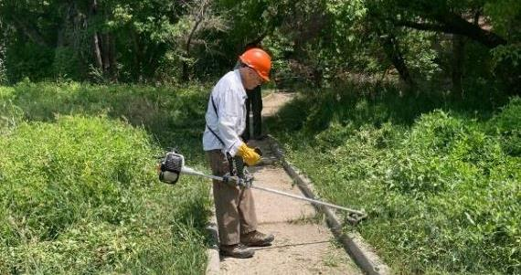

Don Carnicom using his brush cutter to cut grass that was up to 3 feet tall along the Cienega Nature Trail.

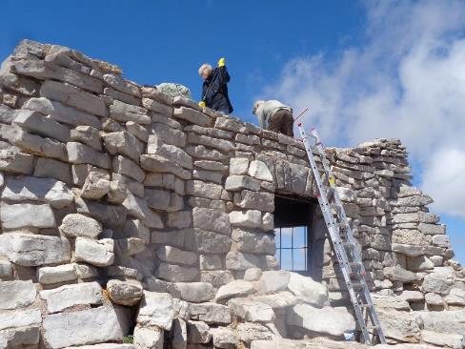

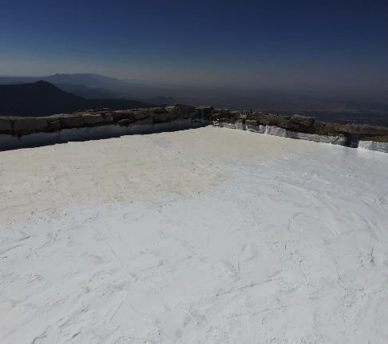

L to R: Sandra Coambs, Joelle Hertel, and Mike Madden are applying a

silicone coating on the roof of Kiwanis Cabin.

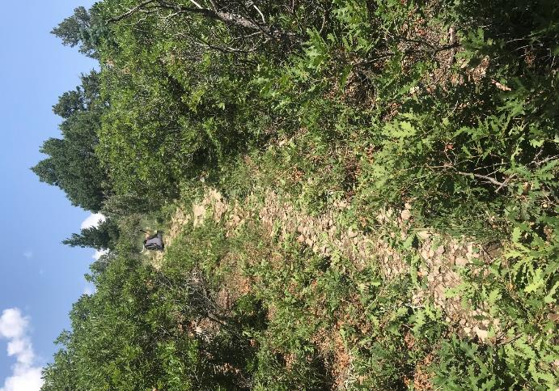

Don Carnicom and Steve Roholt cut oak brush along the Tecolote Trail.

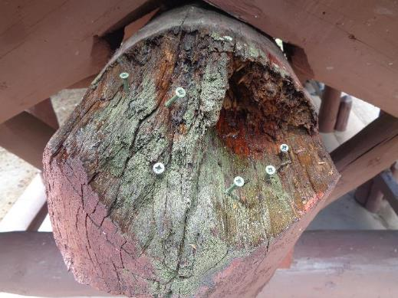

North end of ridge pole showing damage due to exposure to weather for 85 years. Screws provide anchors for epoxy putty that will be placed on the beam to restore its original shape with three flat facets.

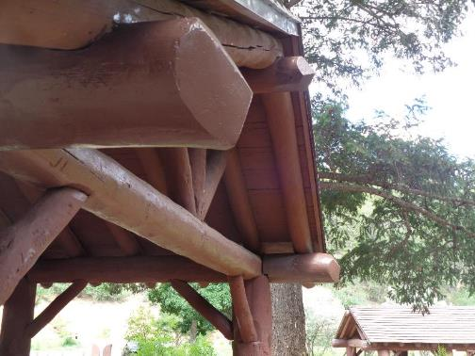

South end of the CCC shelter in Doc Long Picnic Area with three restored beams

-- two large horizontal beams and the ridge pole.

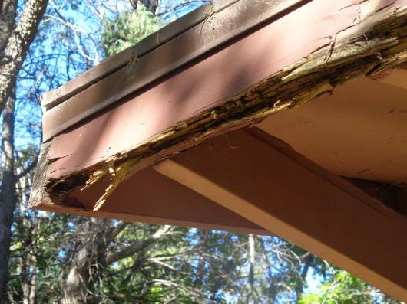

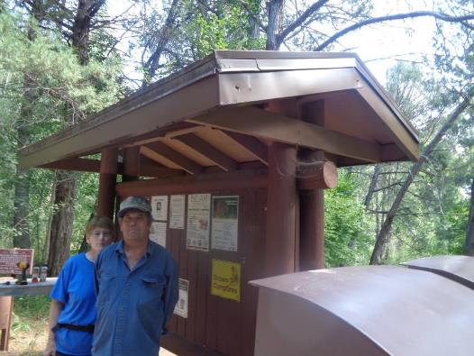

Ellie and Russ Parker are standing at the large kiosk across Cienega Picnic Area Road from the second

restroom. The decayed wooden fascia in the top photograph has been covered with a custom-made

brown sheet steel feature that will prevent further decay and be attractive.

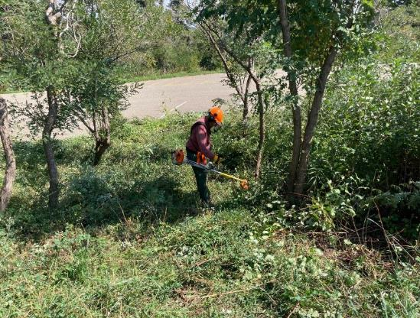

Jerry Carroll cutting brush with the large FOSM power brush cutter in the traffic island.

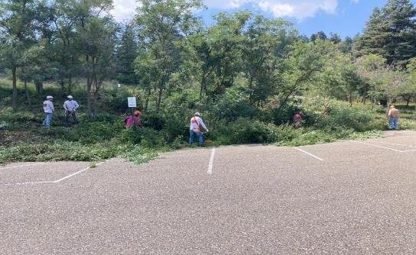

FOSM volunteers and TTYL/YCC crew members cutting brush in the traffic island in the

parking lot at Capulin Snow Play Area. The brush was exceptionally tall and dense, because it

was not cut last year. Cutting the brush provides a place for snow plows to push snow.

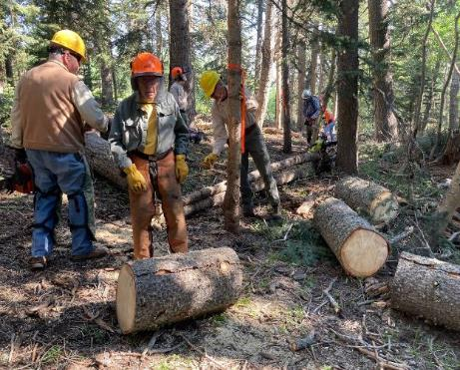

Volunteers removing trees from a Sandia Nordic Ski Club groomed trail

near 10K South Trailhead.

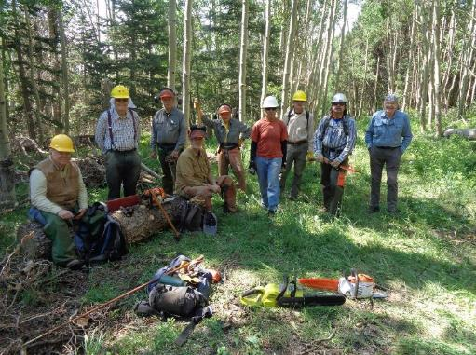

The crew that worked on the SNSC Trail. L to R: Dennis Crowther, Cliff Giles, Jerry Carroll, Dan Benton, Don Carnicom, Steve Roholt, Sim Cook, Michael Arndt and Eric Russell. Note Steve’s green battery-powered chain saw and Dennis’s orange/white battery-powered saw on the grass.

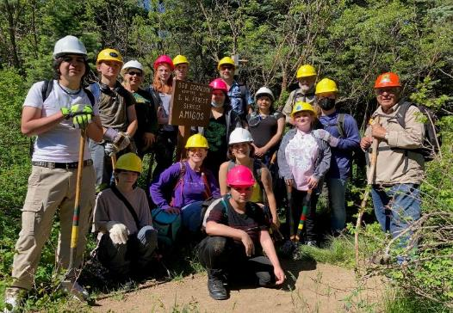

DATA (Digital Arts and Tech Academy) students and teachers on an outing with FOSM volunteers

and a USFS employee to learn about the mountain, trees, erosion, crosscut saws, and firefighting.

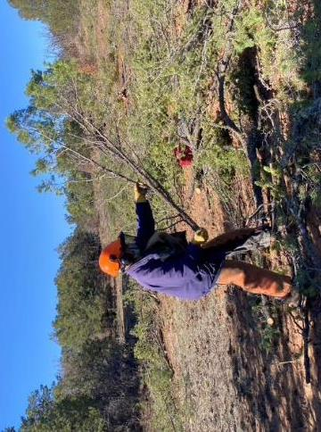

Don Carnicom scattering slash (branches) at the Cedro CFRP site south of the Ranger Station

where FOSM volunteers were felling pinon and juniper trees for meadow restoration.

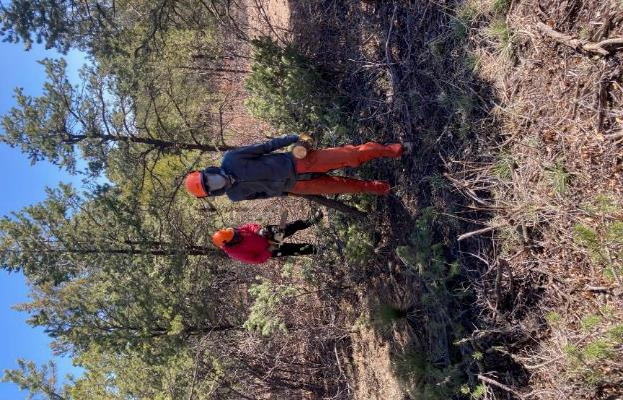

Sawyer Jerry Carroll and sawyer’s assistant Sim Cook working at the Cedro thinning site.

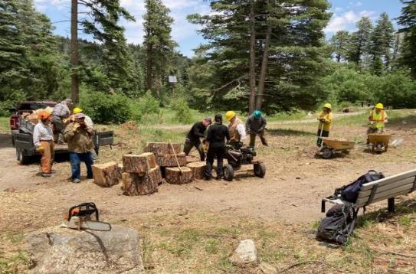

Volunteers are splitting very large rounds of wood from the 36-inch hazard tree felled by

Kerry Wood in Balsam Glade Picnic Area. They are using Lou Romero’s hydraulic power splitter.

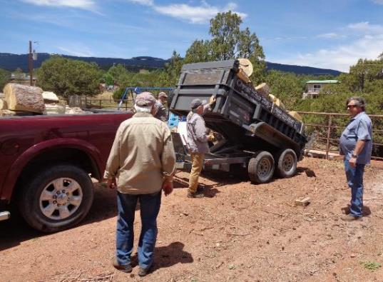

Joe Meade in the center of the photograph is dumping donation wood from his trailer

at the Mountain Christian Church wood ministry lot west of NM-14 and south of NM-536.

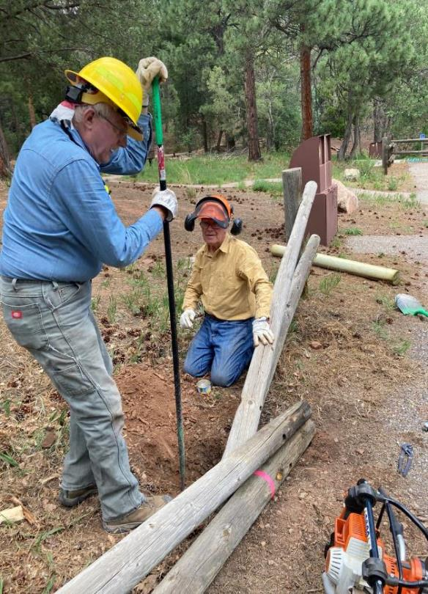

Eric Russell is using a steel bar to remove the buried part of a fence post that broke just below the

surface in Cienega Picnic Area. Jerry Pekarek will remove dirt and wood fragments from the hole.

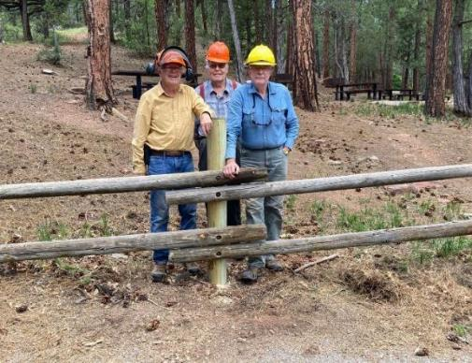

L to R: Jerry Pekarek, Cliff Giles, and Eric Russell at the post they installed in Cienega Picnic Area.

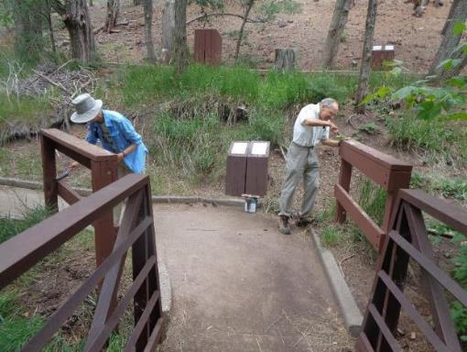

Pauline Ho and Rick Buss painting wooden railings at a bridge on the Cienega Nature Trail.

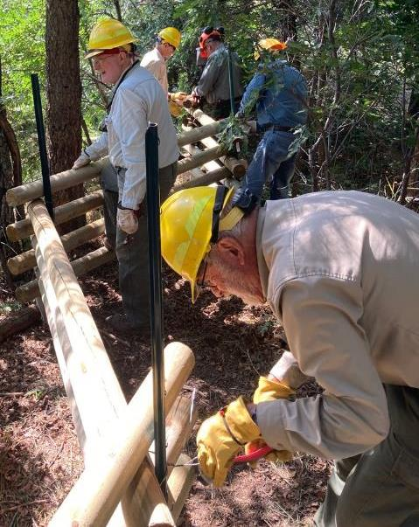

Sam Beard is twisting wire to secure a pole to the steel fence post at the segment of fence being

built at Tree Spring Trailhead. L to R: Eric Russell, Sam, Sim Cook, Jerry Carroll, and Jerry Pekarek.

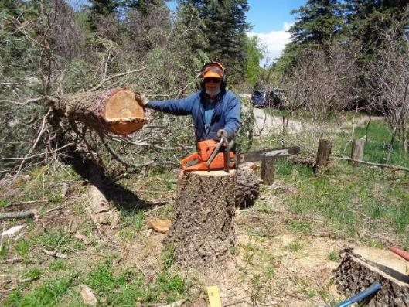

Eric Russell at the hazard tree he has just felled in Nine Mile Picnic Area.

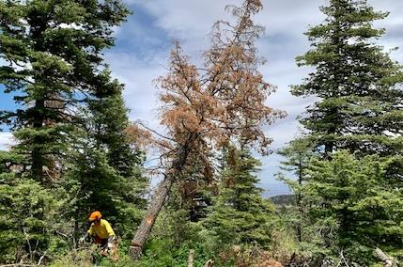

Bob Lowder moving away from the hazard tree he has just felled at the Capulin Snow Play Area.

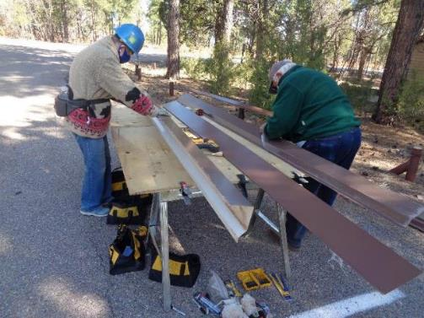

Ellie Parker and Lou Romero pealing the protective plastic film from gable trim for a metal roof

on a restroom in Oak Flat Group Picnic Area.

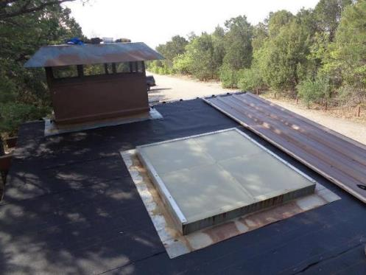

A restroom roof in Oak Flat Picnic Area showing the ventilation structure, black felt underlayment,

skylight, and one brown steel roofing panel.

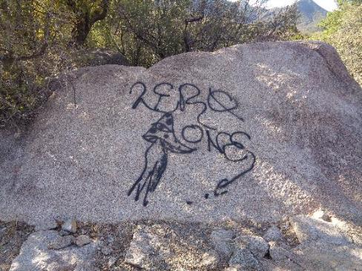

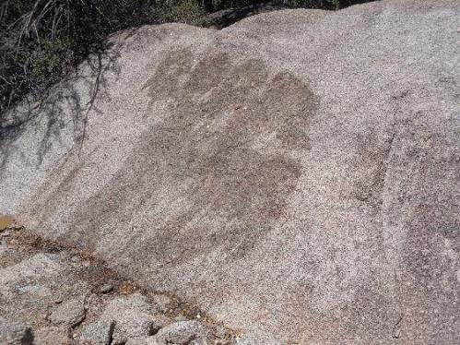

Before and after photographs of a boulder at the Juan Tabo Picnic Shelter

where graffiti was removed.

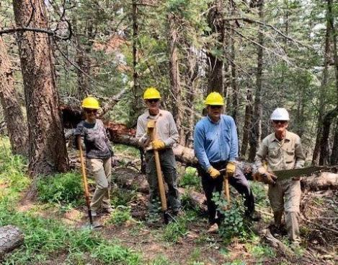

Silke Bletzer, Sim Cook, David McCreery, and Bill Savage at a tree

they have removed from the trail

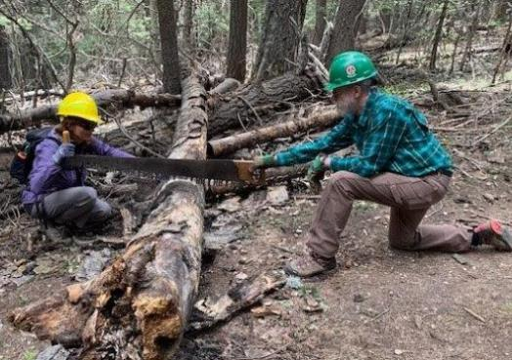

Silke Bletzer and Cleve Sharp using a crosscut saw to remove a log from a trail.

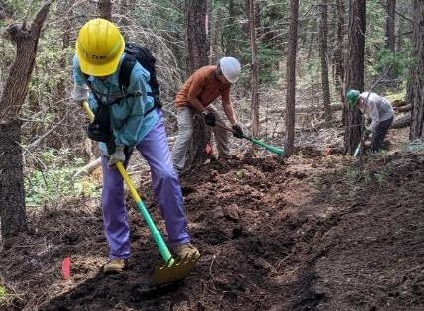

Volunteers using a McCleod and pick mattock to dig a trail tread on a new trail.

L to R: Rav Nicholson, Jeff Huser, and Cleve Sharp.

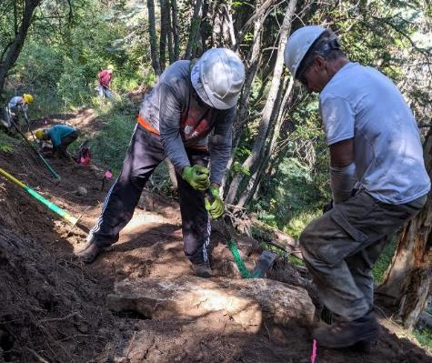

Volunteers are using pick mattocks to remove a rock from a new trail.

L to R: Rich Miller and Jeff Huser. Background: Mike Madden, Eric Russell, and Jim Houle.

**Project Participants in FY2021**

About three dozen members frequently volunteer to work on the weekly projects, and about 20 members typically work each week.

The FOSM officers, Board Members, and the Sandia Ranger District Staff appreciate very much the support of all the FOSM members. The names are roughly in alphabetical order. The volunteers who worked on FOSM projects in FY2021 were Michael Arndt, Robin Bendler, Courtnee Bennett, Dan Benton, Claudia Bergsohn, Tom Baumgartel, David Bernstein, Jenny Blackmore, Silke Bletzer, Dan Briand, Tim Brown, Richard Buss, Marilyn Caldwell, Don Carnicom, Anthony Campbell, Jerry Carroll, Chris Casey, Tom Claus, Casey Cook, Sim Cook, Dewayne Coambs, Phil Cromer, Dennis Crowther, Scott Dietrich, Mari Draper, Gordon Eatman, Helene Eckrich, Joe Espinosa, Vicki Farrar, Heather Farrell, Jay Fielding, Dave Gabel, Bob and Betsy Galloway, Byron Garner, Cliff Giles, Mark Grazier, James Hann, George Guerdrum, Selena Gutierrez, Bruce Hansche, Jane Harrison, Joelle Hertel, Anne Hickman, Pauline Ho, Don Hoke, Jim Houle, Gay Huffman, Jeff Huser, Kathleen Kackerson, Sue Keil, Kris Kelleher, Jim and Judy Levesque, Kathy Lord, Bob and Sally Lowder, Fotoni Lujan, Fran Lusso, Mike Madden, Pat Madden, Bonnie Mauldin, Pam McCoy, David McCreery, Joe Meade, Ben Meisner, Richard Miller, Khondeh Mirshek, Lorna Morrow, Tim Murphy, Rav and Ken Nicholson, Terry Owen, Russ and Ellie Parker, Jim Patrick, Marj Patrick, Jerry Pekarek, Rosalie Rayburn, Pete Rhyins, Eric Rinehart, Amy Rizzo, Steve Roholt, Lou Romero, Eric Russell, Gerhard Salinger, Dustin Sandquist, Bill Savage, Becky Schnelker, Cleve Sharp, Kitsie and Don Smiset, Roland Stumpf, Tim Taylor, Renee’ Tourville, John Vande Castle, Dennis and Linda Vik, Kandi Voss, Walter Wapman, Dave Weaver, Mark Werkmeister, Bill White, and Sam Beard. (Sam Beard)

**Publication of the FY2021 Newsletter**

A huge “Thank You” to the following people who contributed to the publication of the FY2021 Friends of the Sandia Mountains Annual Newsletter: authors who contributed articles, photographers who made informative and interesting pictures, reviewers who found errors in the various versions, and FOSM volunteers who completed the many projects for us to report. This is our year-end historical review that is available to all members, volunteers, and visitors to our meetings. (Sam Beard, Editor)

**FOSM Officers**

* President – Mike Madden * Dan Benton

* Vice-President – Cliff Giles * Sally Lowder

* Treasurer – Tim Brown * Mike Coltrin

* Secretary – Rav Nicholson * Eric Russell

**Board Members \*** Sim Cook

* Sam Beard * Byron Garner

* Don Carnicom