**Report of the FOSM Projects on Wednesday, September 29 to Cut Brush for** **Better Sight Distances**

**at the Cienega Road-Crest Highway Intersection and Cutting Brush along the Road**

**to the Capulin Snow Play Area to Make Room to Push Snow when the Road Is Plowed**

Sam Beard, September 30

On Wednesday, September 29, eight FOSM volunteers completed the following two projects:

1. **Cutting Brush at the Intersection of Cienega Road and the Crest Highway** – Several years ago, an SRD Law Enforcement Officer requested that FOSM cut brush along the creek at this intersection for more sight distance than was provided by the shoulder mowed by the NMDOT. The first year that FOSM cut the brush here the trunks of the willows and other trees were so large that we had to use chain saws to clear the area. Since then, we have been using power brush cutters for most of the area and only use chain saws on the larger trees at the upper end of the area along the creek. We also cut the brush along the road leading to the entrance of Sulphur Canyon Picnic Area.
2. **Cutting Brush along the Capulin Snow Play Area Road** – This short road leads from Capulin Spring Picnic Area to the Snow Play Area. Earlier FOSM had cut brush in the SPA parking lot traffic island and had helped mow the sledding slopes. Although a SRD employee had cut bush along both sides of this road, Manny Chavez, SRD Maintenance Supervisor, requested that FOSM cut the brush farther from the pavement to make more room to push snow when the road is plowed. Both brush cutters and chain saws were used to cut brush along the road and around the edge of the lower parking lot.

The volunteers working on these projects were Lou Romero, Byron Garner, Sim Cook, Sam Beard, Steve Roholt, Jerry Carroll, Cliff Giles, and Jerry Pekarek.

Project photos are presented below.

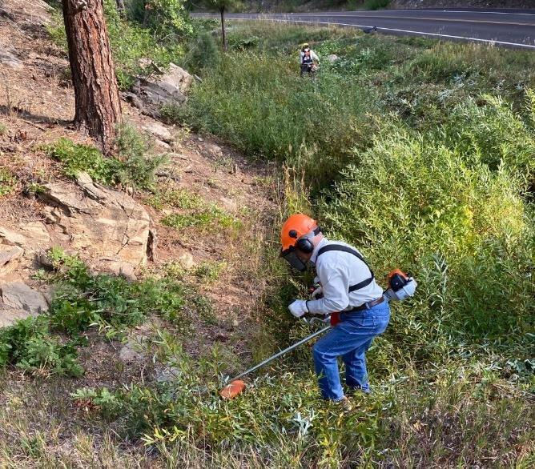

Jerry Pekarek is cutting willows with a power brush cutter near the intersection of the Cienega Picnic Area

Road and the Crest Highway that is visible at the top of the photograph. In the background, Sim Cook

Is cutting brush with the large FOSM brush cutter. All photos by Cliff Giles unless noted otherwise.

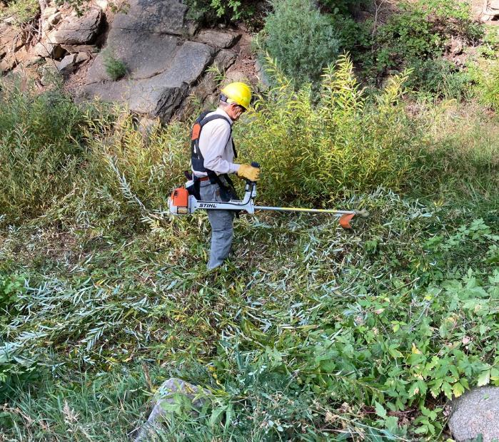

Sim Cook cutting brush with the large FOSM brush cutter to provide good sight distance at the intersection of Cienega

PA Road and the Crest Highway.

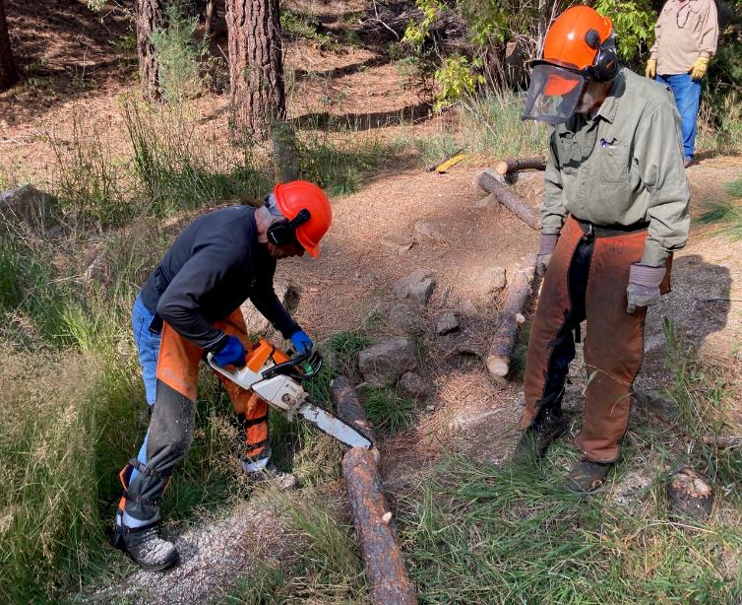

Chain Saw Trainee, Steve Roholt, is bucking a small pine tree trunk in order to get some experience with a gasoline chain saw.

Sam Beard is observing.

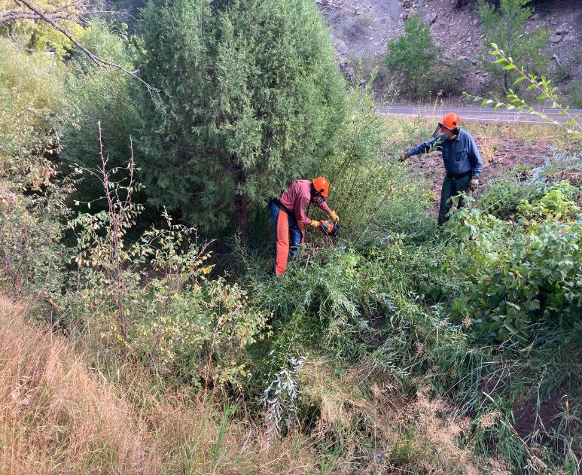

Chain Saw Trainee, Byron Garner, is cutting brush with a gasoline chain saw under the direction of Jerry Carroll.

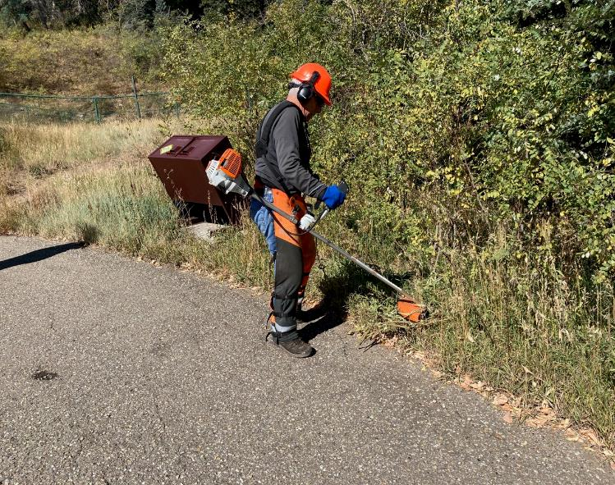

Steve Roholt is cutting brush along the edge of the Capulin Snow Play Area lower parking lot. The new sledding slope

is behind the green fence in the upper left corner of the picture.

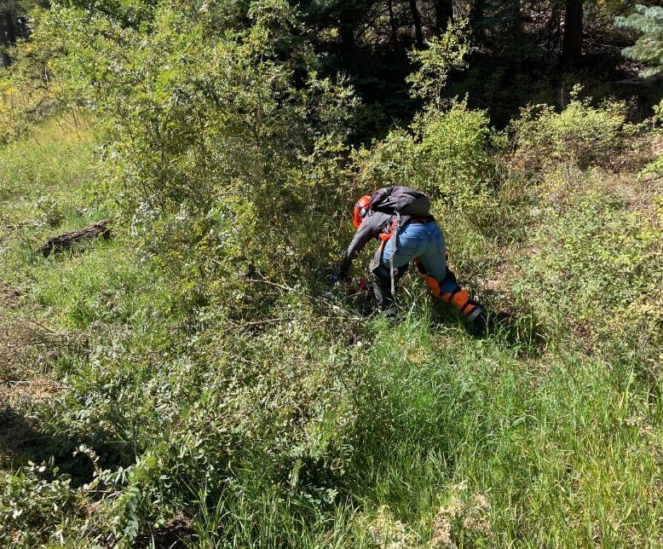

Steve Roholt is using the FOSM battery-powered chain saw to cut brush along the road to the Capulin Snow Play Area.

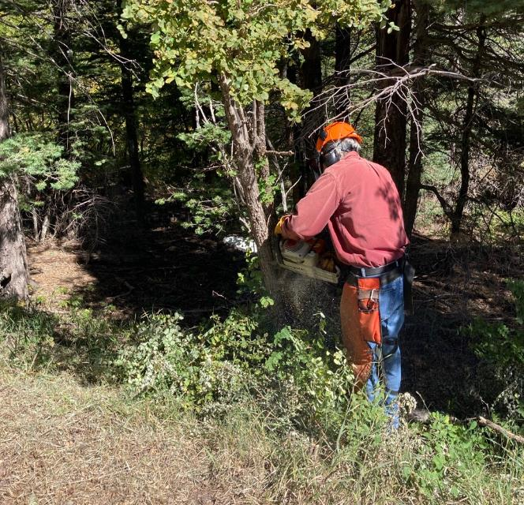

Byron Garner is felling a small tree on the shoulder of the Capulin Snow Play Area Road.

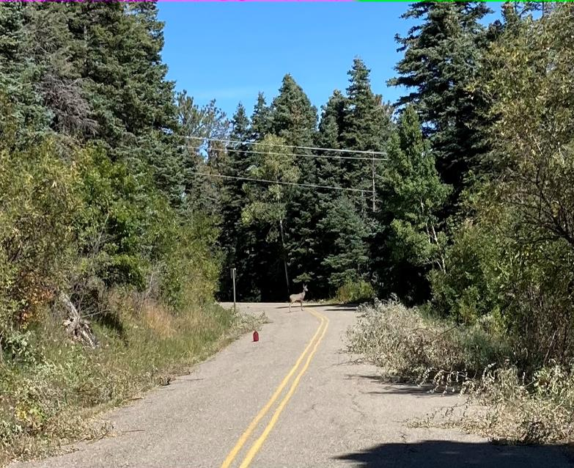

Deer admiring our work. (Caption by Cliff Giles, photographer)

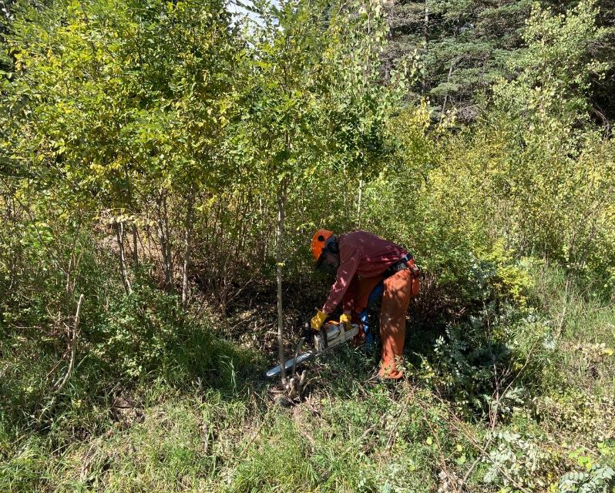

Byron cutting a small aspen beside the Capulin Snow Play Area Road.

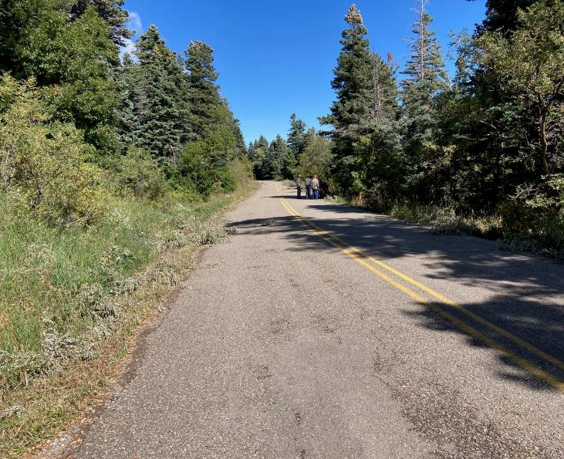

Snow Play Area Road where a week earlier, a SRD employee had cut brush on both shoulders. At the request of Manny

Chavez, SRD Maintenance Supervisor, FOSM cut the brush farther from the road to make more room to push snow.

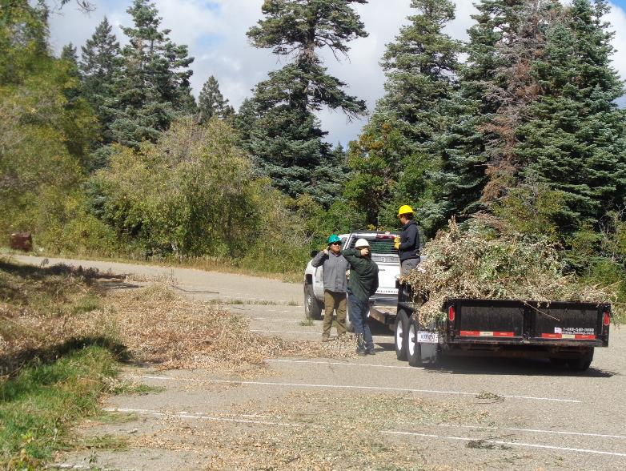

This SRD crew is working with Manny to remove the brush that was cut by FOSM volunteers in the Snow Play Area traffic island

a few weeks ago. Manny is out of the picture to the left cutting grass along the shoulder of the parking lot. Photo by Sam Beard