**Report of the FOSM Paint Crew Projects near the Sandia Ranger District Shop on Tuesday, October 12, 2021**

Ellie Parker, October 14, 2021

On Tuesday, October 12, the FOSM paint crew continued their Fall cleanup project at the Sandia Ranger District maintenance area. With six volunteers, we had the three following teams:

1. **Painting Employee Picnic Table** – Russ Parker and Manny Chavez moved the employee picnic table and benches into the shop allowing Jane Harrison and Silke Bletzer to scrape and apply a much-needed coat of Forest Service brown paint.
2. **Striping Parking Lot** – Ellie Parker striped the employee parking lot applying four coats to each stripe after Russ had used the power blower to blow the area clean.
3. **Tijeras Pueblo Trail Benches** - Pauline Ho, Rick Buss, and Russ Parker took on the benches along the Tijeras Pueblo Trail. They scraped and painted the bench tops FS Cinnamon.

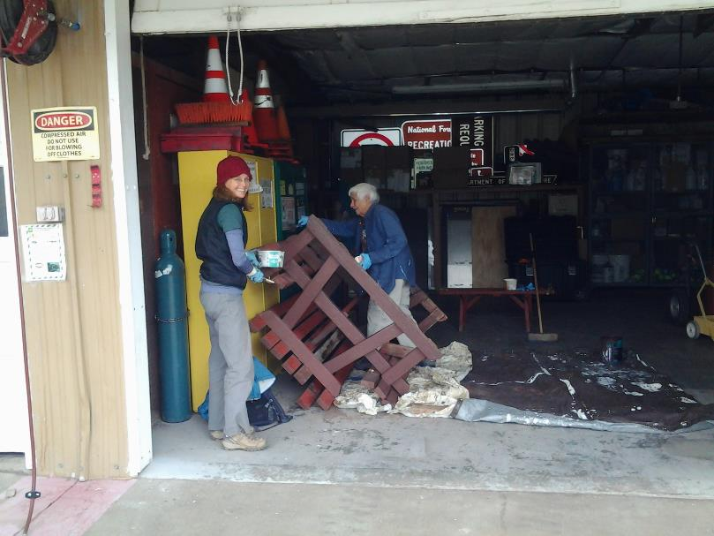

L to R: Silke Bletzer and Jane Harrison painting the picnic table in the wood shop.

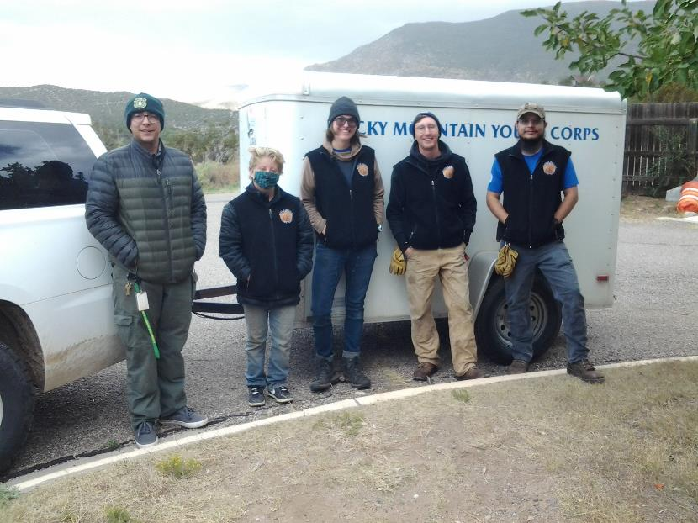

The Rocky Mountain Youth Crops Crew.

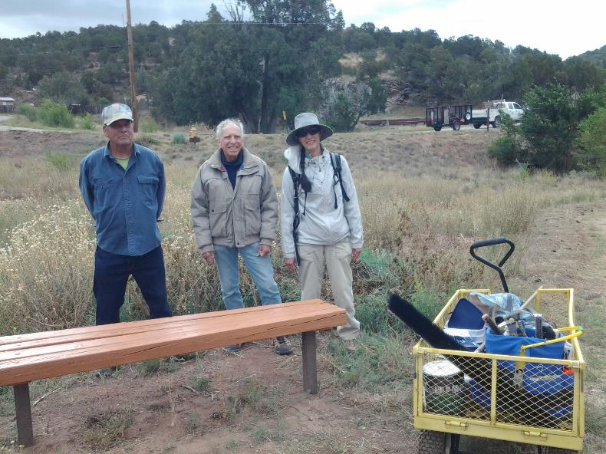

L to R: Russell Parker, Rick Buss, and Pauline Ho at one of the benches they painted on the Tijeras Pueblo Trail.