**Report of FOSM Project in Capulin and Nine Mile Picnic Areas to Split and Haul Fuelwood**

**to a Mountain Christian Church Wood Ministry Wood Lot on Wednesday, October 13, 2021.**

Sam Beard, Oct. 14, 2021

On Wednesday, October 13, twelve FOSM volunteers split, loaded, and hauled three cords of firewood from Capulin Spring and Nine Mile Picnic Areas to a Mountain Christian Church Wood Ministry wood lot west of NM-14. The church donates the wood to needy families in the East Mountain area.

The wood was split with Lou Romero’s power splitter and hauled in Joe Meade’s dump trailer. FOSM very much appreciates the use of Lou’s splitter and Joe’s pickup and trailer which makes it possible for three cords of wood to donated to the church in one day.

The volunteers working on this project were Byron Garner, Dennis Crowther, Jerry Pekarek, Cliff Giles, Sam Beard, Steve Roholt, Jerry Carroll, Sim Cook, Lou Romero, Joe Meade, Tami Meade, and Jory Meade.

The photographs show the volunteers at work during this project.

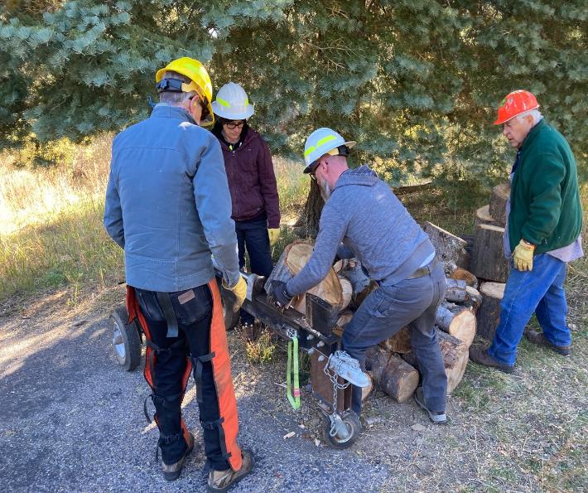

Sim Cook, Tami Meade, Jory Meade, and Lou Romero splitting wood in lower Capulin Picnic Area with Lou’s power splitter.

All photos by Cliff Giles

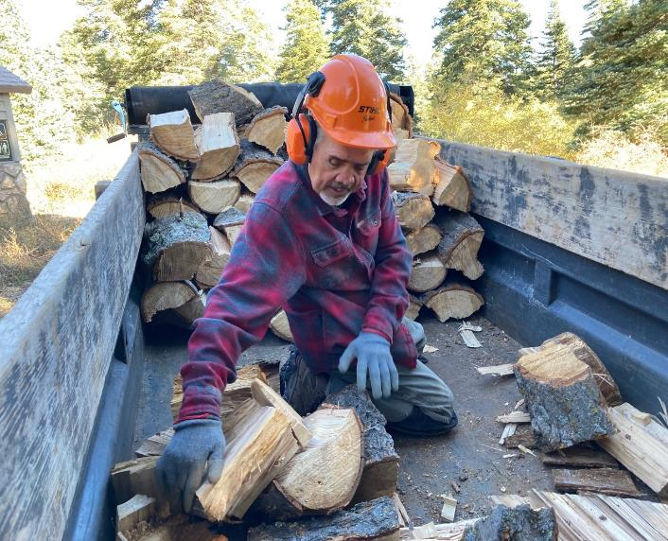

Joe Meade stacking donation wood in his trailer.

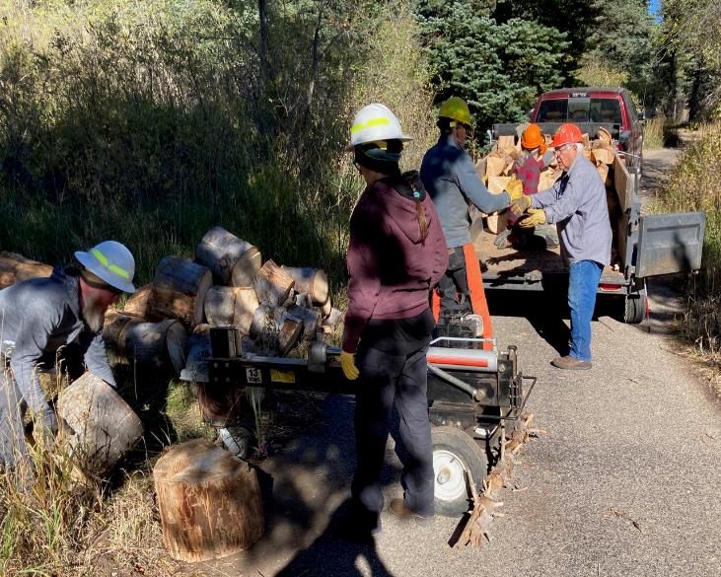

Jory Meade, Tami Meade, Sim Cook, and Lou Romero splitting wood and handing it to Joe Meade in the trailer.

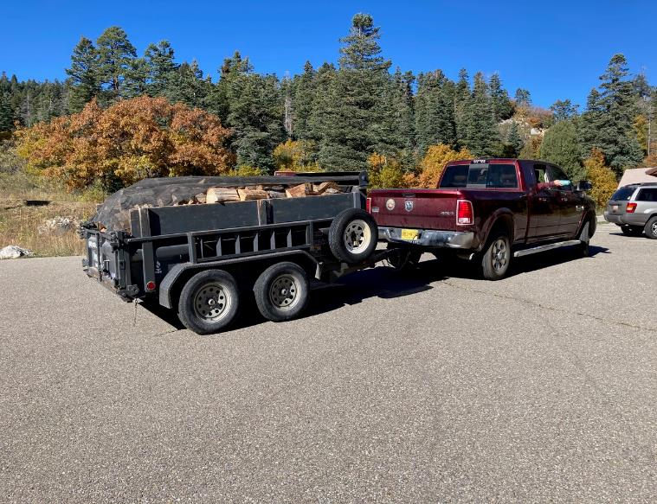

A load of split wood ready to take to the Mountain Christian Church Wood Ministry wood lot west of NM-14 and about one mile

south of the intersection of NM-14 and NM-536.

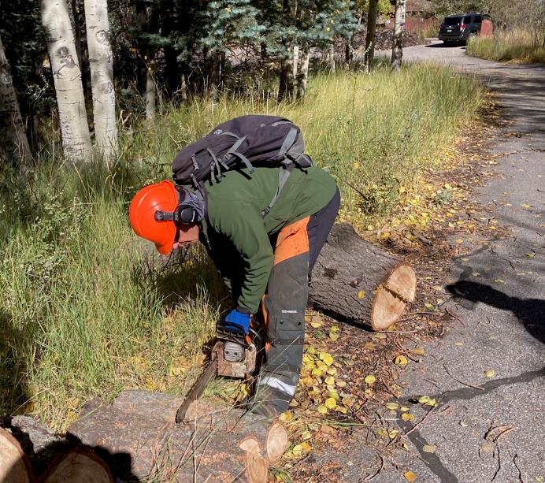

Sawyer trainee Steve Roholt bucking a piece of fuel wood in Nine Mile Picnic Area.

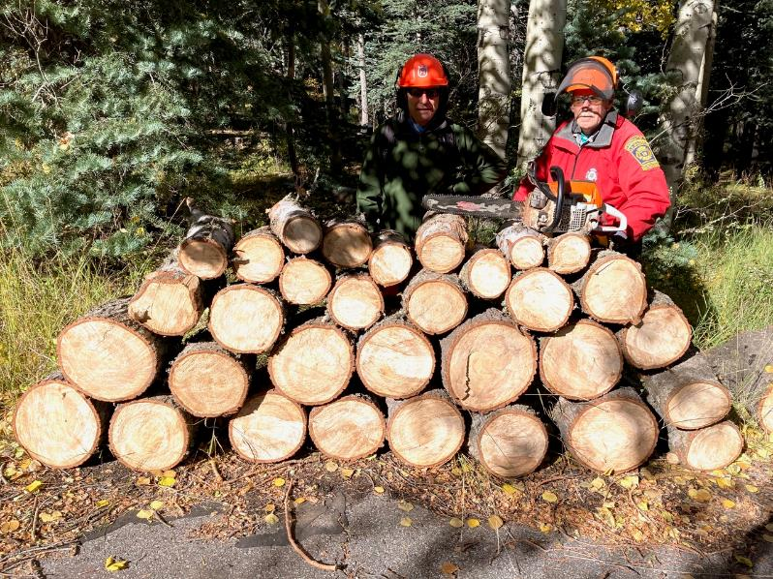

L to R: Steve Roholt and Jerry Carroll behind the stack of wood that they bucked. The hazard trees had been felled earlier in Nine Mile Picnic Area.

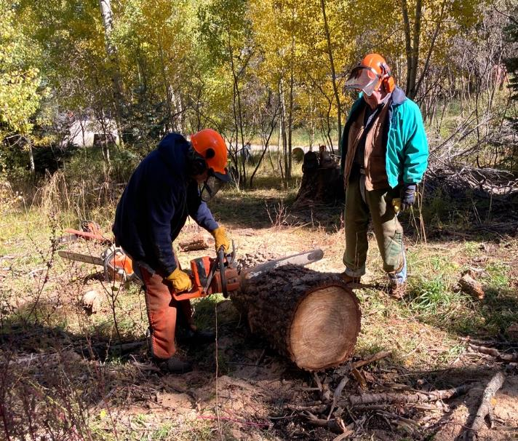

Sawyer trainee Byron Garner cutting a large log while Dennis Crowther observes in the upper part of Nine Mile Picnic Area.

The bucked wood was rolled down to the road in the background where it was split.

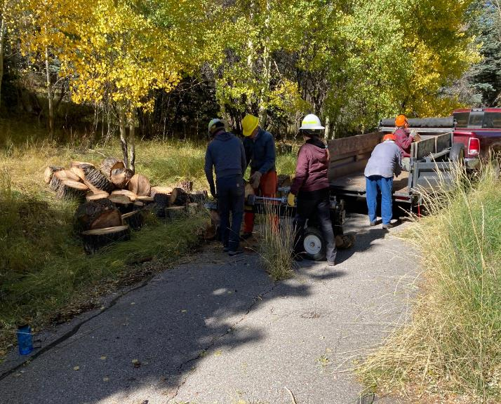

The crew splitting wood and loading it on Joe’s trailer in the upper part of Nine Mile Picnic Area.

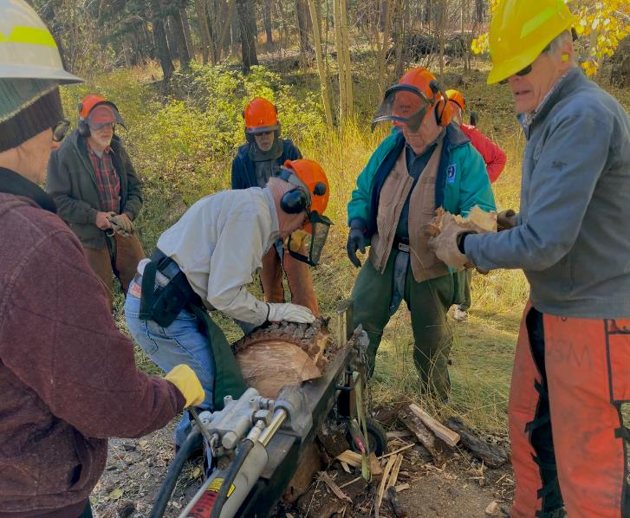

L to R: Tami, Sam, Jerry, Byron, Dennis and Sim splitting wood in Nine Mile Picnic Area. Using Lou’s hydraulic splitter

is much faster and easier than splitting it manually with steel wedges and sledge hammers.

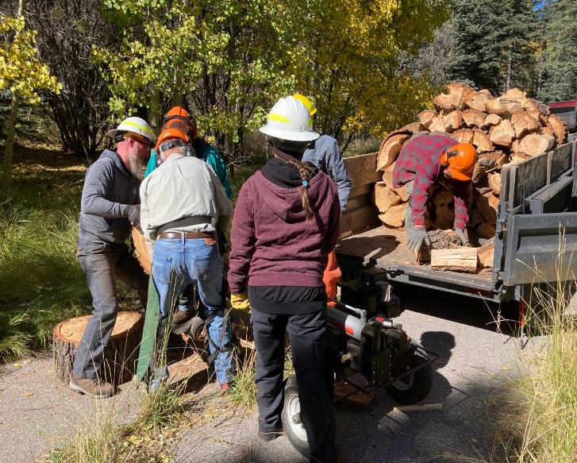

The crew has almost completed splitting this pile of wood and handing it to Joe to stack.