FOSM Report on Low-Low Cutting Stumps on the Sandia Nordic Ski Club Trail near Ellis Trailhead

Saturday, October 16, 2021

Sam Beard and Michael Arndt

At the request of the Sandia Nordic Ski Club (SNSC), FOSM volunteers Sam Beard and Michael Arndt cut five stumps down to the nominal level of the surrounding ground near Ellis Trailhead. Club volunteers were not successful in pulling these large stumps with the SRD grip hoist that they had used to pull smaller stumps.

After felling a tree, the stump is usually low cut to a height several inches above the ground. SNSC will be grooming this trail with their equipment when the snow is not very deep, and they do not want to hit stumps. Five stumps were cut down to the level of the surrounding ground. The soil around the stumps had been dug down several inches, and the dirt on the sides of the stumps had been cleaned off as much as possible so that the chain saw chain would not be dulled by the dirt.

The photographs below were taken during this project.

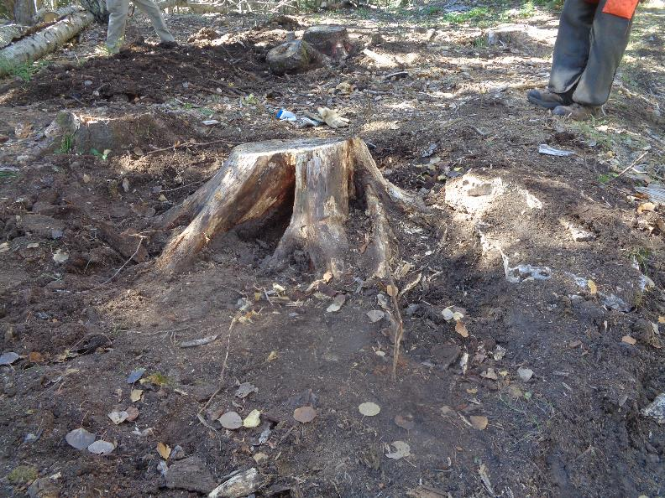

The first stump after the dirt had been dug away from the roots and after the dirt had been brushed from the upper part

where the cut was to be made. In general, the five stumps were cut down to the nominal level of the surrounding ground.

During the preparation of the stump for cutting, the dirt around the stump was dug several inches lower than the cut level.

All photos by Sam Beard unless noted otherwise.

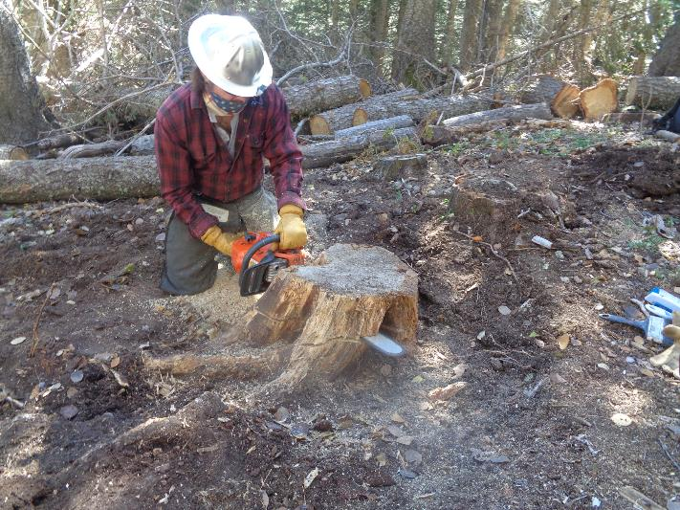

Saw trainee Michael Arndt cutting the first stump. It was very important that the level of the cut and angle of the cut be such that

the bar and chain would not hit dirt before the cut was completed. The Sandia Nordic Ski Club requested that FOSM volunteers low-low cut

these stumps, because they were too large for the SRD grip hoist to pull out.

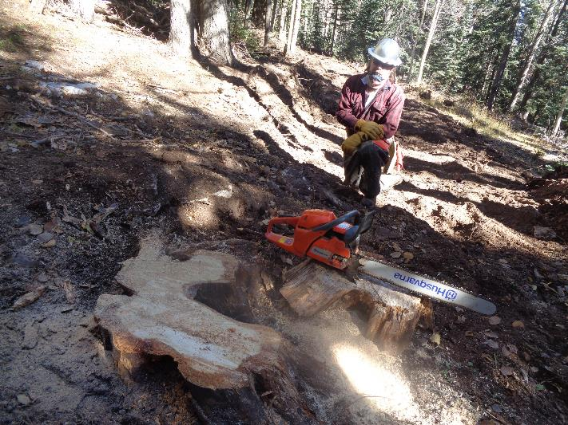

The low-low cut stump is on the left and the saw is sitting on the 5-inch-thick part that was removed.

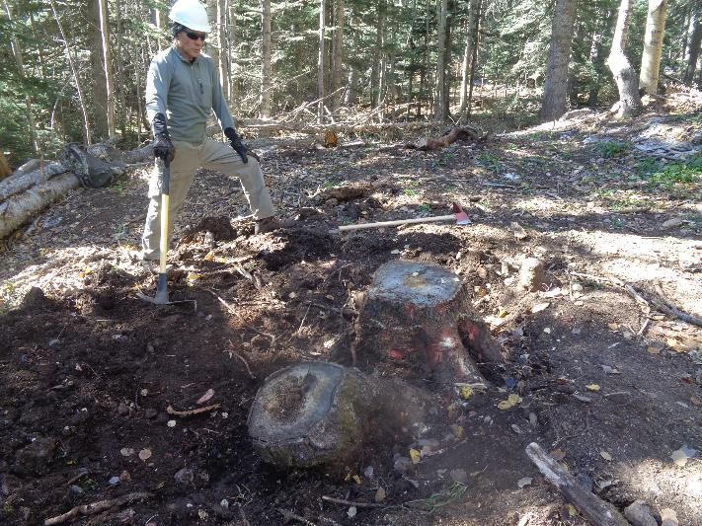

Jeff Huser, Sandia Nordic Ski Club, is looking at the next two stumps to be low-low cut. The bark had not been removed in this photo.

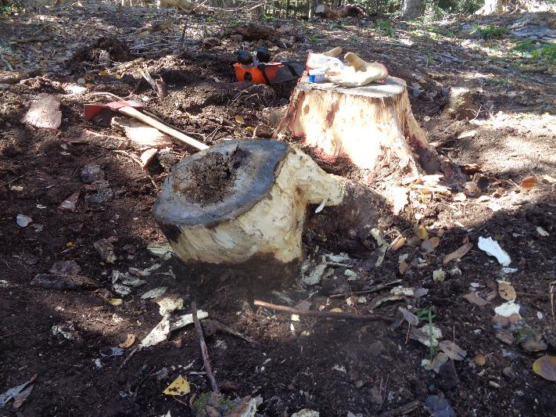

The same two stumps after the bark was chopped away in order to remove dirt from the sides of the stumps. We learned that

it is very important to leave the bark on the stumps until they are ready to be low-low cut. We found that the easiest way to clean

dirt from the stumps was to remove the bark and be careful not to accidently put dirt on the clean sides.

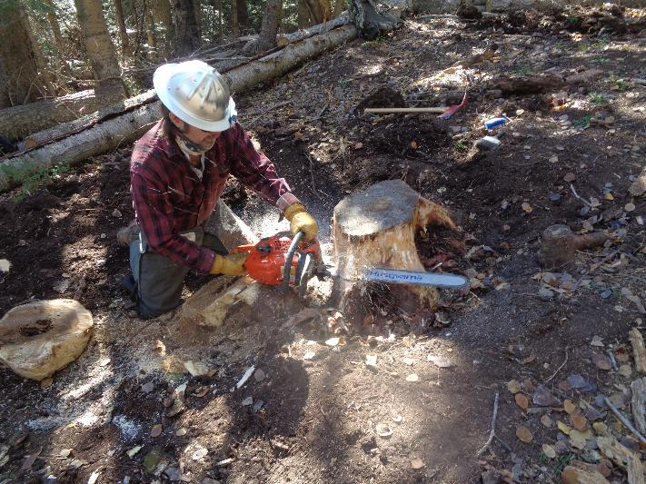

Michael low-low cutting the upper stump in the preceding photograph. He has already cut the lower stump so that it would

not be in the way of cutting the upper stump.

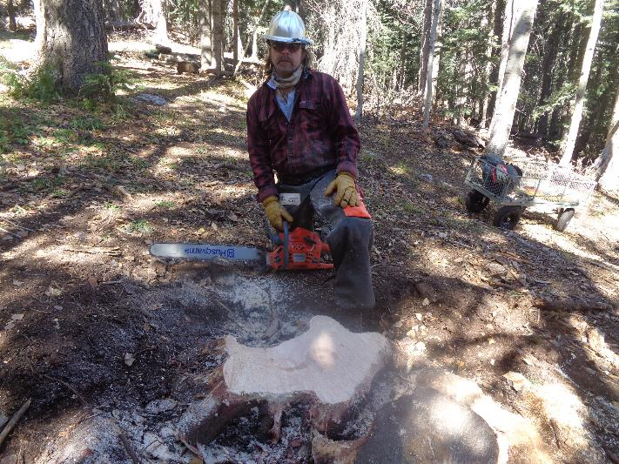

Michael and his saw behind this long stump that he has just cut.

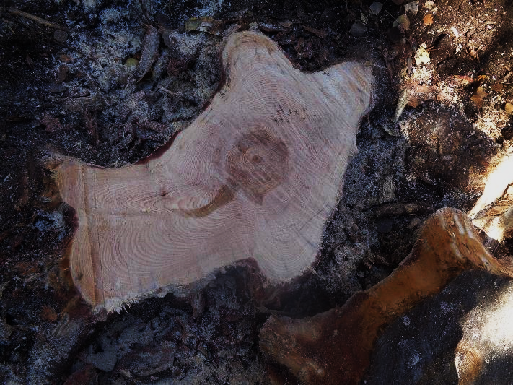

The interesting ring patterns in this stump. Each root has its own set of rings.

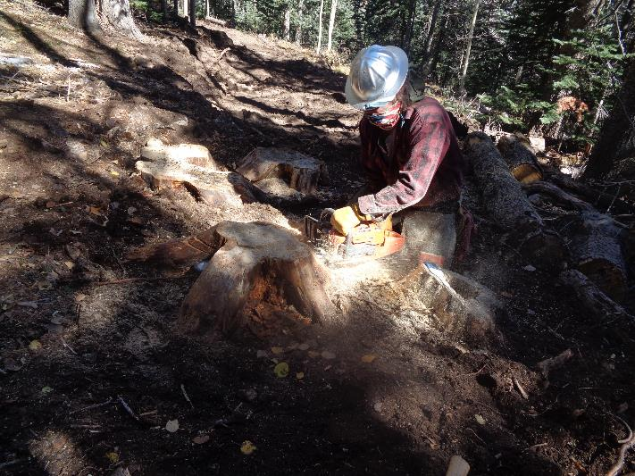

Michael low-low cutting the last stump. Note the two cuts on the left root. The combination of the lower cut

and the angle of the cut would have resulted in the bar and chain hitting dirt before the cut was completed.

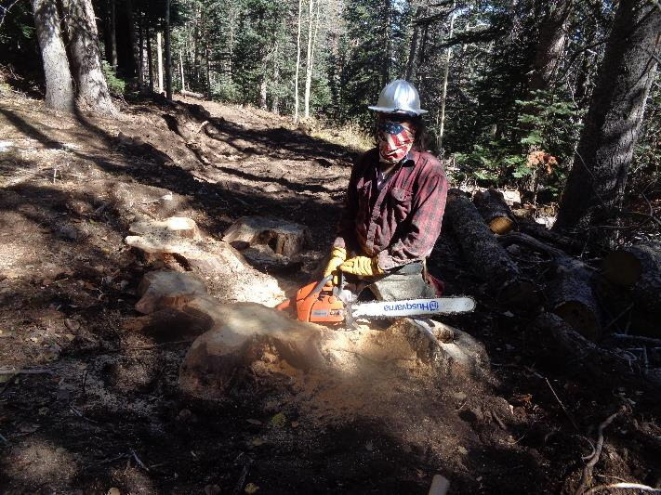

The last cut has been completed. Note that the tops of the cut stumps are at the nominal level of the ground on the left. The chain was

still sharp after the five stumps were cut, because we carefully cleaned the stumps before they were cut.

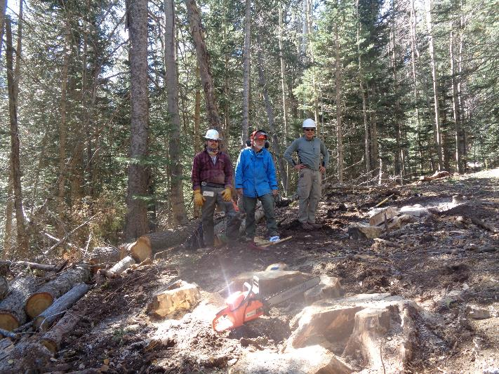

L to R: Michael, Sam, and Jeff. This photograph was taken by a hiker and shows the general area where the stumps were located.

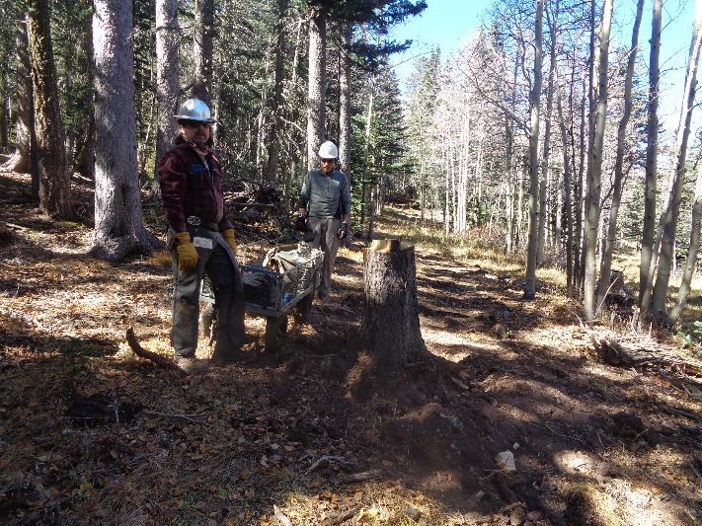

Jeff and Michael hauling the equipment back to Ellis Trailhead in the Tractor Supply Company wagon that Jeff recently purchased.

Michael felled this tree last weekend. The tall stump increases the mechanical advantage when the grip hoist is used to pull the stump

and makes pulling the stump much easier.