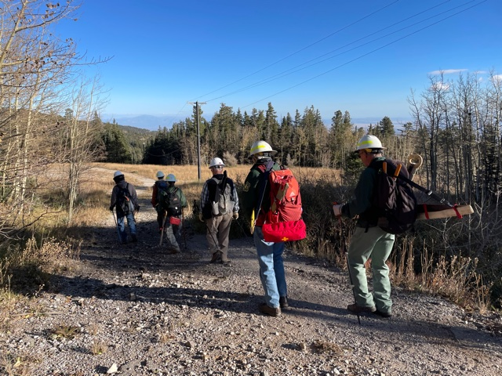
Heigh ho, heigh ho… The crew starts the trail work hike at the Ellis parking lot.

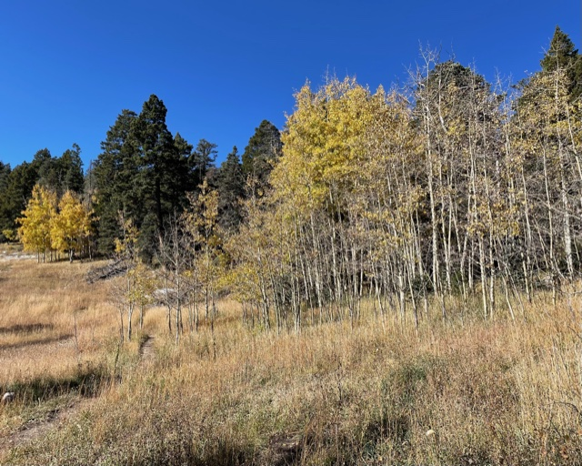
This view looking south near the Ellis/10K North junction shows
the various stages of Aspen colors on the mountain. The trees currently vary from green to leafless depending on location.

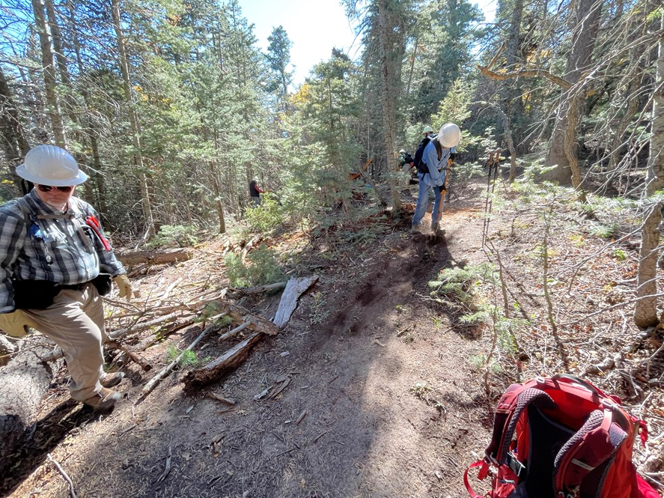
The crew discovered an unreported train wreck on Osha Loop that
consisted of several large fallen dead, multiple-branched fir trees that pretty much obliterated the trail along about a fifty-foot length. A crude walk-around had developed on the uphill side.
Forest debris was moved onto the old trail to prevent users from attempting to use it and the walk-around was considerably improved. This solution was more practical than spending perhaps hours trying to clear the old section with hand tools. Byron, (figure in the distance) is standing just below the bottom end of the train wreck which can’t be seen in this photo.

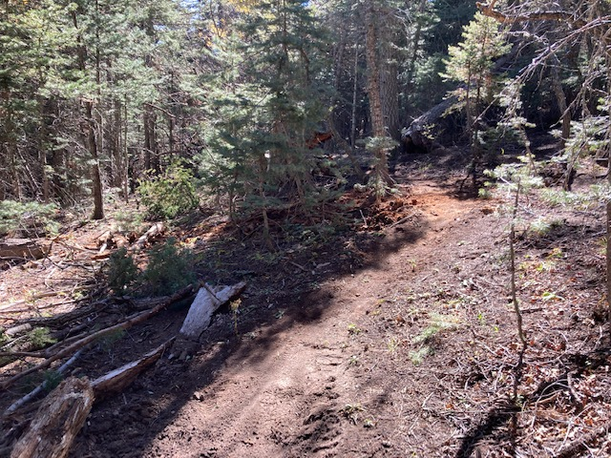
This photo, taken in roughly the same location as the previous shot, shows the improved walk-around.
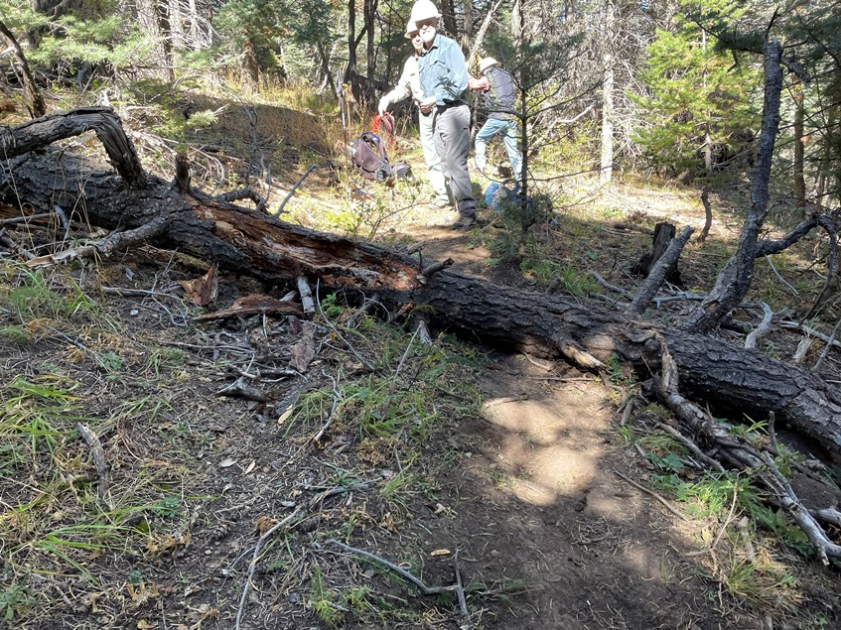
This dead tree had fallen over Osha Loop. A stepover developed at a location below the level of the existing trail. (Where the sunspots are). The soil was soft there and it appeared that some erosion had begun. The original trail, located under the rotted spot on the tree, was higher with a surface that was harder packed.
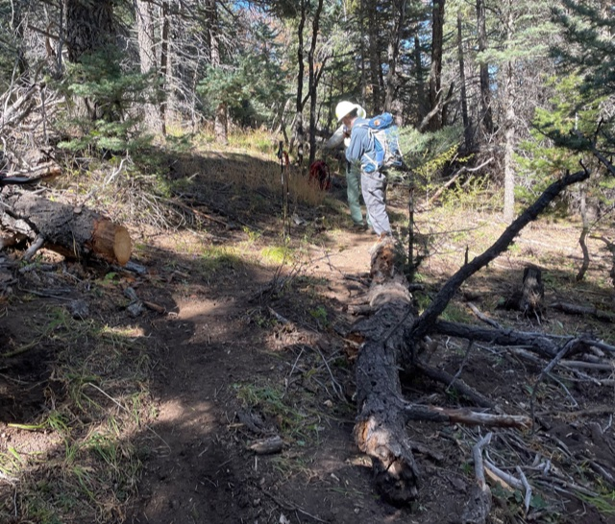
After the tree had been cut, the lower portion was rotated so that the cut portion was blocking the walk-around. The newly exposed original trail section was reworked into a more sustainable condition.
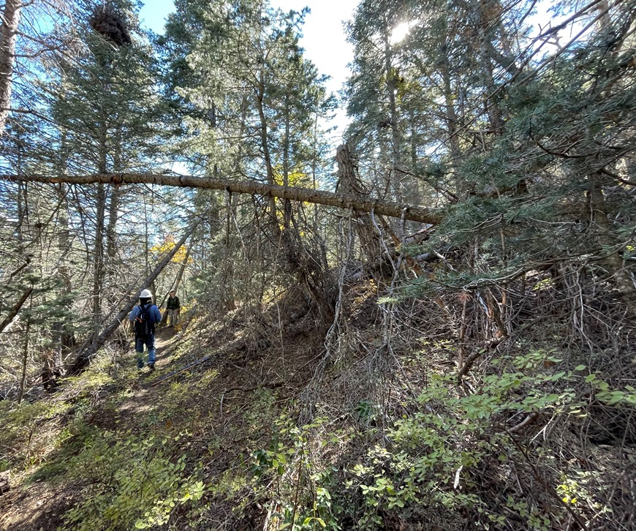
This lengthy dead fir tree was suspended over Osha Loop trail. Its only support was from its slowly rotting root system. Closer investigation indicated that it was unstable and could fall at any time. The crew decided to remove it. The leaning trees in the background were also carefully evaluated (as are all “leaners”) and found to be well supported. Removal was not required at this time.
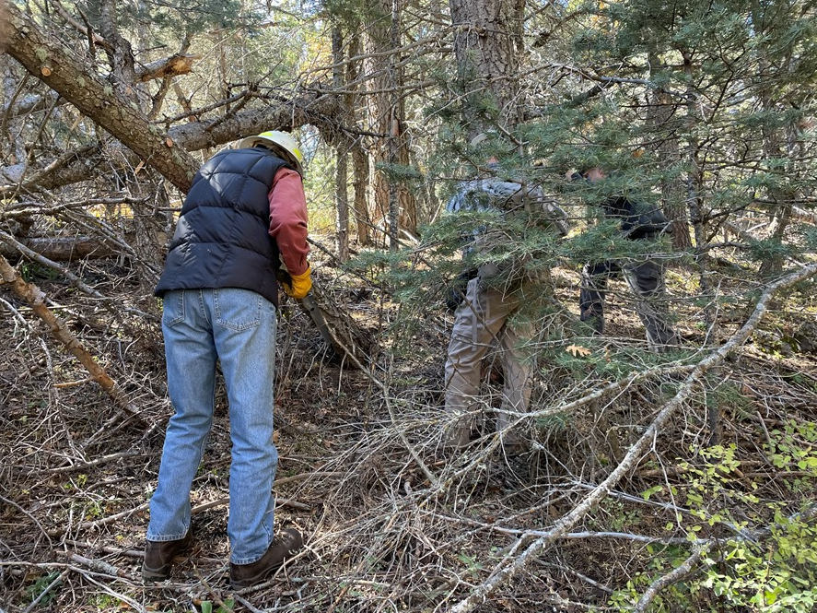
Materials around the base of the leaning tree are being cut away
to provide a safe escape route when the hazard is cut away.
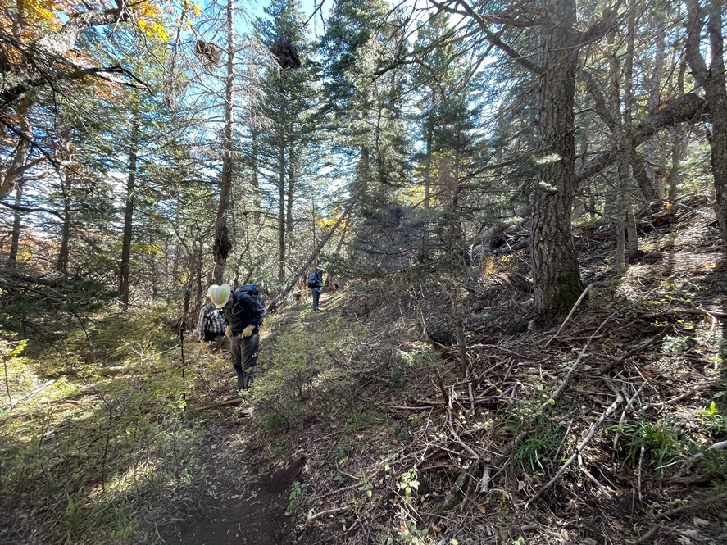
The leaning hazard tree has been removed and the trail is being cleared of resulting debris.
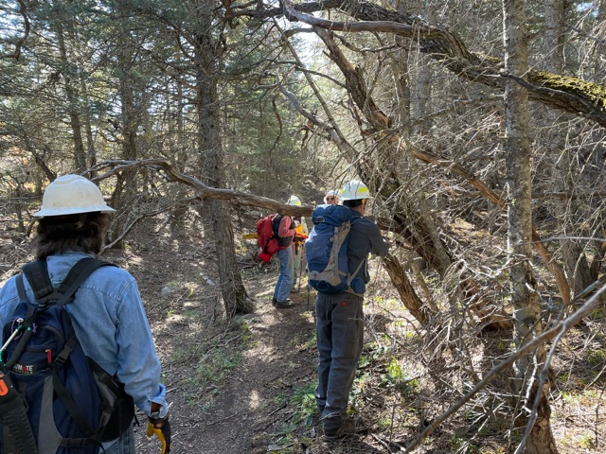
This dead tree branch was protruding into Osha Loop at head-height. It was cut away.
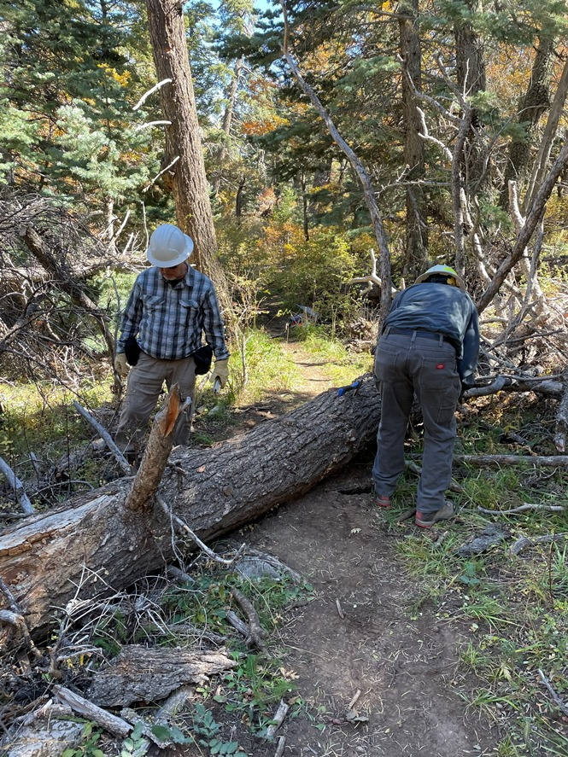
This twenty-inch diameter dead fir was blocking Osha
Loop just above the Osha Spring trail junction.
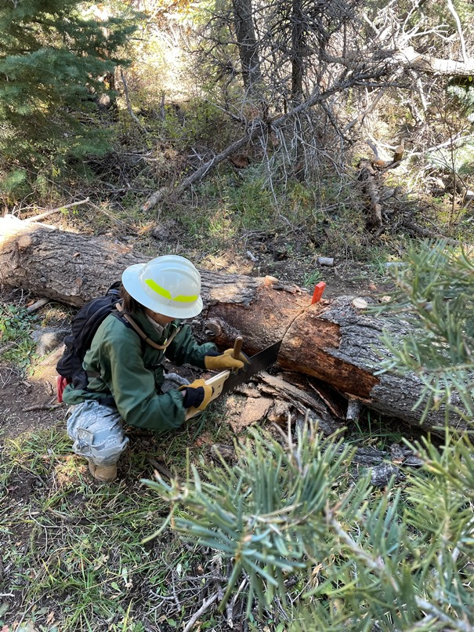
Rav is completing the cut on the big tree.
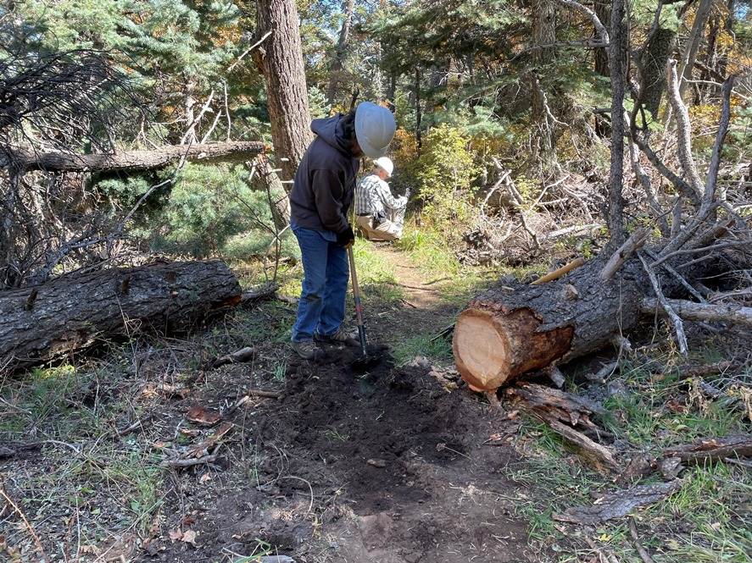
Phil restores the trail tread after the big tree has been cut away.
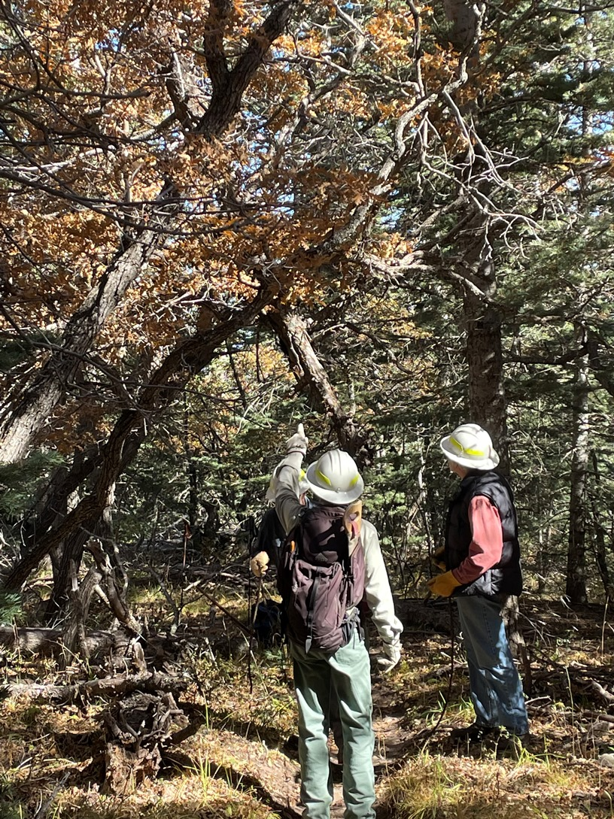
This nasty windowmaker was suspended directly over
Osha Loop trail. It proved to be quite uncooperative,
taking several attempts with a long rope to get it
safely on the ground and away from the trail.
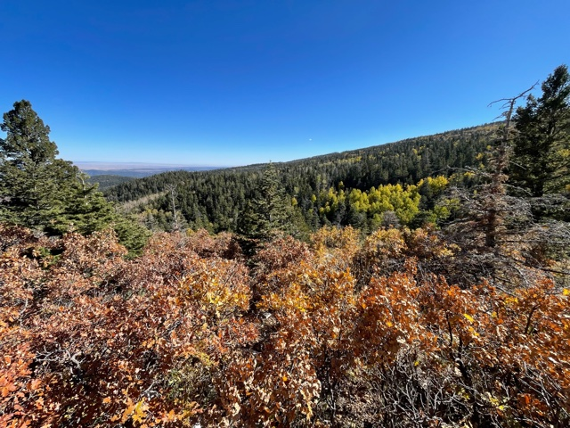
This photo is looking southeast from Osha Loop as the trail approaches the 10K North junction.
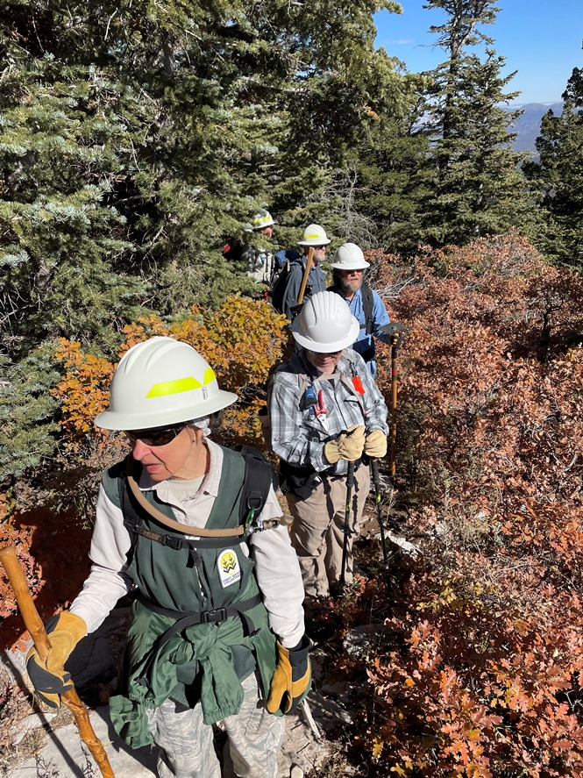
The crew moves through the oak scrub growing along
the trail about where the previous photo was taken.

