FOSM Report of Painting Ranger Station Parking Stripes and Application of Primer

on Arroyo Culvert Guard Rail Posts, Tuesday, October 19, 2021

Ellie Parker and Sam Beard, FOSM Paint Crew, Oct. 21

On Tuesday, Oct 19, the FOSM painters striped the front parking lot at the Sandia Ranger Station, completing our Fall maintenance. Russ prepped the lot using the FS Stihl blower. Jane Harrison is our expert at painting handicap spaces (3) and also painted two fire hydrant barrels. Pauline Ho, Rick Buss and Ellie Parker ran the spray paint carts and applied three coats on each stripe at approximately 28 spaces. The crew also painted lines and letters at the bus and RV area. The morning temperature was not as cool as predicted, and the afternoon wind started earlier than predicted. NM weather .....

While the crew was painting in front of the Ranger Station, Sam Beard was applying a primer coat on the 17 short posts supporting the two guard rails over the culvert over Cedro Arroyo immediately south of the Ranger Station. These posts had not been painted in many years, and weathering of the end-grain wood had occurred. Sam found several gallons of Behr Redwood Solid Color Weatherproofing Stain and Sealer in the Hazmat Building and used it as a primer on the post. On Wednesday, Sam painted the posts on the north side of the culvert with brown paint.

Project photographs are presented below.

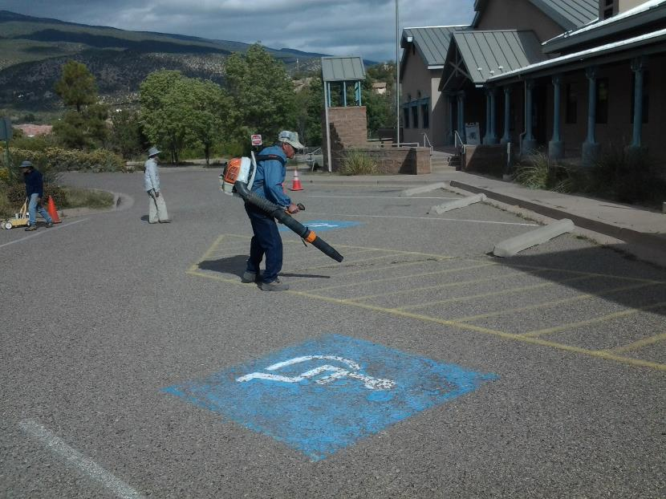

L to R: Rick Buss, Pauline Ho, and Russell Parker working in front of the Ranger Station where they were painting

parking space stripes. Photo by Ellie Parker

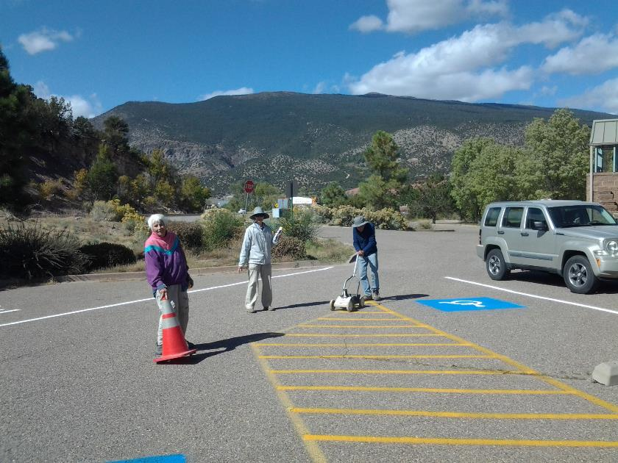

L to R: Paint Crews members Jane Harrison, Pauline Ho, and Rick Buss. Rick is using a cart containing a paint spray can

to mark a No Parking space between two handicap spaces. Photo by Ellie Parker

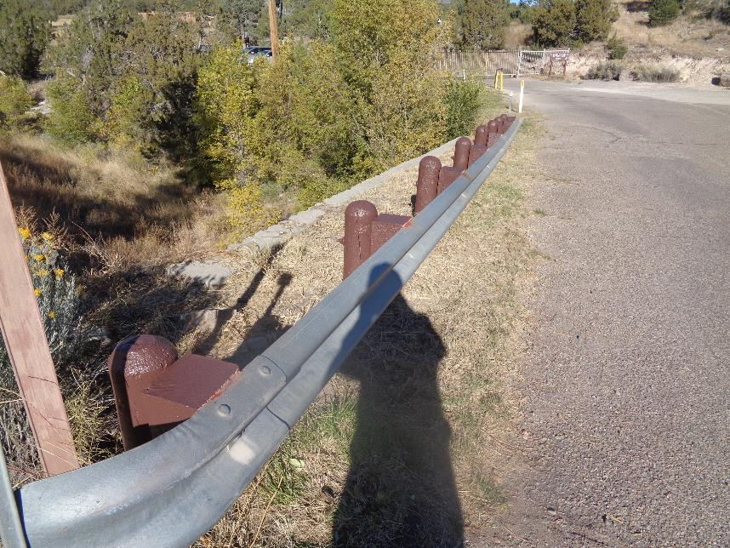

On Wednesday, Sam painted the posts on the north side of the culvert with Behr USFS brown paint. Photo by Sam Beard