Report of FOSM Volunteers Processing One Cord of Wood in Nine Mile Picnic Area

and at Ellis Trailhead for the Mountain Christian Church Wood Ministry

on Wednesday, October 20, 2021

Sam Beard, Projects Chair, Oct. 21

On Wednesday, October 20, eleven FOSM volunteers bucked, split, and hauled one cord of firewood that was donated to the Mountain Christian Church Wood Ministry to be given to needy East Mountain families this winter. Most of the wood was from trees already on the ground, but a few dead trees were felled.

Project photographs are presented below with more details about the work.

The volunteers working on this project were Gerald Muisener (new volunteer), Sam Beard, Jerry Pekarek, Sim Cook, Cliff Giles, Lou Romero, Byron Garner, Eric Russell, Dan Benton, Jerry Carroll, and Mike Madden.

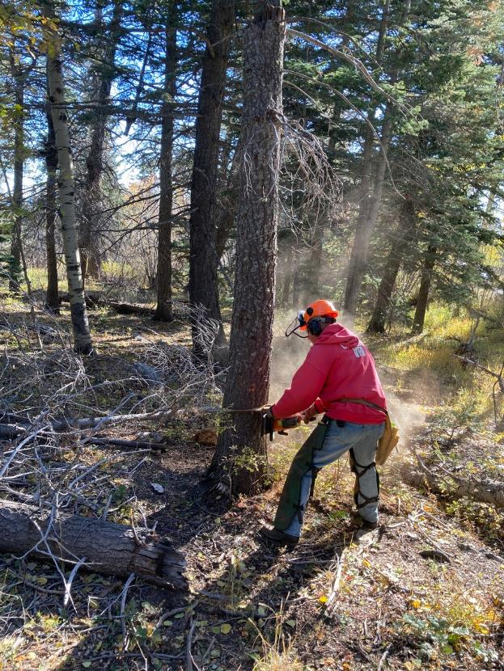

Jerry Carroll felling a cigar butt tree near the Old Crest Highway in the lower part of Nine Mile Picnic

area. All photos by Cliff Giles unless noted otherwise

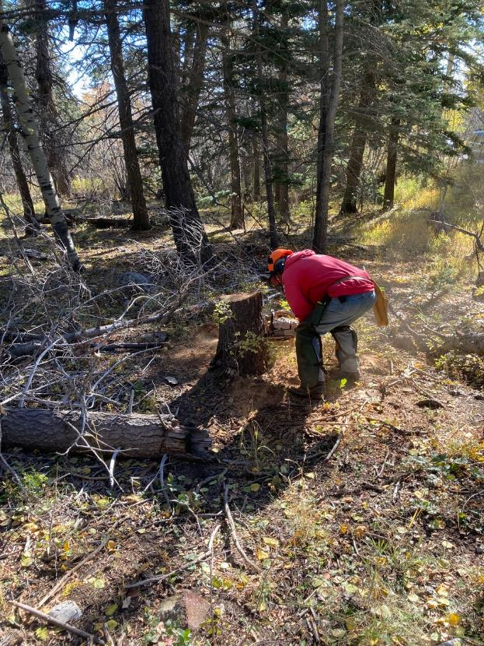

Jerry Carroll low stumping the tree he as just felled.

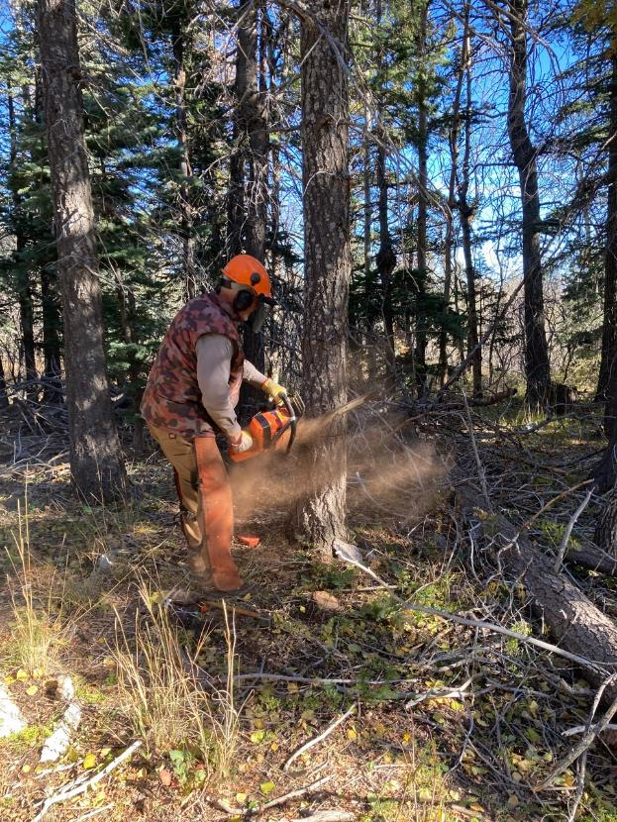

Dan Benton felling a dead white fir in lower Nine Mile Picnic Area.

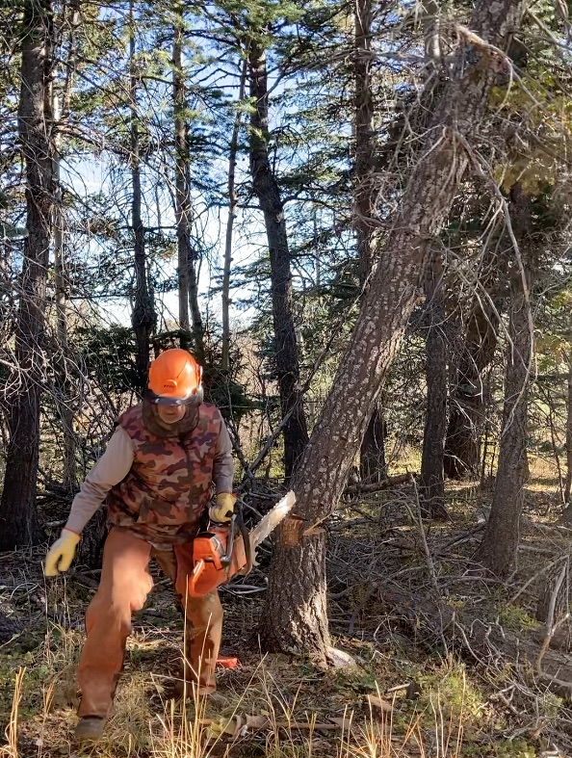

Dan running away as the tree falls.

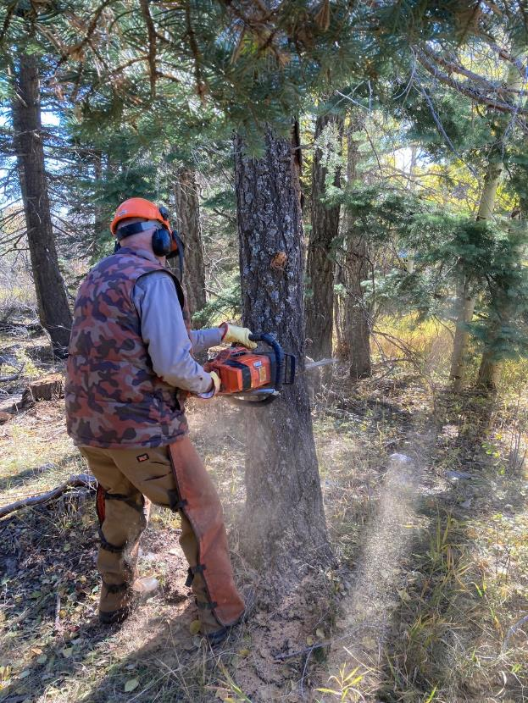

Dan felling another dead white fir.

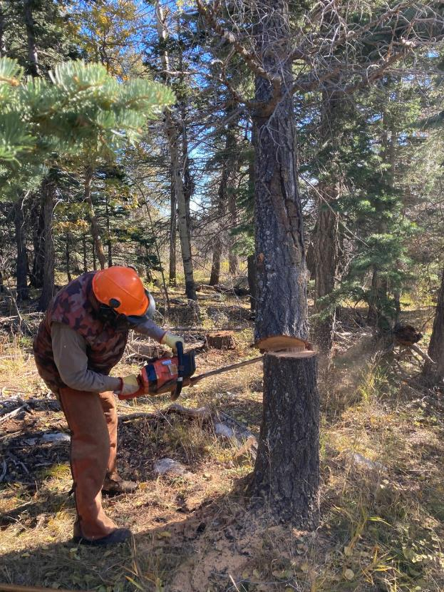

The tree above that Dan was felling hung up in another tree, but the butt of the tree remained on the

Stump. Here Dan is cutting the tree off the stump so that it will fall to the ground.

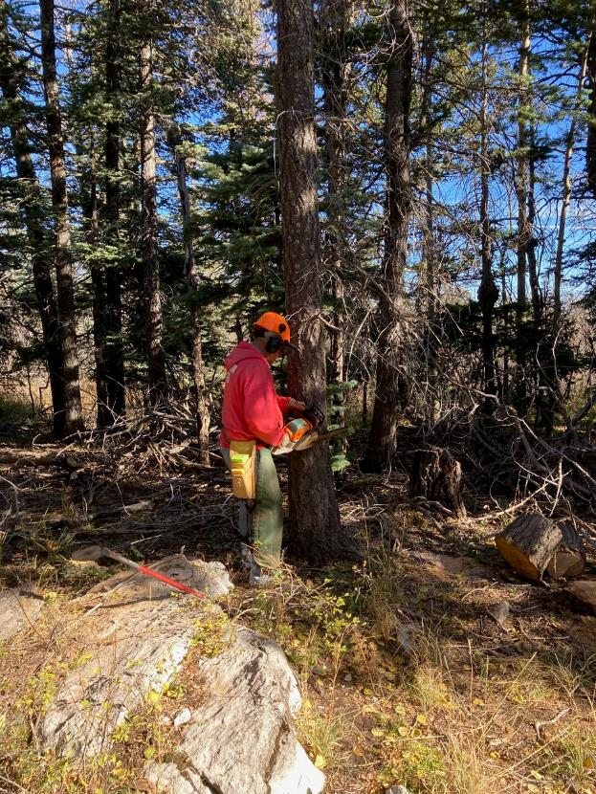

Jerry Carroll making an open face cut in a dead white fir.

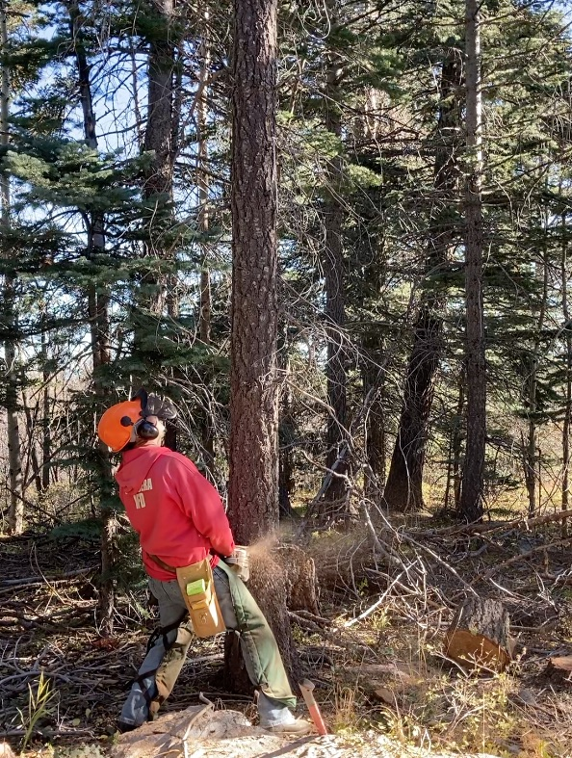

Jerry looking up for above hazards as he is making the back cut to fell the tree.

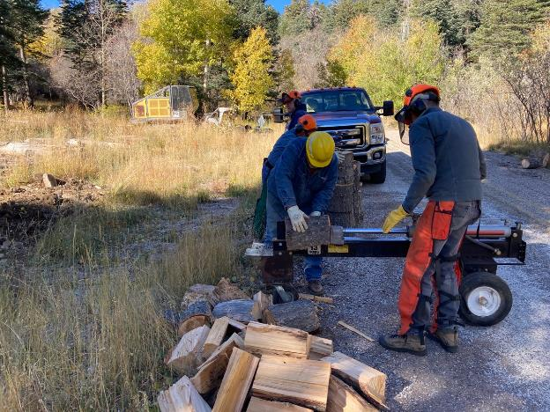

L to R: Gerald Muisener (new volunteer) and Sim Cook using Lou Romero’s power splitter to split the

bucked wood.

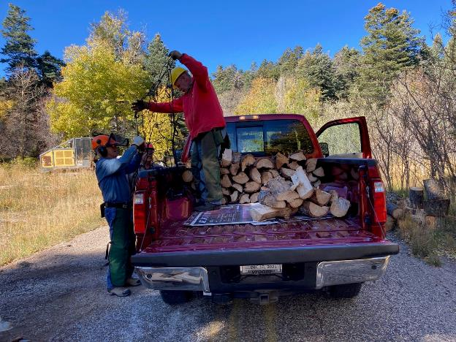

L to R: Jerry Pekarek and Jerry Carroll untangling elastic netting that will secure the load of donation wood that

will be delivered to a church wood lot west of NM-14 and south of the Triangle Intersection. Jerry Carroll is standing

in his new pickup bed that he has graciously donated to haul wood to the church wood lot.

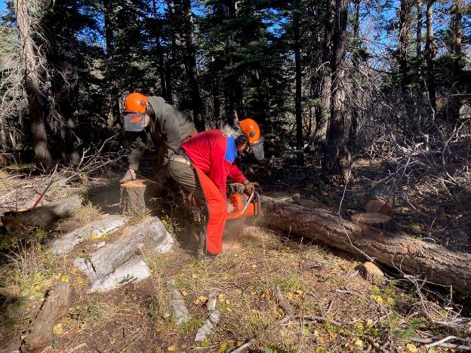

Chain saw trainee Mike Madden is bucking a log in order to get practice for his certification as an

official USFS chain sawyer on October 28. Sam Beard is preparing to move a piece of wood to the

old highway.

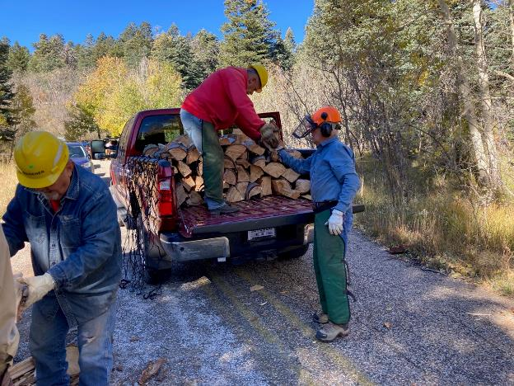

Jerry Carroll and Jerry Pekarek are loading split wood in Jerry’s pickup on the Old Crest Highway.

On the left Gerald Muisener is splitting wood with Lou’s power splitter.

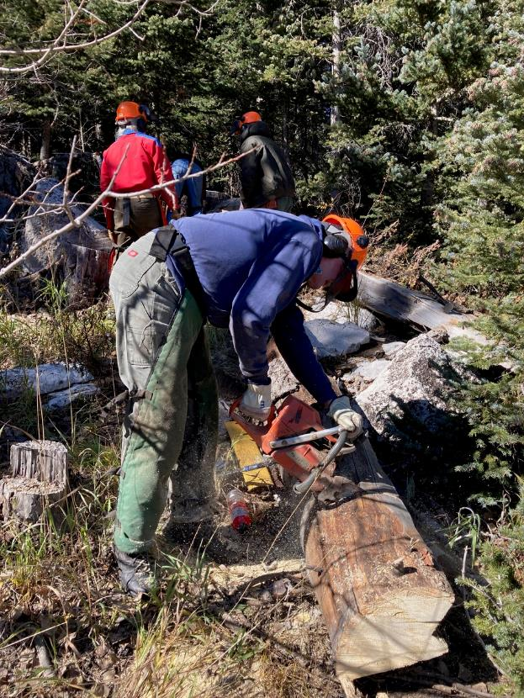

Eric Russell is bucking the large tree that he felled several moths ago at Ellis Trailhead.

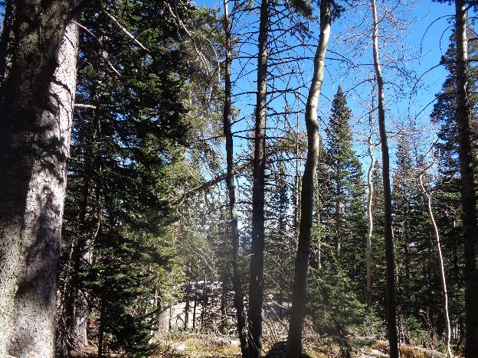

A marked hazard tree near the Ellis Trailhead large red gate is falling after Dan Benton completed

his cut. Photo by Sam Beard

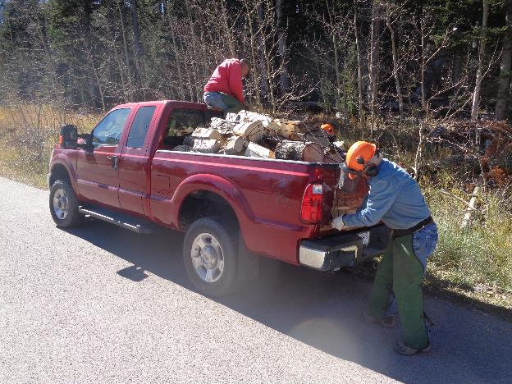

L to R: Jerry Carroll and Jerry Pekarek are attaching the elastic netting what will secure the ½ cord of wood

on the trip to the church wood lot. Photo by Sam Beard