Report of FOSM Processing Donation Wood at Ellis Trailhead

on Wednesday, October 27, 2021

Sam Beard, October 30

On Wednesday, October 27, eight FOSM volunteers bucked, split, and hauled one cord of firewood to the Mountain Christian Church Wood Ministry wood lot on Sandia Haven Road located west of NM-14 and south of the intersection of NM-536 and NM-14.

Please see the photographs and narrative below for project details.

The volunteers were Don Carnicom, Mike Madden, Jerry Carroll, Dan Benton, Lou Romero, Cliff Giles, Byron Garner, and Sam Beard.

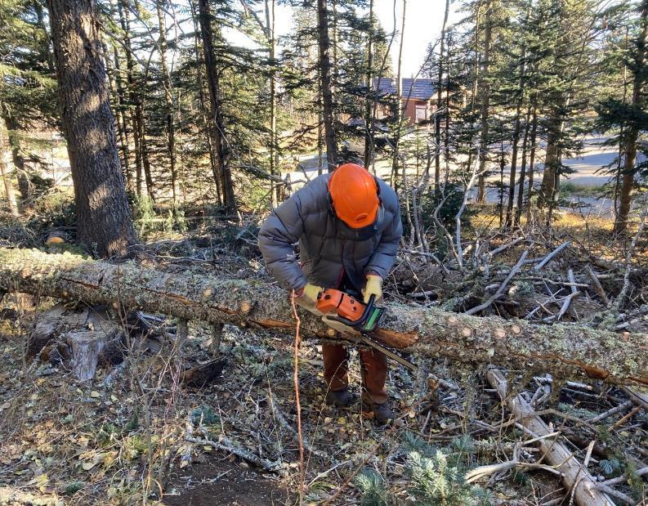

Dan Benton limbing a hazard tree that he felled earlier on the slope above the large gate on the Service Road at Ellis Trailhead.

Note that he is wearing a warm jacket. When we arrived here, the temperature was 27F with a strong, cold north wind.

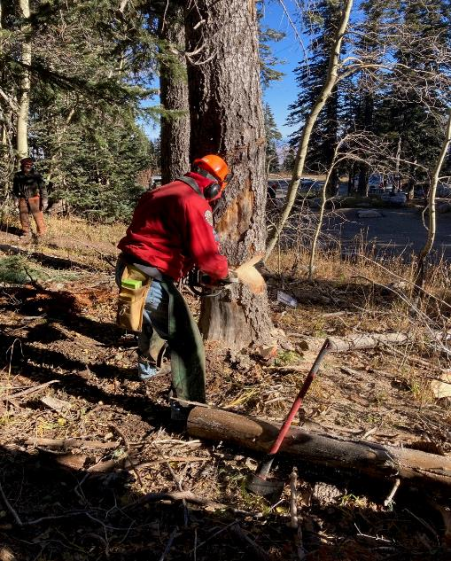

Jerry Carroll finishing the face cut on a dead cigar butt tree near the Service Road.

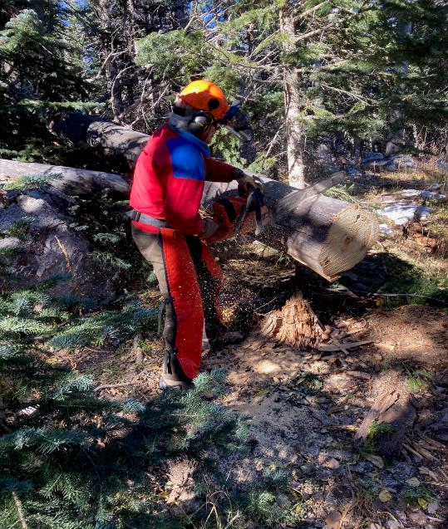

Mike Madden bucking an 18-inch spruce.

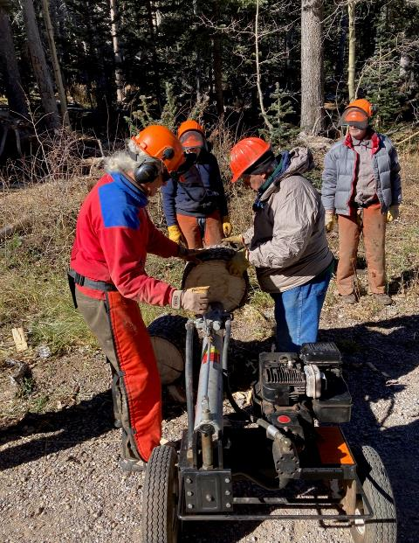

L to R: Mike Madden, Byron Garner, Lou Romero, and Dan Benton. Mike and Lou

are using Lou’s power splitter to split the rounds into quarters.

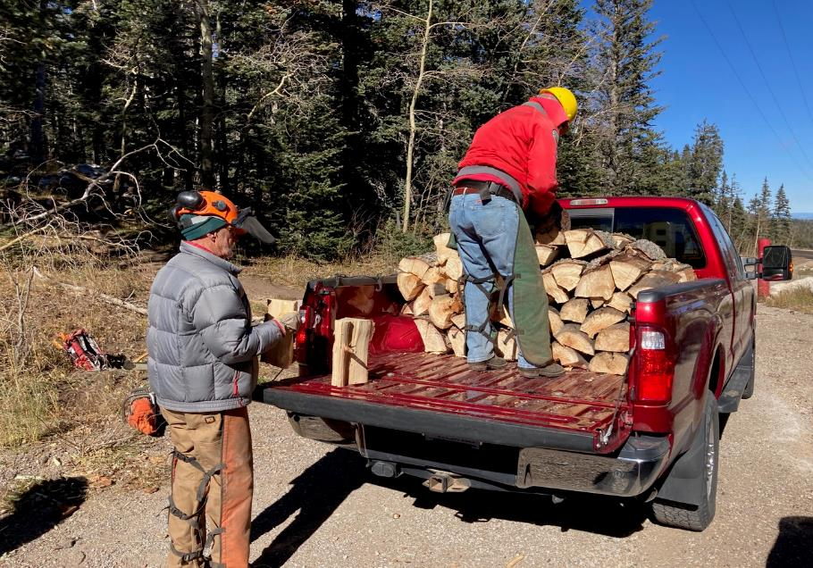

Dan and Jerry loading Jerry’s new truck with split wood.

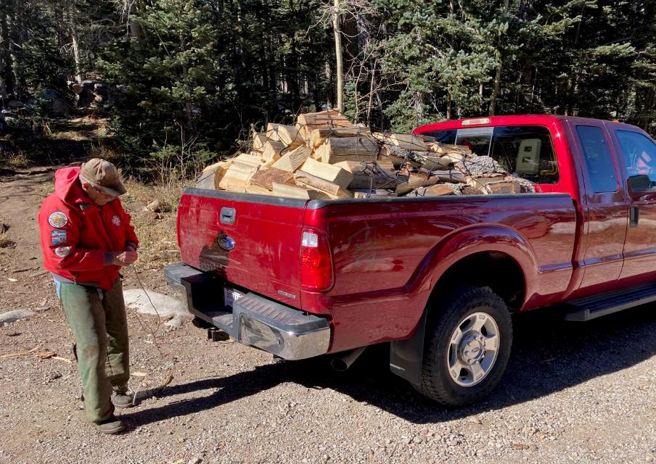

Jerry securing the load with a cargo net.

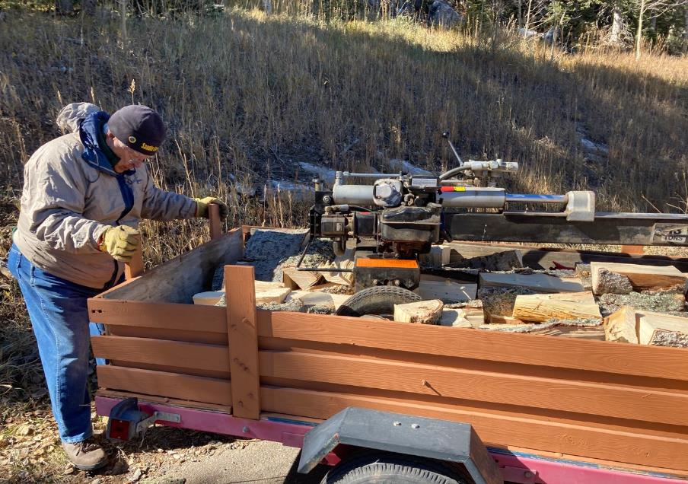

Lou putting the tail gate on his trailer loaded with his splitter and split wood.

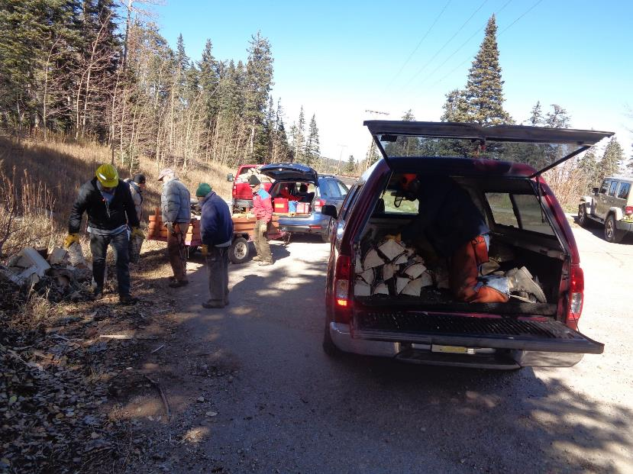

Loading wood on Byron’s truck after Jerry’s truck and Lou’s trailer were full.