**Report of the FOSM Project in Cienega Picnic Area to Fell**

**and Buck Two Large Rocky Mountain Juniper Hazard Trees and Split and**

**Haul the Wood on Wednesday, November 17, 2021**

Dan Benton and Sam Beard, November 18

On November 17, 2021, nine FOSM volunteers removed two dead 20-inch diameter Rocky Mountain Juniper hazard trees from the Cienega Picnic Area and access road. The first tree was near the first picnic table above the upper parking lot. It was limbed, bucked, and split using Lou Romero's gas-powered splitter.  A previously felled Gambel Oak nearby was also bucked and split. Split wood was moved down to the parking lot and loaded onto Joe Meade's truck and trailer with a wheel barrow.  The second hazard tree was located between the first and second restrooms along the access road. The access road was briefly closed for safety while this tree was felled and bucked. Donation wood was delivered to the Mountain Christian Church Wood Ministry wood lot.  The volunteers participating were Lou Romero, Joe Meade, Tami Meade, Jory Meade, Byron Garner, Jerry Carroll, Cliff Giles, Sim Cook, and Dan Benton. (Dan Benton)

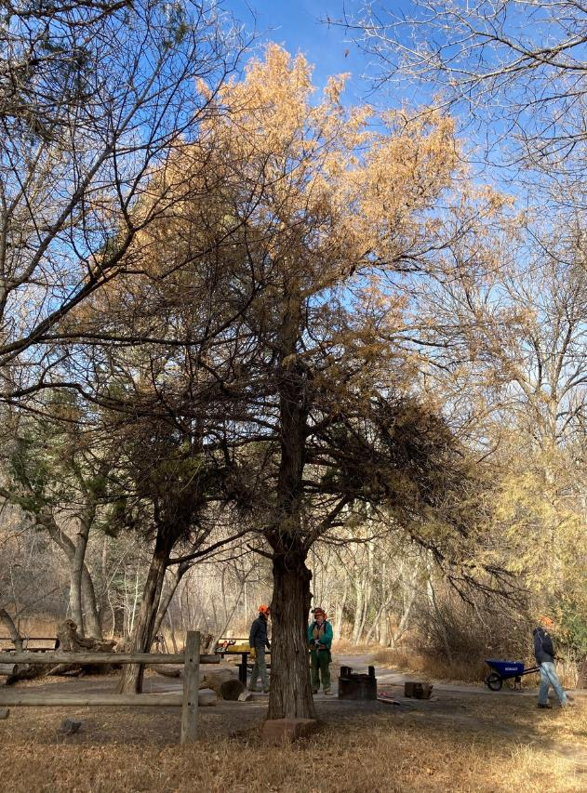

The large dead Rocky Mountain juniper near Cienega Spring above the upper parking lot

in Cienega Canyon Picnic Area. All photos by Cliff Giles

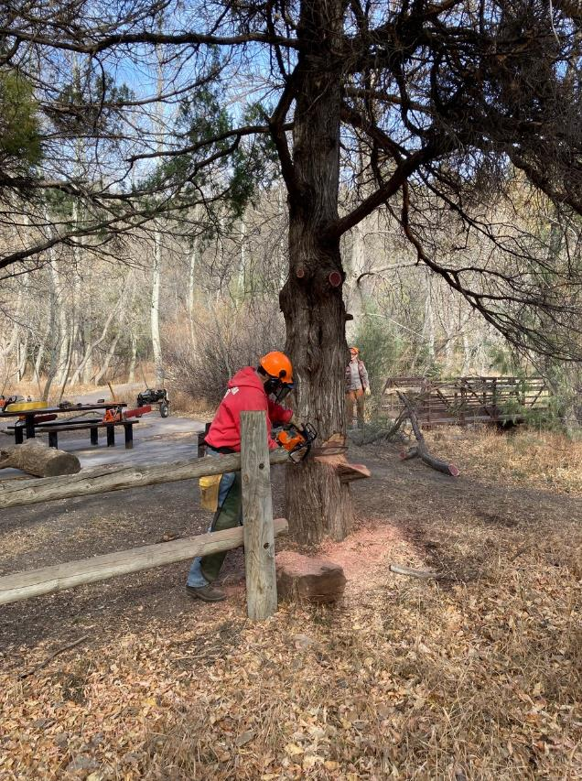

Jerry Carroll completing the face cut in the large juniper.

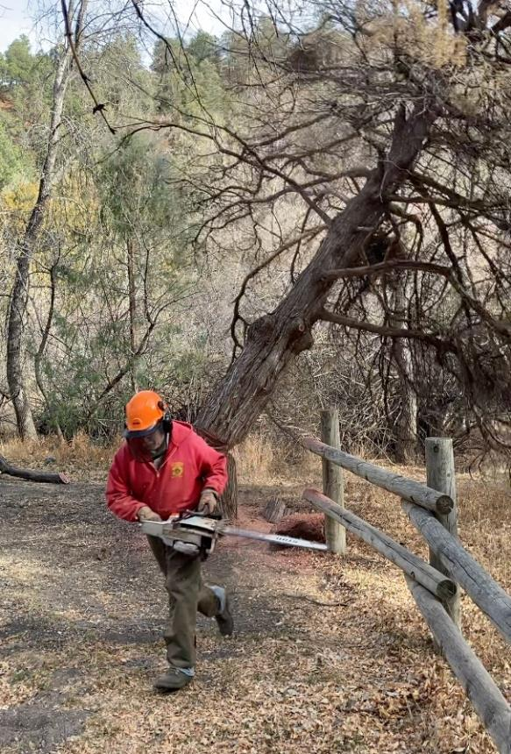

Jerry running away as the tree falls.

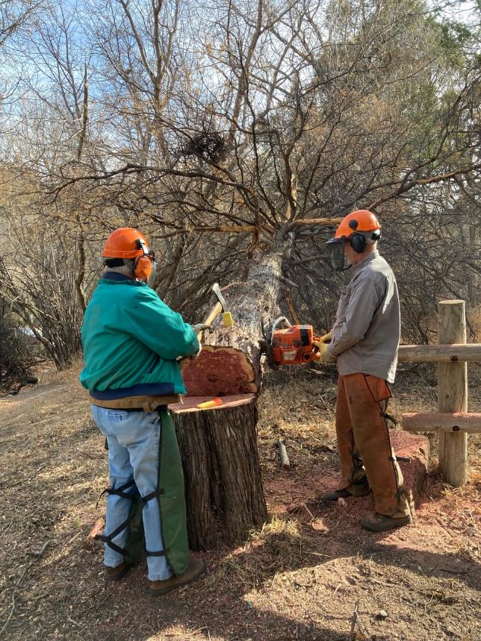

Dennis Crowther driving wedges for Dan Benton who is cutting the tree off the stump.

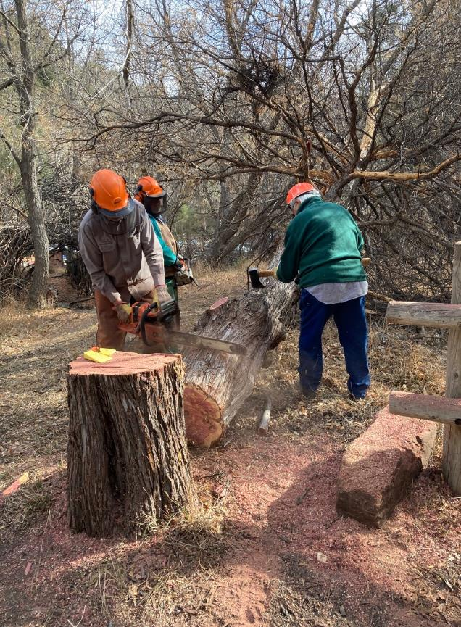

Dan and Dennis bucking the tree while Lou Romero marks the 12-inch bucking locations with this axe.

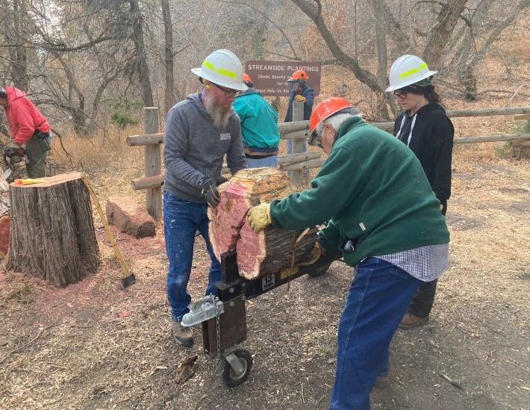

L to R: Jory Meade, Lou Romero, and Tami Meade splitting wood.

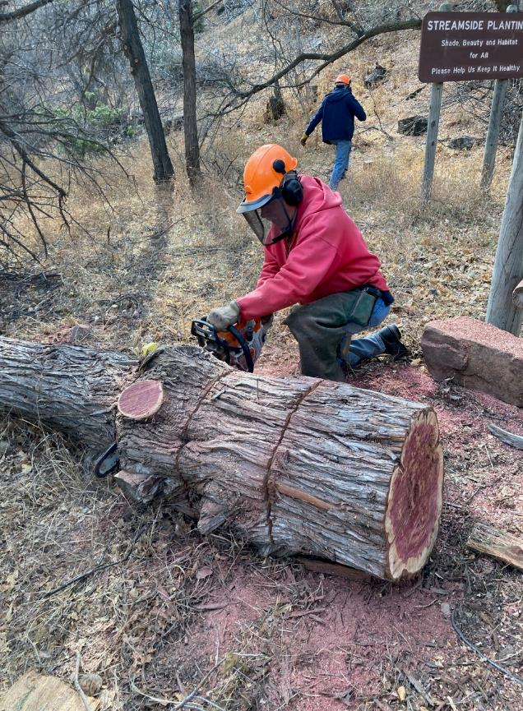

Jerry bucking the large trunk.

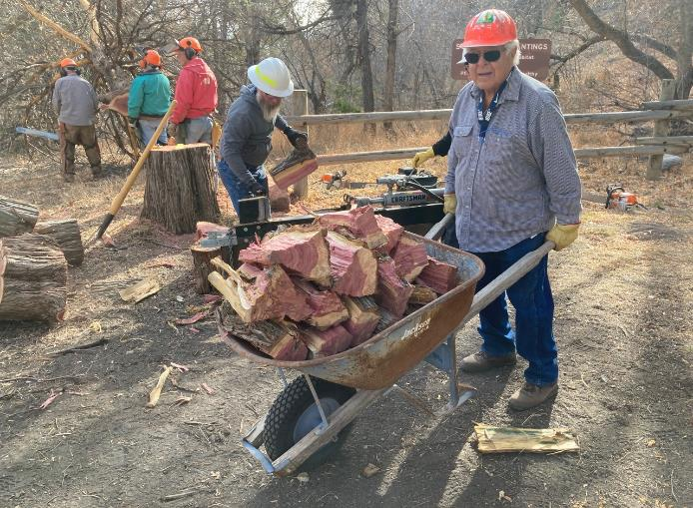

Lou hauling wood down to the parking lot.

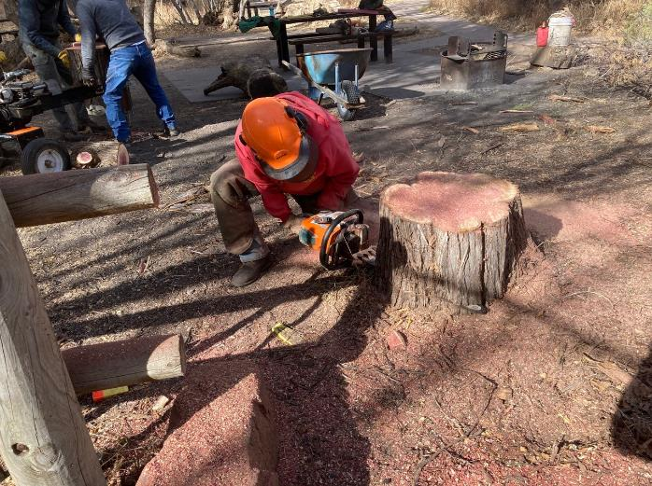

Jerry low cutting the stump.

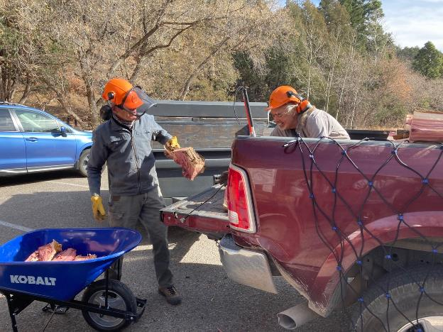

Sim Cook handing wood to Joe Meade to stack in the pickup.

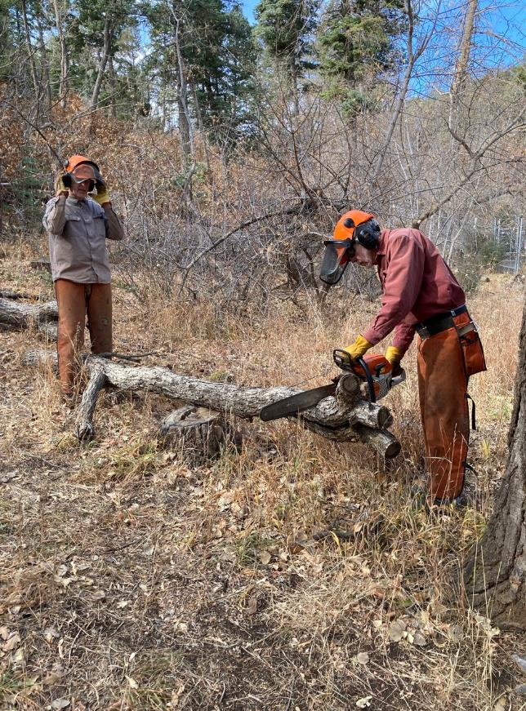

Dan Benton watching Byron Garner buck an oak log.

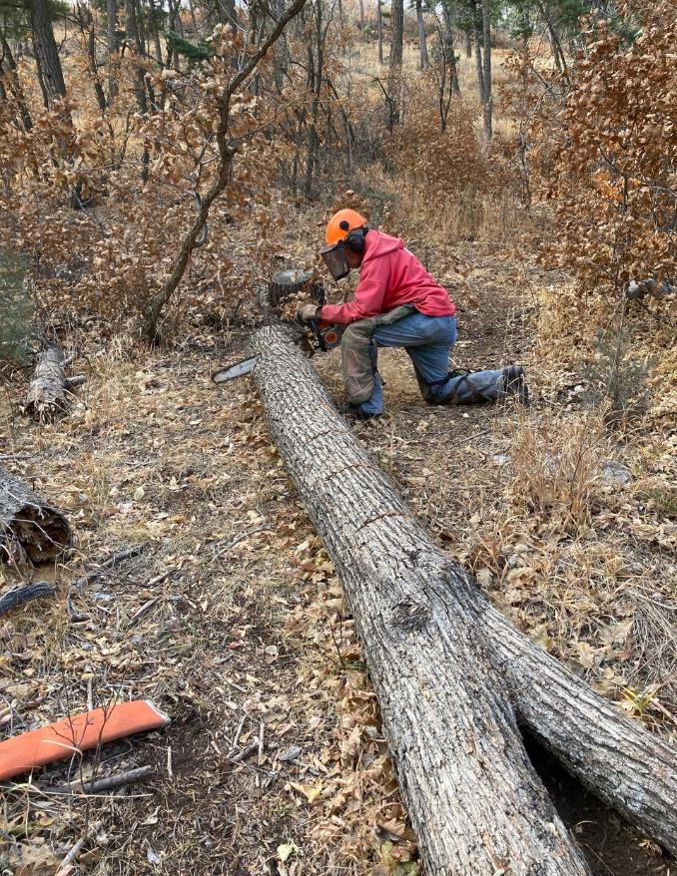

Jerry is bucking an oak log.

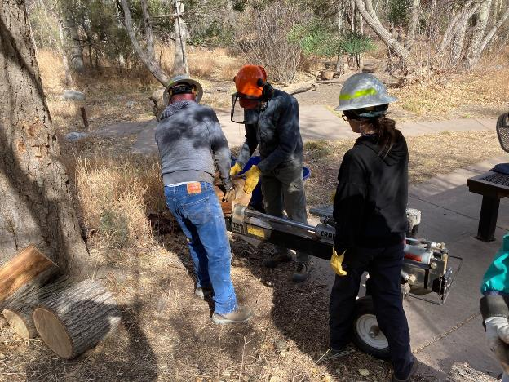

L to R: Jory, Sim, and Tami splitting oak wood.

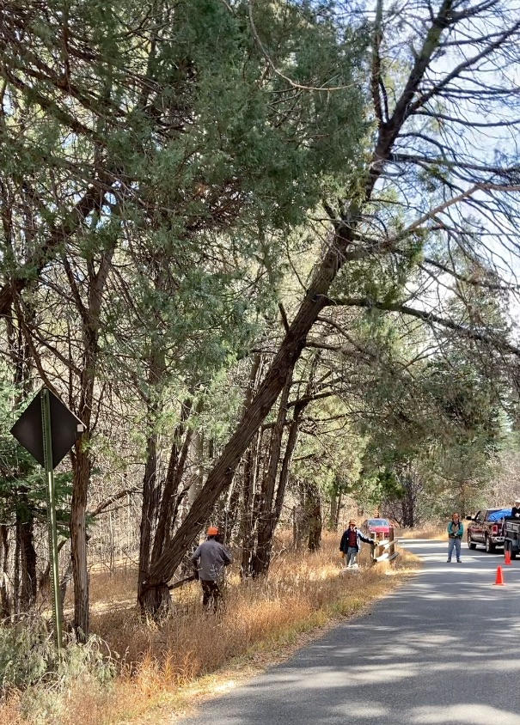

Dan Benton running away as the juniper falls across the road.

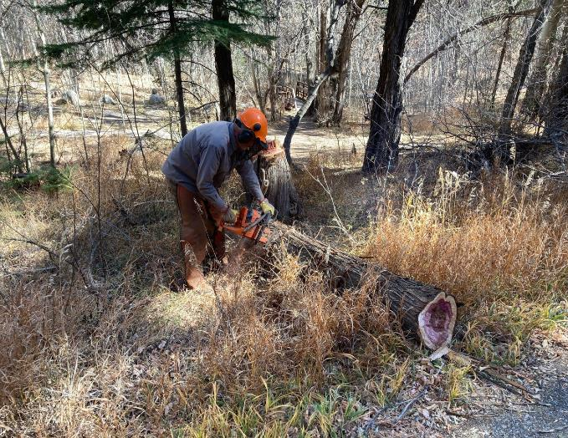

Dan bucking the juniper between the restrooms.

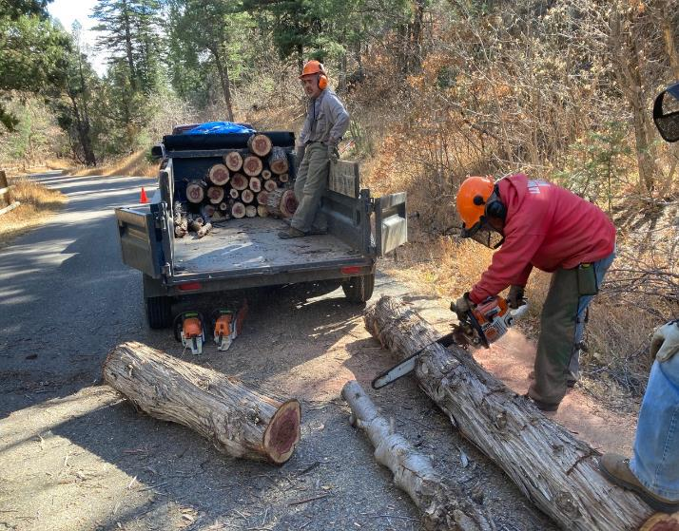

Jerry bucking a juniper log while Joe waits to stack the wood in the trailer.

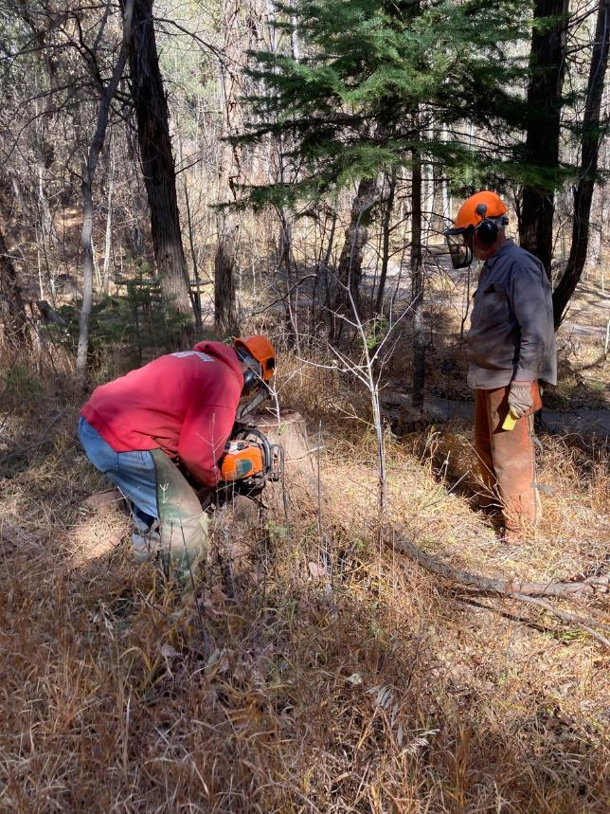

Jerry low stumping the juniper while Dan waits to drive wedges.