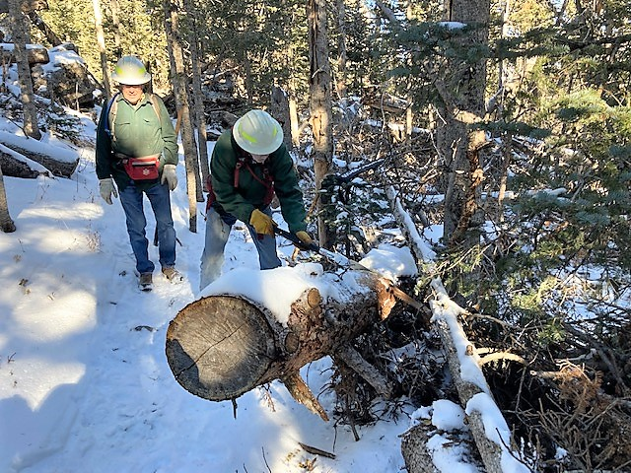
This 14&1/2-inch diameter tree had been cut years ago but had settled and was now protruding into Lower Switchback not far above the junction with the Tram access road. It was cut back.

(Photo by Jamey Browning)
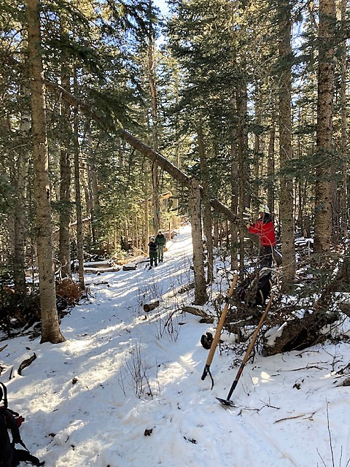
This was the first hang-up tree to greet us on Lower
Switchback located just above the Ellis parking lot cutoff trail. The first cut to remove it is starting. Photo looking south.

(Photo by Jamey Browning)

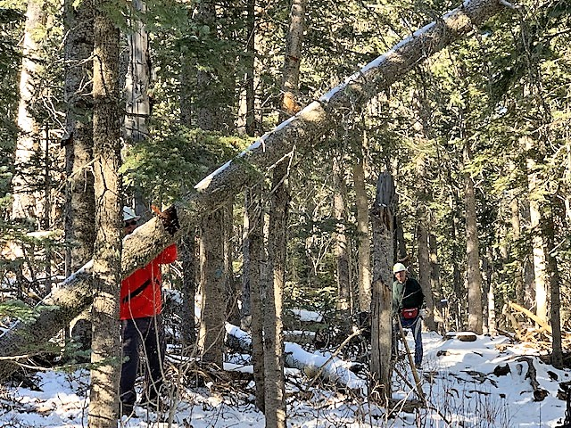
Same tree as previous photo, this photo looking north. The perspective in the photo, taken from a distance away, is a bit askew as it appears that the sawyer is standing close to the tree while cutting. The lengthy new Silky saw allows such cuts to be made at a safer distance.
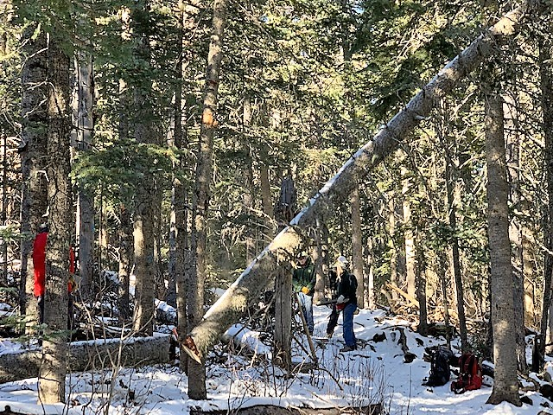
The hang-up tree begins its journey to the ground.

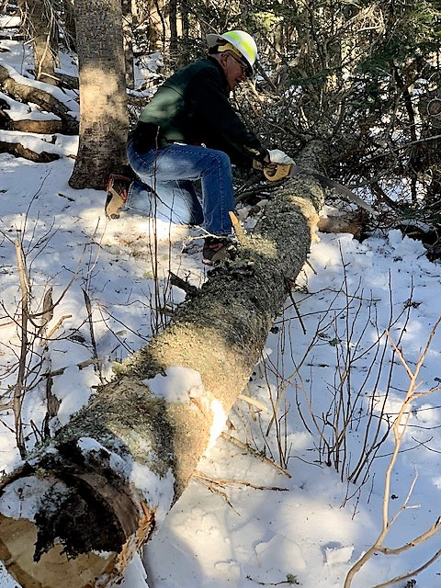
The hang-up hazard tree has been downed. The cut sections were moved off the trail.
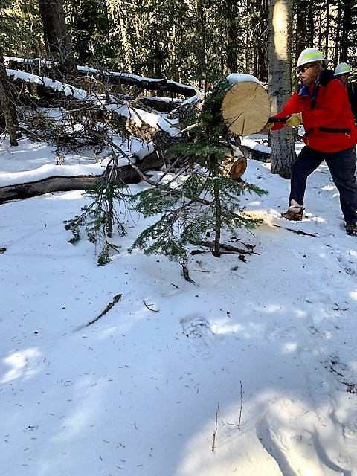
Another previously removed tree that settled into the
trail space is cut back. No doubt the small fir tree
appreciates the removal of its unwelcome neighbor.
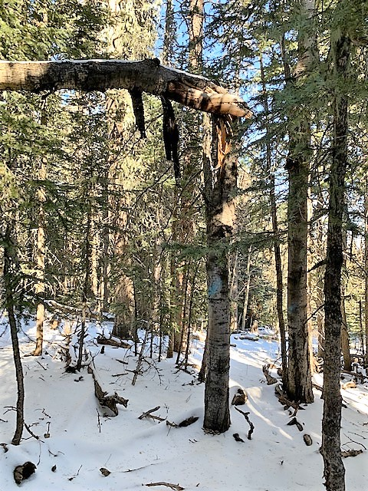
This broken aspen tree was probably familiar to those who
hike Upper Switchback trail. The broken section hangs
over the trail to the left and extends almost 20-feet
into the forest

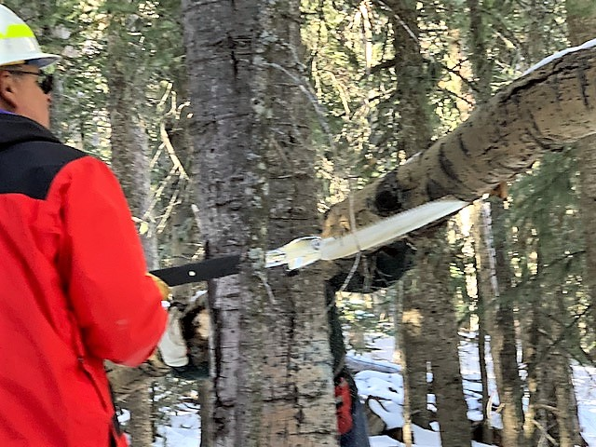
The broken section of the fallen aspen is being undercut well back into the forest where it is closer to the ground. One of the crew’s new Silky Katanaboy saws is being used. (Thanks again Kerry!) It was hoped that it would break loose and fall to the ground. It did. In fact the entire tree, including the main trunk on the other side of the trail came down saving the crew some work.

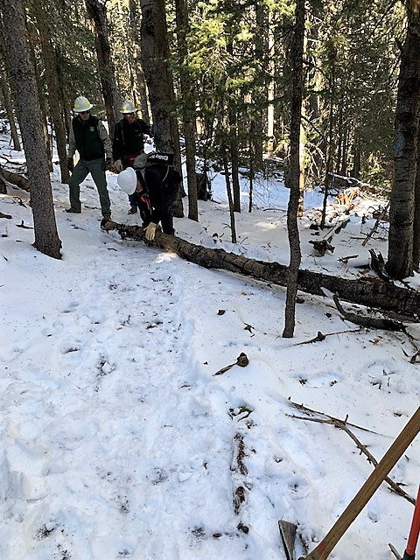
The crew prepares to move the cut aspen trunk off the trail.
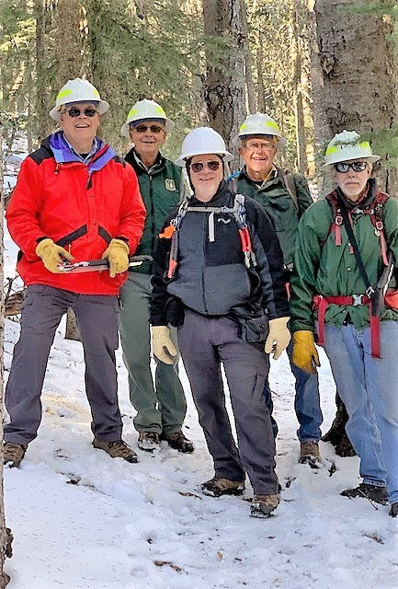
Monday’s crew (Left to right) David McCreery, Bob Lowder,
Jamey Browning, Jerry Pekarek and Byron Garner.
(Not pictured – Sally Lowder)

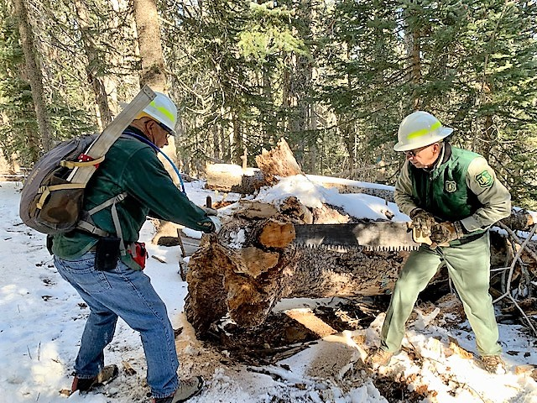
This huge (25-30 inches?) spruce had fallen adjacent to Upper Switchback years ago. It large roots were protruding into the trail. They had been partially cut back over time, but although blunted, some still stuck out. The crew used a crosscut saw to cut away the roots and flatten the base of the tree.

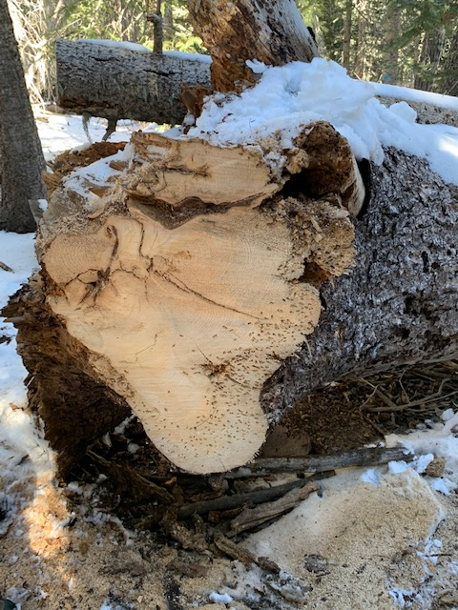
The roots have been cut away and a flat surface remains.
The cut section measures 24-inches from top to bottom.

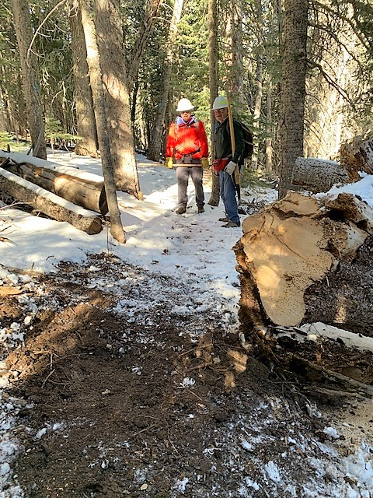
The trail surface above the big tree has been reworked so
that there is plenty of space for users to pass by.

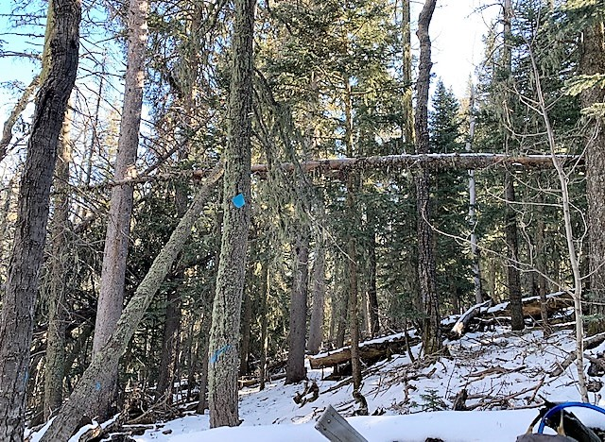
This interesting display of dueling hang-ups was located on Upper Switchback. The base of the horizontal tree is located about 25 feet uphill to the right.

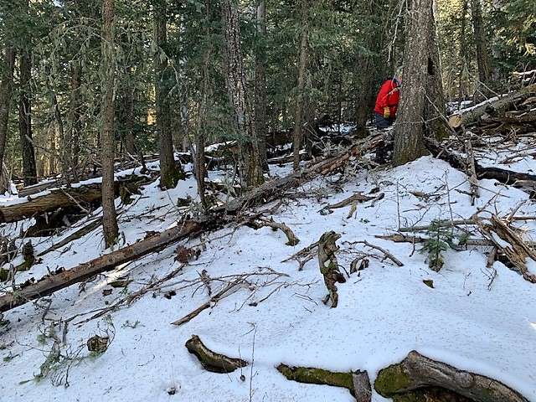
After the horizontal tree was cut on the hillside toward its base, it and the lower tree leaning against it fell to the ground.
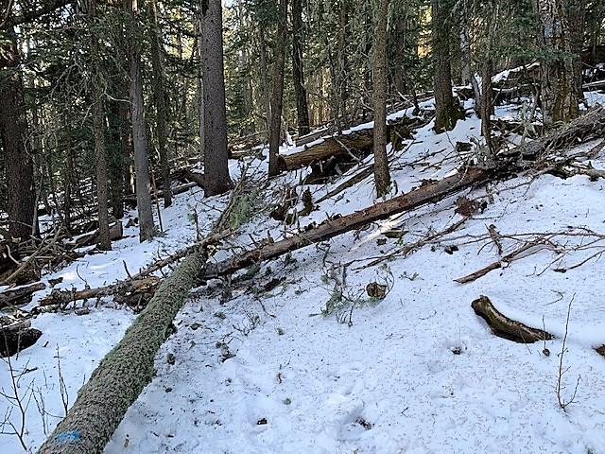
This is what the trail looked like after both hang-ups came down. Both trees were cut into sections and resulting debris was moved off the trail.
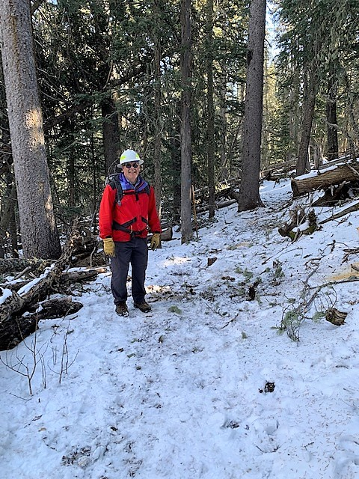
Hazard is removed and trail is clear.

