**Report of Graffiti Removal near End of Indian School Road on December 1, 2021**

Sam Beard, Dec. 3

On Wednesday, December 1, five FOSM volunteers removed about a dozen graffiti tags from boulders southeast of the end of Indian School Road. We hiked about ¾ mile to one of the foothills peaks covered with boulders.

The photos below show the graffiti tags before they were removed or partially removed and the boulders after we worked on them. We found lichen growing on some of the paint; therefore, these tags were quite old.

The volunteers were Anne Hickman, Sim Cook, Byron Garner, Cliff Giles, and Sam Beard.

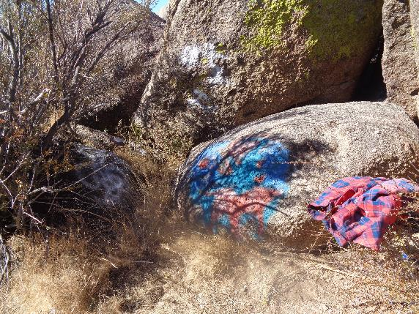

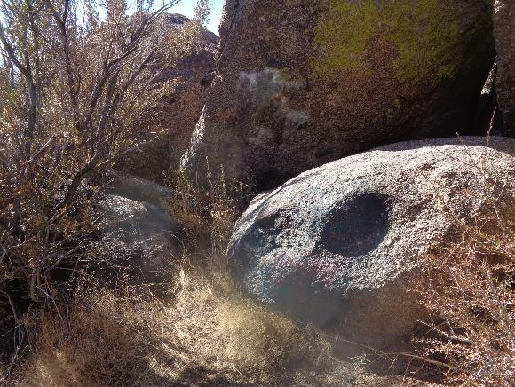

The first seven pages show graffiti tags and the boulders after the graffiti tags were removed.

It is not possible to always remove all the graffiti. All photos by Sam Beard

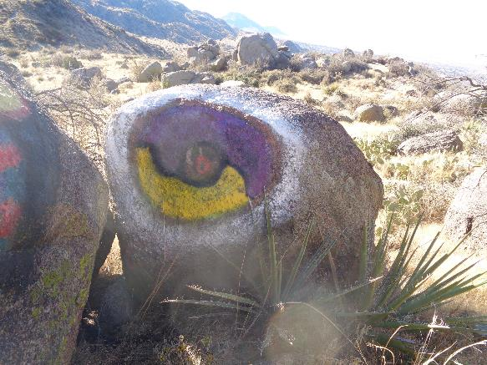

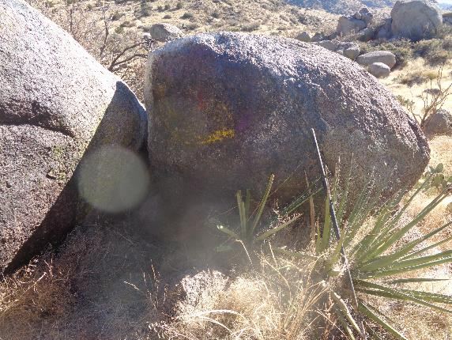

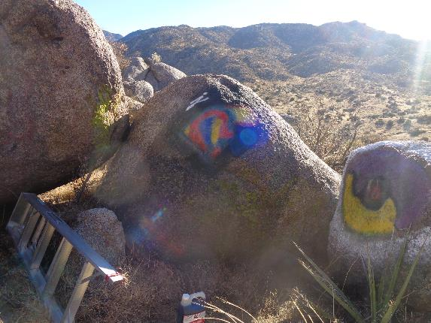

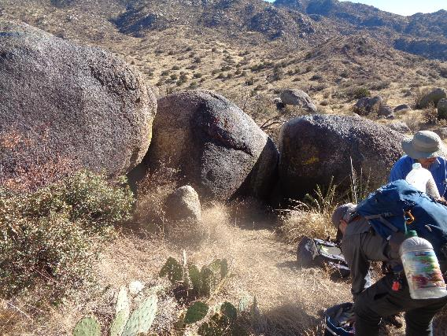

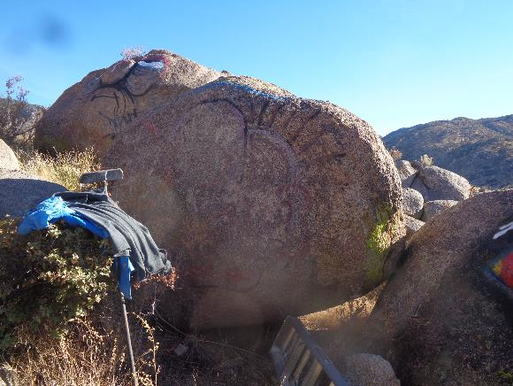

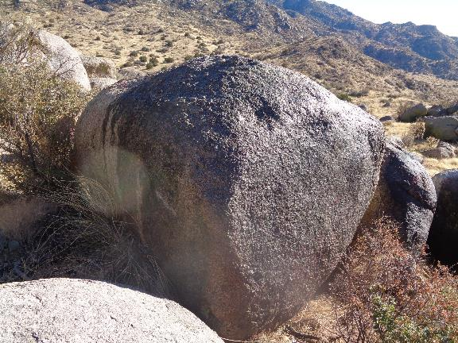

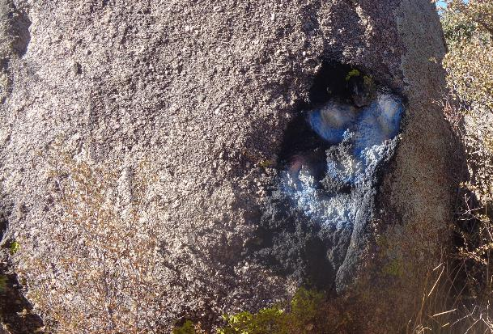

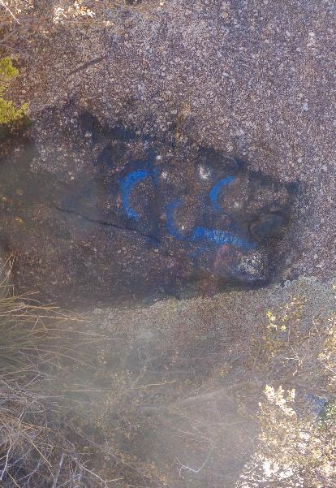

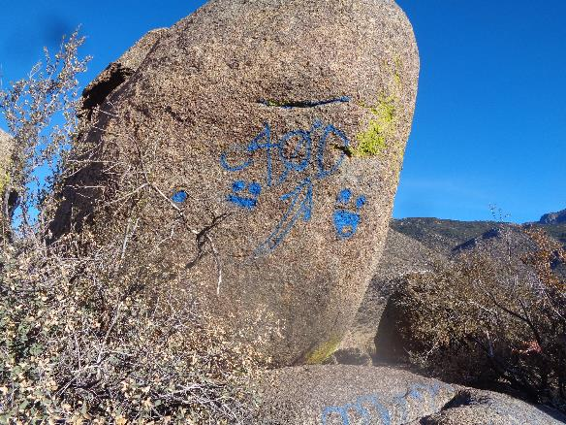

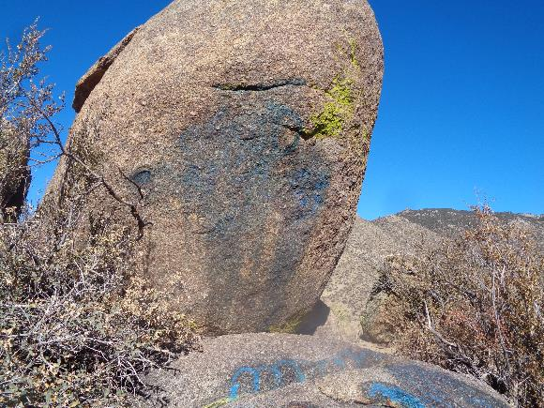

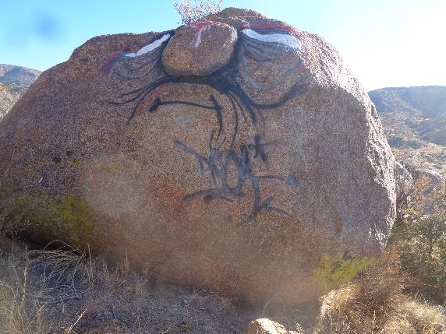

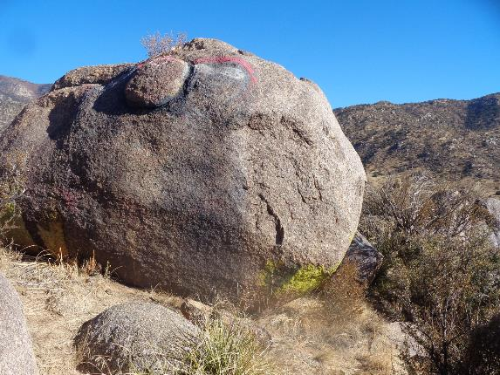

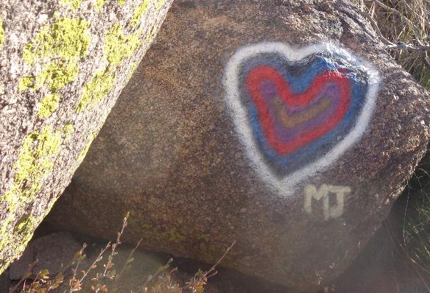

MJ – Does anyone know a Mary Jane?

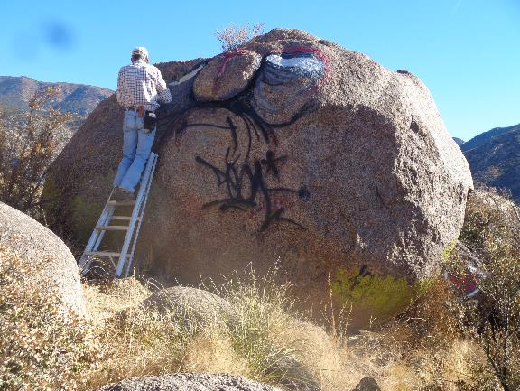

Sim Cook removing the high graffiti tag.

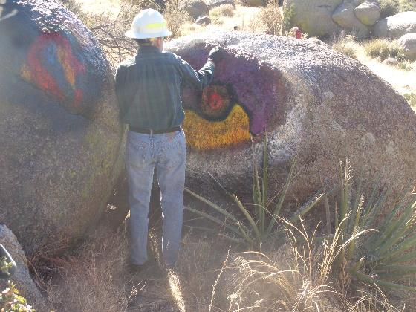

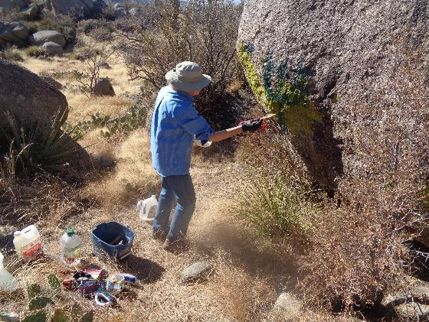

Byron Garner (top) and Anne Hickman (bottom) removing graffiti tags.

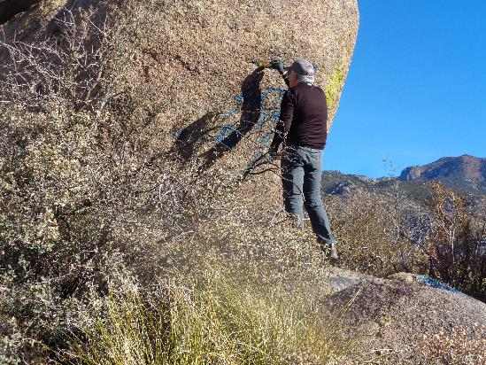

Cliff Giles removing a blue graffiti tag.

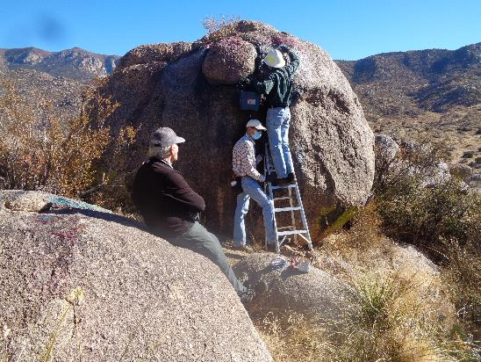

Sim is holding the ladder for Byron who is removing a high graffiti tag.

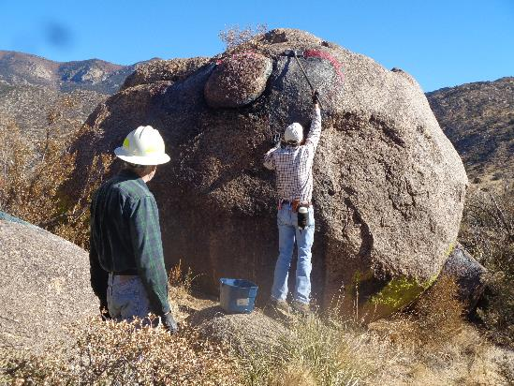

Sim washing off the chemical and dissolved paint with water and a brush on a long handle.

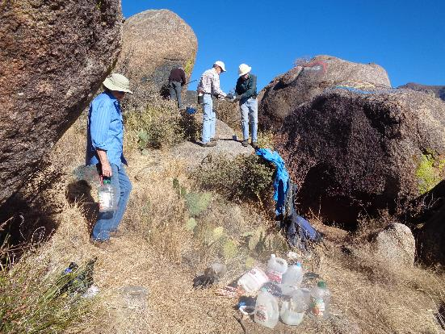

The graffiti removal work site. Graffiti tags were on all these boulders.