**Report of Buried Cable Trail Maintenance and Marking a Segment**

**of Challenge Trial Extension with Blue Diamonds on Saturday, December18, 2021**

Sam Beard, Dec. 19

On Saturday, December 18, Steve Roholt, Michael Arndt, and Sam Beard removed approximately two dozen logs from the edges of Buried Cable Ski Trail and installed blue diamonds along the recently completed segment of Challenge Trail Extension from near Dry Camp Trailhead to the base of Sandia Peak Ski Area.

At the request of Steve Roholt, the crew cut off the ends of logs protruding into Buried Cable Trail corridor to make the trail safer and easier to ski. The maximum diameter of the logs removed was about 16 inches. Michael was recently certified as a USFS B (intermediate) chain sawyer, and Steve was certified as an A (apprentice) sawyer. Michael used his Husqvarna saw with a 24-inch bar, and Steve used the FOSM Husqvarna battery-powered saw with a 16-inch bar.

After completing the Buried Cable Trail work and having lunch at Balsam Glade Picnic Area, we drove to Dry Camp Trailhead. We crossed the Crest Highway and hiked up the new 0.9-mile segment of Challenge Extension Trail parallel to the highway to the base of the Sandia Peak Ski Area. We removed one small tree from the trail and installed blue diamonds on trees in both directions. From near the Ski Area Overflow Parking lot, the first ascending part of the extension trail follows an old road that is just above the highway in one place. We were walking in one to two inches of snow on both trails.

Project photographs are presented below.

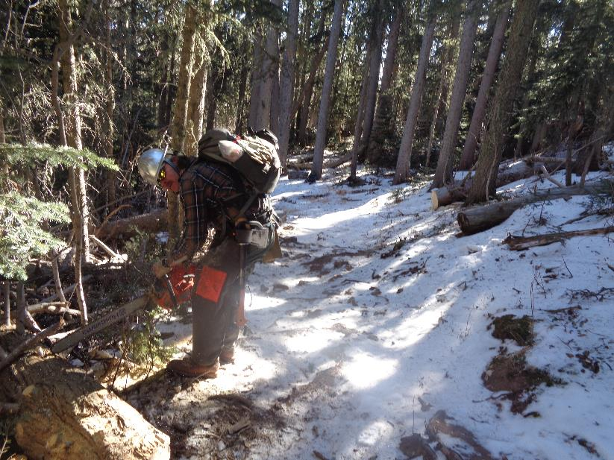

Michael Arndt cutting off the end of a log on the edge of Buried Cable Trail. Note that the lower part of this trail is wider

after the ends of several logs protruding into the trail were cut. All photos by Sam Beard

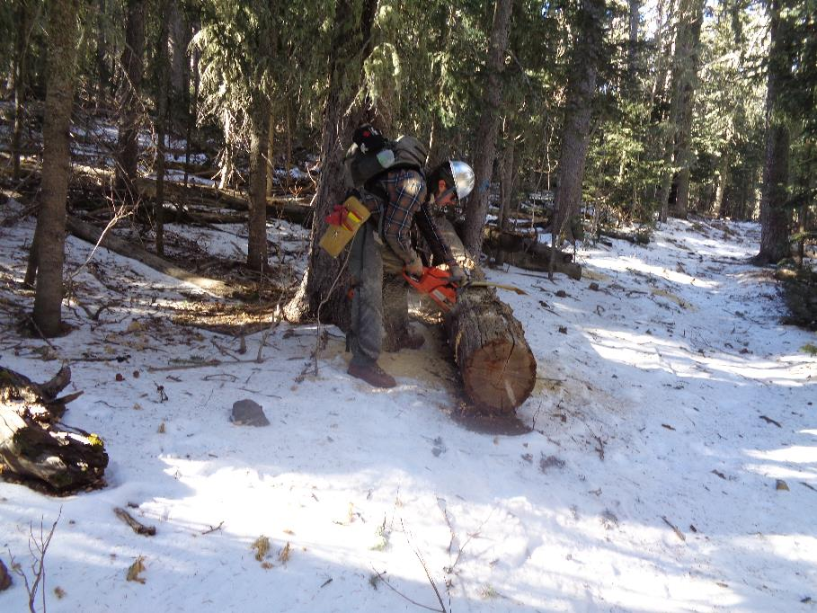

Looking up Buried Cable Trail with Michael cutting off the end of a log protruding into the trail corridor. The ends of several small

logs were cut off along the length of this trail.

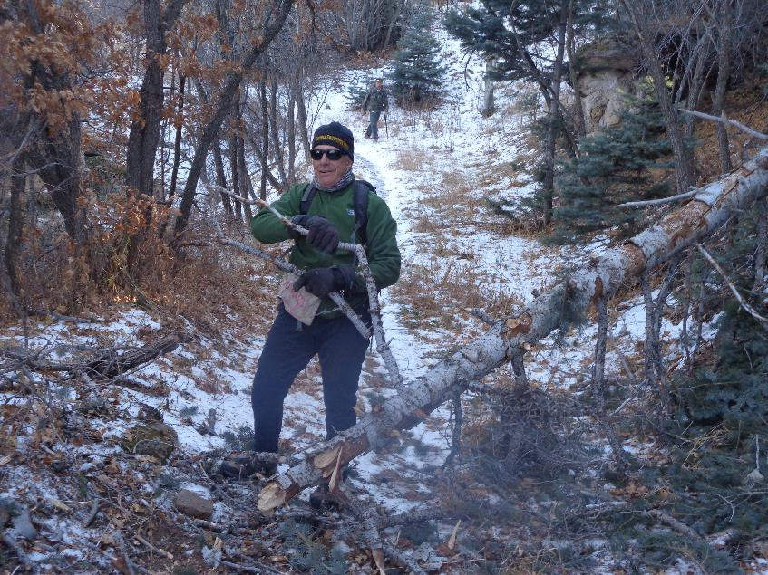

After completing the work on Buried Cable Trail, we nailed diamonds on trees in both directions along Challenge Trail Extension from

the east side of the Sandia Peak Ski Area base to the mountain side across the highway from Dry Camp Trailhead. Steve Roholt

is throwing branches from a fallen tree on the extension trail. Michael Arndt is in the background.

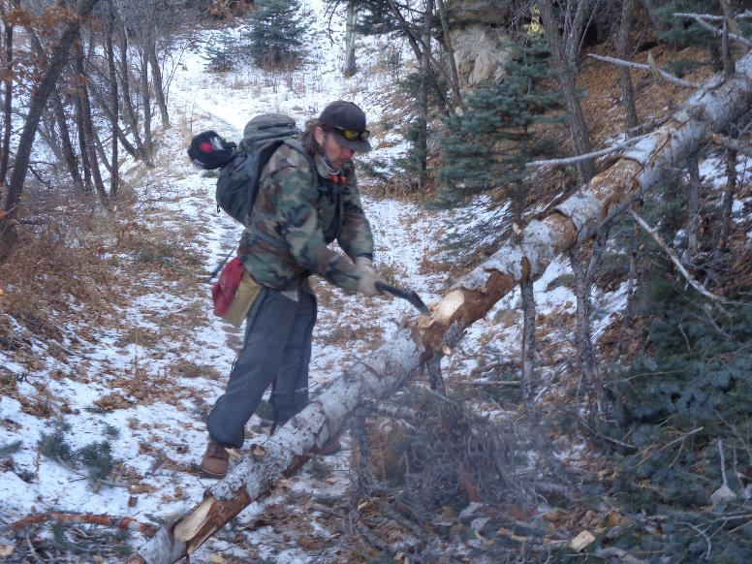

Michael is bucking the down tree with his axe.

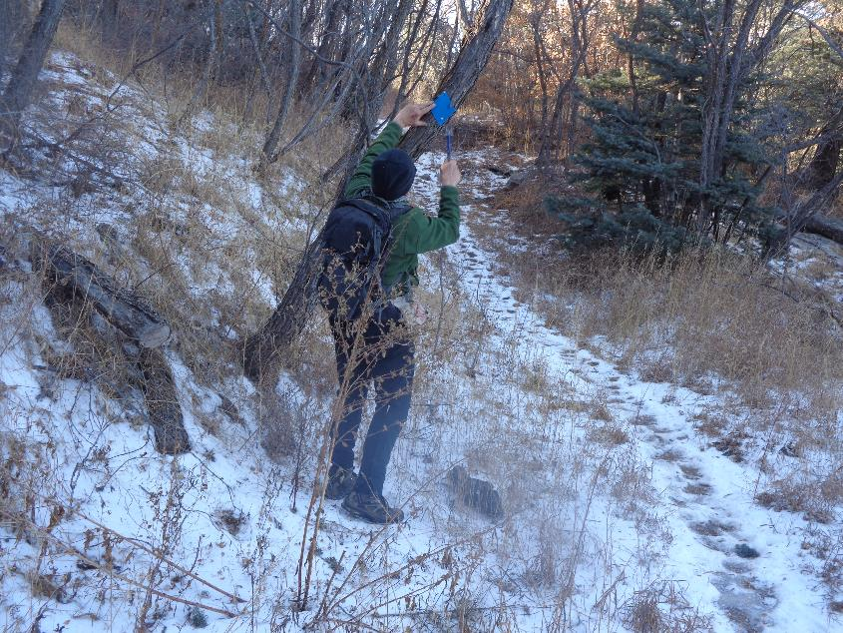

Steve Roholt nailing a diamond to an oak tree. The oaks were so hard that many of the aluminum nails bent. The hill in the background

is a short distance from the Ski Area.

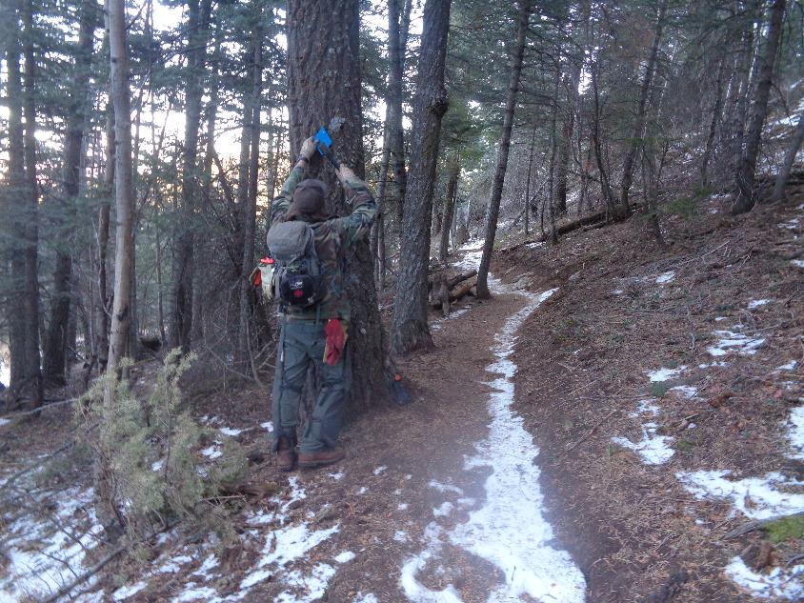

Michael nailing a diamond to a tree on the way back to Dry Camp Trailhead.