**Report of the FOSM Project to Remove Down Trees**

**from 10K North Trail on Wednesday, January 19, 2022**

Sam Beard, Jan. 21

On Wednesday, six FOSM volunteers removed 28 down trees from 1.5 miles of the 10K North Trail in the snow. The diameter of the largest log removed was 30 inches where it was cut. The diameter of the largest log found across the trail was over 40 inches.

The photographs below present the work that the volunteers did and the results of their work.

The volunteers were Dan Benton, Jerry Carroll, Eric Russell, Lou Romero, Cliff Giles, and Sam Beard. Russell Berman, SRD Trails Foreman, removed one of the largest log across the trail.

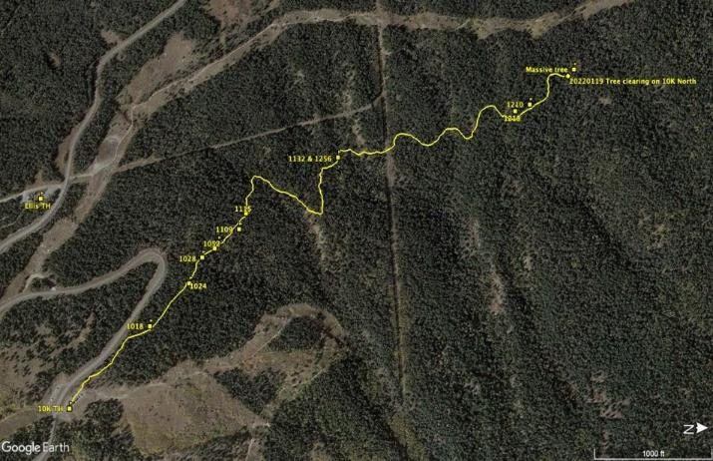

Map of 10K North Trail where the crew worked on Wednesday. 10K N Trailhead is in the lower left corner

of the figure. The almost vertical line in the center is the powerline to the Crest.

All photos and maps by Cliff Giles unless noted otherwise.

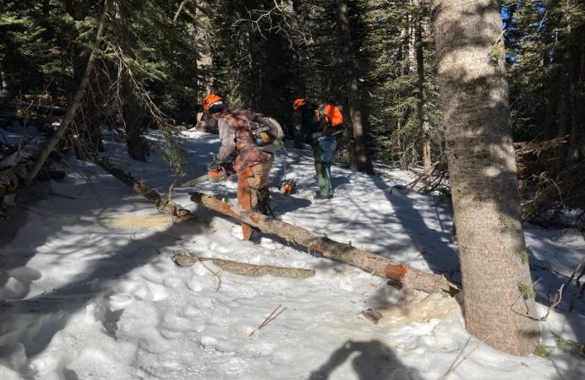

Dan Benton cutting a small log with the battery-powered FOSM chain saw.

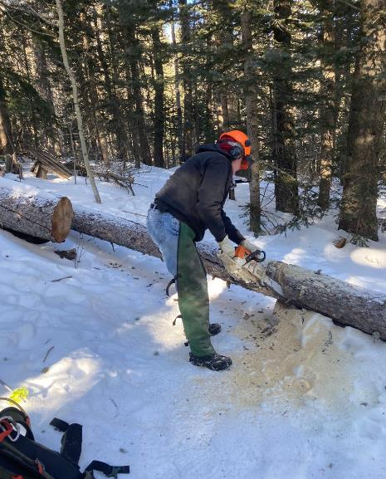

Eric Russell bucking a 10-inch log.

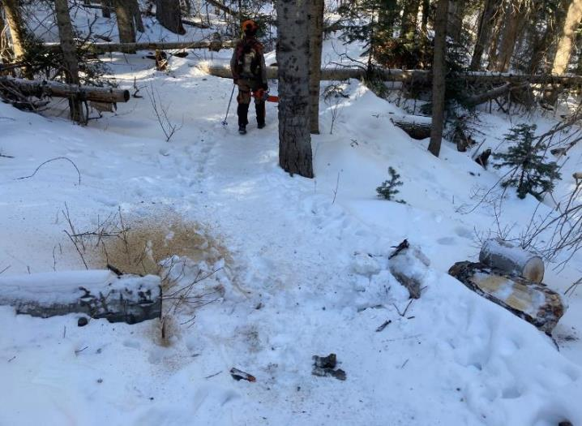

A segment of trail where the sawyers and swampers have removed the down trees.

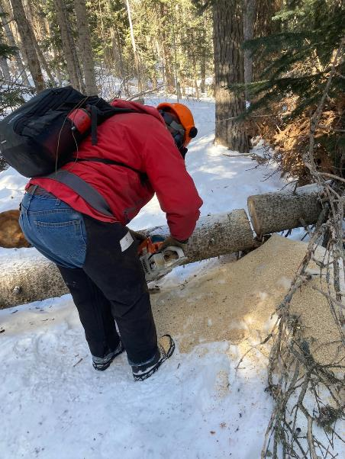

Jerry Carroll bucking an 8-inch down tree. Note the sawdust on the snow.

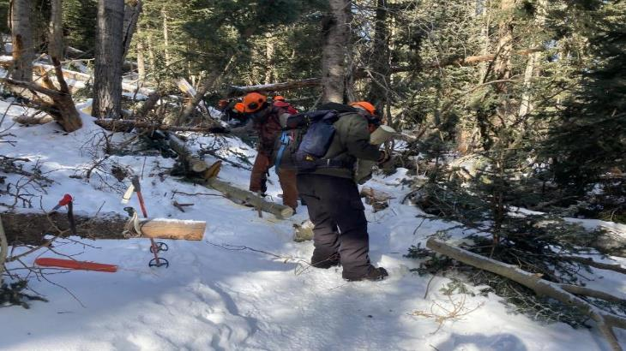

Dan is bucking a small log, and Sam Beard is moving a piece that Dan cut.

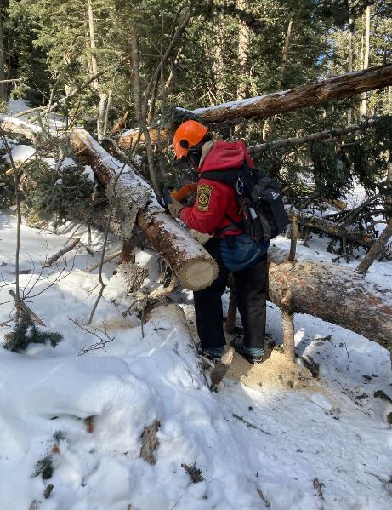

Jerry is cutting a small log in preparation for removing the other logs in this train wreck.

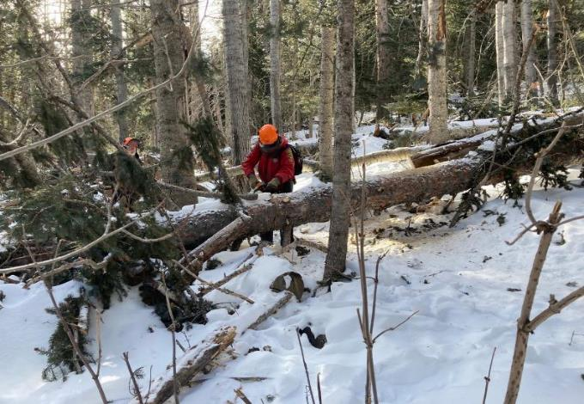

Jerry is limbing this 16-inch down tree.

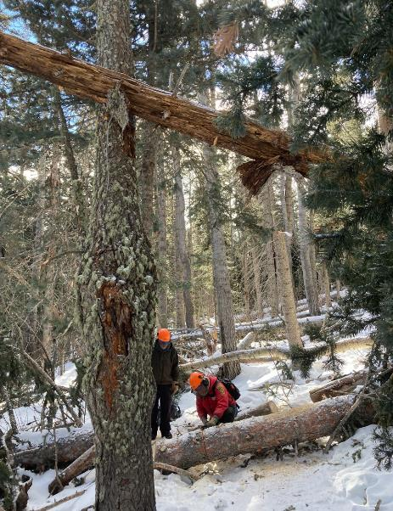

Jerry is bucking the large log. Note the brown tree in the upper part of the photo.

This tree was a hang-up that was not well supported.

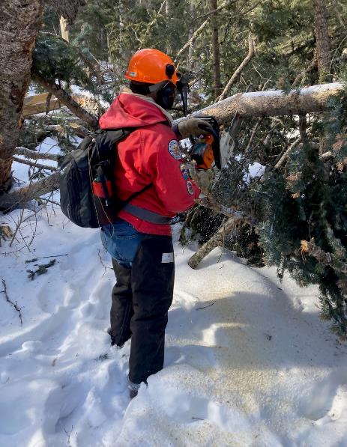

Jerry is still working on the train wreck so the he can safely buck the larger down trees.

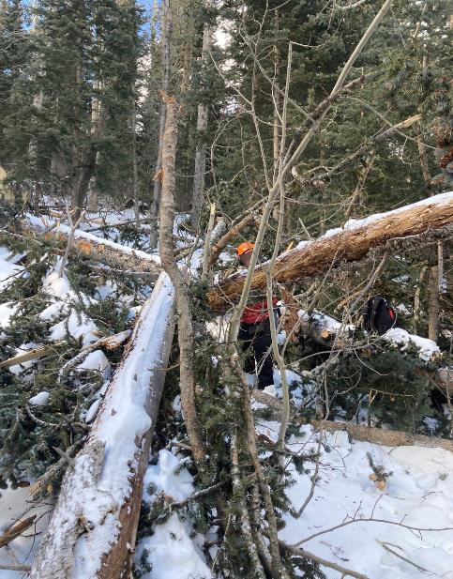

Jerry clearing an area so that he can safely remove the hang-up across the right side of the photo.

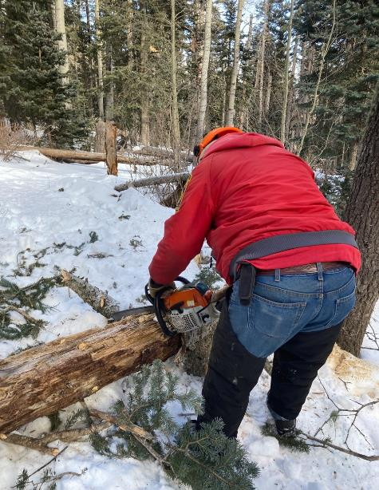

Jerry is bucking the hang-up he has safely felled to the ground.

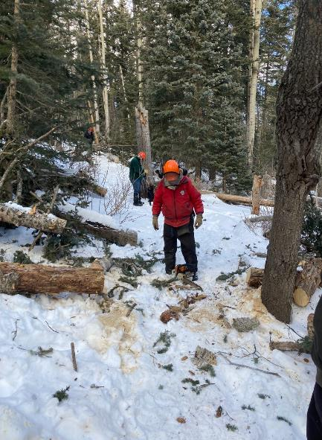

The train wreck has been removed so that the trail is now open.

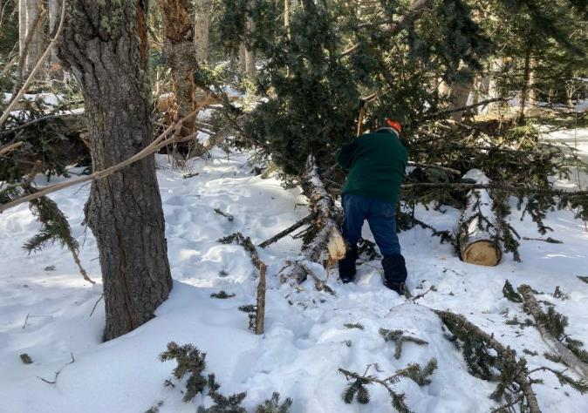

Lou Romero using his axe to remove branches from a down tree.

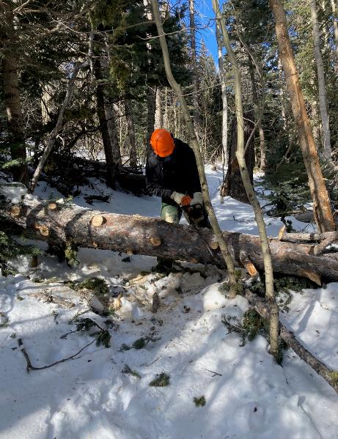

Eric Russell making compound angle cuts in a large log so that the cut piece can be easily

removed to clear the trail.

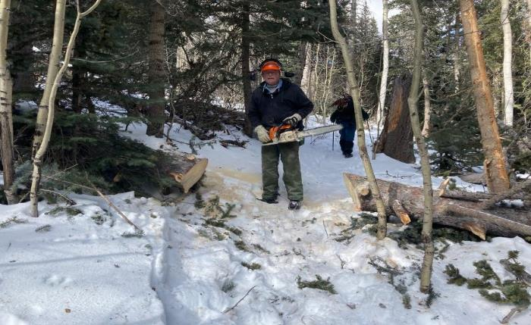

The cut piece of log has been moved, and the trail is open.

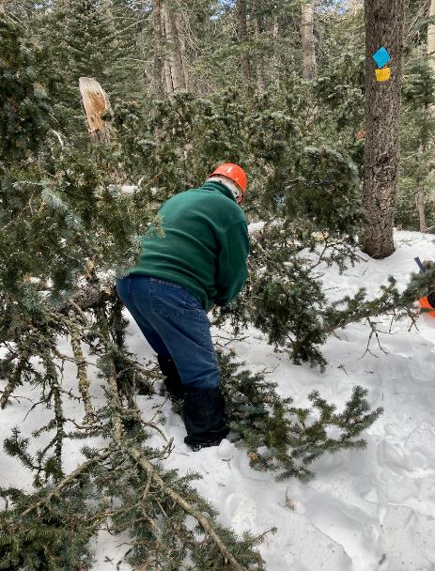

Lou limbing another tree with his axe to make the trail corridor wider. Note the blue diamond and

yellow caution sign on the tree that is located at a curve with a descent to the left.

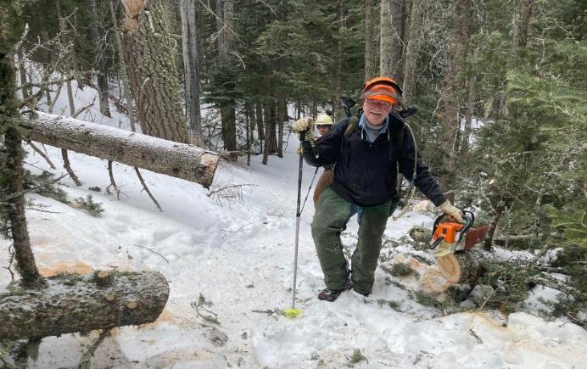

Eric has just removed another log to open the trail.

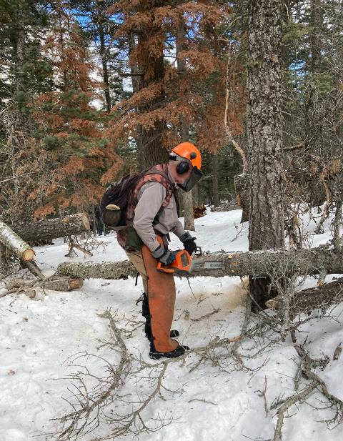

Dan bucking another log with the electric chain saw.

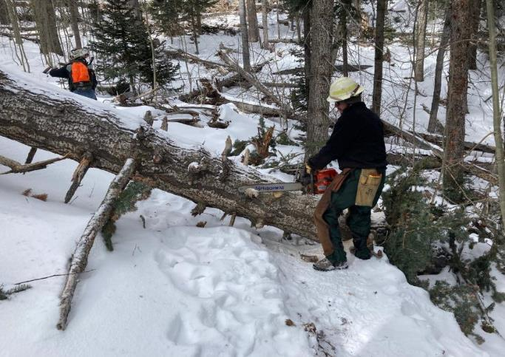

Russell Berman, SRD Trails Foreman, cutting limbs off this very large log before he starts bucking it.

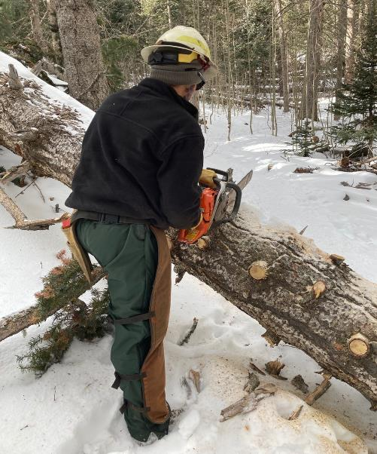

Russell ready to buck this log with a large chain saw with a 24-inch bar.

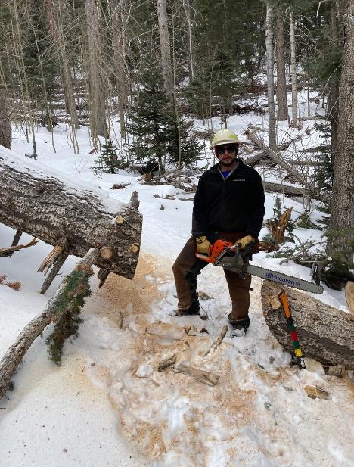

Russell completed bucking the log to open the trail.

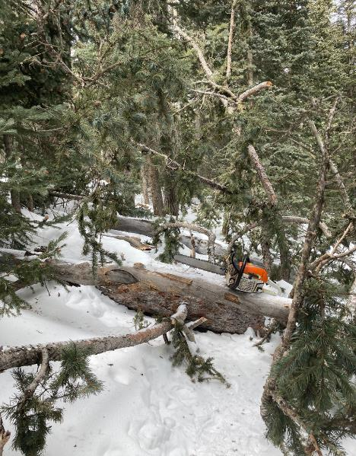

A train wreck far out on 10K North Trail.

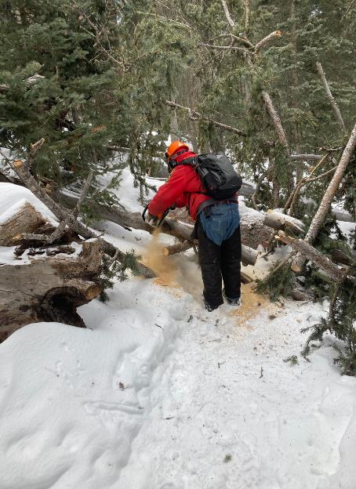

Jerry beginning to clear the train wreck.

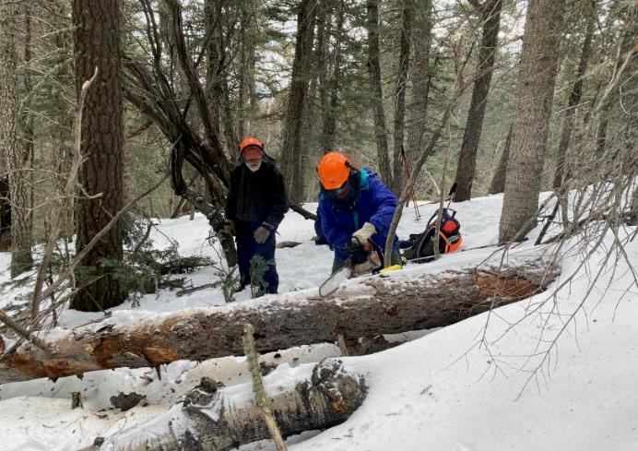

Eric Russell bucking a large log near where all the crew but Dan and Jerry turned around. Sam is observing.

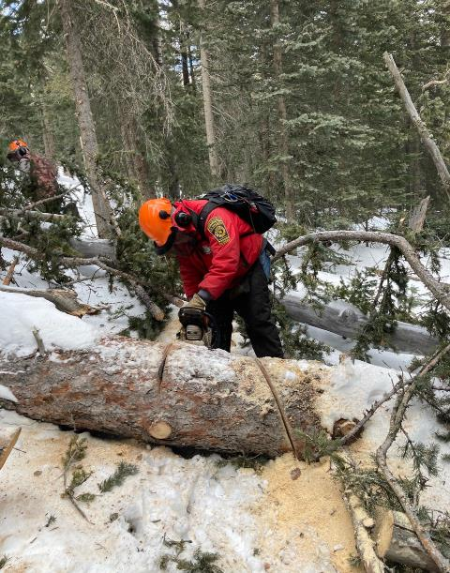

Jerry making compound angle cuts in a large log so that he can remove the cut piece.

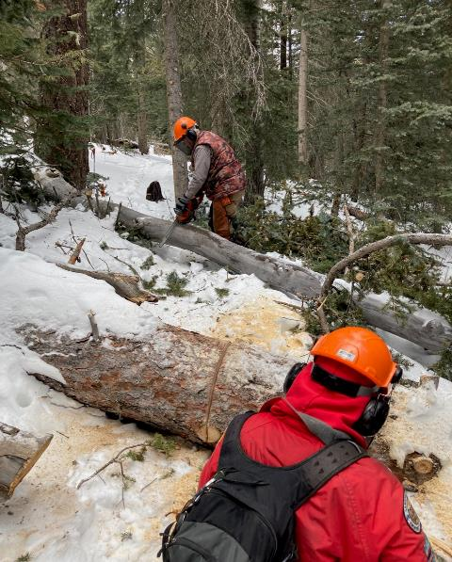

Dan and Jerry working on this log jam.

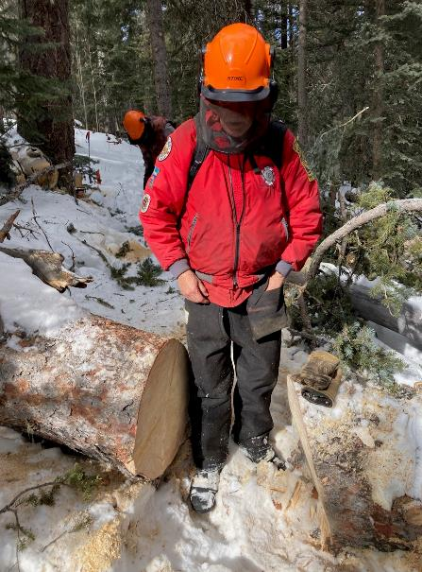

Jerry has completed the first two cuts in this large log.

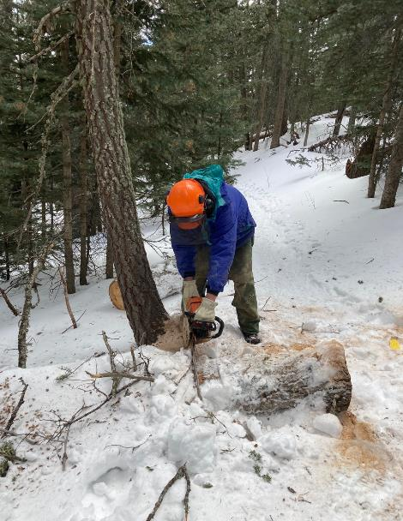

Eric bucking a log almost buried in the snow.

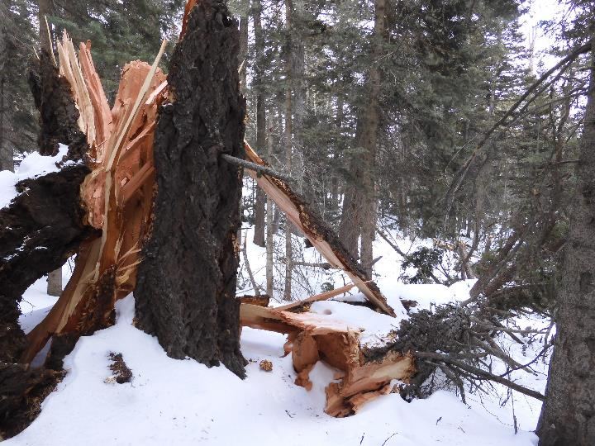

Dan and Jerry hiked farther down the trail and found this huge tree that fallen and left a splintered stump.

Photo by Dan Benton

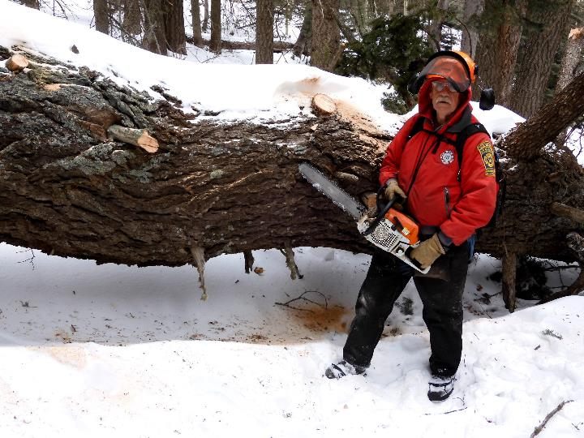

Jerry beside the very large trunk. Obviously, his chain saw bar is not long enough to cut the trunk here.

Using the 16-inch bar as a scale, the trunk on the left side of the photo is approximately 40 inches in diameter.

Photo by Dan Benton

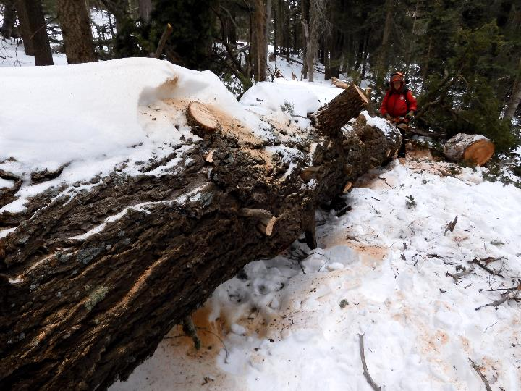

Jerry and Dan cut off the large branches.

Photo by Dan Benton

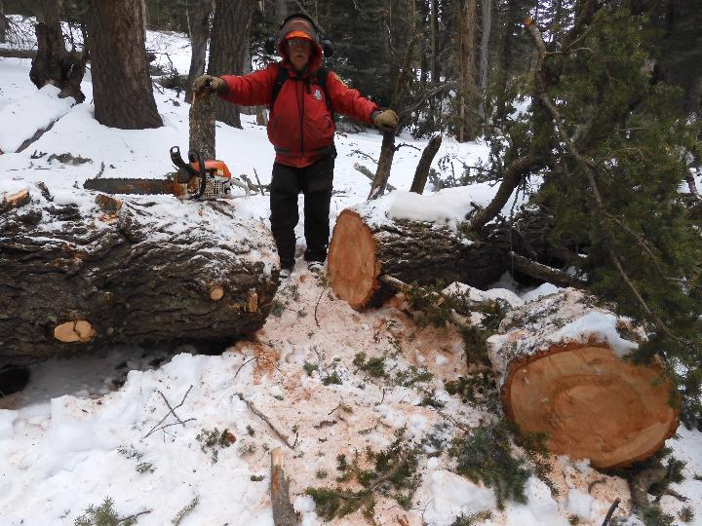

Jerry wisely decided to buck the log where the diameter was smaller.

Photo by Dan Benton

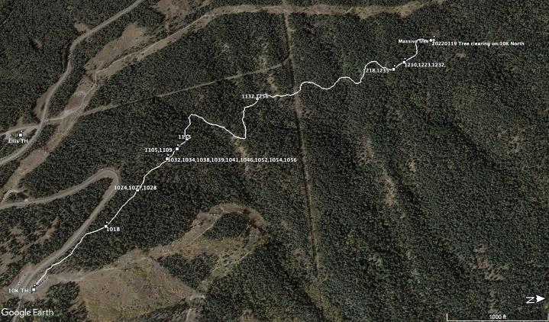

Slightly different map of the trail where the crew removed 28 down trees in the cold snow.