Report of FOSM Removal of Logs from 10K South Trail with Chain Saws on Monday, January 31, 2022

Sam Beard, February 2

On Monday, January 31, 2022, five FOSM volunteers removed four logs from 10K South Trail from the trailhead to the south side of the Sandia Peak Ski Area with chain saws. The maximum diameter of the trees removed was about 16 inches. Byron Garner’s crew had removed about a dozen smaller logs with hand saws in front of our crew that day.

The trail tread was firm enough for us to walk without snowshoes.

The volunteers were Jerry Carroll, Eric Russell, Dennis Crowther, Lou Romero, and Sam Beard.

Photos are presented below.

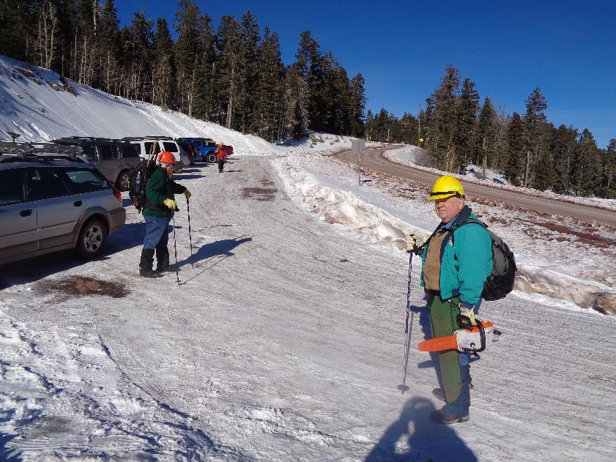
L to R: Lou Romero and Dennis Crowther at the trailhead on the Crest Highway. All photos by Sam Beard

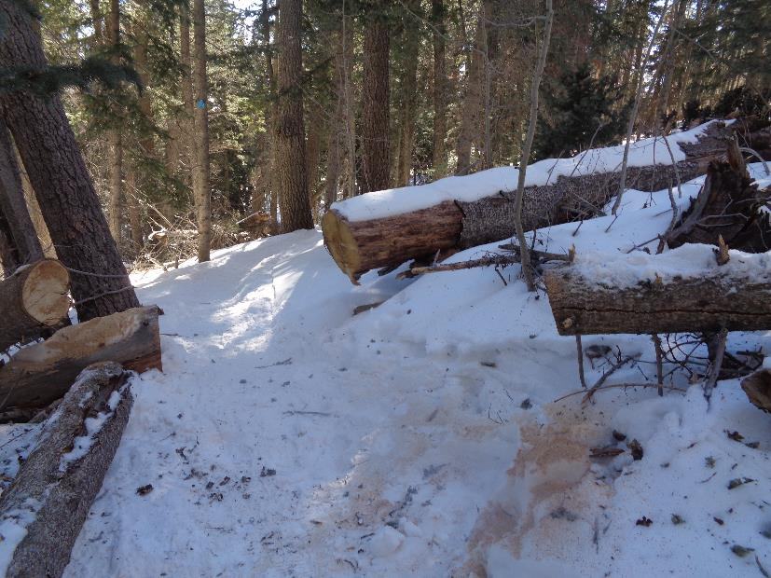
Two logs cut with a chain saw.

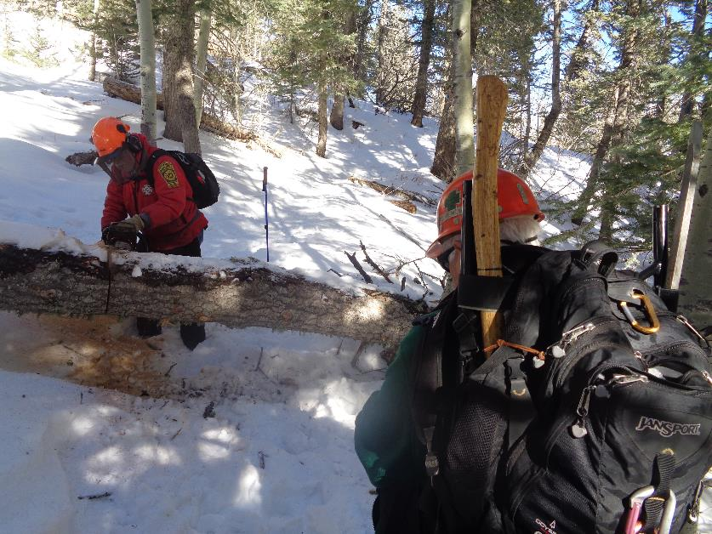
Jerry Carroll is cutting a 16-inch log. Lou Romero is in the foreground.

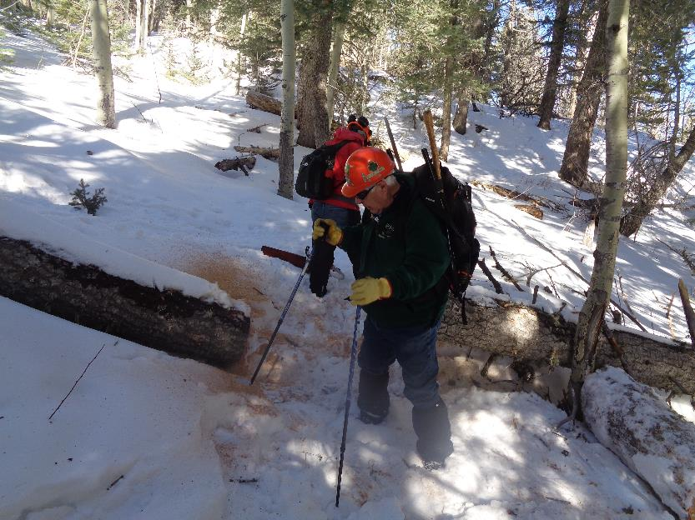

Lou at the cut log after helping to remove the piece on the right side of the photo.

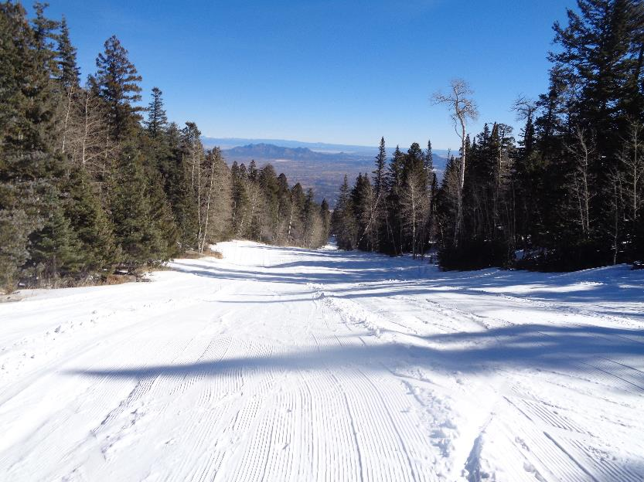
Looking down one of the groomed downhill ski runs. We met three people skiing up a ski run so that they could enjoy
Telemarking down.

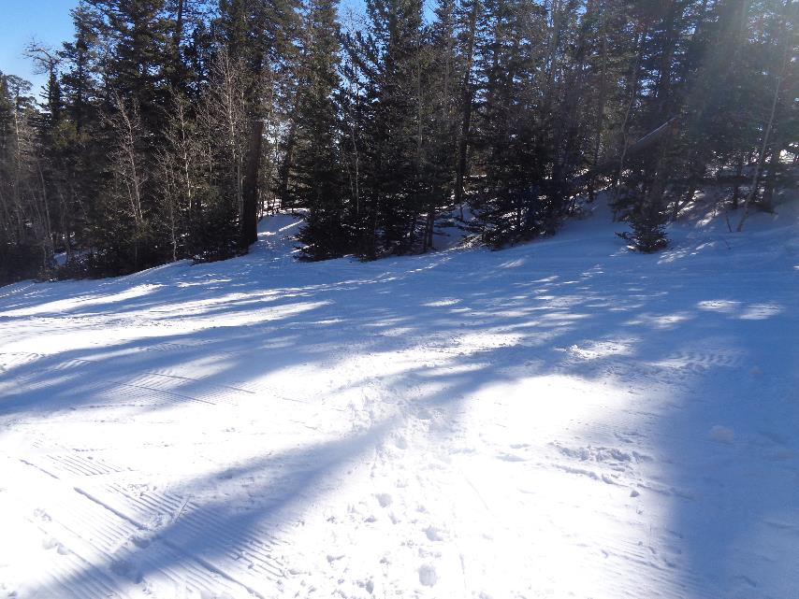
The path where some crew members walked across a ski run and continued on the trail route through the forest.

