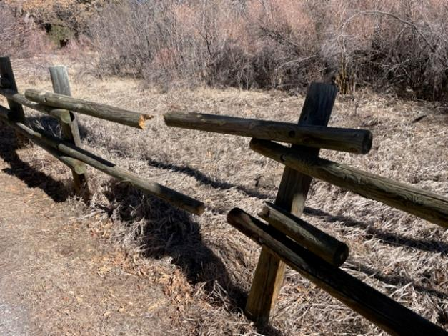

Broken poles in Sulphur PA on Monday, March 14, 2022

All photos by Don Carnicom

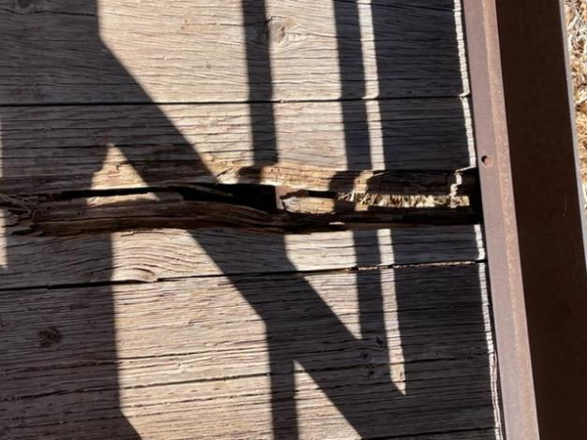

Damaged board on bridge at upper Cienega PA parking lot.

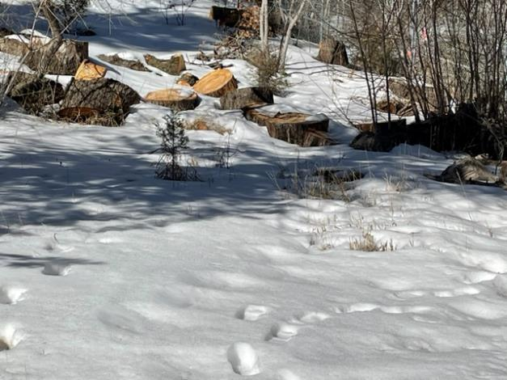

Snow in upper Cienega PA on Monday, March 14, 2022