**Report of Three FOSM Projects on Wednesday, March 16, 2022**

Sam Beard

On Wednesday, March 16, FOSM crews completed the following three projects:

1. **Fence Maintenance** – In Sulphur Canyon Picnic Area, a crew replaced three broken fence poles and one post.
2. **Bridge Maintenance** – At the upper parking lot in Cienega Canyon PA, a crew replaced a board in the deck of a pedestrian bridge.
3. **Graffiti Removal** – In La Cueva and Juan Tabo Picnic Areas and at the La Luz Trailhead parking lot, a crew removed approximately a dozen tags. Most of them were small and easily removed. On the way out of Juan Tabo PA, the crew removed two tags on signs near the intersection of FR-333 and the exit from the PA.

The volunteers working on Wednesday were Dan Benton, Sim Cook, Jerry Pekarek, Jerry Carroll, Cliff Giles, Dennis Crowther, Don Carnicom, and Sam Beard.

Project photographs are presented below.

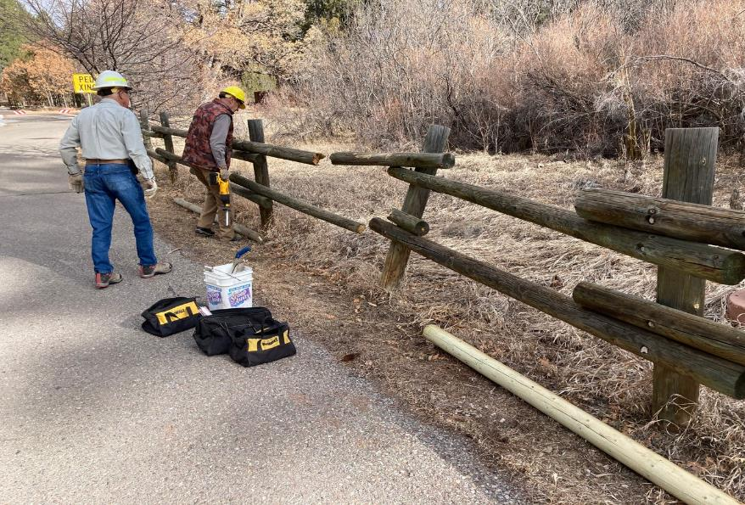

The damage to this fence in Sulphur Canyon Picnic Area was two broken poles and a broken post. L to R: Jerry Pekarek and Dan

Benton are preparing to cut the rusty threaded rods securing the broken poles to the posts. All photos by Cliff Giles unless noted otherwise.

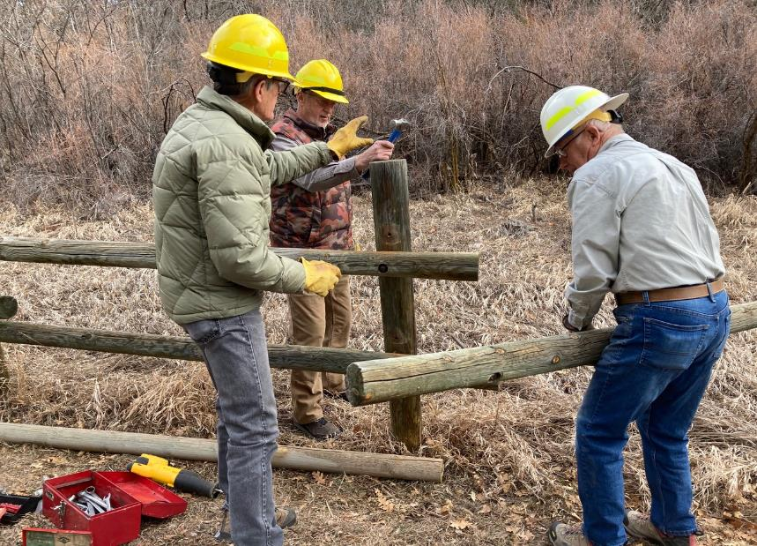

Sim Cook, Dan, and Jerry are removing the broken pole from the fence.

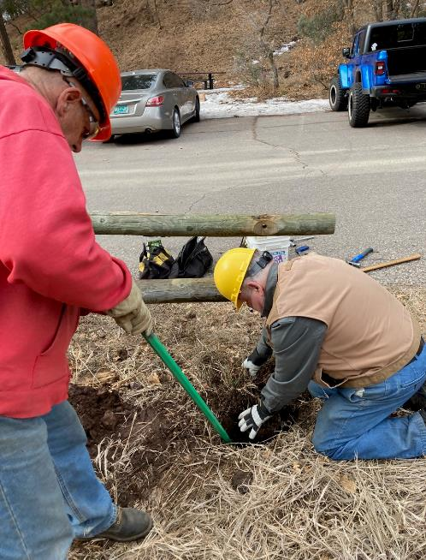

L to R: Jerry Carroll and Dennis Crowther are digging out the lower part of the broken post

that was still in the ground. Removing the lower part of the broken post is the most difficult task in replacing a post.

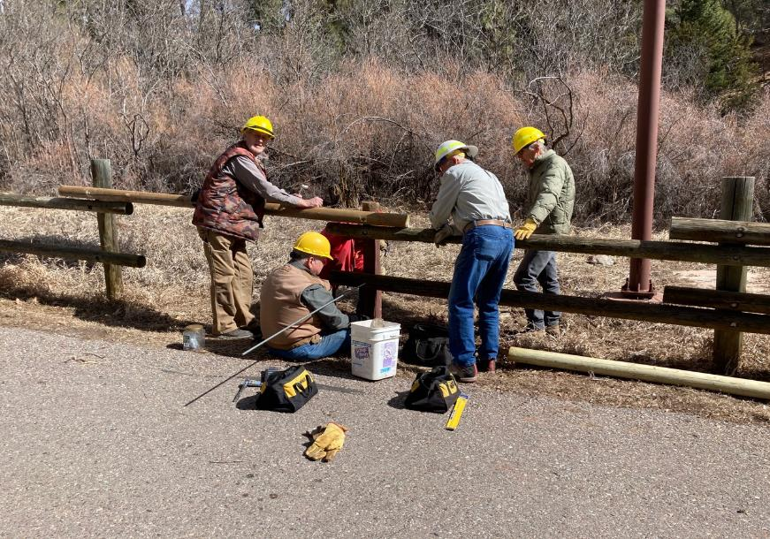

L to R: Dan, Dennis, Jerry Carroll, Jerry Pekarek, and Sim Cook are bolting the two new poles to the posts.

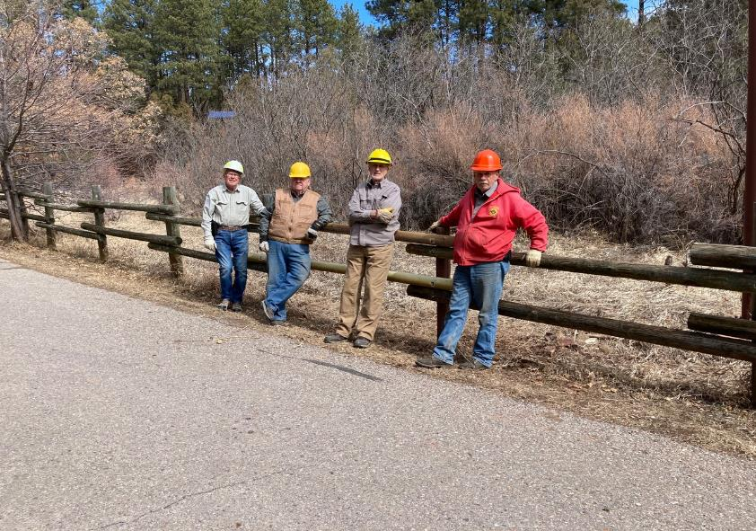

L to R: Jerry Pekarek, Dennis, Dan, and Jerry Carroll leaning on the fence that they have just repaired.

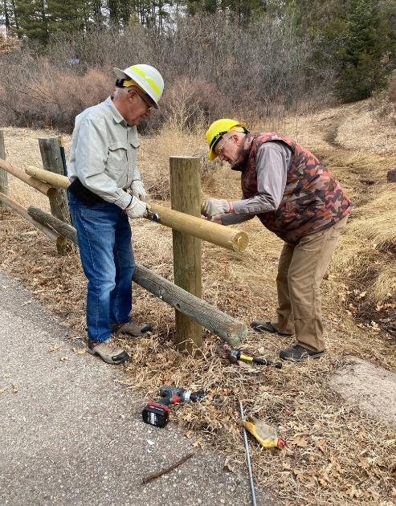

The part of the old pole that was extending past the post had been broken. Jerry and

Dan are completing the installation of a new pole.

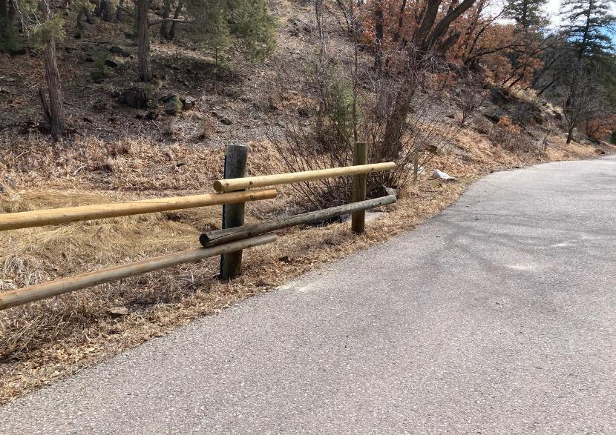

The installation of a new upper pole has been completed.

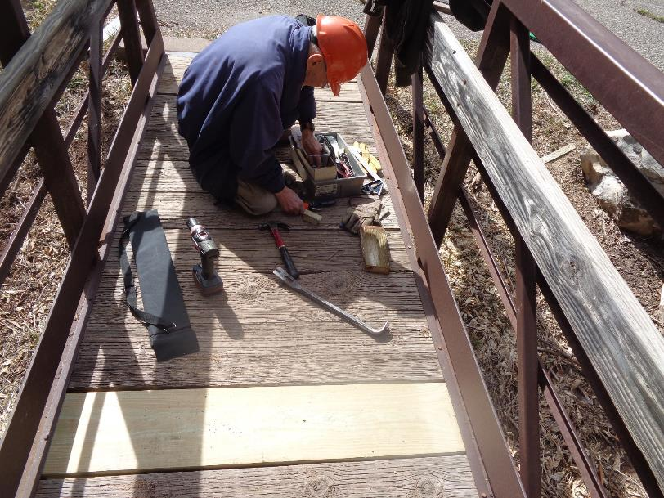

Don Carnicom and Sam Beard have almost completed the installation of a new 2x8 pressure treated board in the bridge

at the upper parking lot in Cienega Canyon Picnic Area. Replacing the rotten board was difficult, because each end of the new board

must be placed in a steel C-shaped channel. The length of the new board is such that one end is inserted in the right channel,

the board is lowered, and the board is pushed into the left channel so that both ends are secured in a channel. The final step

in the installation is placing a bolt or screw through the steel into each end of the board. Photo by Sam Beard

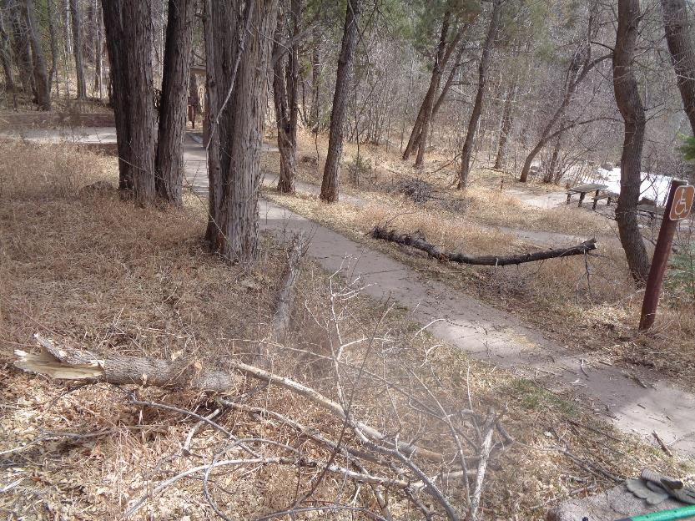

As they were leaving the picnic area, Don and Sam removed a 5-inch oak tree that had fallen across a path and was protruding into the road.

Photo by Sam Beard

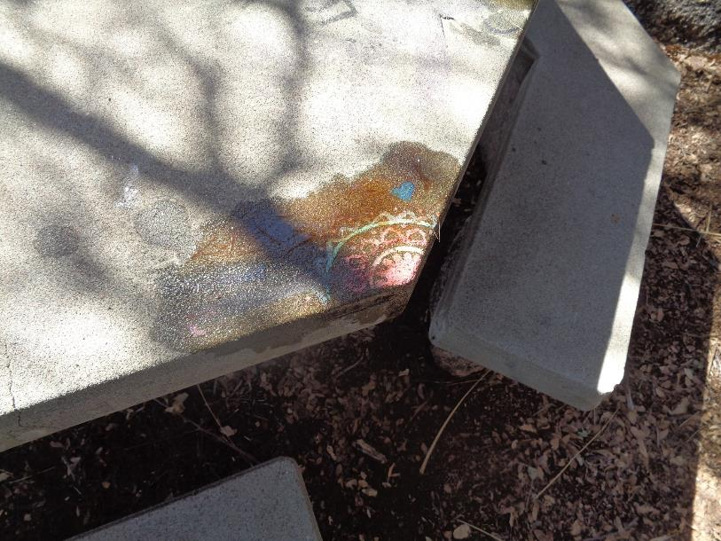

Graffiti on one corner of a picnic table near the second parking lot in La Cueva Picnic Area. Two other small graffiti tags

were also found on this table. Photo by Sam Beard

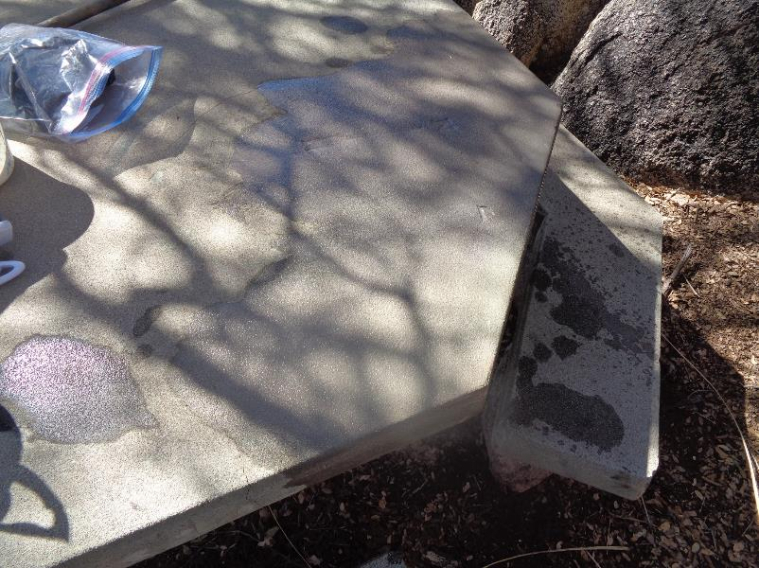

The colorful graffiti tag has been removed. Photo by Sam Beard

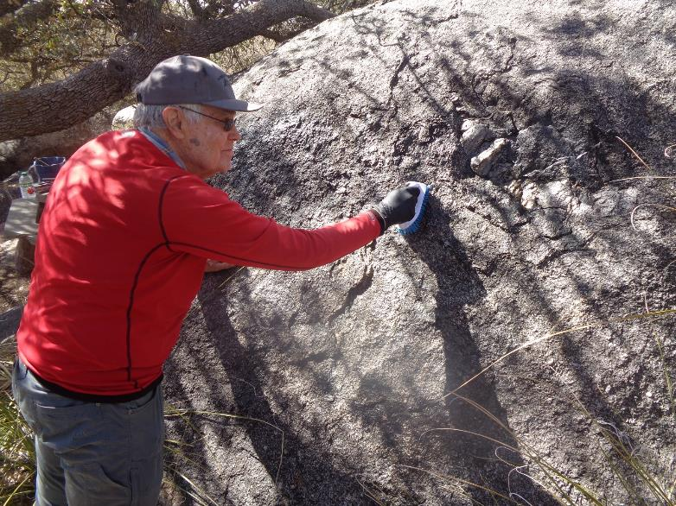

Cliff Giles is removing an unusual 24-inch by 24-inch graffiti tag from this boulder. The tag was gray lines about ½-inch wide

with a dusting of sparkles on the lines. The gray lines on the gray boulder were not as obvious as most tags.

Photo by Sam Beard

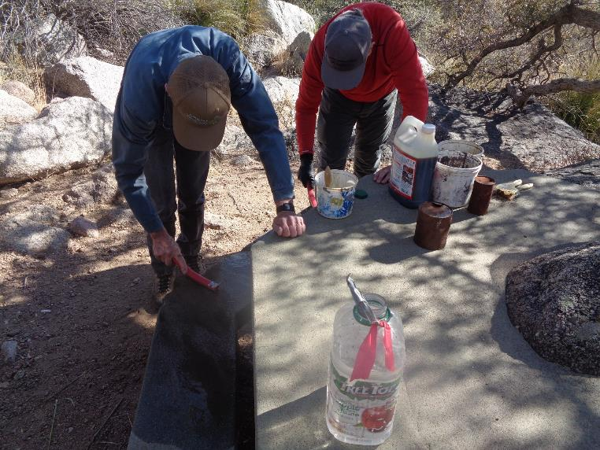

Sim Cook and Cliff Giles are removing tags of several red hand prints from the bench of this picnic table.

Note the boulder on the right side of the photo. This concrete table top was poured around the boulder so that the

upper part of the boulder was above the table top. Photo by Sam Beard

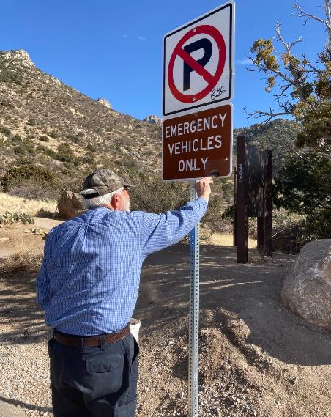

Sam is removing two small black tags from these signs at La Luz Trailhead parking lot.

The sensitive surface graffiti removal chemical is designed to not remove paint.

Note the small black tag on the corner of the upper sign.

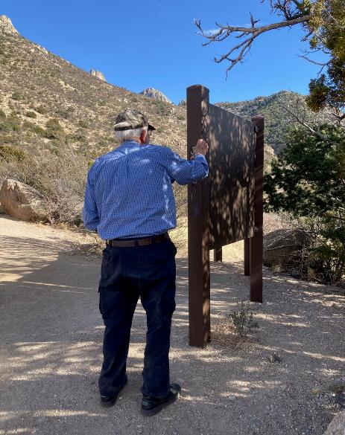

Sam is removing black tags from the kiosk posts at the parking lot.