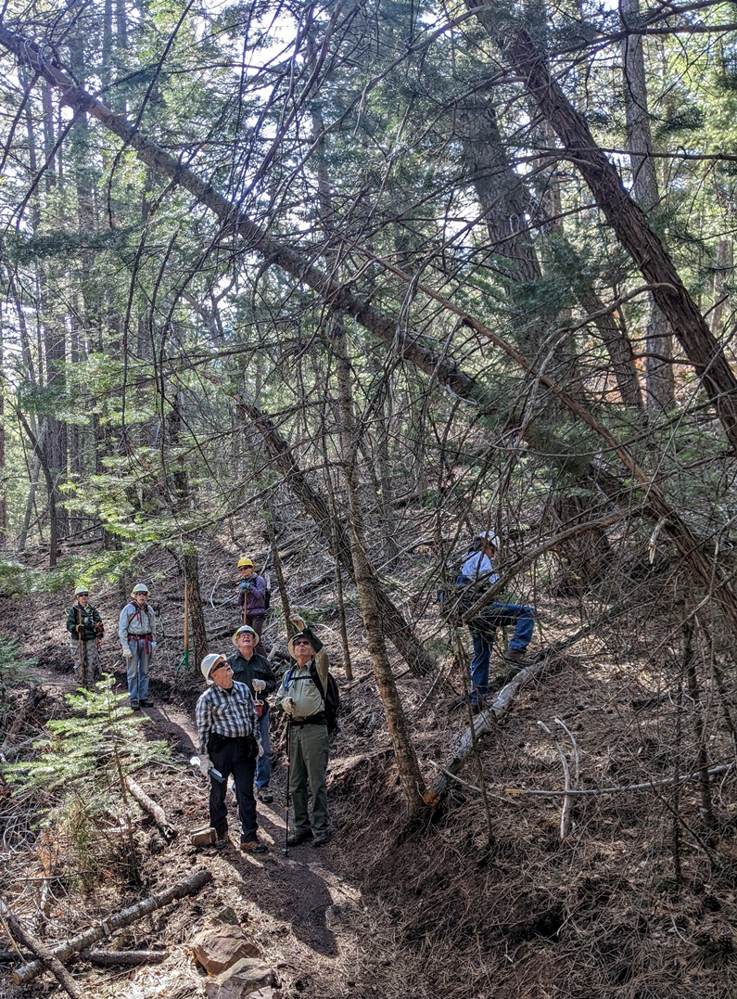
The crew studies this fine collection of leaners and hang-ups on Un Poquito Trail.
Phil heads up to check out the base of the largest dead tree in the group. Photo is
looking downhill.

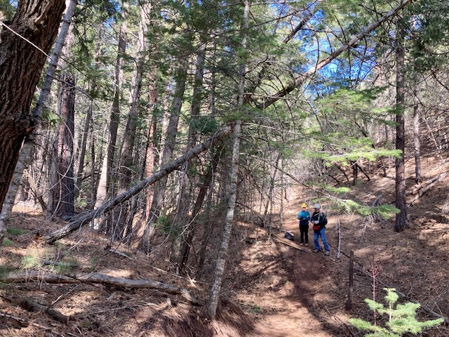
The large hang-up had rotted off its base. It was poorly supported along its length and posed a hazard to users. Photo looking downhill. The other leaning trees were found to be stable.
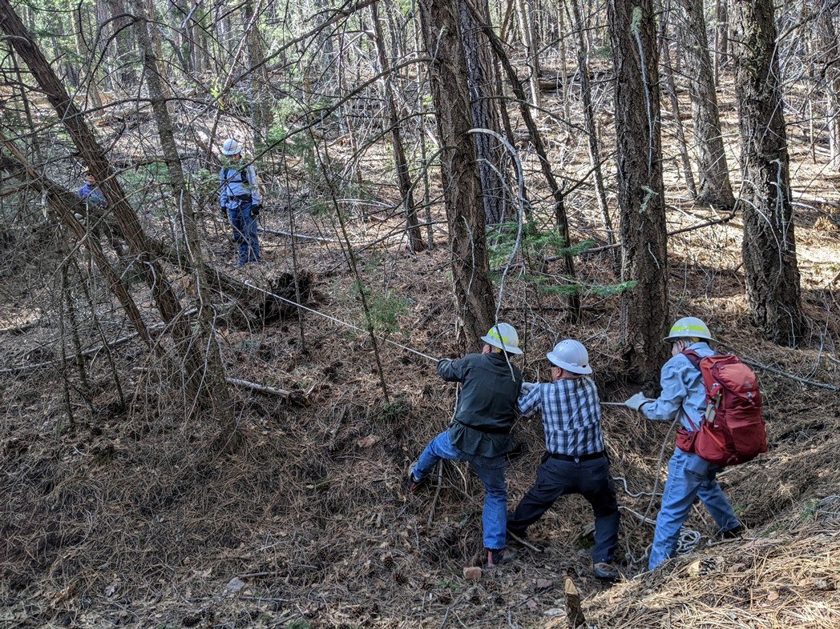
A long rope was attached to the base of the tree. It was pulled in such a manner as to release it from its
supporting branches. Spotters monitor the trail in both directions during operations such as this.

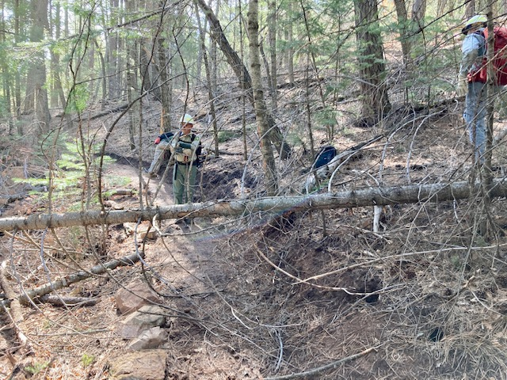
The previously hung-up tree is now safely down and ready to be cut away from the trail.

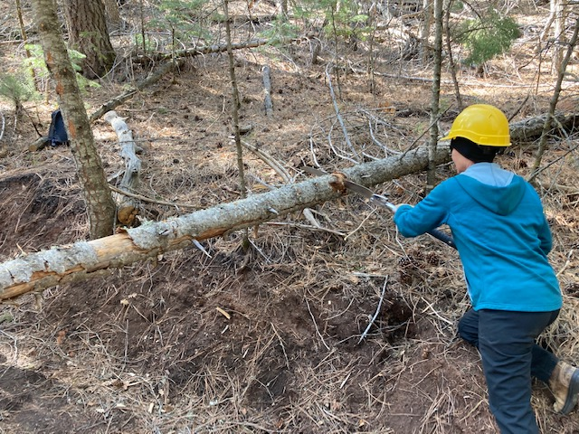
The tree in the previous photos is being cut for removal.
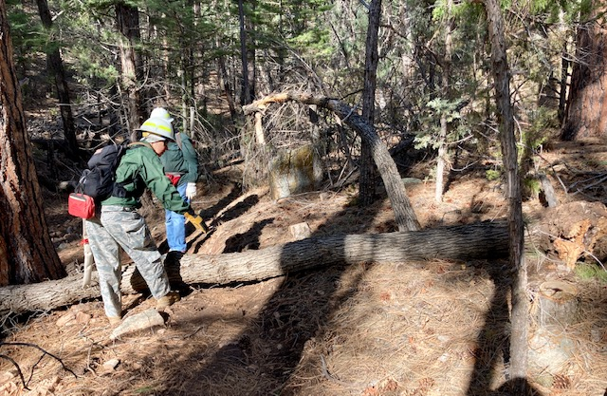
This dead eight-inch diameter dead tree was down across Un Poquito trail.
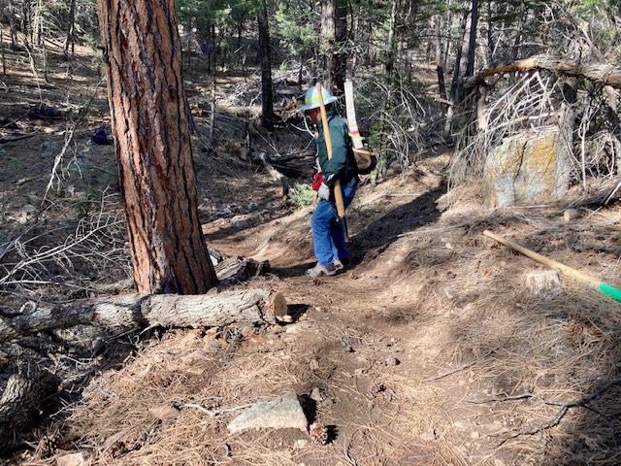
Fallen tree in previous photo has been removed from the trail.

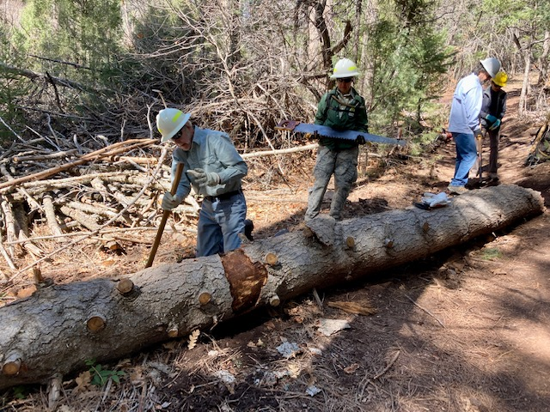
Those who hike Armijo Trail may be familiar with this fallen tree. It has been there for at least a year or two and although the top end had been removed creating a narrow walk-around, it still protruded into the original tread and created a possible hazard for cyclists going downhill. The crew, well-armed with the appropriate gear decided to remove it.
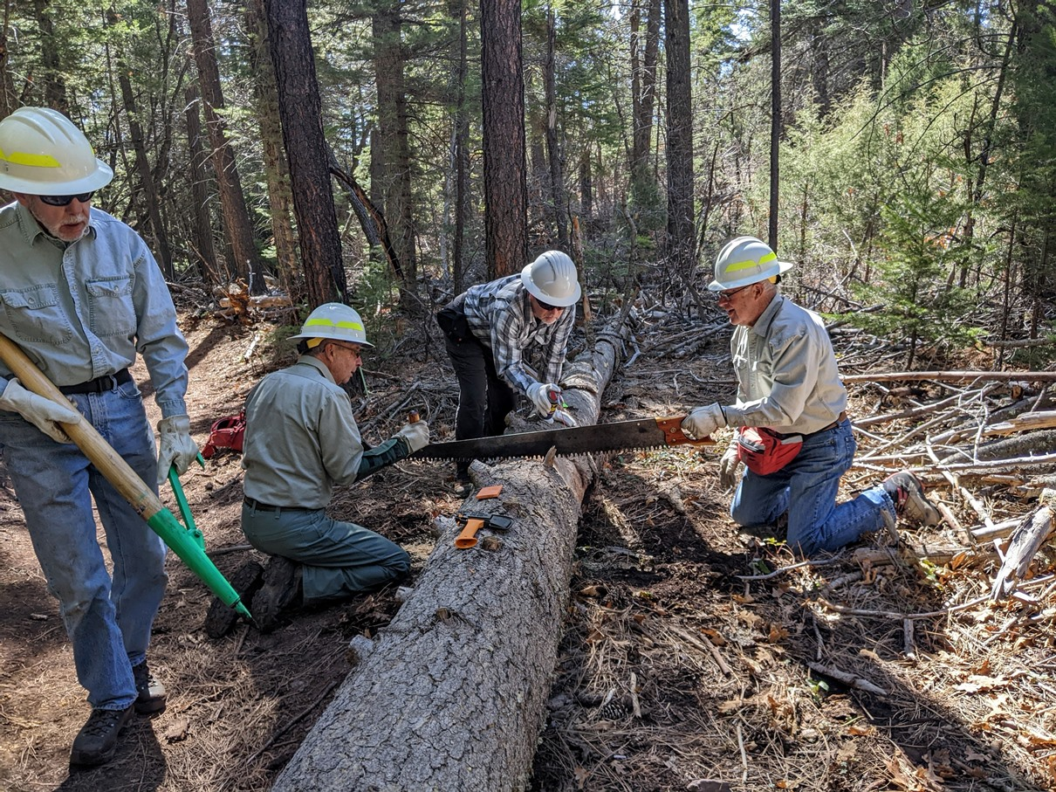
The crew begins the cut on the sixteen-inch diameter fallen tree on Armijo trail. The saw is being sprayed with WD-40 lubricant. This was helpful because the log was well saturated with water and the wood tended to swell as it was cut.

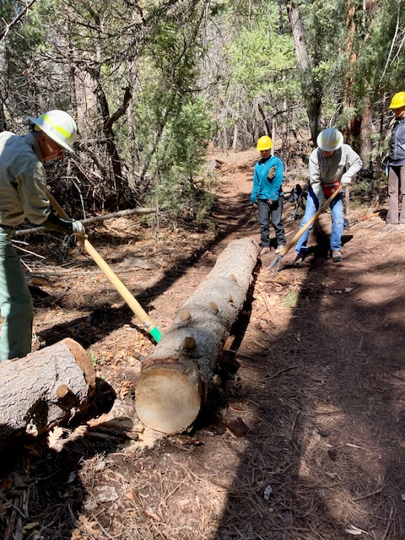
After the tree was cut, it was moved into the drainage to reduce the erosion that
was occurring at this location. This action also improved the trail definition.
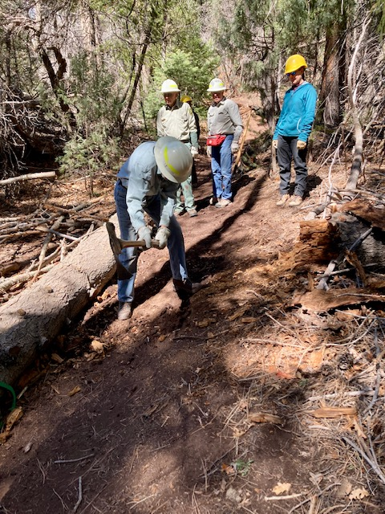
After the log had been stabilized, the trail was re-benched toward the uphill side.

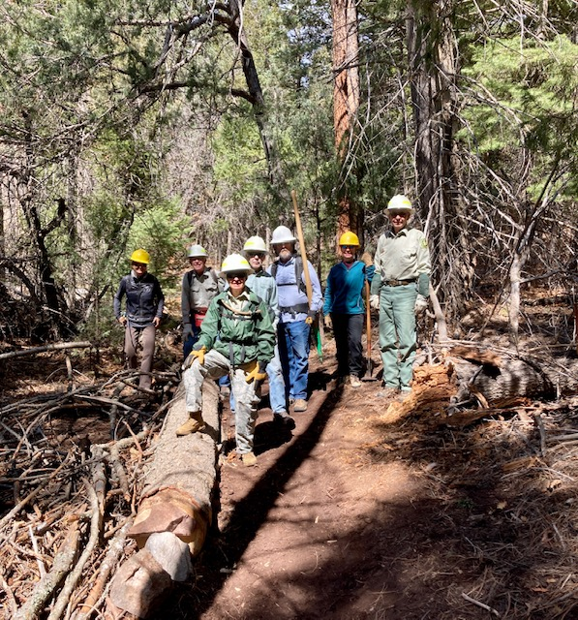
Mission accomplished… Monday’s crew, from left to right, Silke Bletzer, Jerry Pekarek, Rav
Nicholson, Byron Garner, Phil Cromer, Jenny Blackmore and Bob Lowder. Not shown –
Jamey Browning.
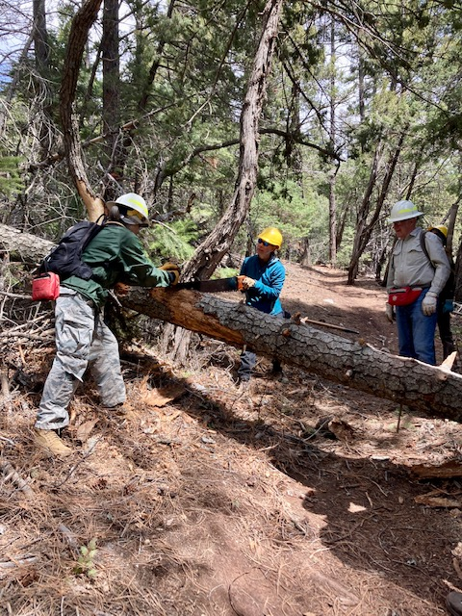
This fallen tree was located on Faulty Trail a short distance above the Armijo Junction.
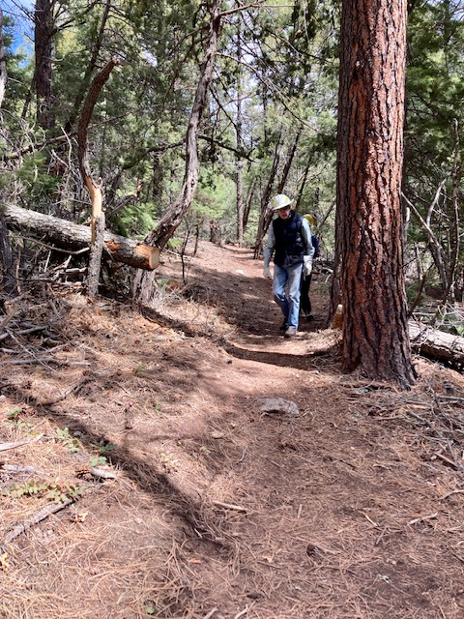
Tree in previous photo has been removed from Faulty.

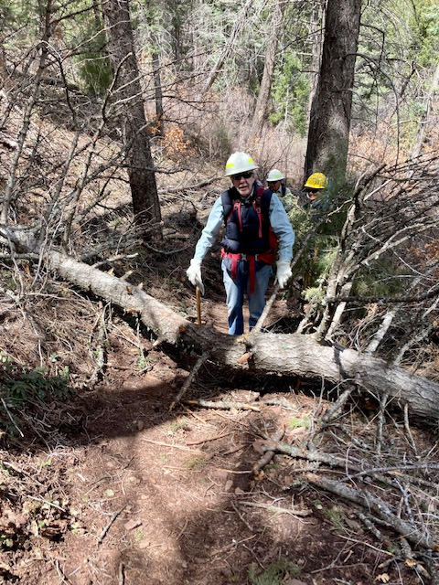
This fallen tree on Faulty Trail was located about half-way between the Armijo and
Madera Locura junctions.
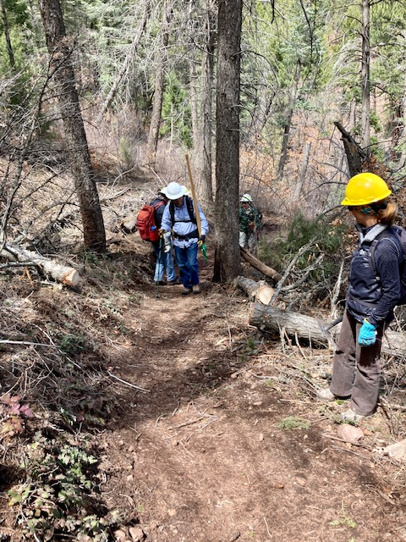
Tree in previous photo has been removed.

