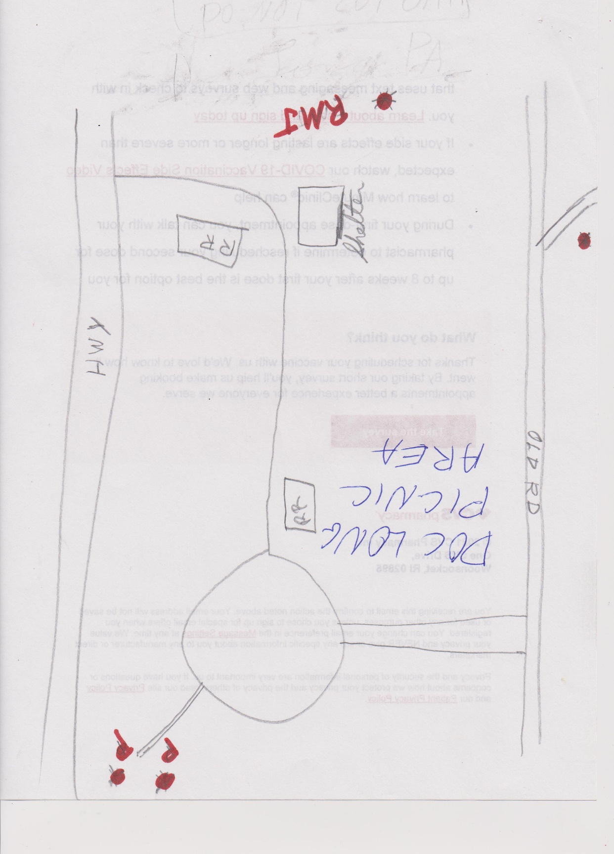

Hazard tree locations in Doc Long PA are shown as a red dot.

Tree species: P, Pine; RMJ, Rocky Mountain Juniper.

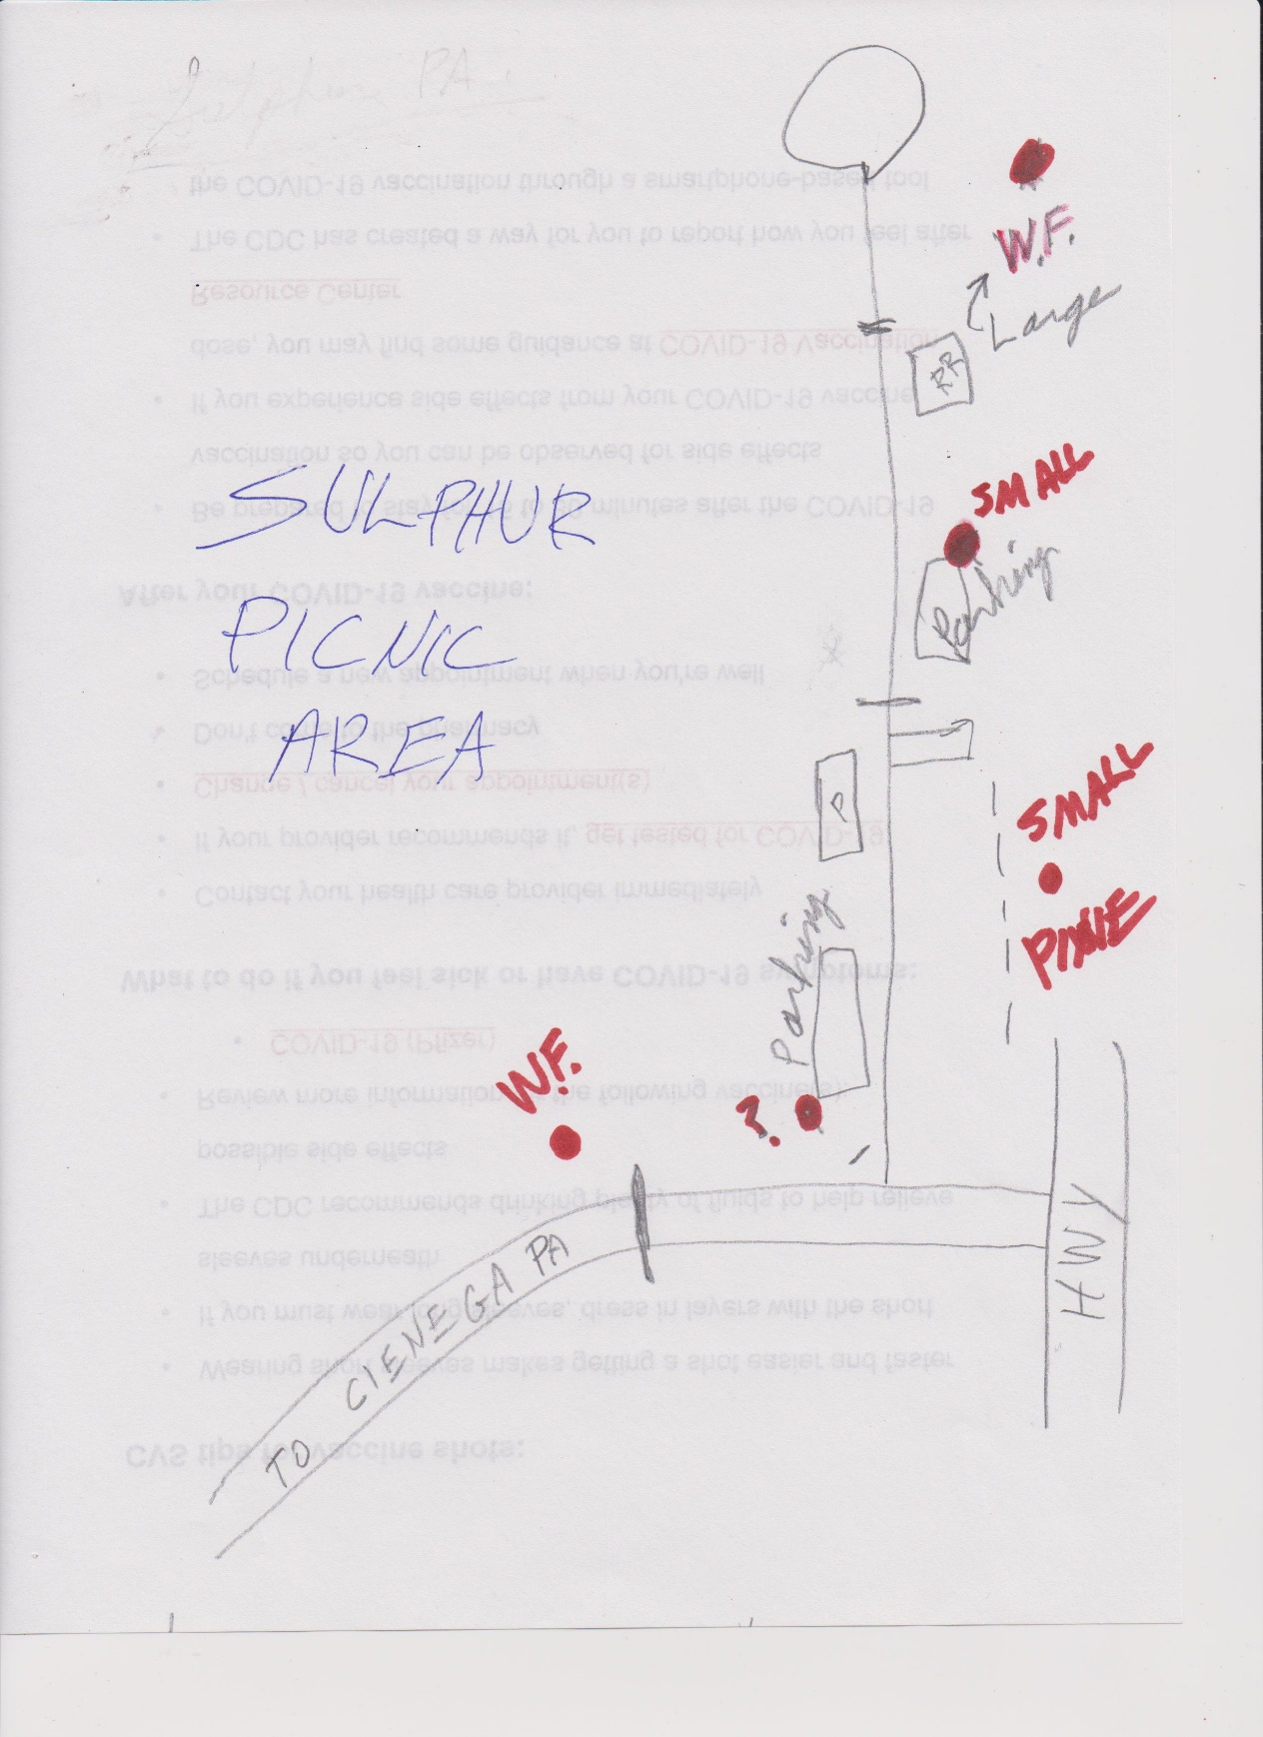

Hazard tree locations in Sulphur Canyon PA are shown as a red dot.

WF, white fir; P, pine.