Report of FOSM Project to Install a Kiosk at Ranger Rock Trailhead

near the Sandia Ranger Station on Wednesday, April 6, 2022

Sam Beard, April 7, 2022

On Wednesday, April 6, FOSM volunteers worked with Russell Berman, SRD Trails Foreman, to install a kiosk at the trailhead of two trails going to the Ranger Rock climbing practice site southeast of the ranger station near the vehicle gate. Two trailhead signs were also installed.

Project photographs are presented below.

The volunteers were Dennis Crowther, Tony Pachelli (new volunteer), Cliff Giles, Sim Cook, Mark Grazier, Dan Benton, Eric Russell, and Sam Beard.

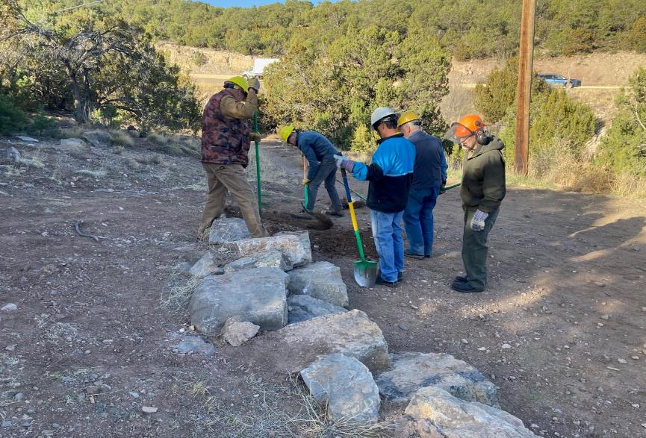

FOSM volunteers leveling the ground where Russell Berman, SRD Trails Foreman, will place more boulders at the Ranger Rock Trailhead

located just south of the Ranger Station. L to R: Dan Benton, Sim Cook, Tony Pachelli, Dennis Crowther and Sam Beard.

Photos by Cliff Giles, unless noted otherwise

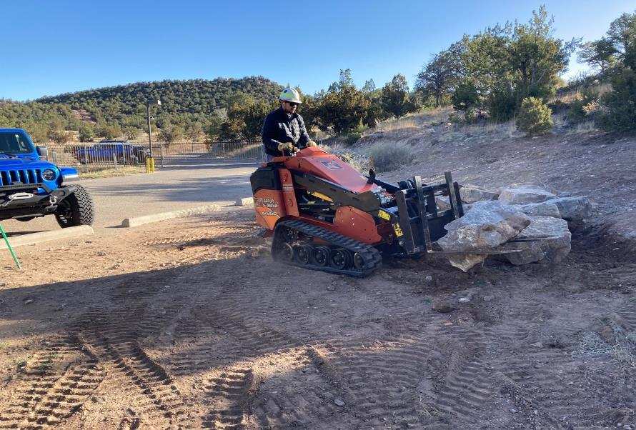

Russell using the SRD Ditch Witch skid steer to move a boulder.

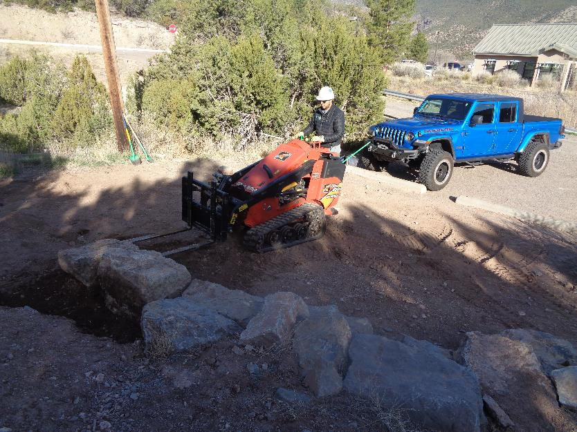

Russell placing a boulder at the trailhead. Photo by Sam Beard

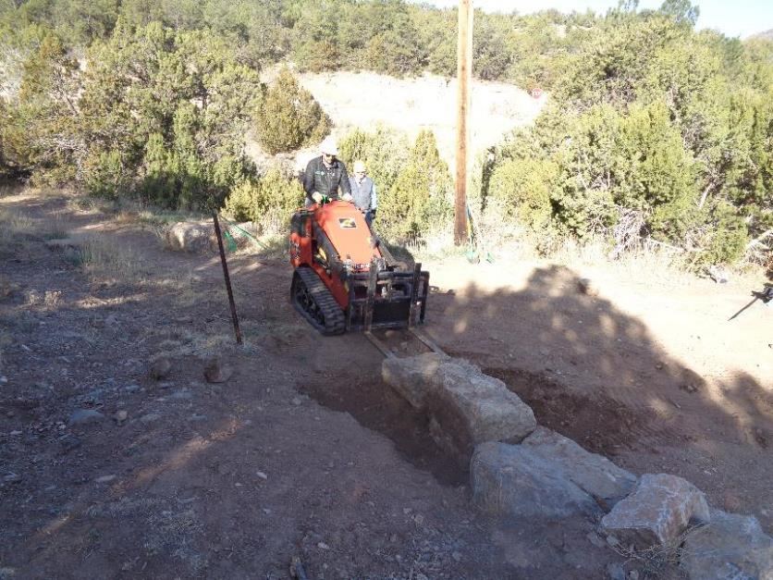

Russell pushing the boulder at the end of the line of boulders.

Photo by Sam Beard

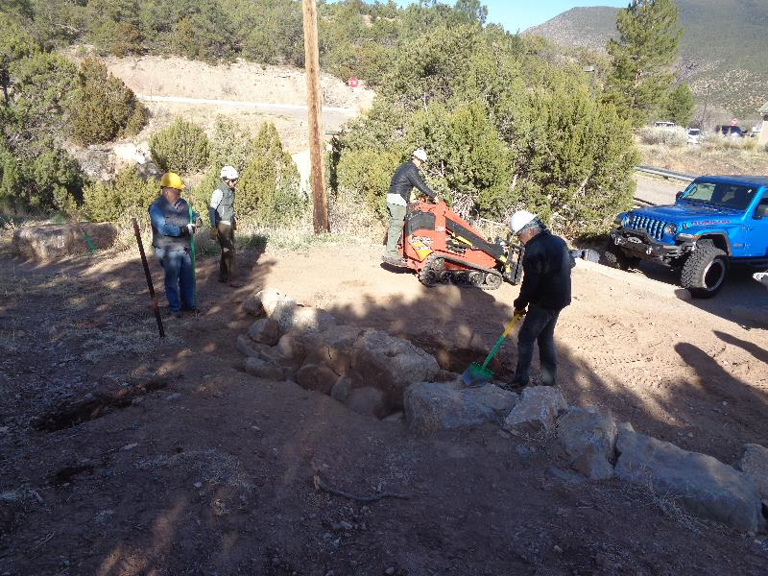

Volunteers have placed rocks behind the boulders to help fill the space. L to R: Dennis Crowther, Mark Grazier,

and Cliff Giles Photo by Sam Beard

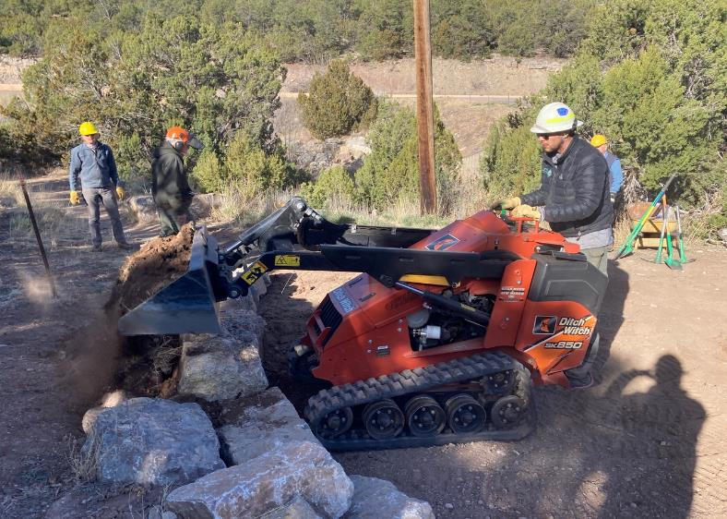

Russell piling dirt over the rocks behind the boulders.

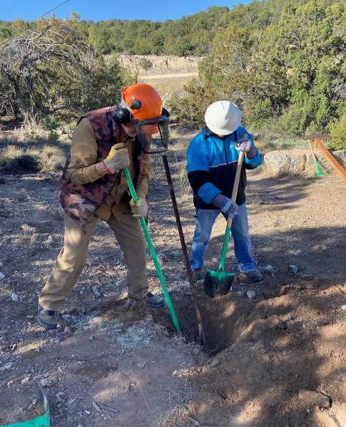

Dan and Tony digging out an old rusty steel sign post.

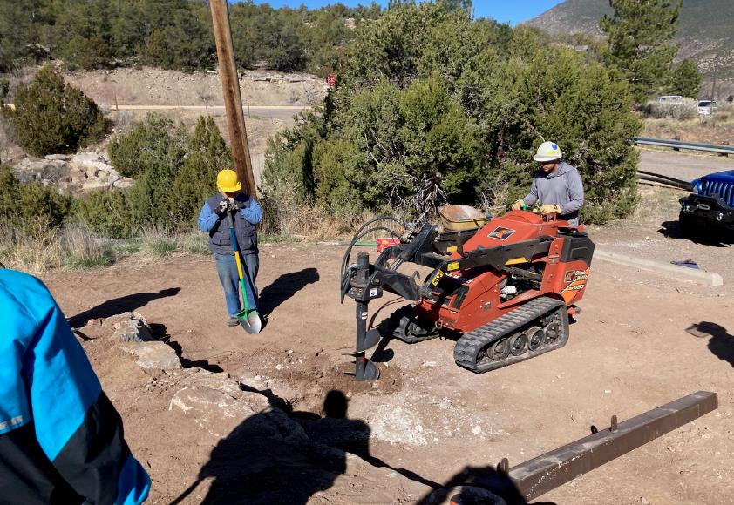

Russell beginning to drill a hole for one of the kiosk posts. The goal was to drill a hole 30 inches deep,

but the auger hit rocks before it was that deep.

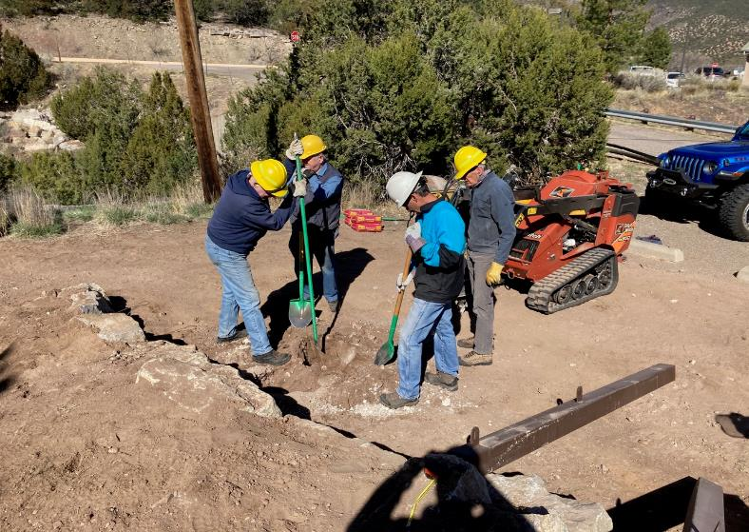

Volunteers cleaning out the hole that Russell drilled. L to R: Eric Russell, Dennis Crowther, Tony Pachelli, and Sim Cook.

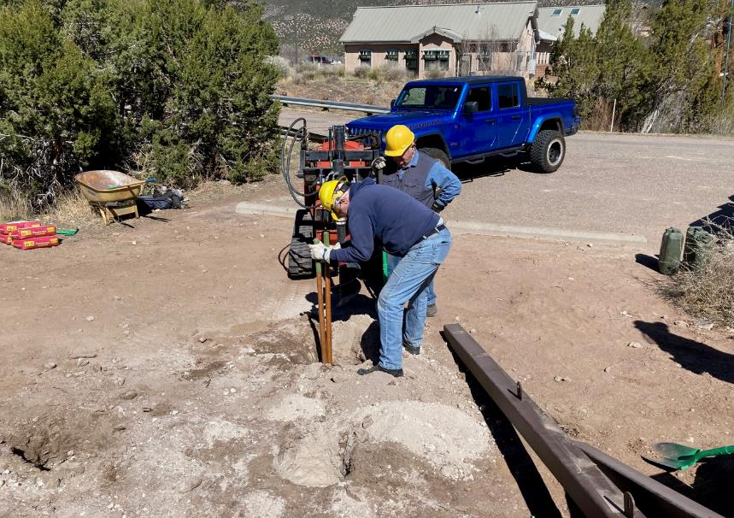

Russell drilled holes at five locations in attempts to find a place where he could drill to 30 inches deep.

Eric is cleaning out the hole while Dennis observes.

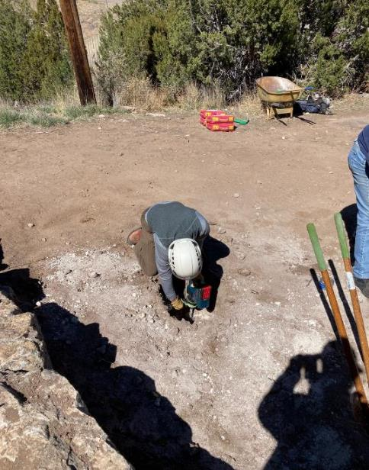

Mark Grazier using a battery-power hammer drill to put holes in a layer of rock

in one of the original holes.

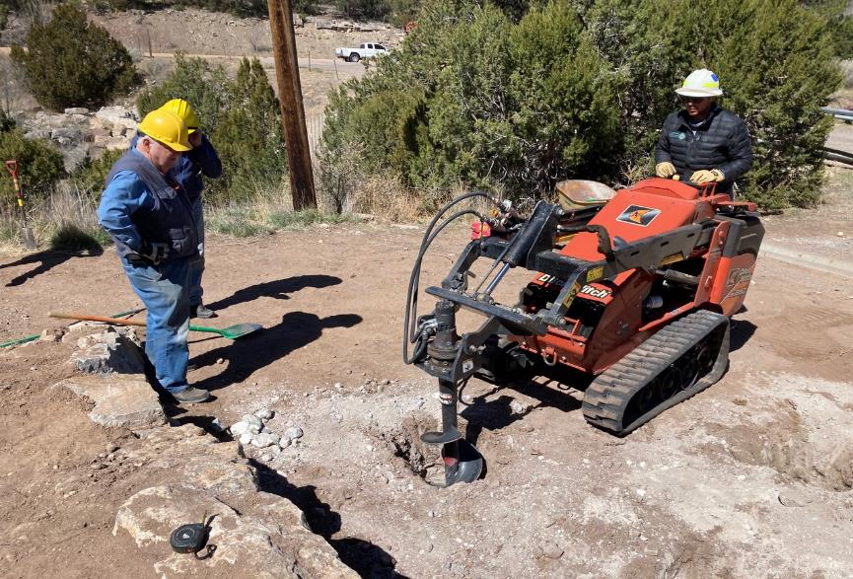

Russell using the Ditch Witch in an attempt to drill the hole deeper after Mark drilled holes in the rock.

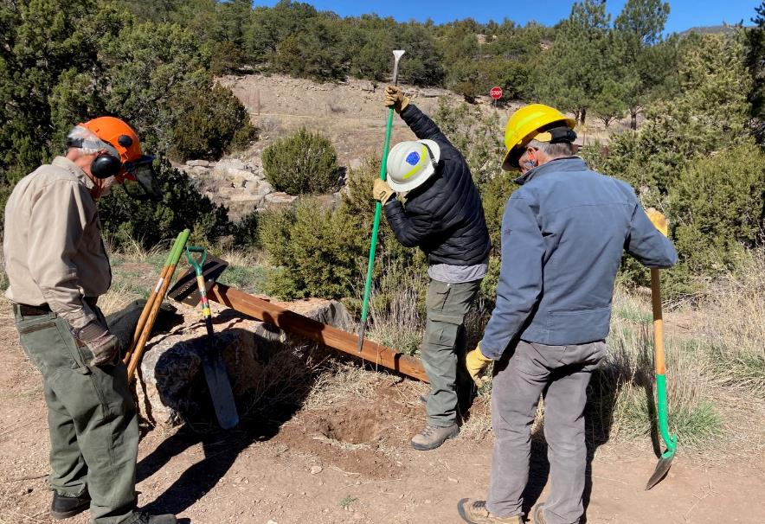

Digging a hole for a trailhead sign post on the west side of the lower trailhead that leads to the bottom of the Ranger Rock climbing practice site.

L to R: Sam Beard, Russell Berman, and Sim Cook.

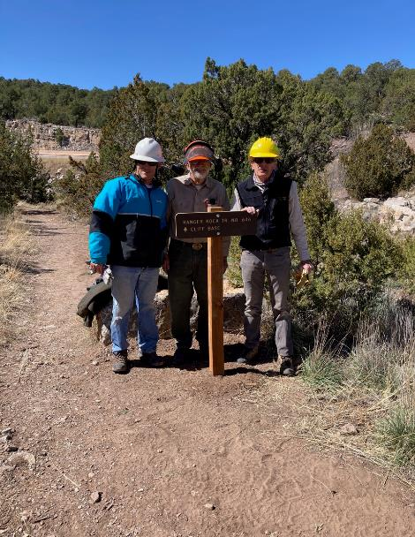

After much work with a rock bar, the hole was 20 inches deep, and the post was installed.

L to R: Tony Pachelli, Sam Beard, and Sim Cook.

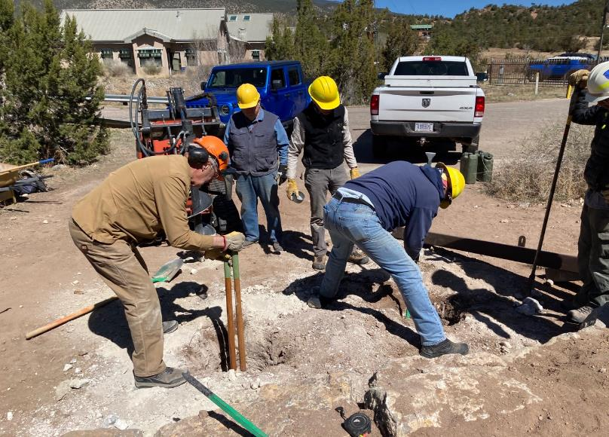

Volunteers digging the post holes to a depth of 30 inches. L to R: Dan, Dennis, Sim, and Eric.

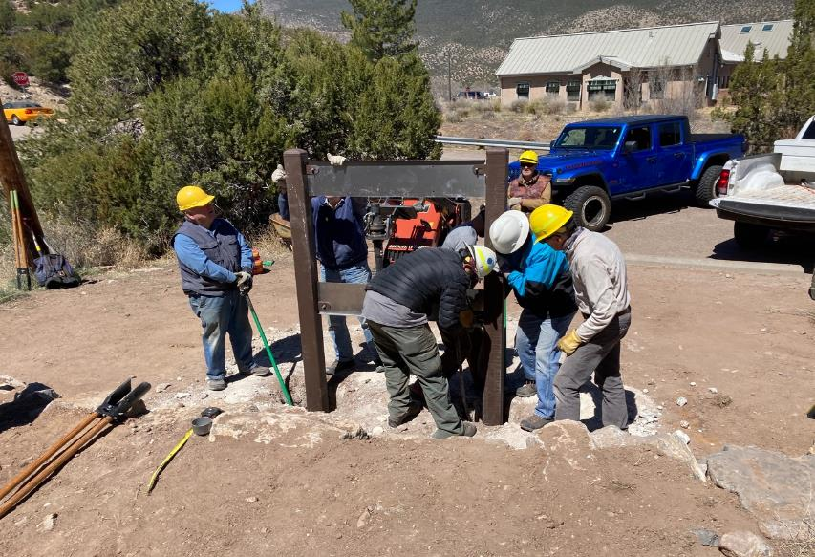

Setting the posts in the holes. Note the steel panels that were used to position the posts in the correct locations

so that the kiosk panel could be bolted in place.

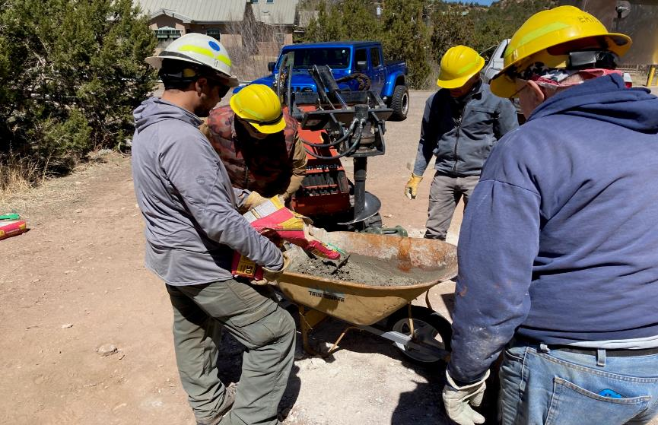

Mixing the quick-setting concrete to pour into the holes. L to R: Russell, Dan, Sim, and Eric.

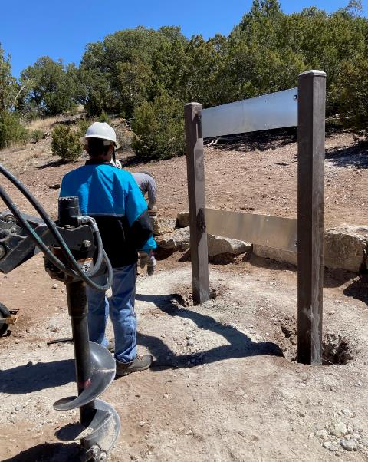

Tony looking at the posts that have been set in concrete.

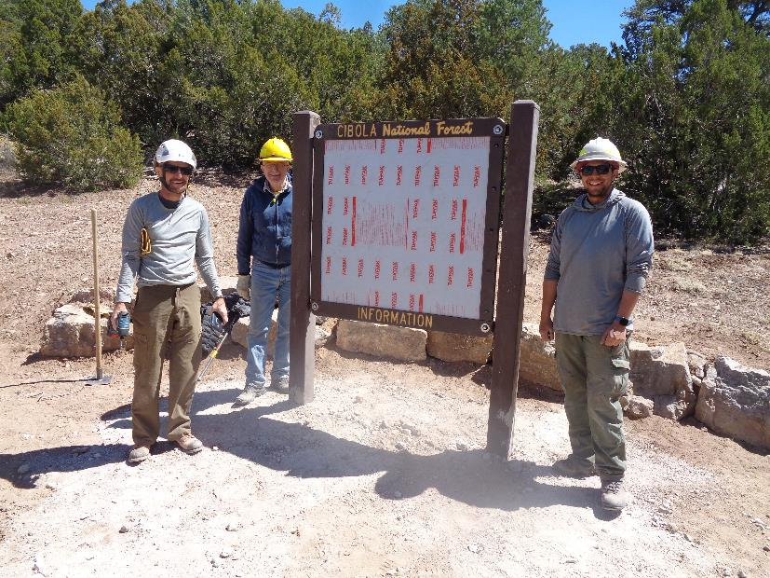

The kiosk panel has been bolted to the posts. L to R: Mark, Eric, and Russell.

Photo by Sam Beard

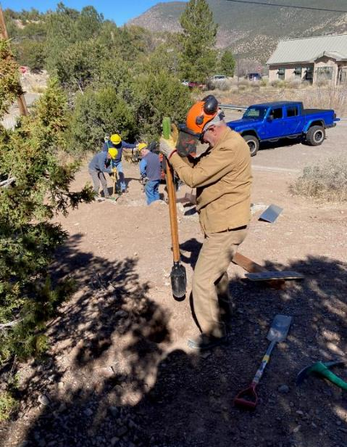

Dan Benton starting to dig a hole for the trailhead sign to the trail leading

to the top of Ranger Rock.

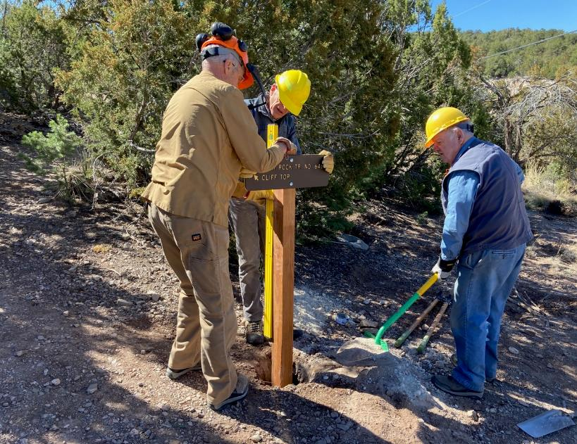

Setting the post straight in the hole. L to R: Dan, Sim, and Dennis.

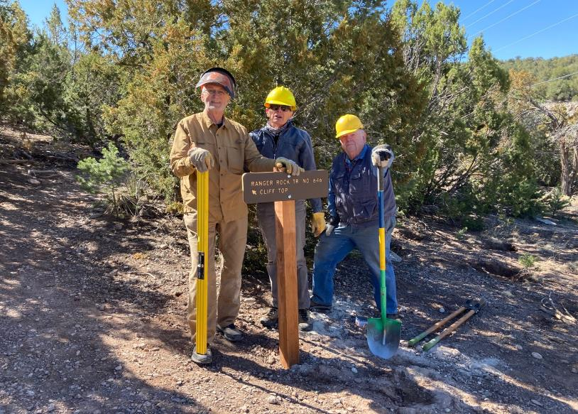

The crew around the installed sign post. L to R: Dan, Sim, and Dennis.