**Report of FOSM Project to Remove Hazard Trees in Doc Long**

**and Sulphur Canyon Picnic Areas on Thursday, April 14, 2022**

Sam Beard, April 17

On Thursday, April 14, nine volunteers felled a total of 13 hazard trees in Doc Long and Sulphur Canyon Picnic Areas. Six trees were felled in Doc Long PA, and the largest tree was a Rocky Mountain Juniper with a diameter of 24 inches. Seven trees were felled in Sulphur PA, and the largest tree was a white fir with a diameter of 26 inches.

Photos of the project are presented below.

The volunteers working on Thursday were Dan Benton, Robert Hembach (new volunteer), Sam Beard, Dennis Crowther, Michael Arndt, Jerry Carroll, Lou Romero, Mike Madden, and Don Carnicom.

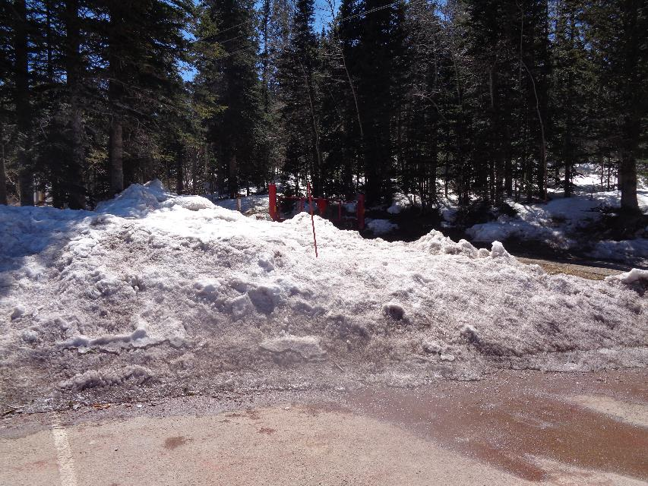

On Wednesday, April 13, when I went to select hazard trees at the Ellis Trailhead, I found this large pile of snow at the parking lot

and snow in the forest on north-facing slopes. I will return to select hazard trees here after the snow melts. All photos by Sam Beard

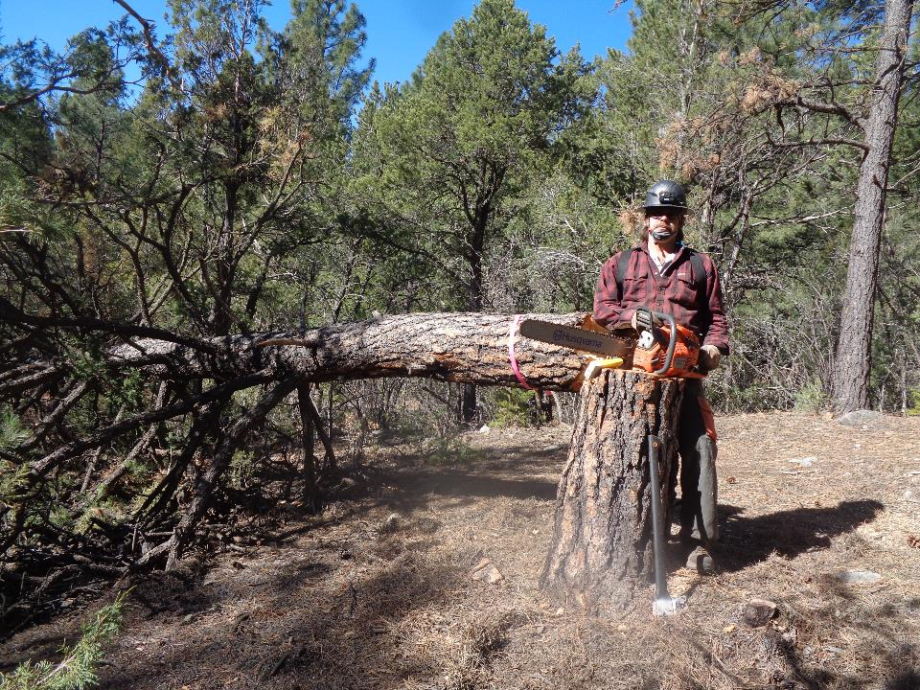

Michael Arndt at the tree that he felled in the upper part of Doc Long Picnic Area.

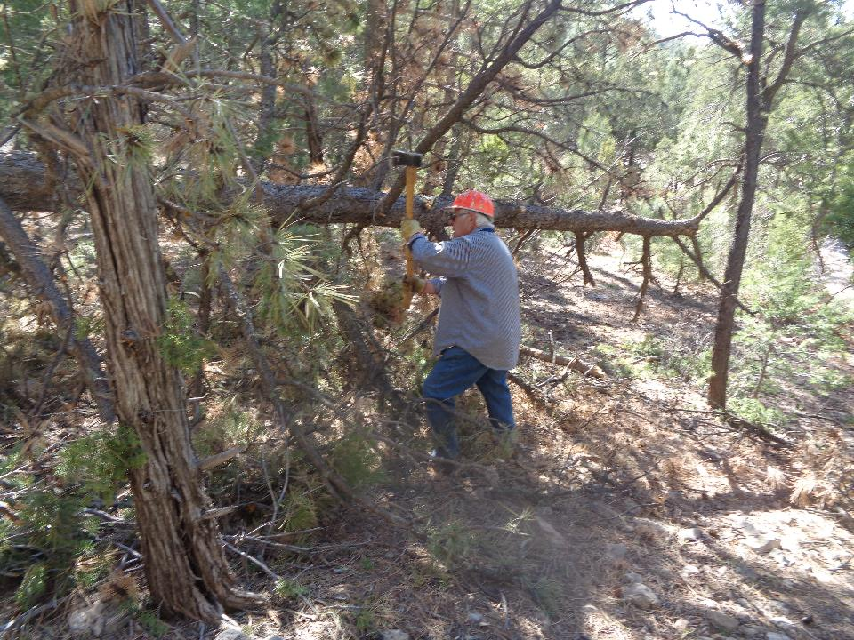

Lou Romero limbing a pine tree in Doc Long PA.

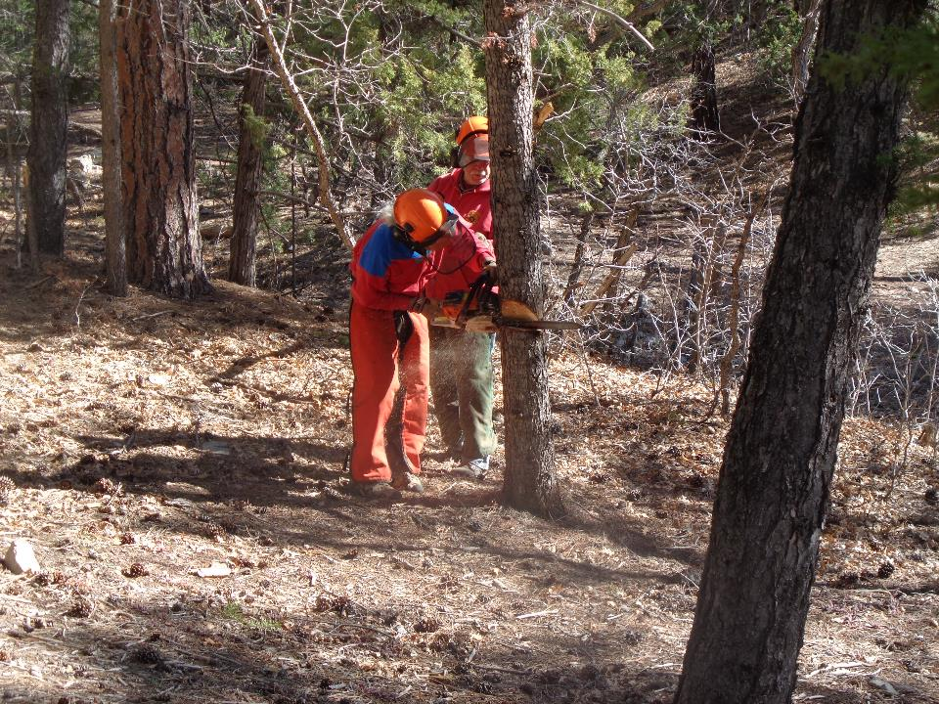

Jerry Carroll training Mike Madden to fell a tree in Doc Long PA.

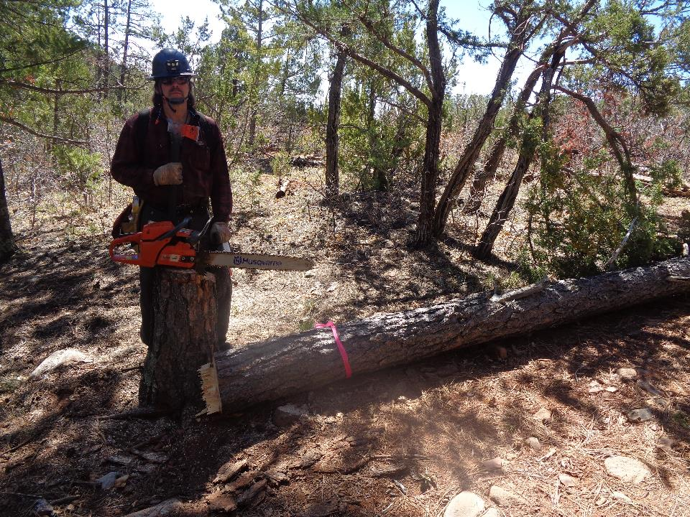

Michael at a 12-inch pine he felled beside the trail between Doc Long PA and Sulphur Canyon PA.

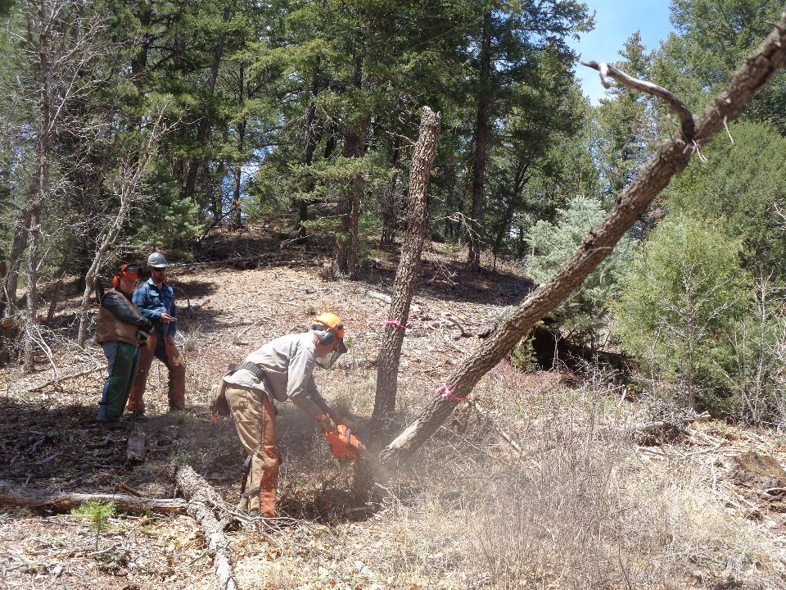

Dan Benton felling two dead trees at the traffic circle in the upper end of Sulphur Canyon PA. L to R: Dennis Crowther and Robert Hembach

are observing.

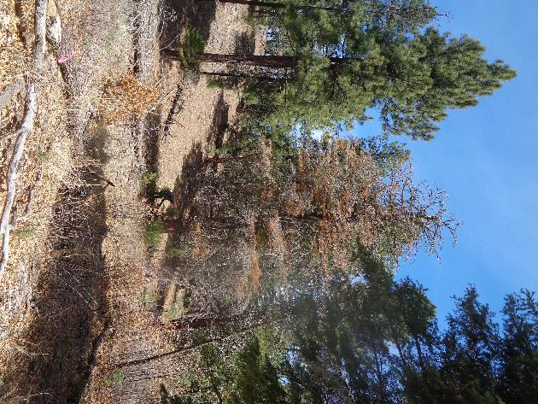

Michael preparing to fell this 26-inch diameter fir at the traffic circle in Sulphur Canyon PA.

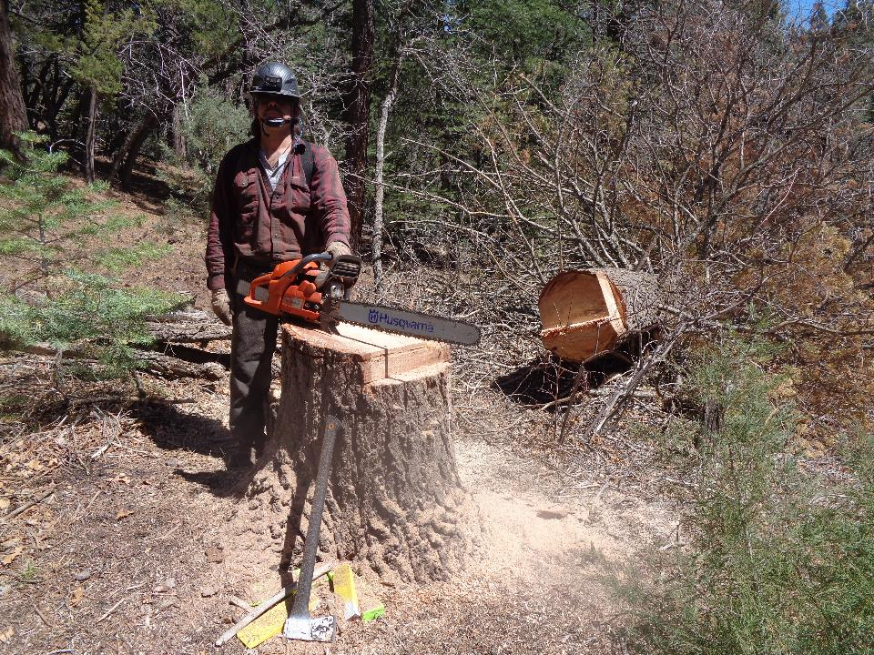

Michael at the stump of the hazard tree he has just felled.

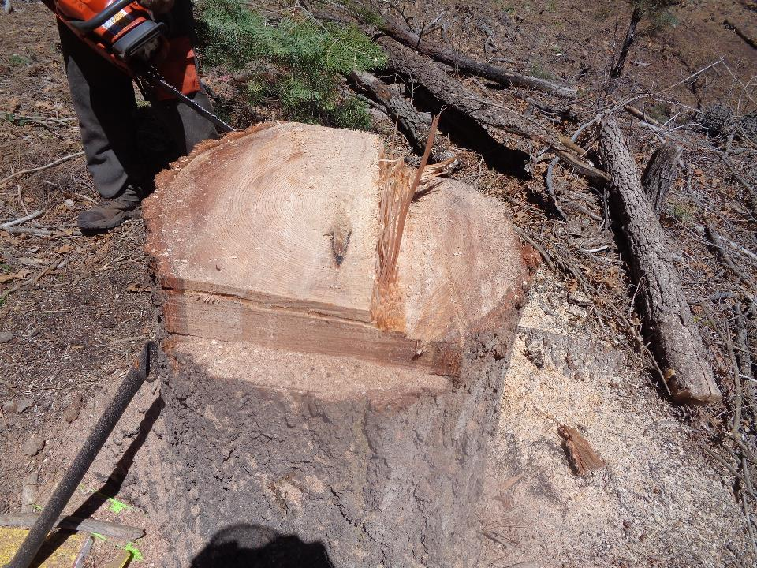

Michael cut a slab of wood and bark off each side this tree to reduce the size of the trunk so that he could safely fell the tree with

his saw with a 24-inch bar.

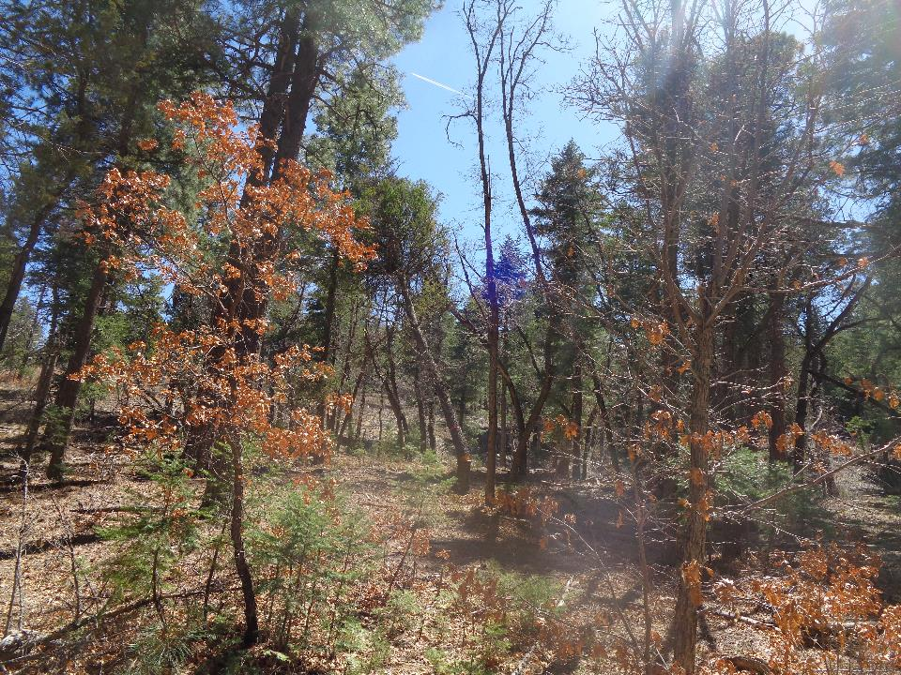

Jerry Carroll has just felled this hazard tree with a dead top beside the road in the upper part of Sulphur Canyon PA.

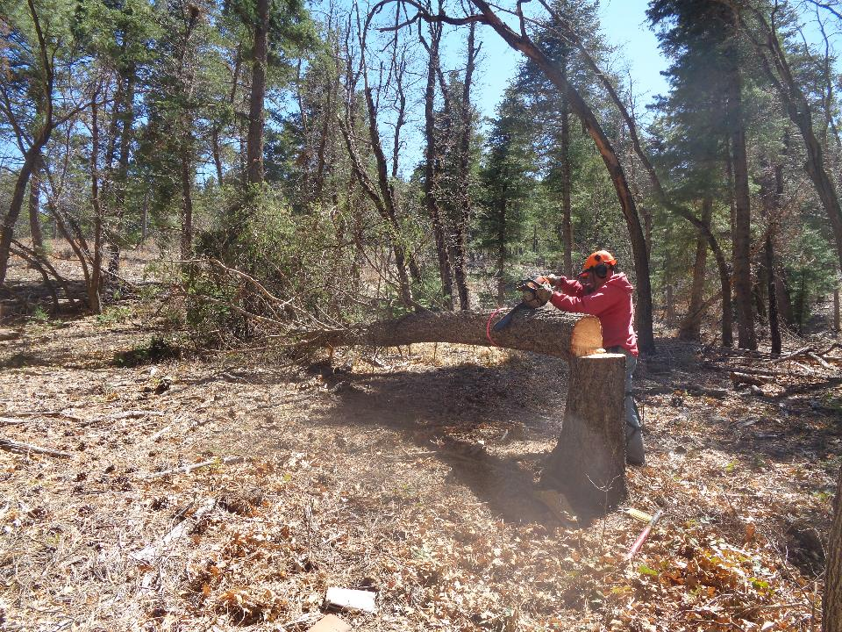

Jerry bucking this tree so that it will drop off the stump.

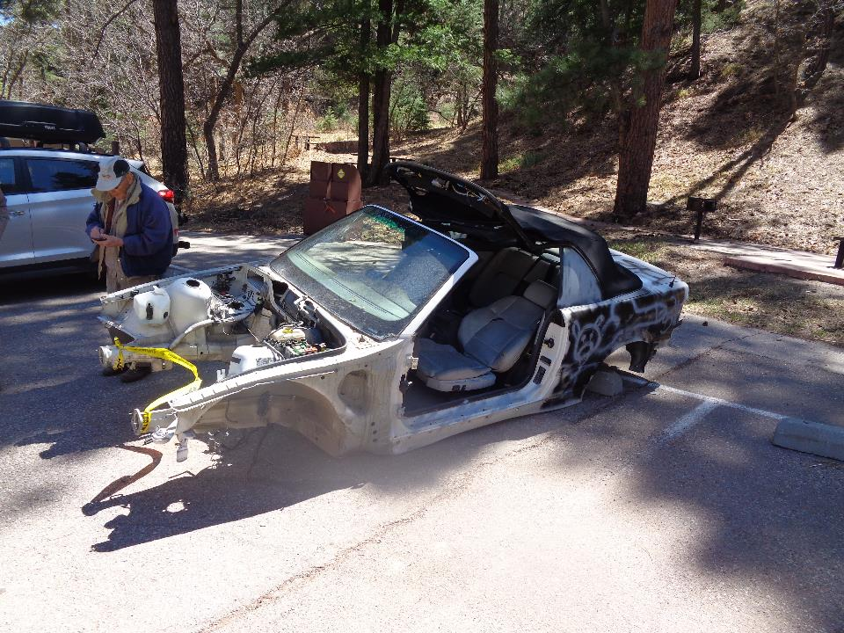

Don Carnicom beside the remains of this BMW convertible that has been stripped for parts and left in Sulphur Canyon PA.

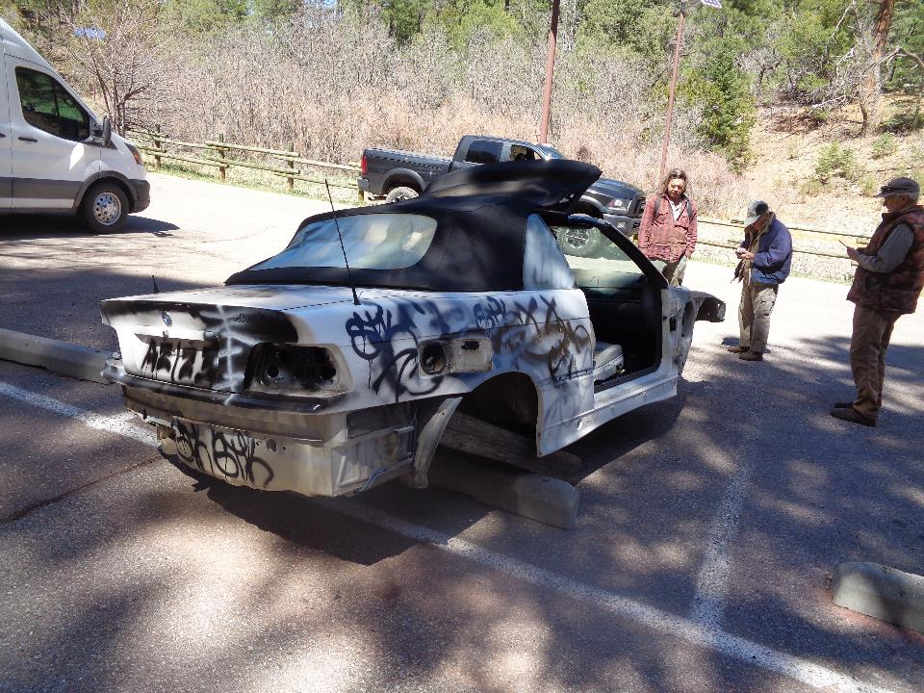

Another view of the stripped car. L to R: Michael Arndt, Don Carnicom, and Dan Benton.