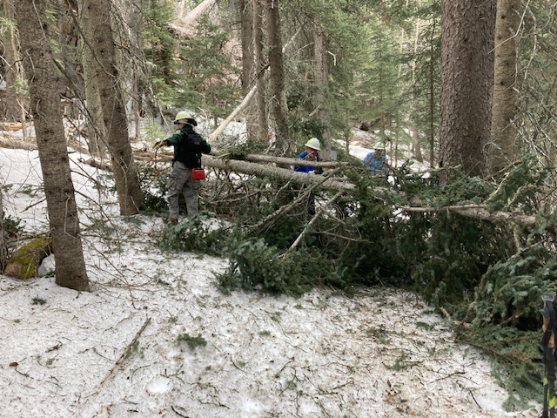
This double-trunk (8”and 5”) fallen fir was completely blocking Survey Trail. It appears to be quite new as there had been no previous report about it and no bypass tracks were noted. At the time of this photo, many of the protruding branches have been removed.
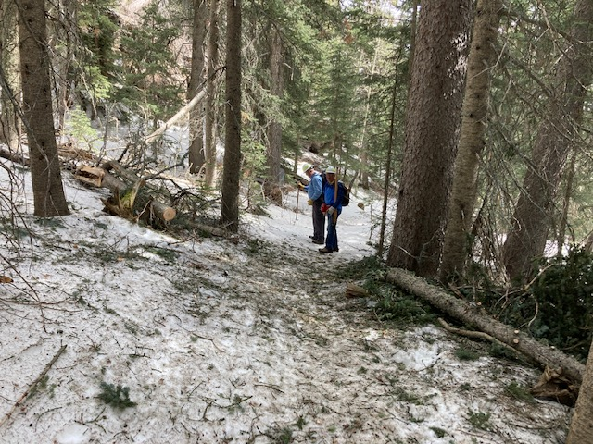
The fallen tree has been removed.
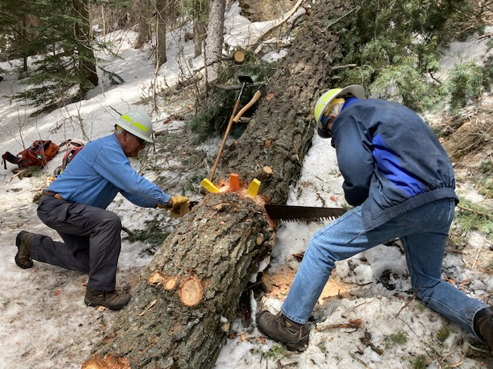
This massive 22-inch diameter fallen fir was first worked on by our FOSM crew in January. Due to the amount of snow covering it, it was only possible to remove a small portion of the lower end to at least make it possible for users to pass. The crew returned Monday to cut it back further away from the trail tread.

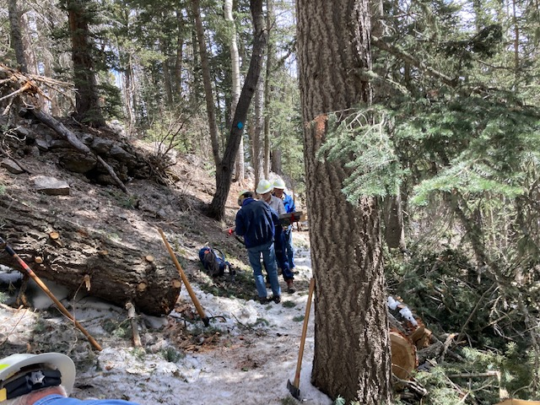
The big tree has been cut back and the trail widened. This view looking north.
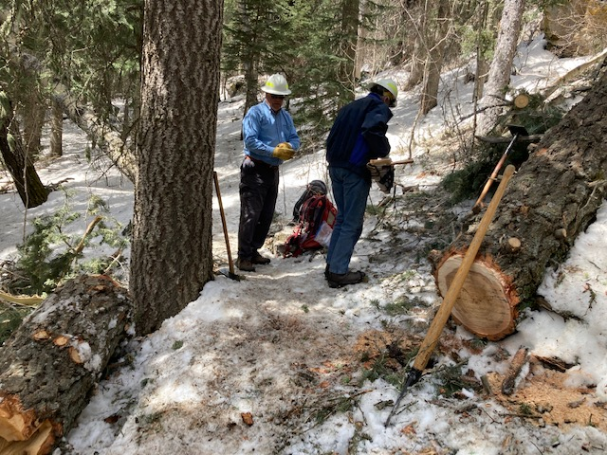
This is another photo of the big tree, this time looking south.

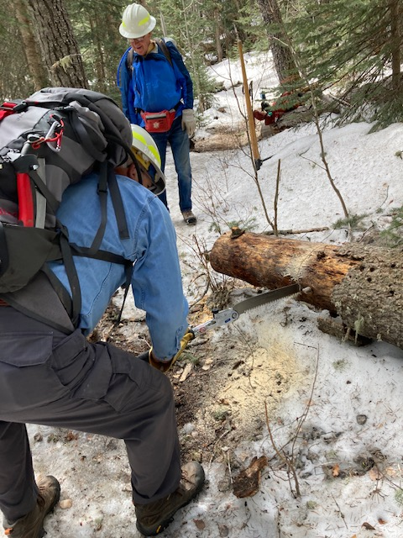
This 10-inch diameter log was also first cut during
the winter when deep snow prevented removal of a
longer section.
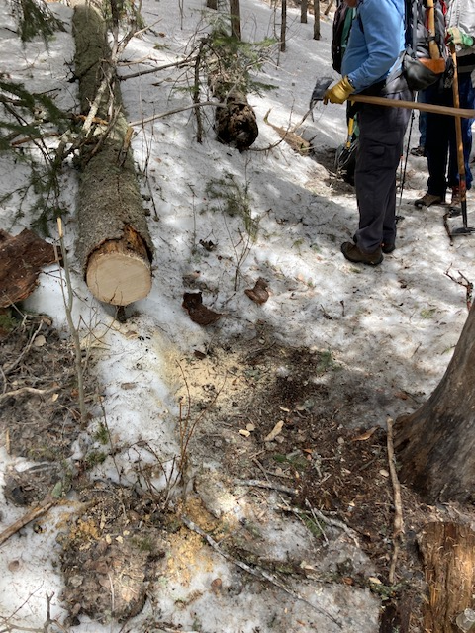
The protruding section log in the previous photo
has been removed.
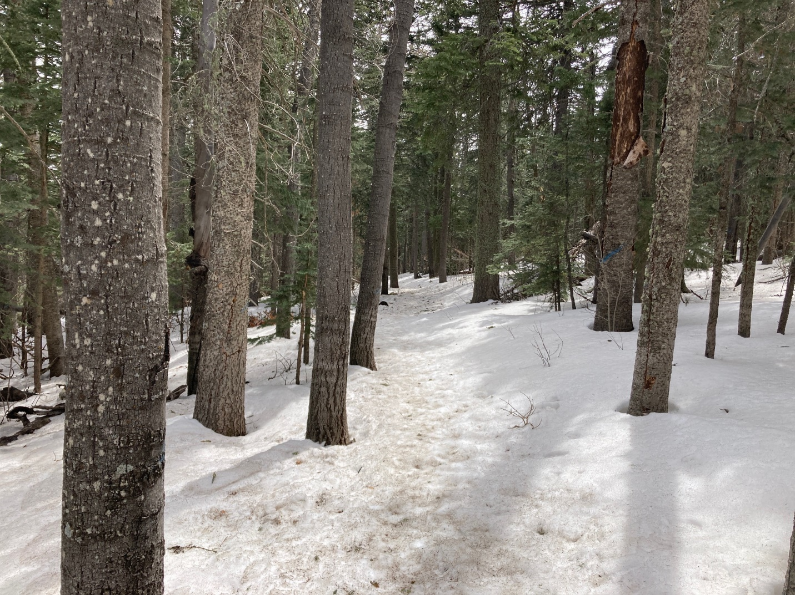
A typical scene along Survey trail as it appeared Monday.

