Report of the FOSM Project to Fell Hazard Trees in Cienega Canyon Picnic Area

on Wednesday, April 20, 2022

Sam Beard

On Wednesday, April 20, ten FOSM volunteers began removing marked hazard trees from Cienega Canyon Picnic Area. Approximately 17 hazard trees were felled in all parts of this picnic area – road to the PA, lower restroom, area between the two lower restroom, second restroom, and the upper parking lot. The maximum diameter of the felled trees was 18 inches. Four identified hazard tree remain to be felled.

The volunteers working on this project were Cliff Giles, Sim Cook, Dennis Crowther, Byron Garner, Steve Roholt, Dan Benton, Lou Romero, Michael Arndt, Tony Pachelli, and Sam Beard.

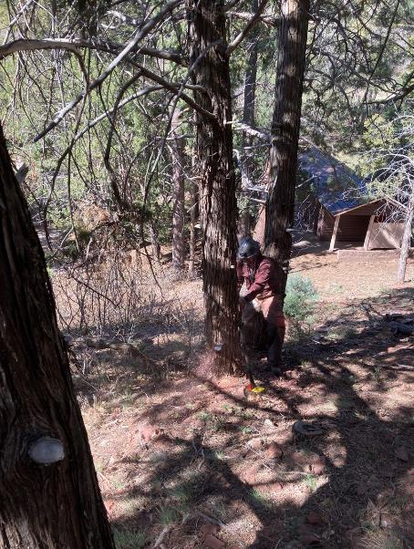

Michael Arndt felling a dead Rocky Mountain Juniper on the hillside at the upper parking lot in Cienega Picnic Area.

All photos by Cliff Giles unless noted otherwise.

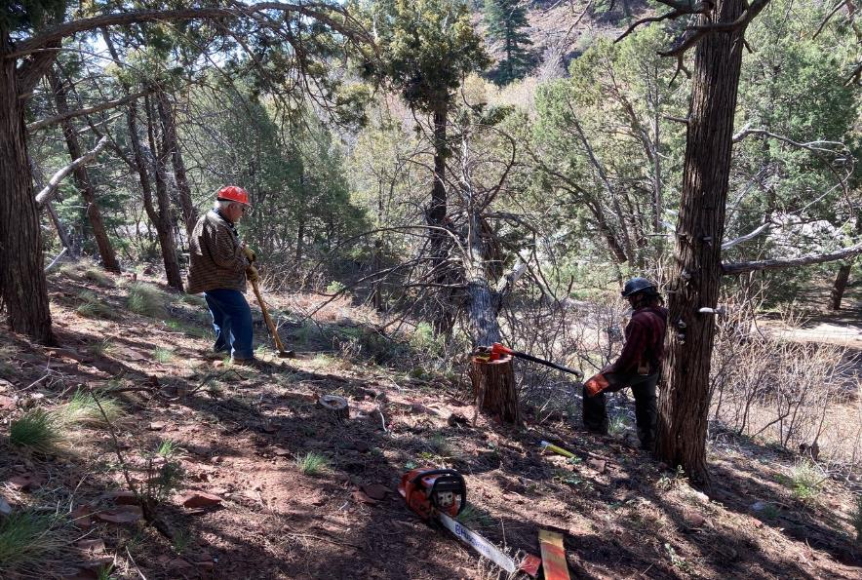

L to R: Lou Romero and Michael Arndt looking at the dead tree that Michael has just felled.

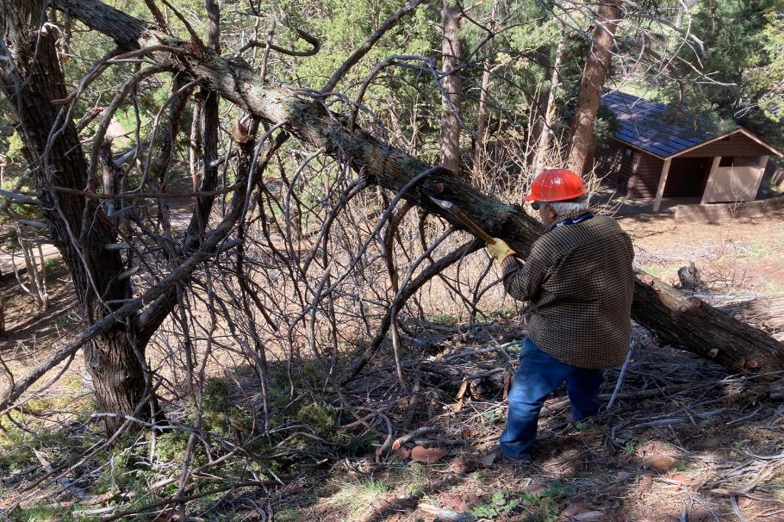

Lou is limbing the felled tree.

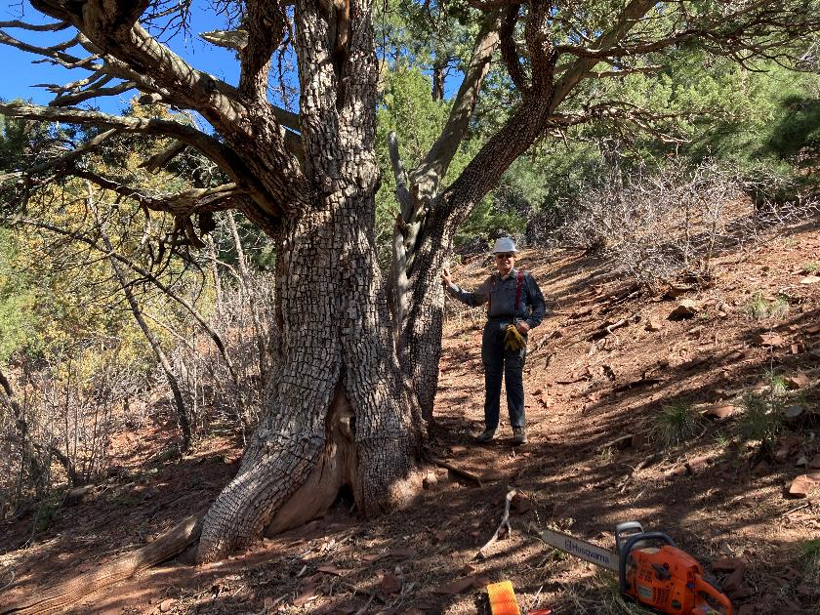

Cliff Giles at the 60-inch alligator juniper near the upper parking lot in Cienega PA. Photo by Michael Arndt

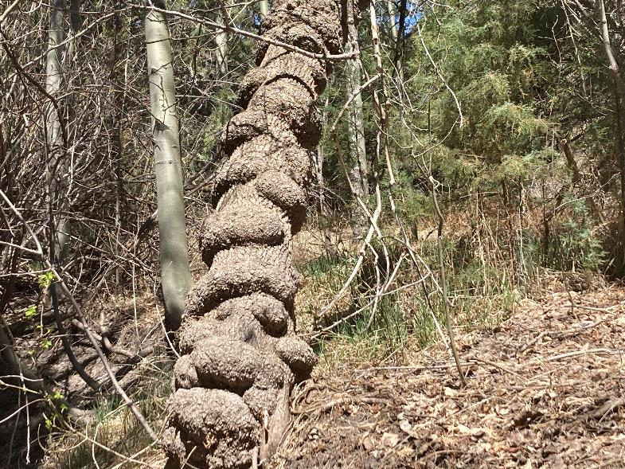

A Gambel oak with growths on the sides. Photo by Michael Arndt.

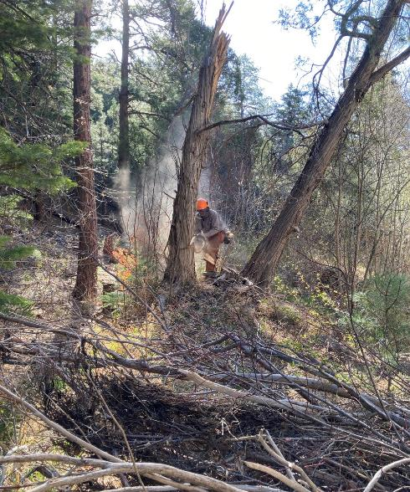

Dan Benton felling a dead tree between the two lower restrooms in Cienega

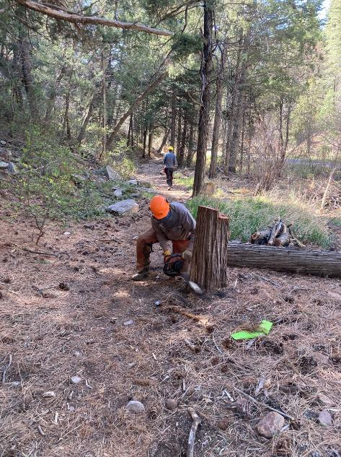

Dan cutting the stump lower.

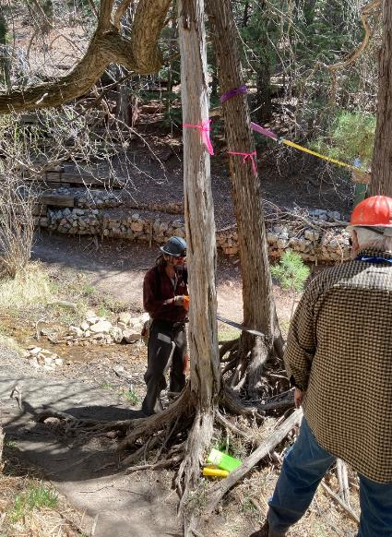

Michael felling a small dead tree at the creek near the second rest room.

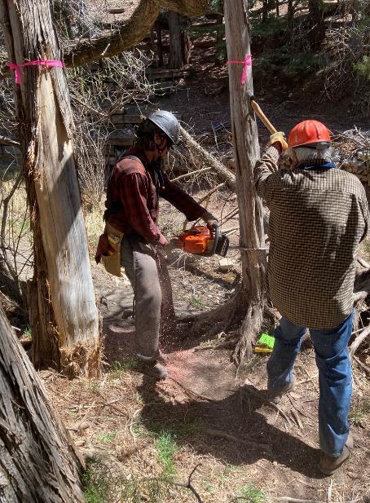

Lou Romero pushing a small tree that Michael is cutting.

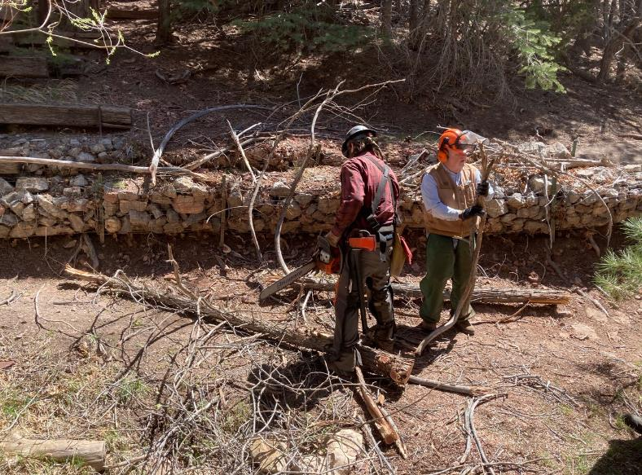

Michael and Dennis Crowther limbing the felled small trees.

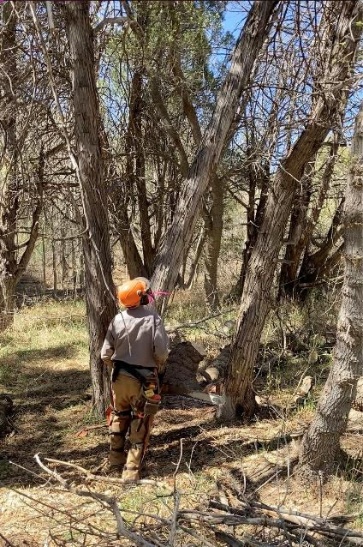

Dan is watching the dead tree fall that he has just cut.

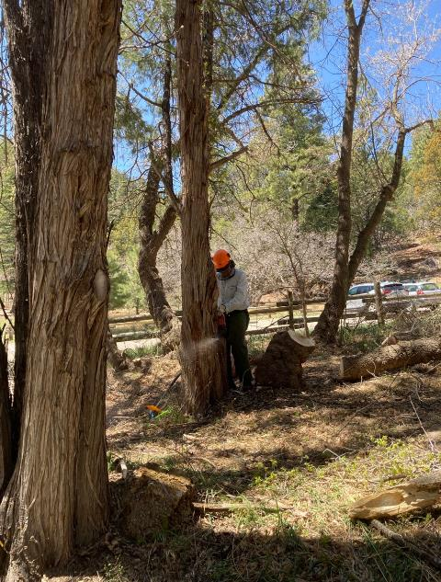

Eric Russell is felling a dead tree in the picnic area across the road from the second restroom.

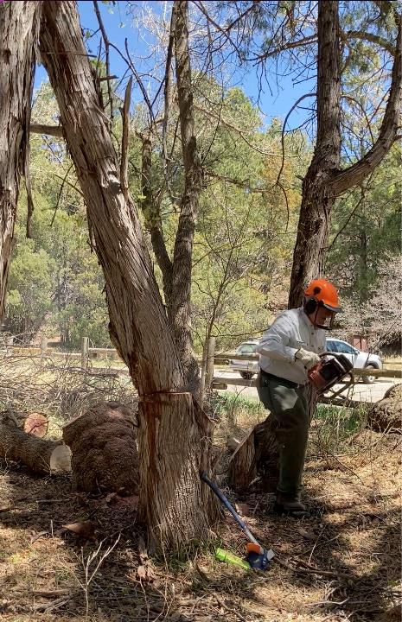

Eric running away from the tree he has just felled.

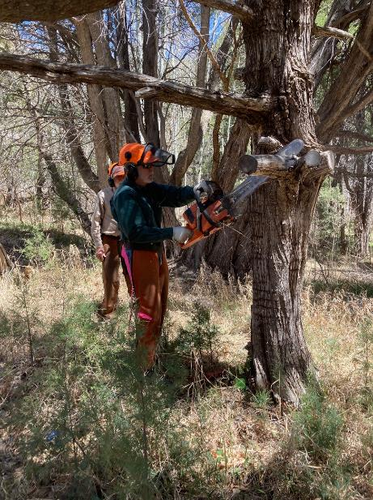

Byron Garner cutting branches off the tree he is preparing to fell.

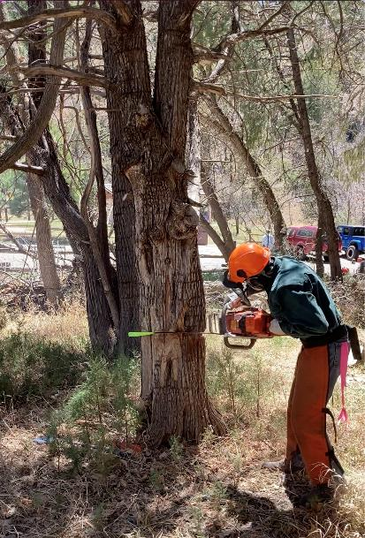

Byron making the back cut on a dead Rocky Mountain Juniper.

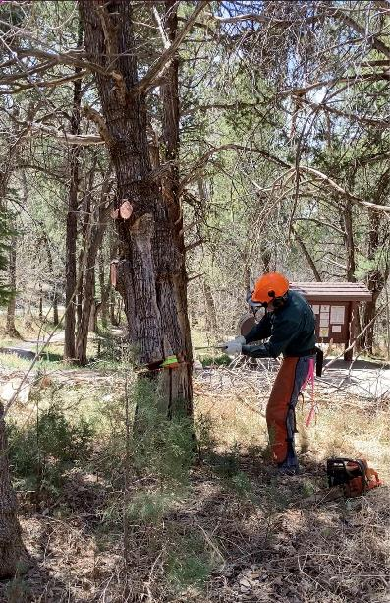

Byron hitting three wedges in the kerf in an attempt to force the tree to fall.

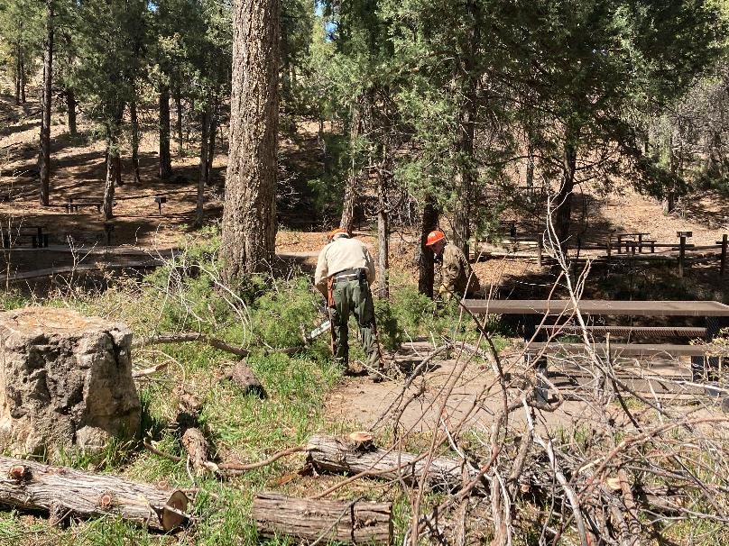

Sam Beard and Lou Romero are limbing the Rocky Mountain Juniper that Michael Arndt felled near the first restroom.

Photo by Michael Arndt

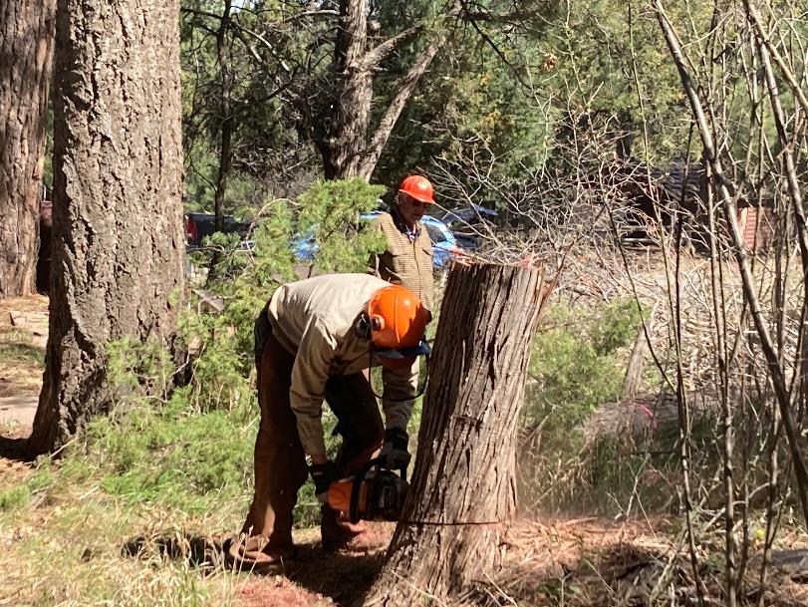S

Sam is low stumping the tree that Michael felled. Photo by Michael Arndt