Report of FOSM Project by Steve Roholt and Sam Beard to Fell Several Hazard Trees at Ellis Trailhead
and Remove Down Trees from Two Trails in the Crest Area on Tuesday, May 10, 2022

Sam Beard
On Tuesday, May 10, Steve Roholt and Sam Beard worked approximately one-half day felling several hazard trees at Ellis Trailhead and removing down trees from Crest area trails.
The initial objectives of the outing were to start removing hazard trees at the trailhead and to provide opportunities for Steve to practice felling and bucking hazard trees with chain saws. Steve felled three hazard trees with diameters ranging from 5 inches to 12 inches. He also limbed and bucked a large fir tree top that had broken and fallen at Challenge Trailhead. He bucked an 8-inch fir tree that had fallen across the unofficial trail to the right of the Service Road and just past the large red gate.
We then drove to the gate on Kiwanis Meadow Road and ate lunch at the picnic table. Unfortunately, we found bright green spray paint on the two map displays there. After lunch, we limbed and bucked a 14-inch Engelmann spruce that had fallen across the road near the gate. Forest gnomes had cut a 4-foot-wide opening in the small end of the tree. We completed the removal of the spruce so that the road is now completely clear.
Tomorrow FOSM volunteers will remove the remaining six hazard trees at Ellis Trailhead. We will also remove the very large spruce (estimated diameter of 30 inches) across South Crest Trail near the junction with Kiwanis Meadow Trail.
Project photos are presented below.

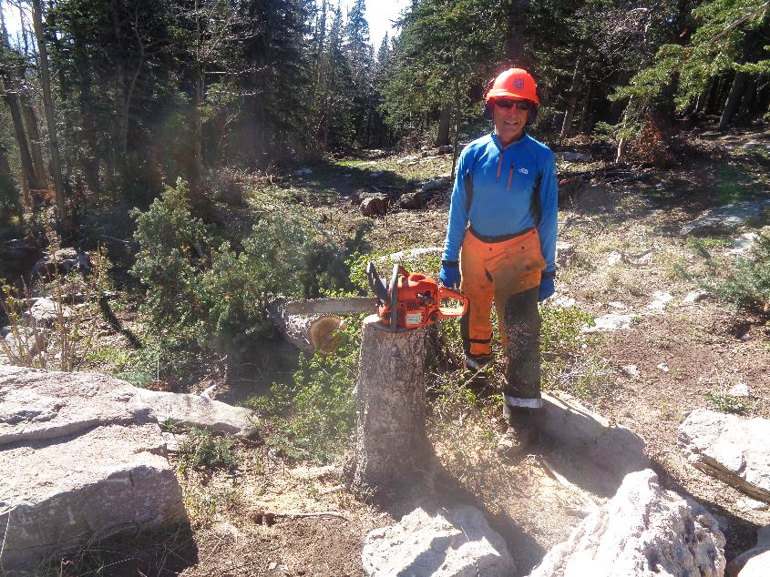
Steve at the stump of the fir he felled on the east side of the upper parking lot at Ellis Trailhead. All photos by Sam Beard
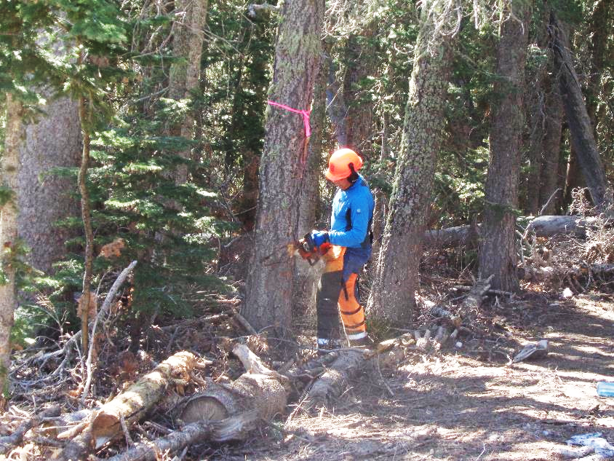
Steve making the face cut on a 12-inch white fir beside a ski trail near the trailhead.
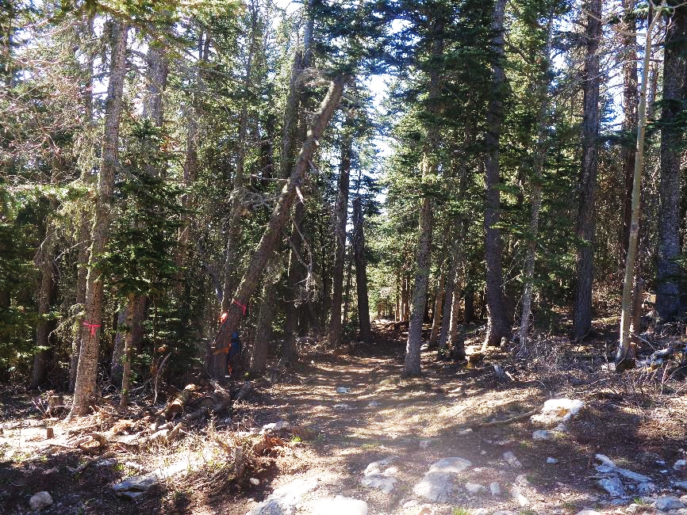
The fir falling across the trail.
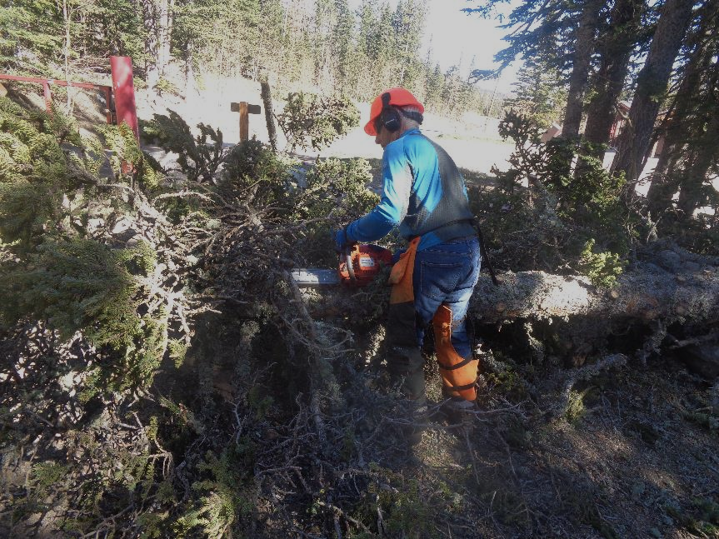
Steve limbing the very large fir top that fell between the red gate and Challenge Trailhead.
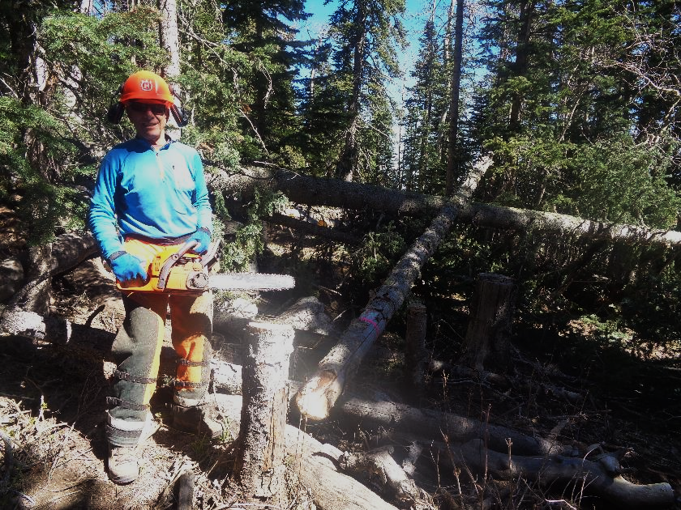
He used the battery-powered chain saw after 10 am to fell this dead 5-inch fir on the right side of the Service Road just past the red gate.
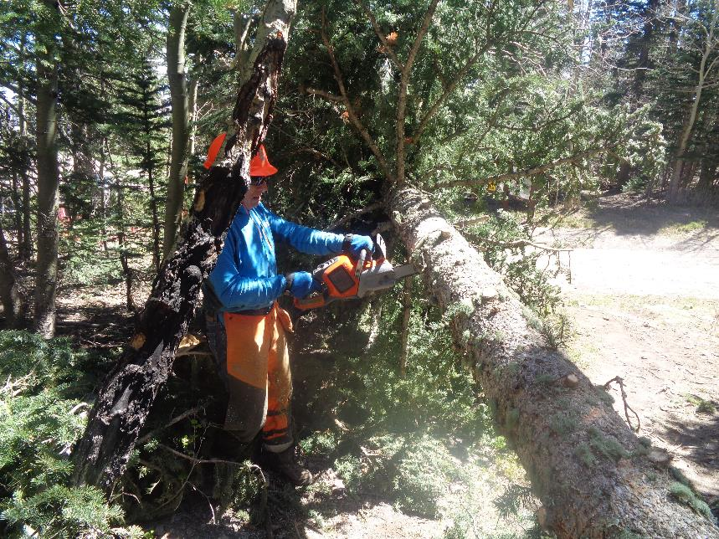
Bucking the fir tree that fell across the unofficial trail near the red gate.
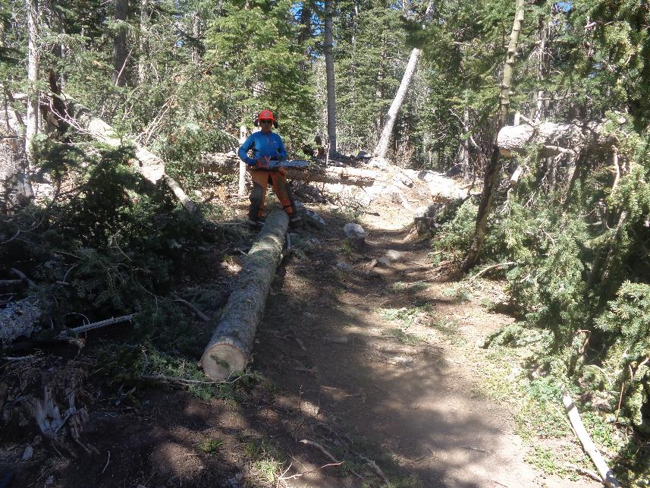
The trail is now completely clear.
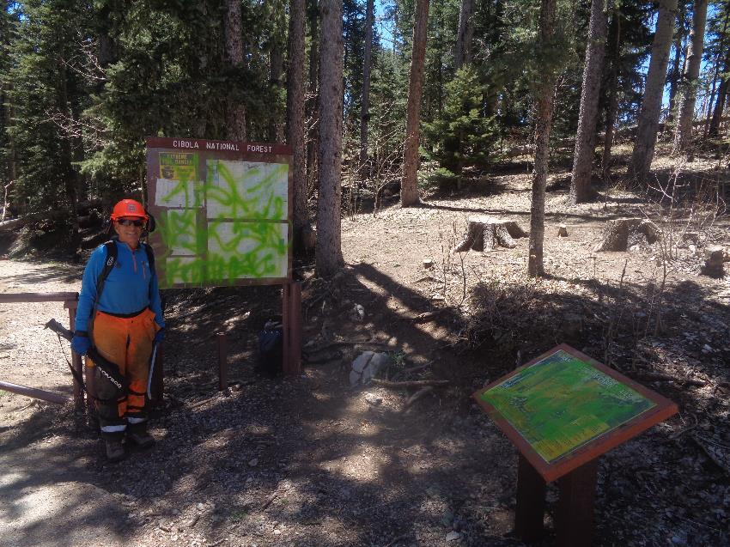
Graffiti on the two signs at the gate on the Kiwanis Meadow Road.
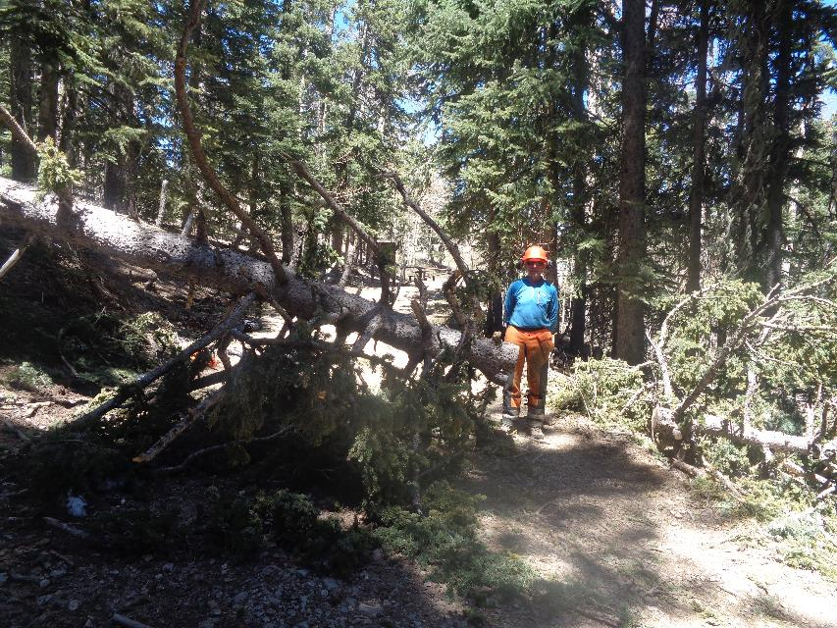
The 14-inch spruce across Kiwanis Meadow Road.
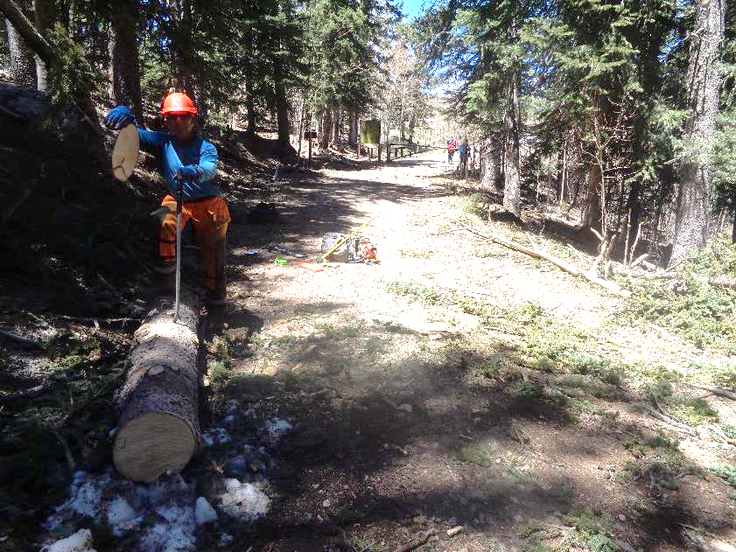
We used the battery-powered Husqvarna chain saw to remove this tree after lunch.

