**Report of Graffiti Removal from Rocks at Dirt Parking Lot at Intersection**

**of FR-333 and La Luz Trailhead Road on Thursday, June 16, 2022**

Sam Beard

On Thursday, June 16, three USFS employees and FOSM volunteer, Sam Beard, removed approximately a dozen graffiti tags from rocks around the dirt parking lot at the intersection of FR-333 and La Luz Trailhead Road on the west side of the mountain. The SRD employees were Manny Chavez, Chris Baca, and Adriana Gonzales.

Two coats of the World’s Best Graffiti Removal System chemical for paint removal from rocks and mortar were applied to the dozen paint tags on the rocks. Manny Chavez then used the high-pressure power washed to remove the chemical and paint from the rocks. The project was completed in about an hour. Manual removal with the chemical, plastic bristle brushers, and the FOSM battery-powered low-pressure washer would have required 2 or 3 hours.

Photographs are presented below.

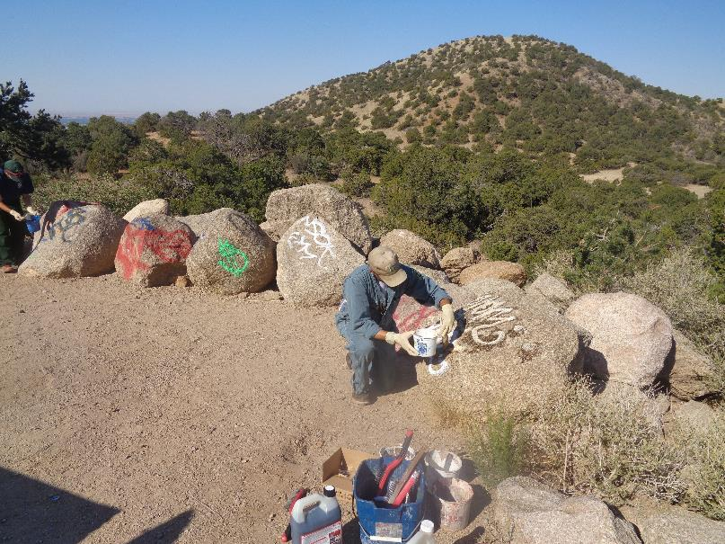

Chris Baca, Sandia Ranger District, applying graffiti removal chemical to a tag at the dirt parking lot. All photos by Sam Beard

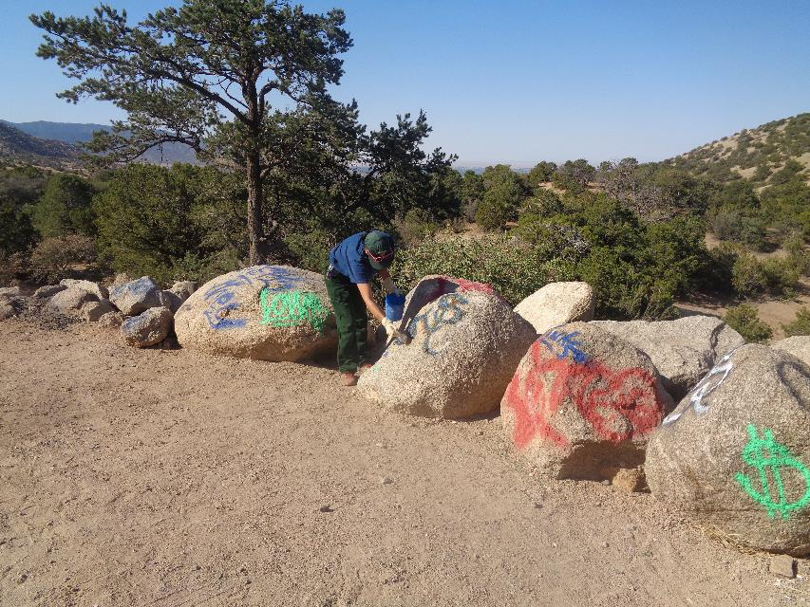

Adriana Gonzales, Sandia Ranger District, applying graffiti removal chemical to a tag.

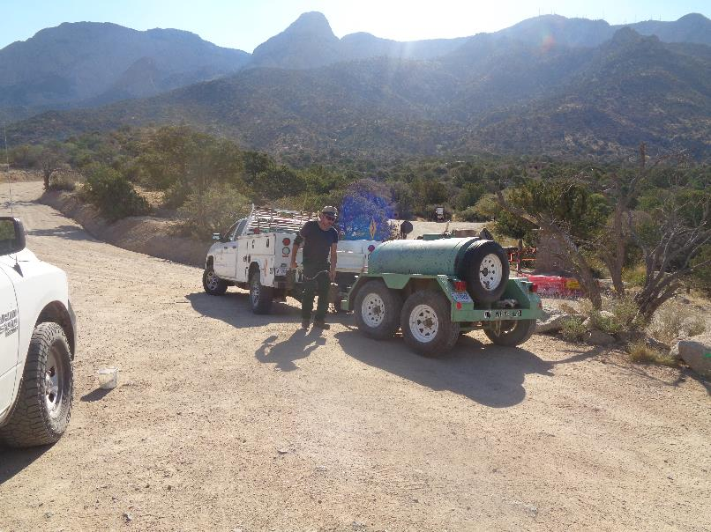

Manny Chavez, SRD Maintenance Supervisor, brought the “water buffalo” to the site to provide water for the high-pressure power washer

to remove chemical and dissolved paint from the rocks.

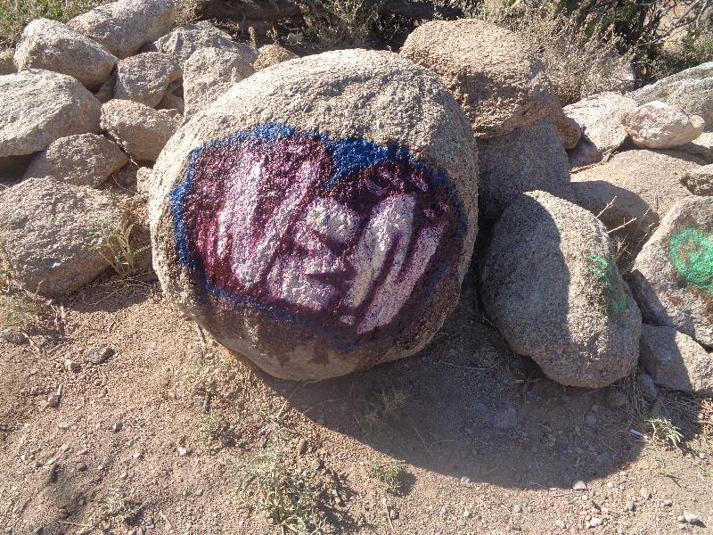

Red, white, and blue graffiti tag on a rock. Graffiti removal chemical has already been applied to the tag, and the dissolved

paint is flowing down the rock surface.

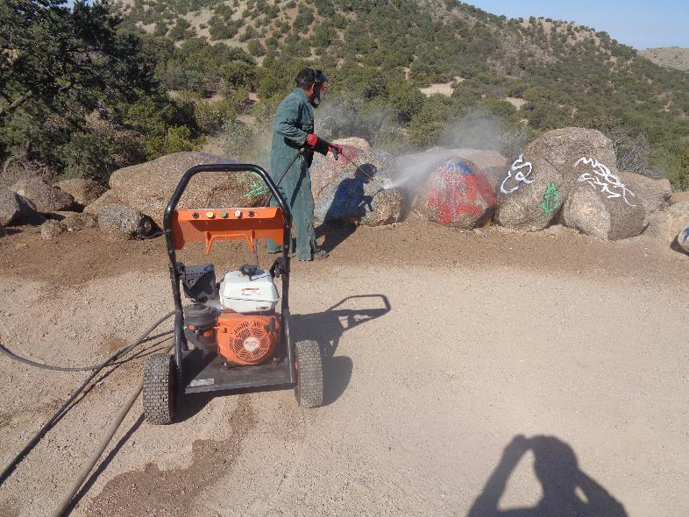

Manny is using the high-pressure power washer to remove paint from the rocks after two applications of the chemical.

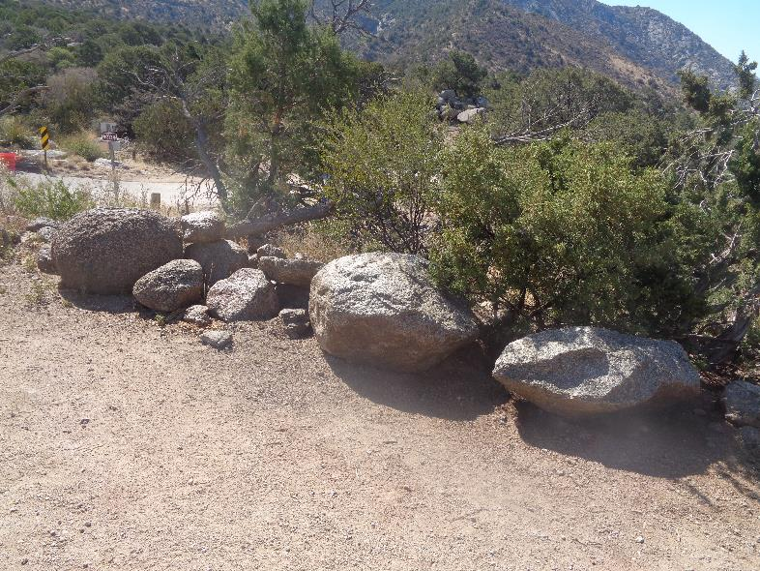

Graffiti has been removed from these rocks.

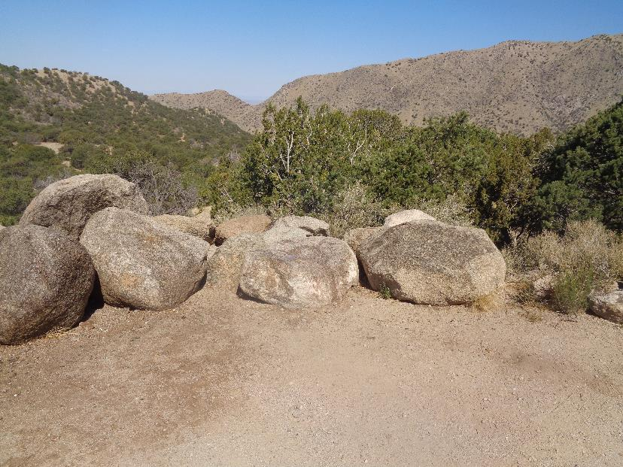

Graffiti has been removed from these rocks on the southwest side of the parking lot.

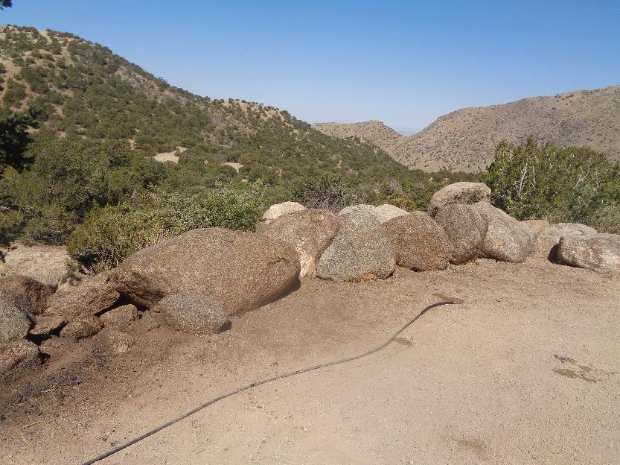

Graffiti has been removed from these rocks on the west side of the parking lot.

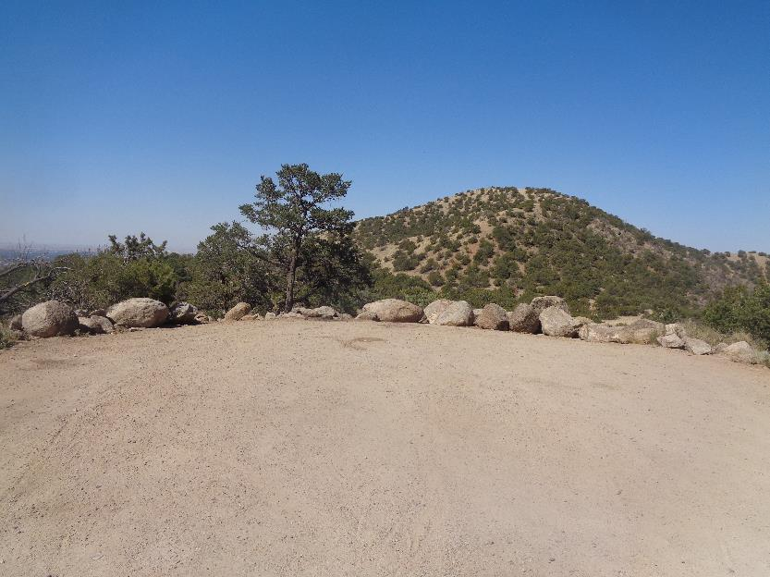

Rocks around the parking lot after all the graffiti had been removed by the chemical and pressure washer.