**Report of FOSM Project to Buck and Split Fuel Wood in Nine Mile Picnic Area**

**on Wednesday, June 29, 2022**

Sam Beard

On Wednesday, June 29, FOSM volunteers bucked and split approximately two cords of fuel wood in Nine Mile Picnic Area. Julie Padilla, SRD Recreation Staff Officer, requested that FOSM remove two piles of logs here before a contractor begins rebuilding the picnic area.

The two piles of logs with diameters up to 24 inches were located adjacent to the upper parking lot and the group area. After the logs were bucked with chain saws, they were split into quarters with Lou Romero’s power splitter. Jerry Carroll hauled about one cord of wood to the Mountain Christian Church Wood Ministry wood lot on the west side of NM-4 and south of the Triangle.

The volunteers working on this project were Cliff Giles, Jerry Pekarek, Lou Romero, Dan Benton, Byron Garner, Steve Roholt, Jerry Carroll, Don Carnicom, and Sam Beard.

Project photos are presented below.

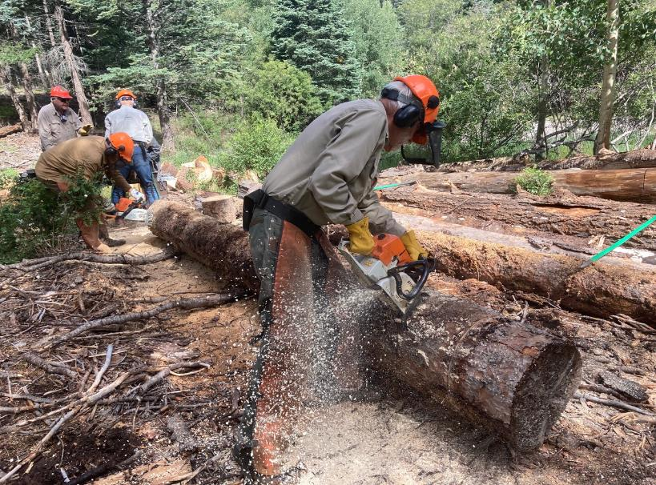

L to R: Sam Beard and Dan Benton buck a large log that was left in Nine Mile Picnic Area after the thinning project there was completed a

few years ago. Julie Padilla, SRD Recreation Staff Officer, requested that FOSM remove two piles of these logs before the contractor

begins renovating this picnic area. All photos by Cliff Giles unless noted otherwise

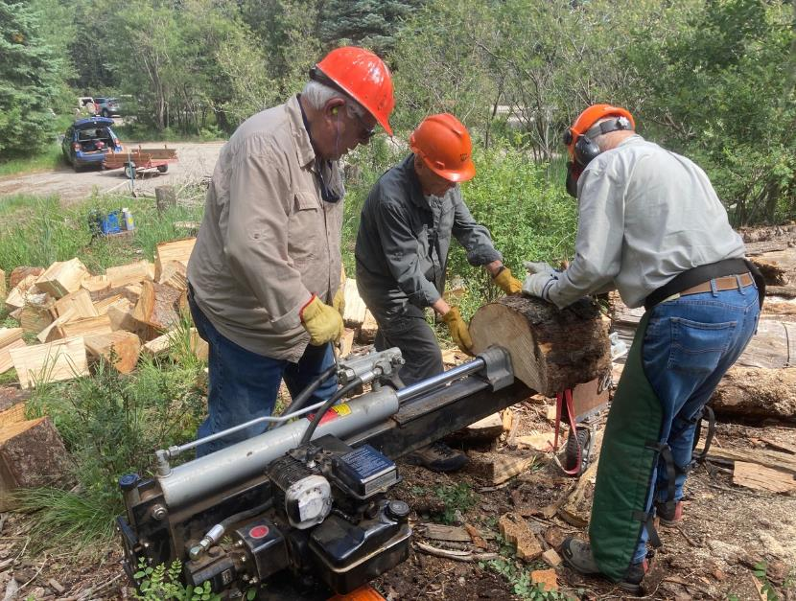

L to R: Lou Romero, Don Carnicom, and Jerry Pekarek splitting wood with Lou’s power splitter. This wood will be given

to the Mountain Christian Church Wood Ministry who will donate it to needy East Mountain families.

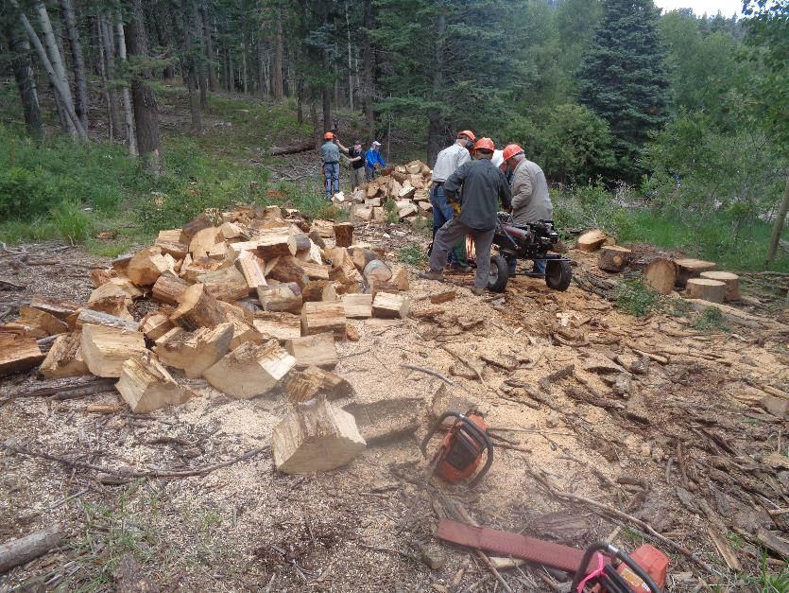

Splitting wood in Nine Mile Picnic Area. The upper parking lot is at the upper right corner of the photograph.

This crew has almost completed splitting all the wood in the upper pile of large logs. Photo by Sam Beard

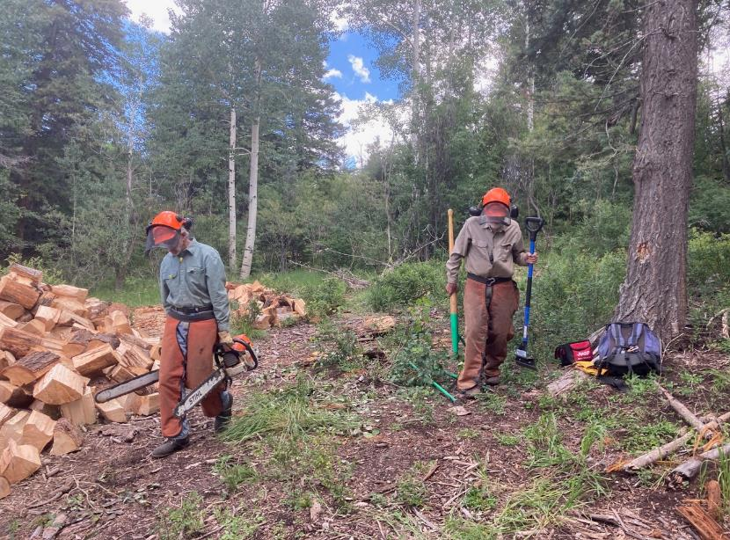

Byron Garner and Sam Beard retrieving tools from the work site.

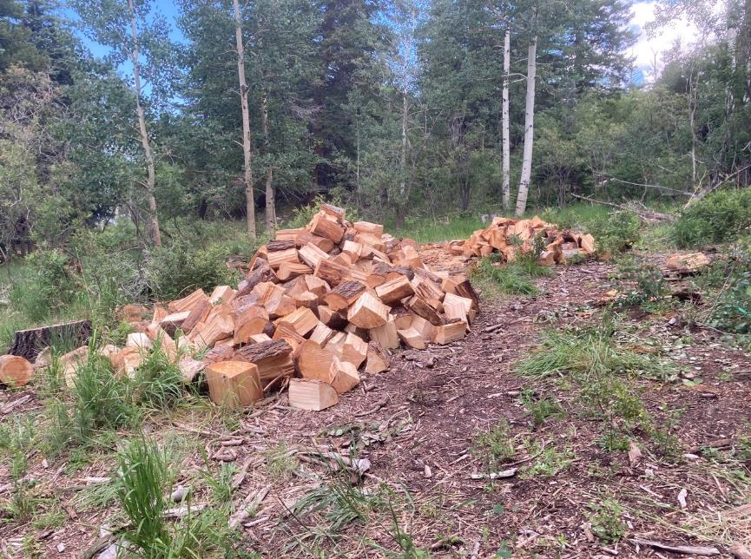

Two piles of split fuel wood.

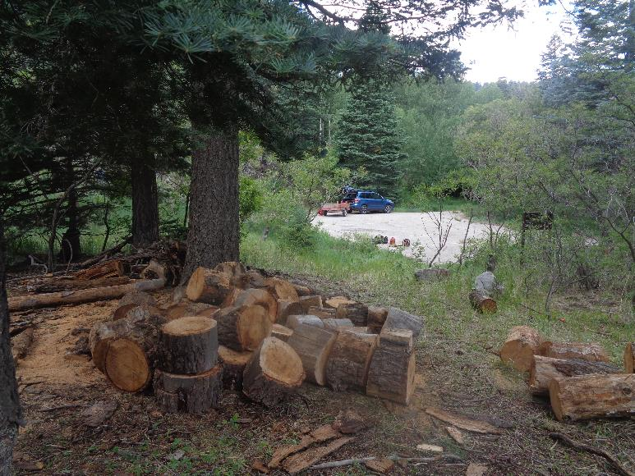

These bucked rounds from a lower smaller pile of logs will probably be split next Wednesday.

Photo by Sam Beard

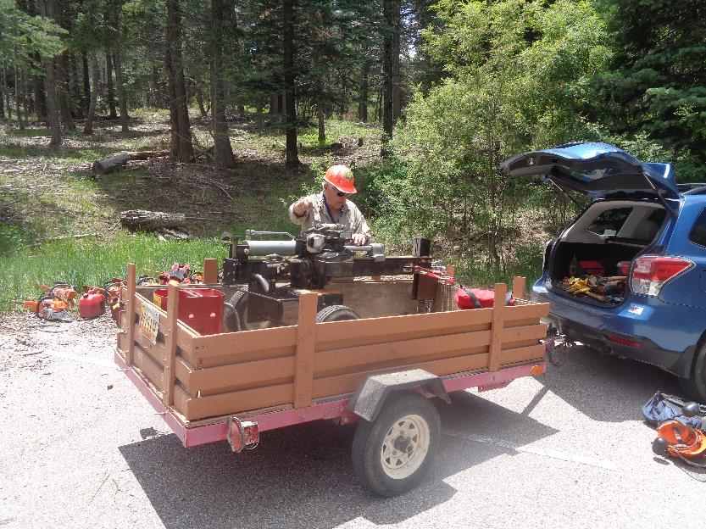

Lou Romero with his power splitter that was used to split approximately two cords of wood on Wednesday.

Photo by Sam Beard