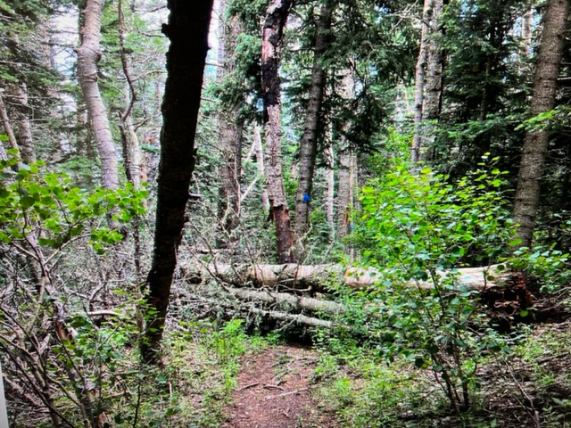

This three-tree trainwreck was completely blocking Gravel Pit trail. There was a very poor walk-around at the lower end. The fallen trees were five, nine and seventeen inches in diameter. The dark tree in the left center of the photo was a dead seven-inch diameter fir that was suspended over the trail and found to be poorly supported. It was pulled down using a long rope.

The tree in the previous photo is being cut prior to removal.

The five-inch bottom tree has been removed. The nine-inch diameter middle tree is being cut.

The cut section of the middle tree is being rolled off

the lower side of the trail. In the background, protruding branch stubs are being cut off so that the large log can

be more easily rolled off after it is cut.

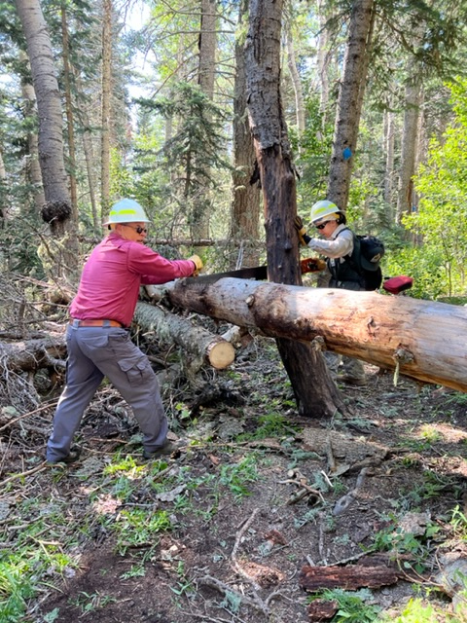

The cut is started on the top log.

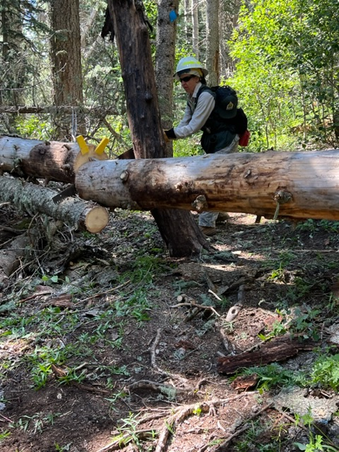

This shot captures the instant the cut goes through and

the log starts to drop. The two yellow wedges are just

starting to fall off.

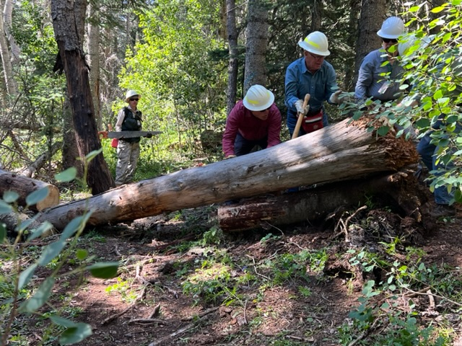

The stump end of the top log had been resting on the stump end of the second log. The crew is working to roll the top log off.

The top log is being rolled off the lower margin of the trail.

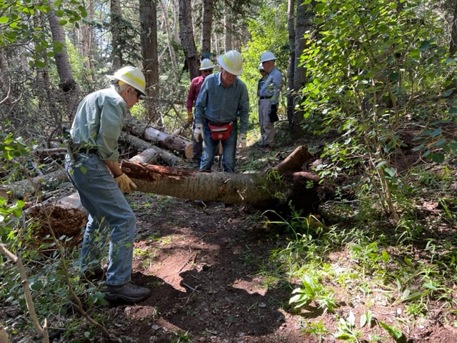

The stump of the middle log is also being moved off the trail.

Monday’s crew (Left to right) David McCreery, Jerry Pekarek, Jamey Browning, Rav Nicholson, Silke Bletzer, Bob Lowder and Byron Garner. (Not pictured – Sally Lowder)

The three-tree blockade has been removed.

This fifteen-inch diameter fallen tree was blocking Gravel

Pit trail. The trunk extended uphill some fifty feet

and was firmly supported by other trees and their branches. It was also resting on the stump of another fallen tree seen in a shadow in the upper right of the photo. Several large roots at the base were intact. After careful evaluation by the crew, it was determined that it was much safer to reroute the trail than to attempt its removal.

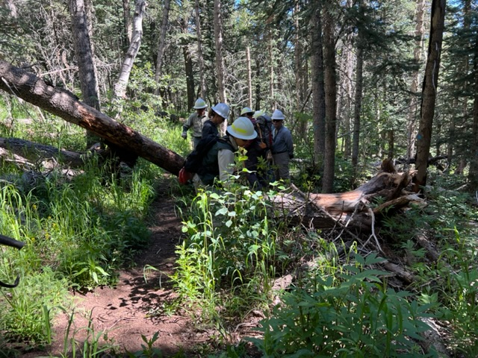

Work begins on the reroute. Vegetation had to be cut and several portions of trees that had been cut away from the trail in the past removed, including one that was fifteen inches in diameter and another fourteen inches in diameter.

Some of the broken roots of the fallen tree are being cut back to provide safe passage for users of the reroute. The crew does clearing work in the background.

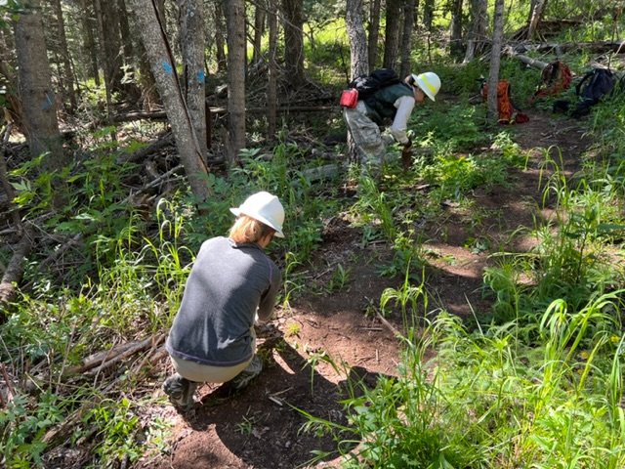

Doing some fine tuning on the reroute.

One of the old previously cut tree trunks is being rolled off the reroute path.

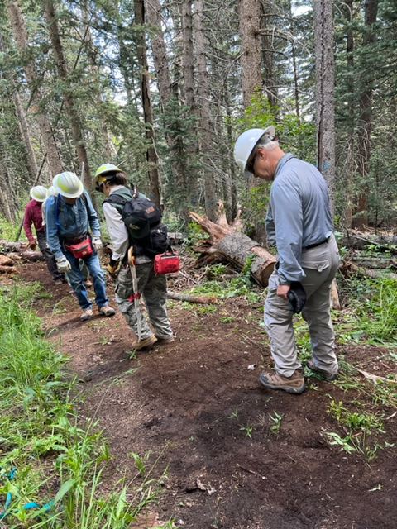

The crew performs the “FOSM Dirt Dance” to help pack down

the new trail tread.

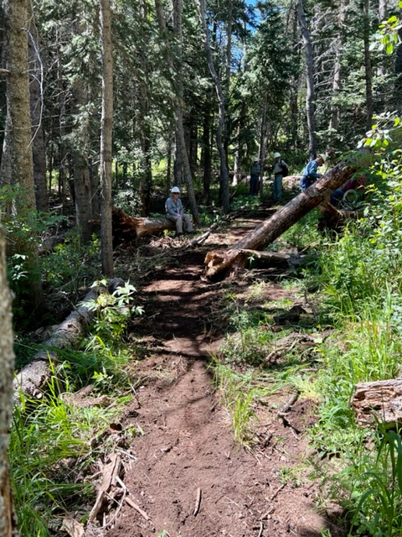

The reroute is complete and ready for use.

This photo shows the damage to Rocky Point trail where

the root ball of a fallen tree damaged the tread.

The crew is placing dirt, debris and rocks into the hole left by the root ball so that the trail tread can be repaired.

In order to provide a safe route above the damage, it was necessary to move the tread uphill.

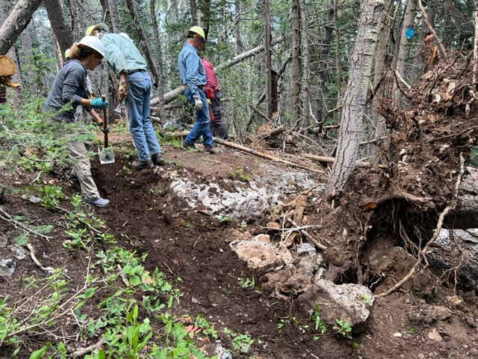

Work continues on the tread repair. The root ball hole has been filled.

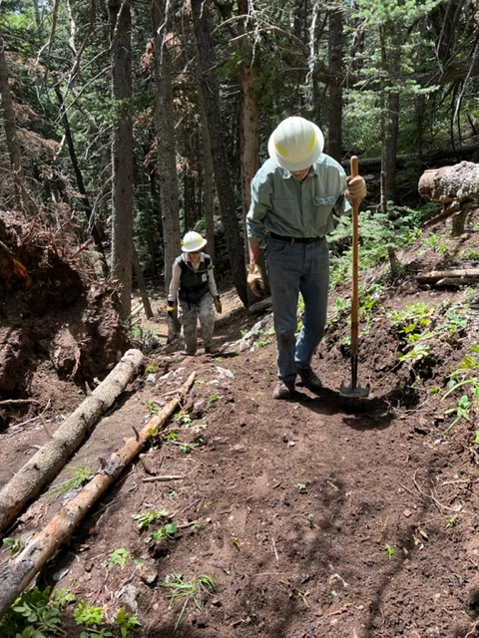

Final work being done on the tread repair. Tree sections

to the left define the lower margin of the trail and direct downhill users away from the remaining root ball hole to the left.

Just downhill from the trail work on Rocky Point, the crew discovered this broken aspen top that had fallen along

its trunk. It was still green and had new leaves forming

on the broken section. It was a possible hazard to trail users.

A long rope was attached to the broken section and it

was pulled down.

After the top portion of the fallen trunk was cut away, the lower portion was moved off the lower side of the trail.