**Report of FOSM Projects in Nine Mile Picnic Area and Exploration**

**of Two Recently Flagged Trail Construction Routes in the Ellis Trailhead and Kiwanis Meadow Areas on Wednesday, July 13**

Sam Beard

On Wednesday, July 13, FOSM volunteers worked on projects in Nine Mile Picnic Area and scouted Kerry Wood’s flagging for two short trail construction projects in the Ellis Trailhead and Kiwanis Meadow areas.

1. **Firewood for Church Wood Ministry** – A tall dead aspen in Nine Mile PA was felled and bucked to 12-inch lengths. A white fir with rotten roots that fell recently was limbed and bucked. This wood, some split last Wednesday, and some small felled trees bucked to about 4-foot lengths were hauled in two pickup loads to the Mountain Christian Church Wood Ministry wood lot. A few cords of wood have been removed from this PA at the request of Julie Padilla, SRD Recreation Staff Officer, so that the USFS would not be required to pay a contractor to move the wood before rebuilding this PA.
2. **Moved Three Picnic Tables from Group Area –** FOSM volunteers unbolted and moved three surplus steel picnic tables from the Nine Mile PA Group Reservation Area to the FOSM Guard Station. Two of them will be installed as outdoor chain saw work benches.
3. **Scouting Two Future Trail Construction Projects** – After lunch at Ellis Trailhead, several volunteers scouted two short trail routes flagged recently by Kerry Wood, CNF Trails and Wilderness Manager. The first 400-foot-long segment was an extension of Switchback Trail to the Service Road gate so that this trailhead would be at Ellis TH near the new Rocky Point Trailhead. Clearing the corridor for this trail will require the removal of a very large amount of timber that has fallen over recent years. The second short flagged trail is a reroute of South Crest Trail near the north Gravel Pit Trailhead to eliminate a steep rough segment of this trail that followed the old buried cable right of way. This route lies through typical mountain vegetation with several large down trees. We plan to start clearing the corridor for this reroute next Wednesday, July 20.

The volunteers working on Wednesday were Joelle Hertel, Don Carnicom, Jerry Carroll, Steve Roholt, Dan Benton, Lou Romero, Jerry Pekarek, Cliff Giles, Dennis Crowther, Sim Cook, and Sam Beard.

Project photographs are presented below.

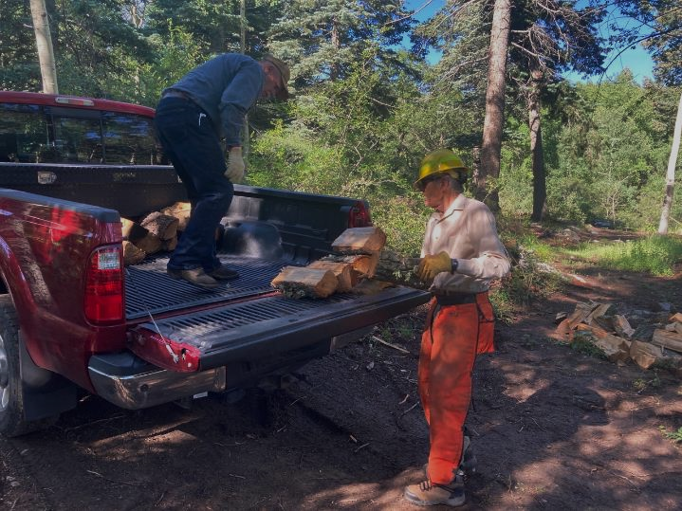

L to R: Jerry Carroll and Sim Cook loading Jerry’s pickup with Church Wood Ministry wood that was split earlier. All photos by Cliff Giles

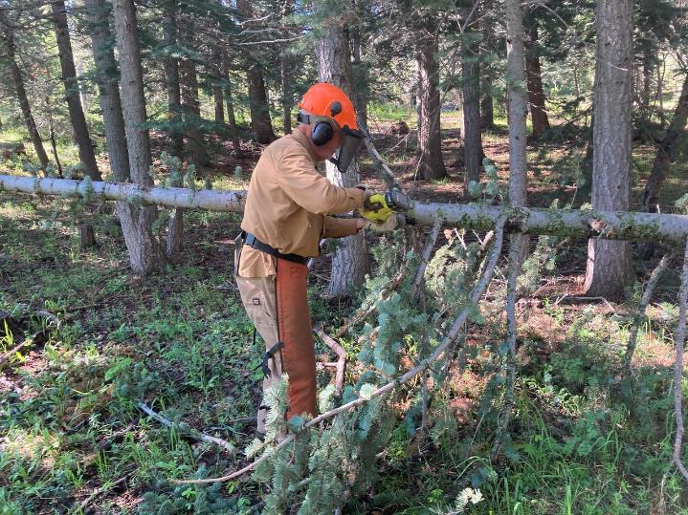

Dan Benton bucking a small tree that was felled earlier.

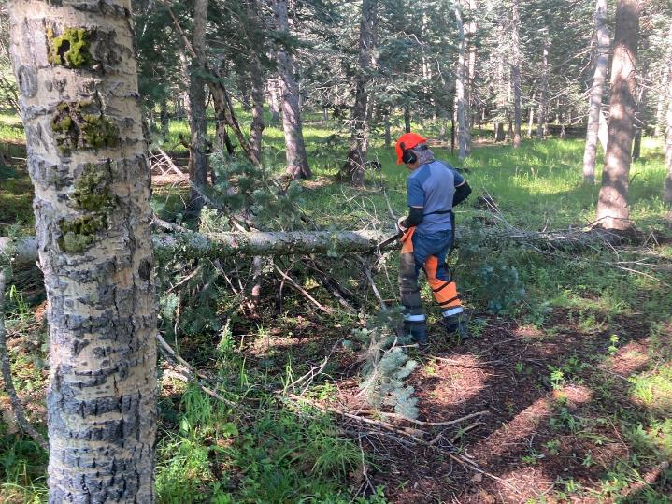

Steve Roholt limbing a small white fir that fell in the picnic area.

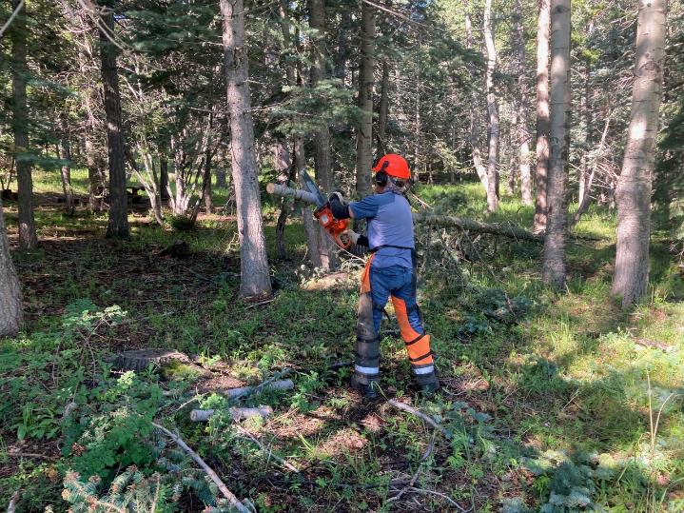

Steve bucking the small tree.

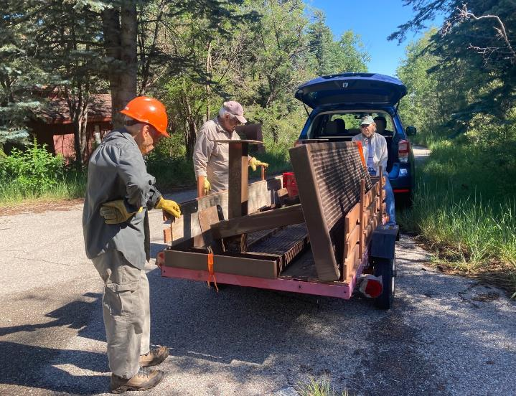

L to R: Don Carnicom, Lou Romero, and Joelle Hertel loading two surplus steel picnic tables from the Nine Mile PA reservation group area.

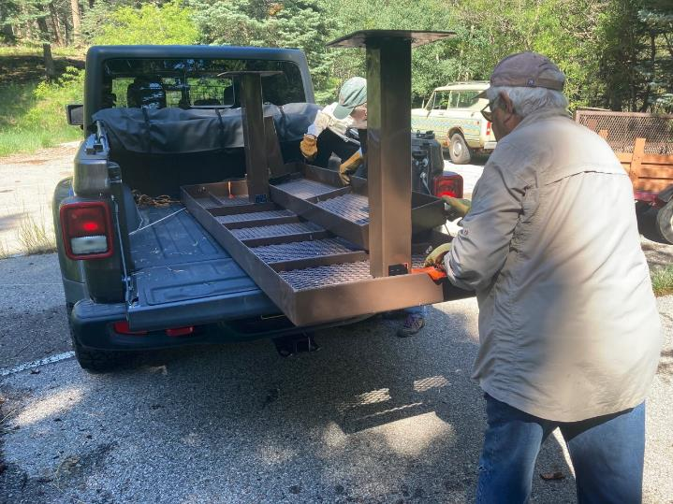

Joelle and Lou loading a surplus steel picnic table in Joelle’s truck.

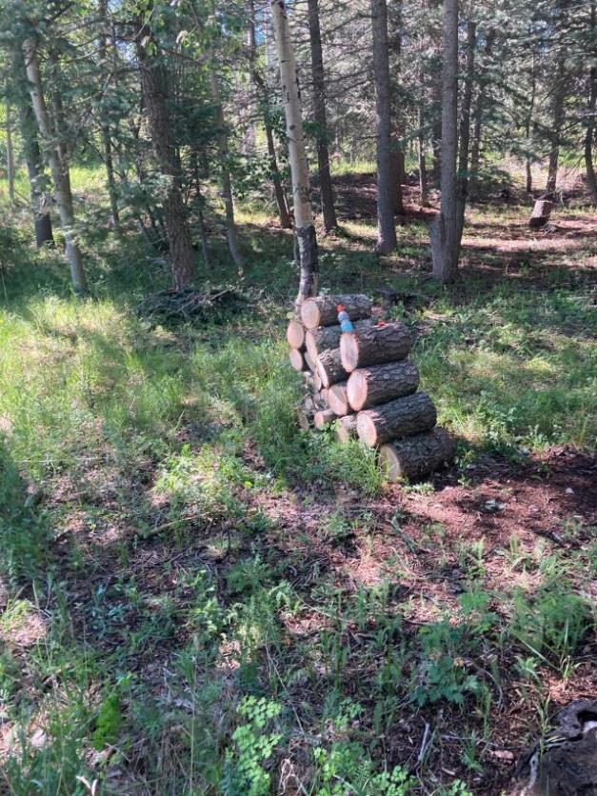

Bucked white fir wood that will be hauled to the Church Wood Ministry wood lot.

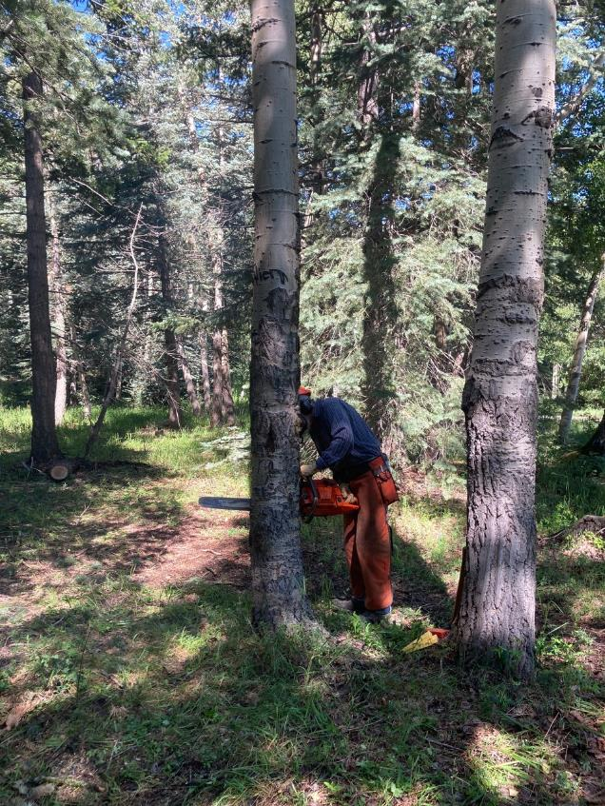

Byron Garner making the face cut in this dead aspen.

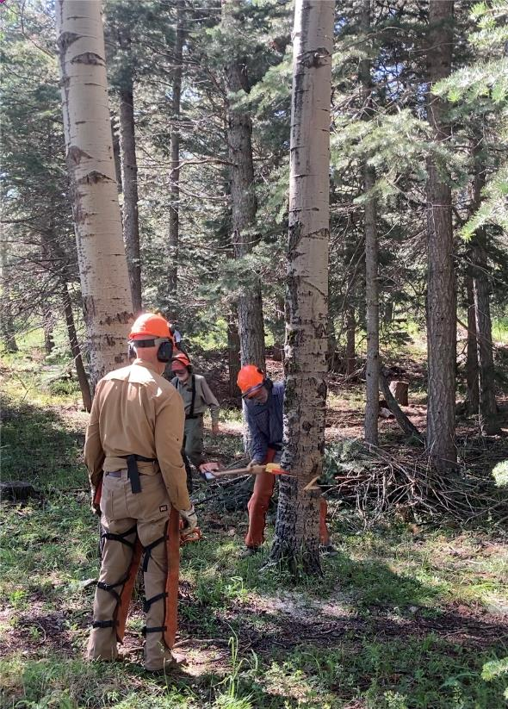

Byron driving wedges in the aspen to make it fall.

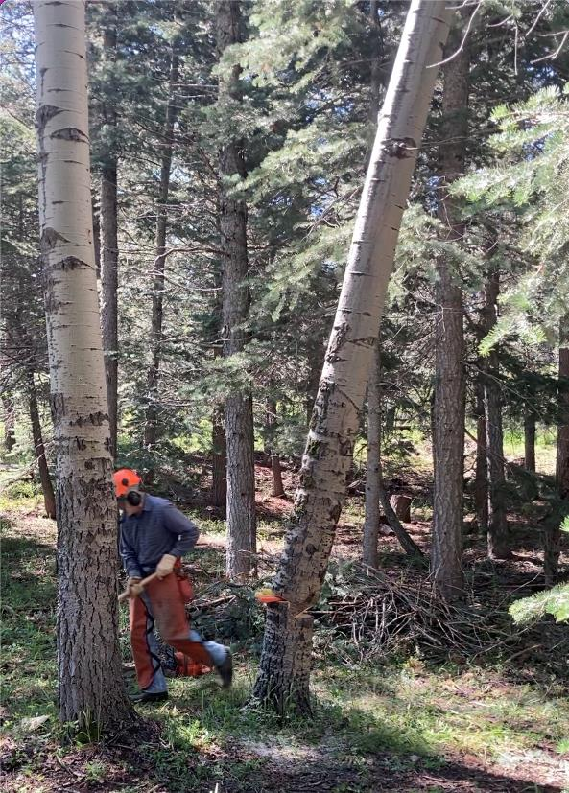

Byron running away from the falling tree.

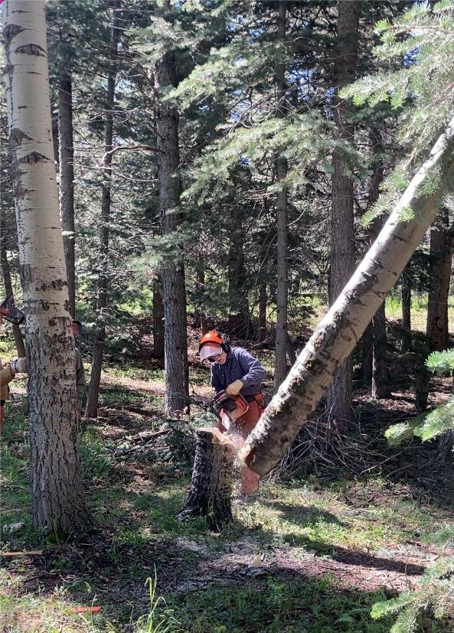

Byron cutting the hung-up aspen off the stump.

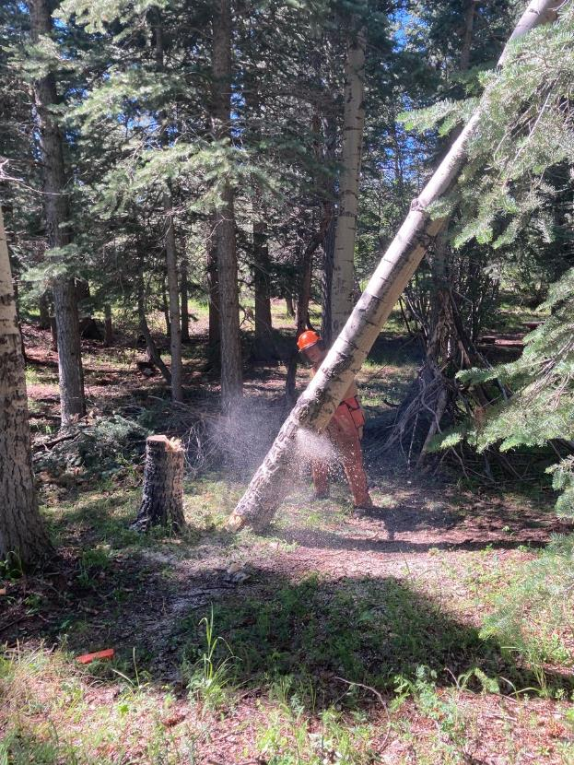

Dan cutting the hung-up aspen so that it will fall off of the adjacent tree branches.

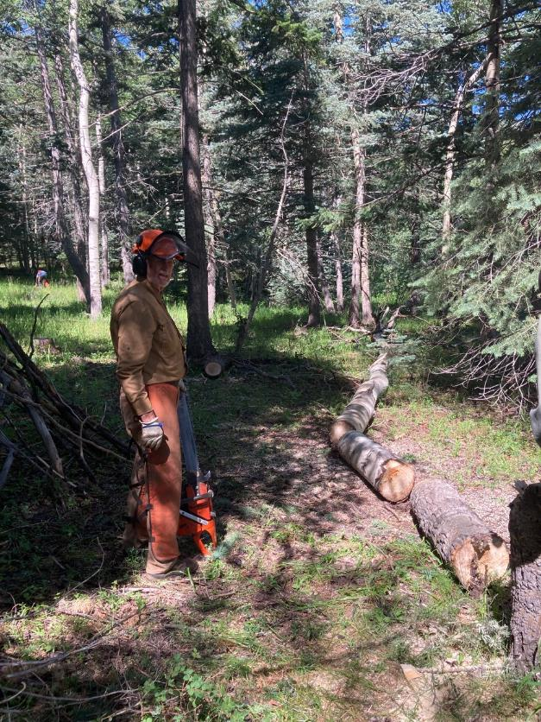

Dan and the partially bucked tree that has fallen to the ground.

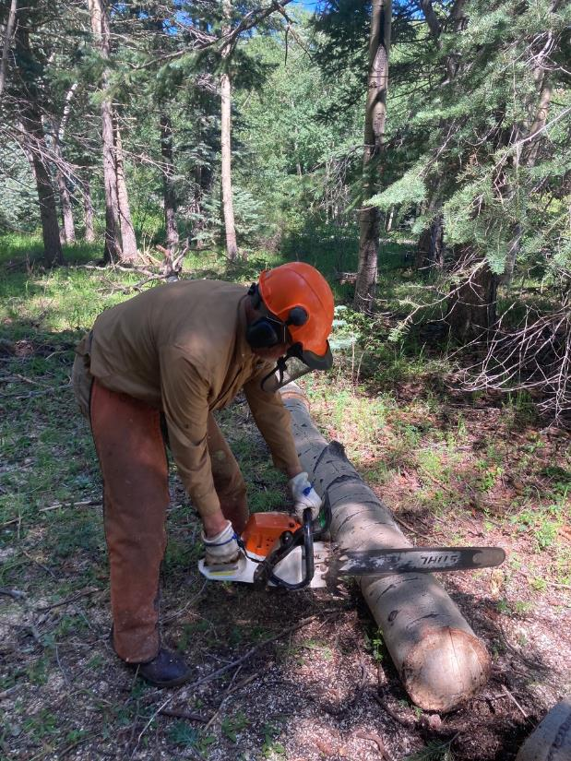

Dan bucking the aspen on the ground into 12-inch lengths.

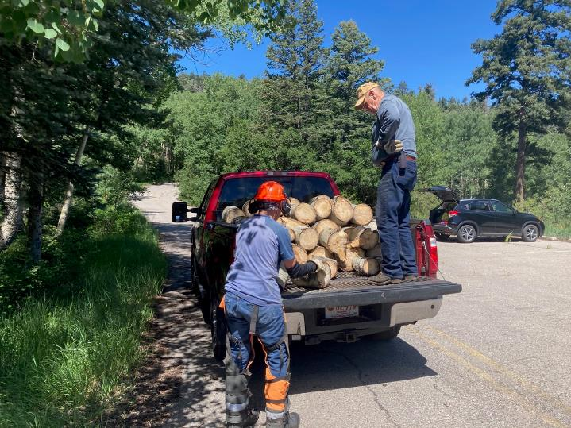

L to R: Steve Roholt and Jerry Carroll stacking aspen and white fir in Jerry’s pickup. This load was the second one hauled to the Church wood lot on Wednesday.