**Report of Painting Stripes in the Parking Lots at La Luz Trailhead, in Juan Tabo Picnic Area**

**and in La Cueva Picnic Area on Tuesday, July 12, 2022**

Anne Hickman

On Tuesday, July 12, the FOSM crew painting stripes in the La Luz Trailhead parking lot, the Juan Tabo PA parking lots, and in some of the La Cueva PA parking lots.

The painters were Anne Hickman, Jane Harrison, and Sam Beard.

Project photographs are presented below.

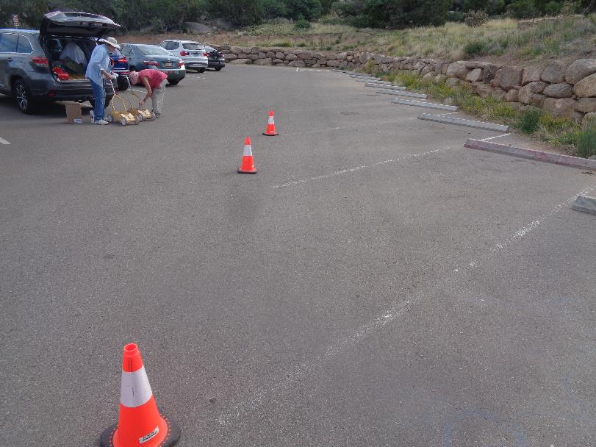

The parking stripes on the east side of the La Luz Trailhead parking lot needed to be painted. All photos by Sam Beard

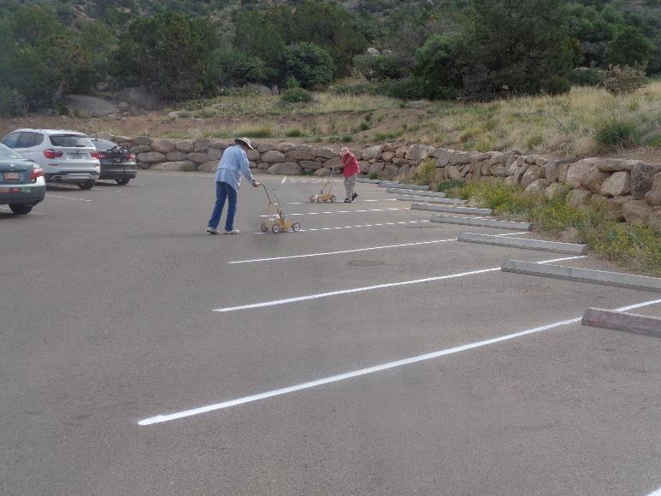

L to R: Anne Hickman and Jane Harrison painting stripes in the La Luz parking lot. Today was the first time that the crew

painted stripes in the new parking lot.

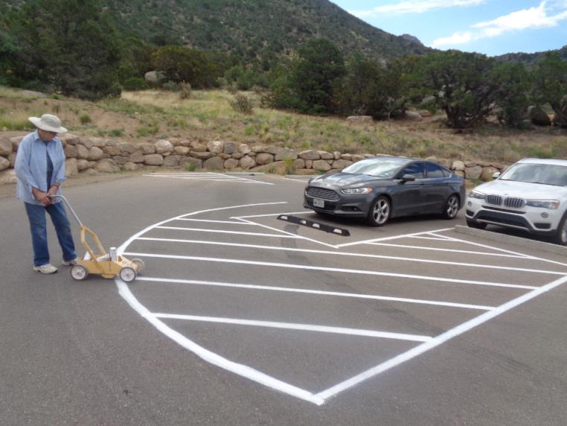

Stripes at the north end of the parking lot.

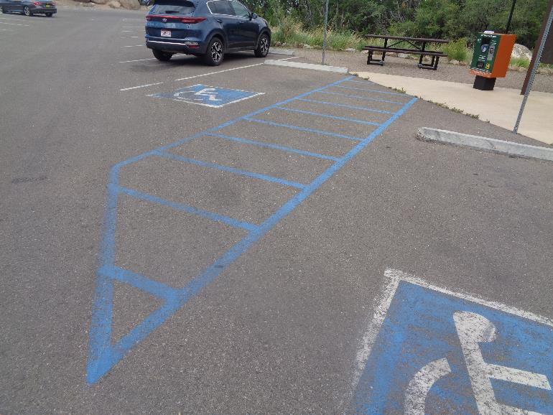

Blue stripes beside the pay post needed to be painted.

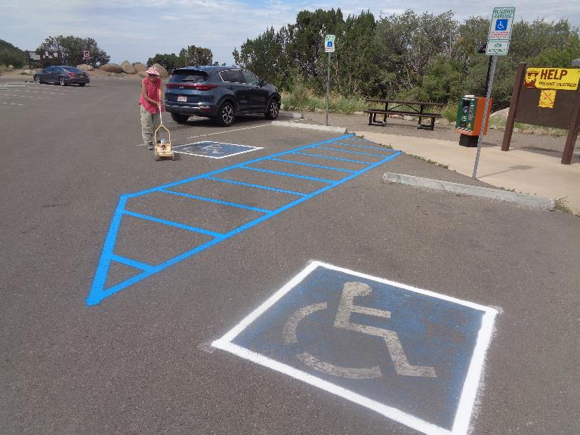

Jane Harrison painted the blue stripes and also the white stripes around the wheel chair figure.

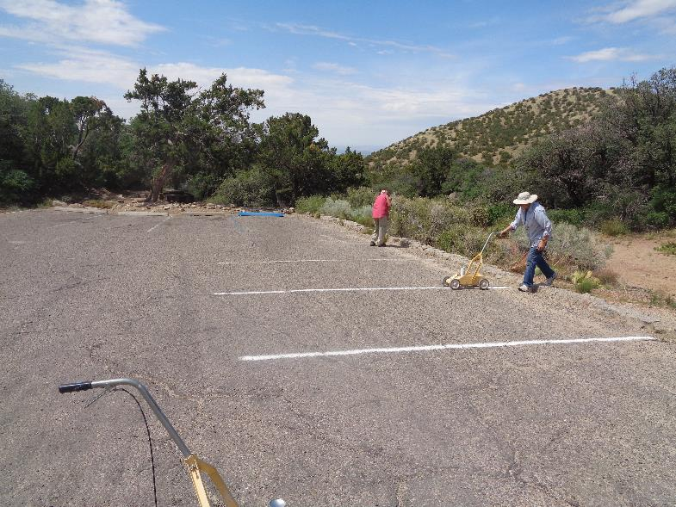

Jane and Anne painting stripes in the first parking lot in La Cueva PA. The stripes in the picnic areas

had not been painted for several years.

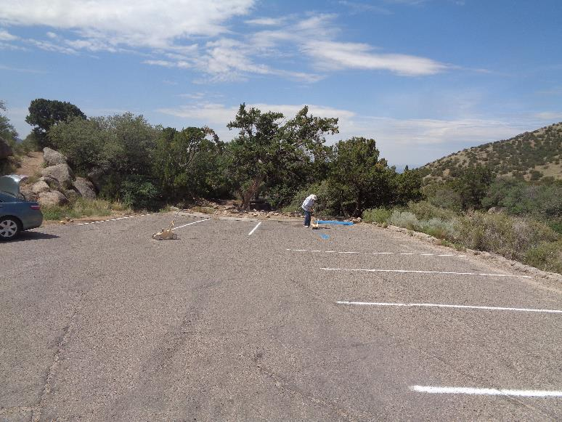

Anne is painting a blue stripe in the corner of the parking lot.

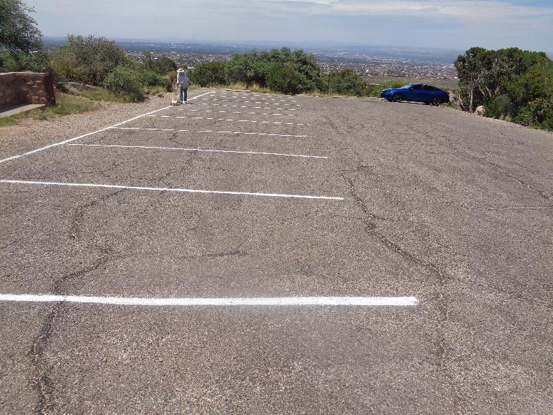

The last stripe to be painted in this La Cueva PA lot. The driver in the blue car backed away from the stripes when he saw that

we were painting. After we finished, he drove over and parked in the stripes again.

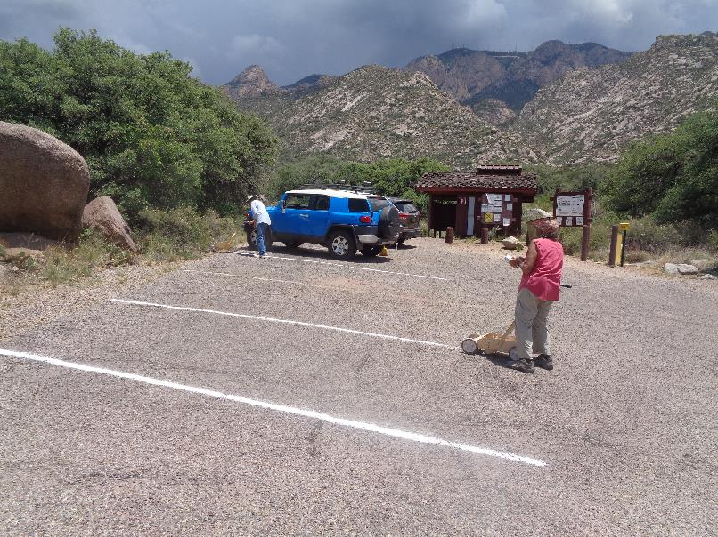

Painting stripes in the lot at the La Cueva PA restroom. Note the dark clouds over the Crest.

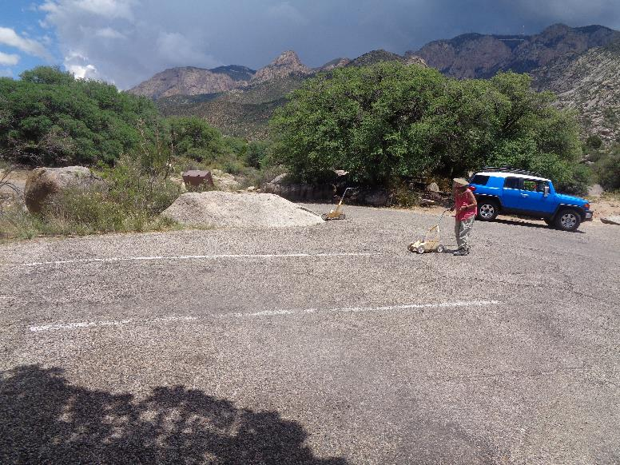

Painting in the small lot south of the restroom. We stopped painting after completing this lot due to the lightning.