**Report of FOSM Project to Clear a Corridor for Rerouted Segment of the Sandia Nordic Ski Club Klaus Trail and Remove Down Trees from this Trail on Saturday, July 16, 2022**

Scott Dietrich and Sam Beard

On Saturday, July 16, Scott Dietrich, President of Sandia Nordic Ski Club, together with Sam Beard and Mike Madden led an outing of FOSM members to clear a rerouted section of the Sandia Nordic Klaus Trail. The group, which in addition to those mentioned above also consisted of Eric Russell, Michael Arndt, Dennis Crowther, Cliff Giles and Steve Roholt, worked on the section of Klaus across the Service Road from the small clearing just south of the gravel pit. Saturday’s work included bucking several large trees which had fallen previously and ranged in diameter from 18-30+ inches. A mix of mostly dead and a few live trees ranging in diameter from 3 to 18 inches were also felled to create the new trail corridor. The crew also felled several dead cigar butts ranging in diameter between 12-18 inches.

Project photographs are presented below.

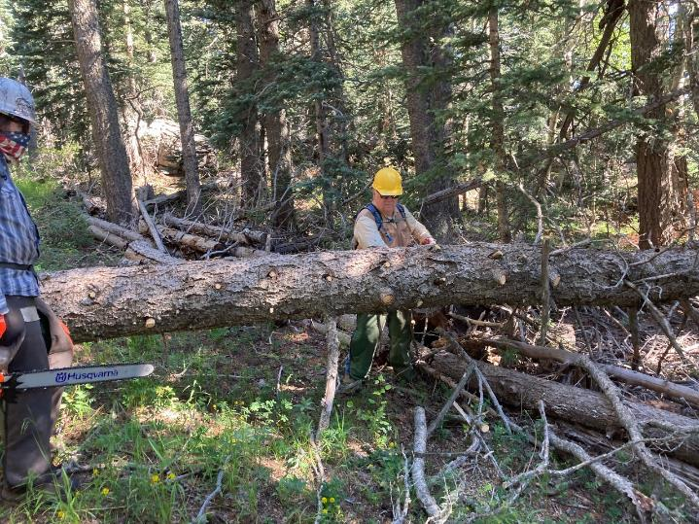

Dennis limbing log while Michael waits to buck it. All photos by Cliff Giles unless noted otherwise

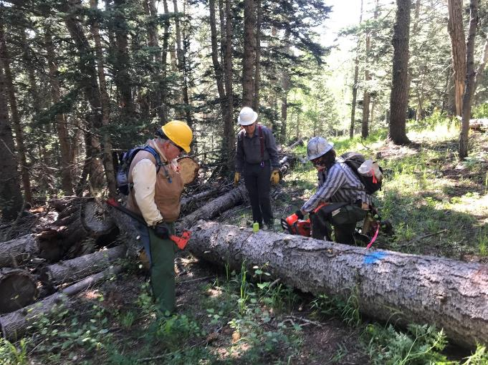

Michael Arndt bucking a large tree that had previously fallen across the new corridor as Cliff Giles and Dennis Crowther wait to move the bucked log off the trail. Photo by Scott Dietrich

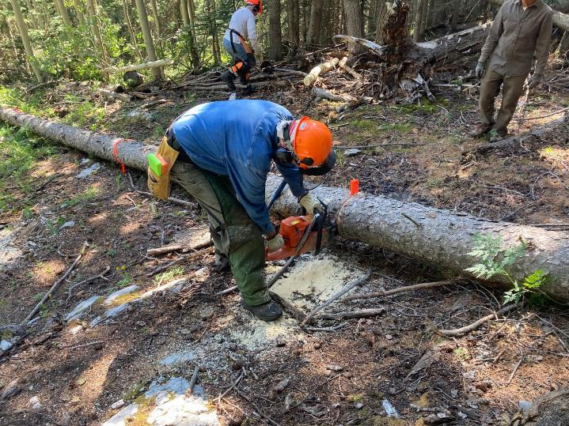

Eric Russell bucking a log.

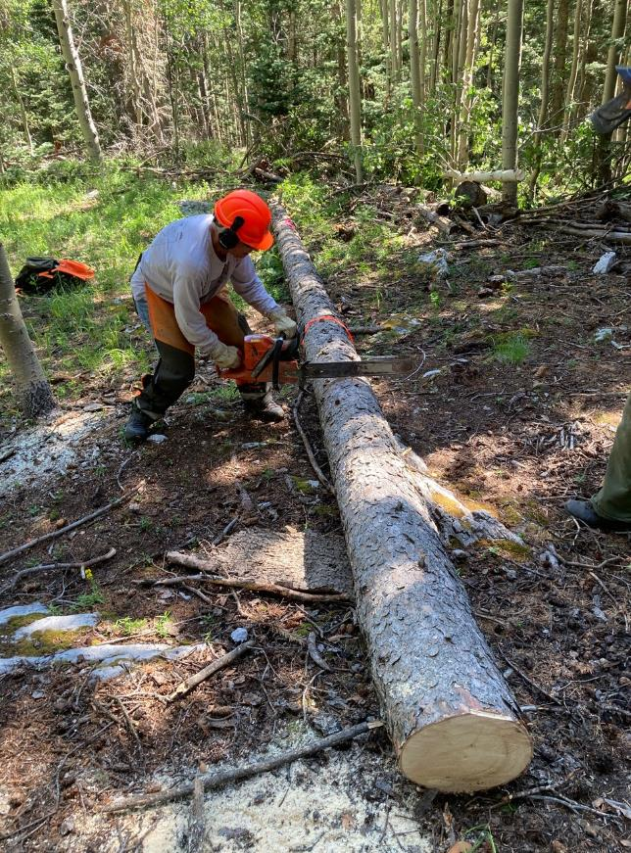

Steve Roholt bucking a log.

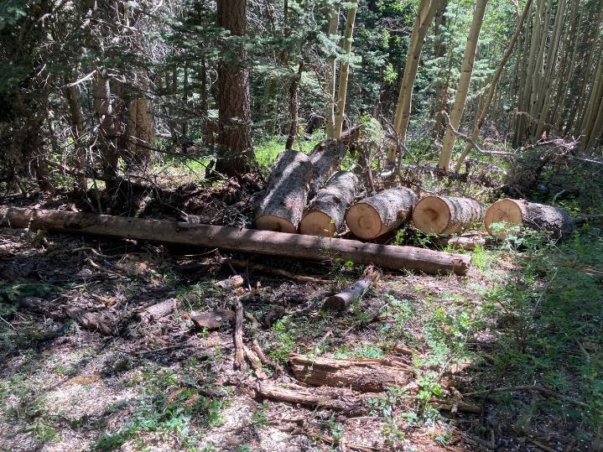

Bucked log sections that have been moved off the trail.

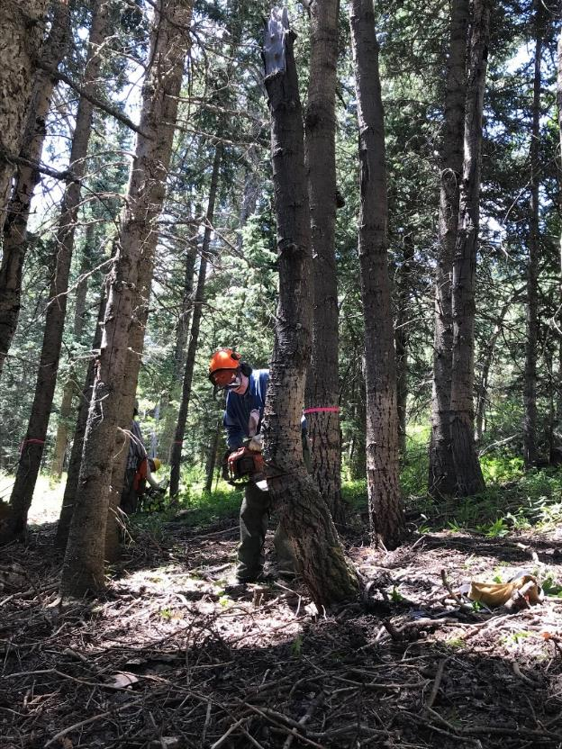

Eric Russell felling a small aspen cigar butt from the new Klaus reroute.

Photo by Scott Dietrich

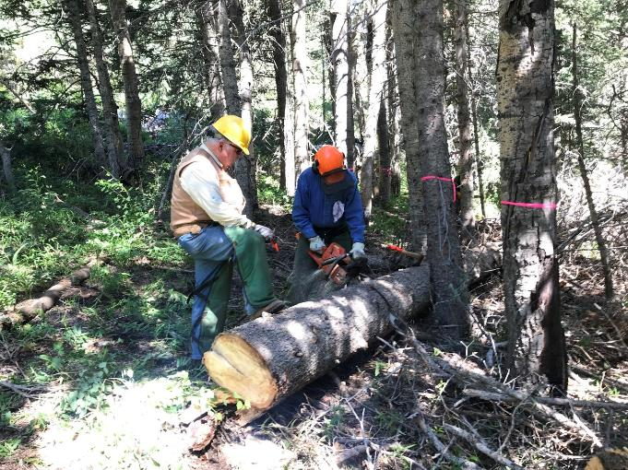

Eric Russell bucking a fallen tree from the trail as Dennis Crowther waits to move the bucked log off the trail.

Photo by Scott Dietrich

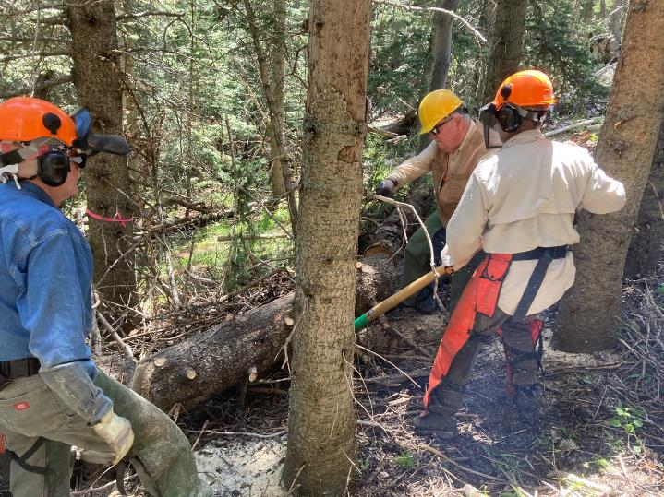

Eric watches while Scott and Dennis move log section away from trail.

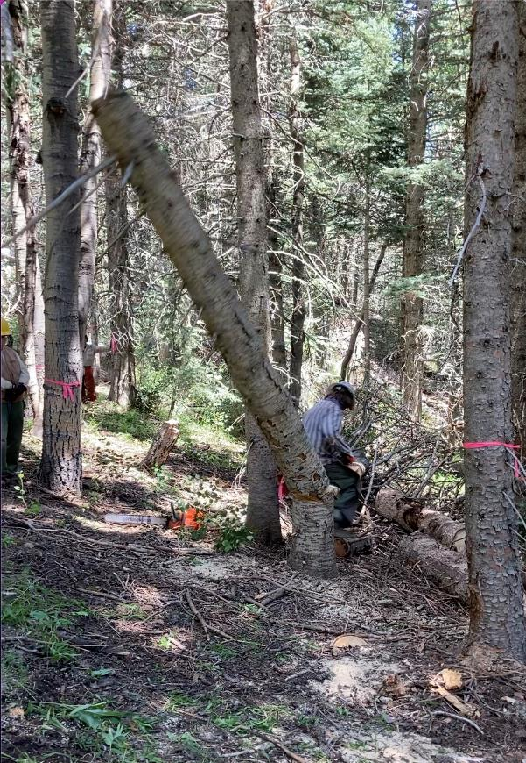

Michael Arndt running away from a falling tree.

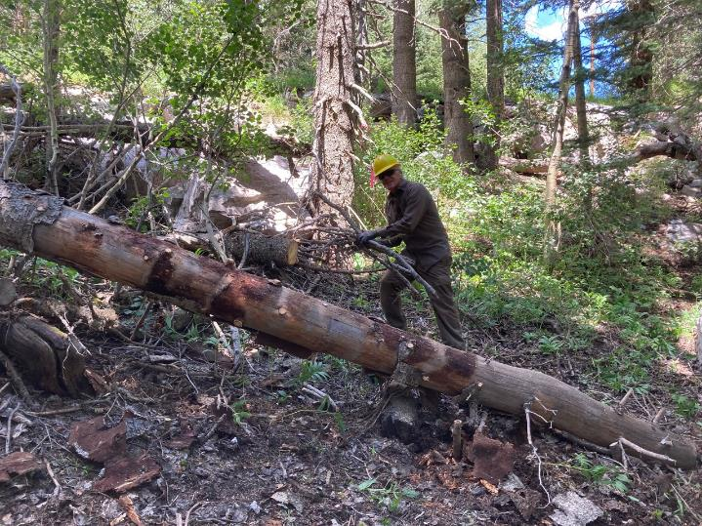

Mike Madden moving branches off the trail.

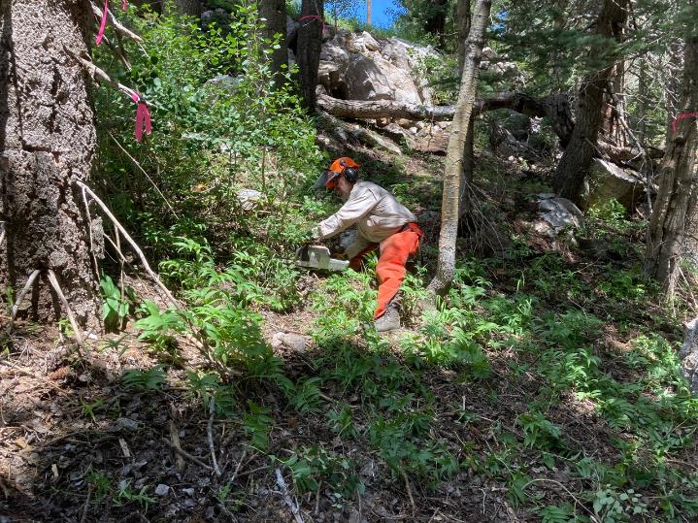

Scott cutting brush off the trail.

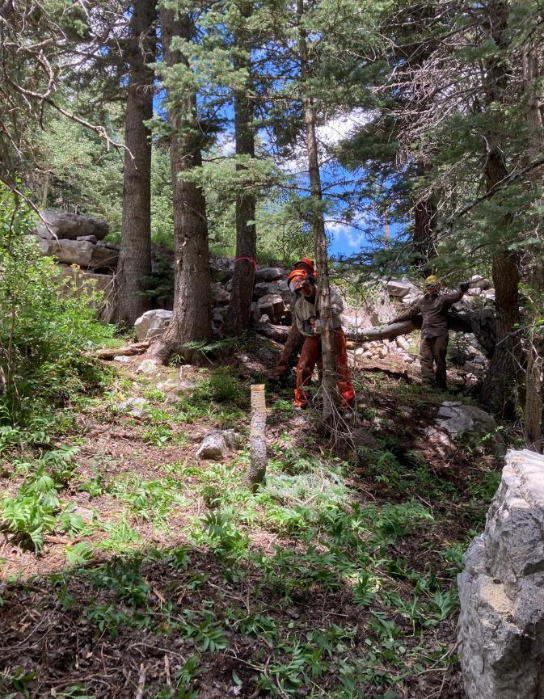

Scott Dietrich felling a small tree.

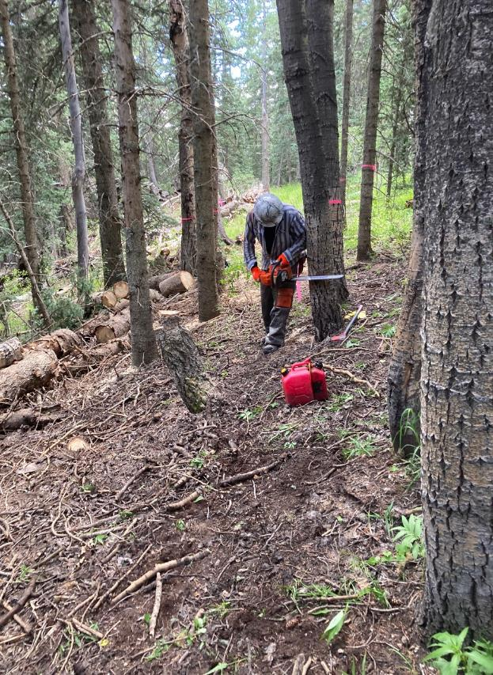

Michael Arndt starting a face cut in an aspen.

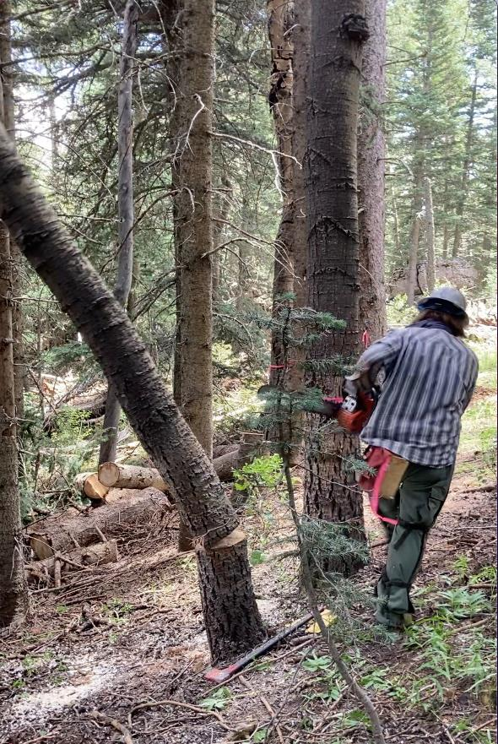

Michael running away from a falling tree.

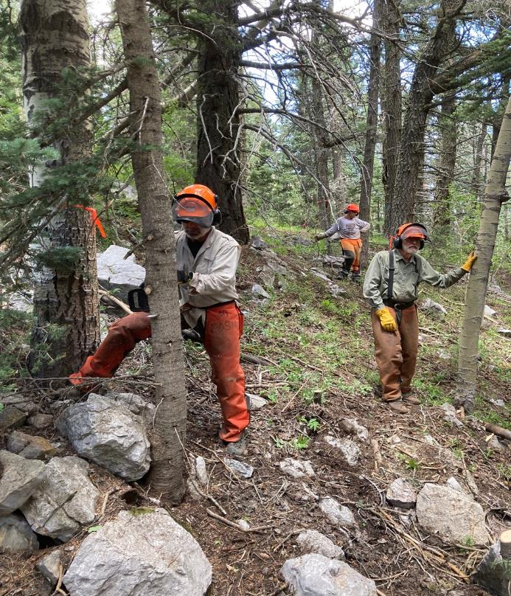

Scott felling a small tree with Sam and Steve in the background.

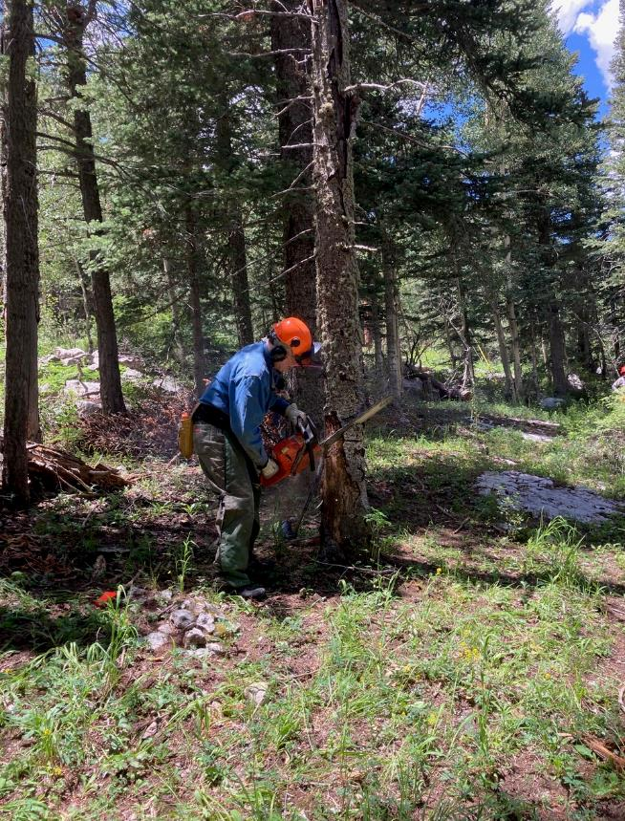

Eric starting a face cut in a dead fir.

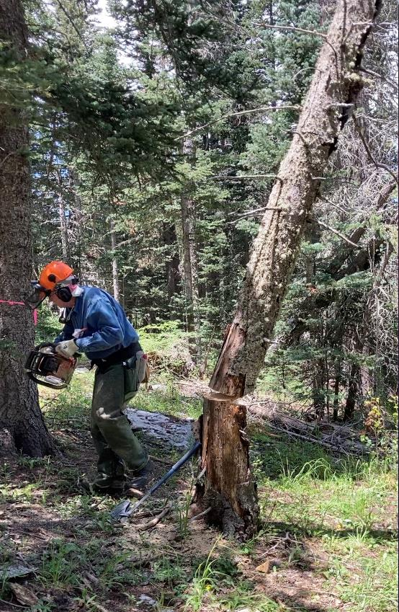

Eric running away from the falling tree.

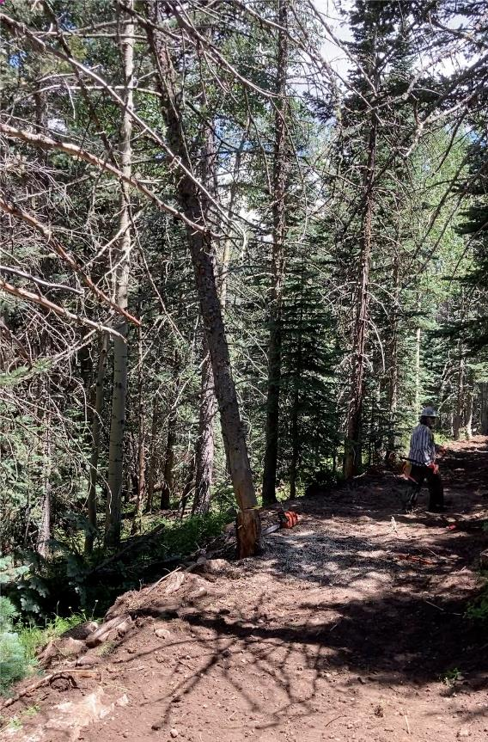

Michael running away from a falling tree on segment of graded trail.

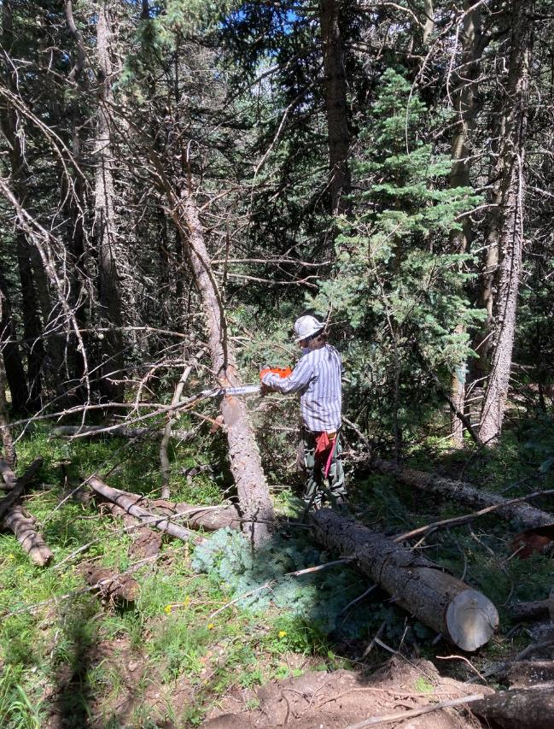

Michael limbing a tree that was hung-up.

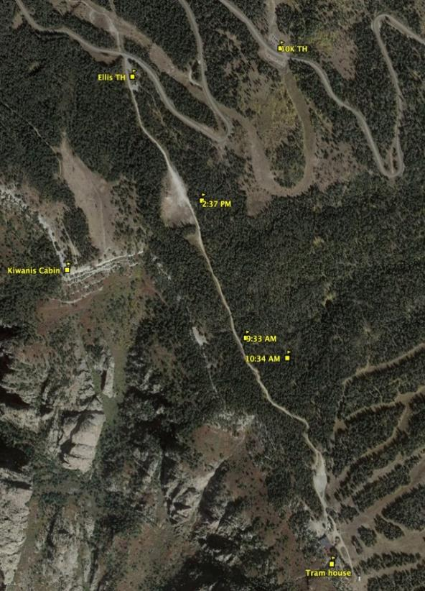

Google Earth Satellite Photograph showing the area on Sandia Mountain between Ellis

Trailhead and the Upper Tram Terminal. The AM and PM times indicate where the Klaus

Trail work occurred on Saturday. The Service Road lies between Ellis TH and the Tram

Terminal.