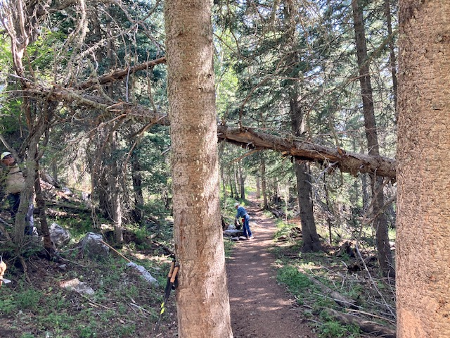

This ten-inch diameter fallen tree was located a little less than a mile from the Crest highway on Crest Trail 130 North. This photo is looking north.

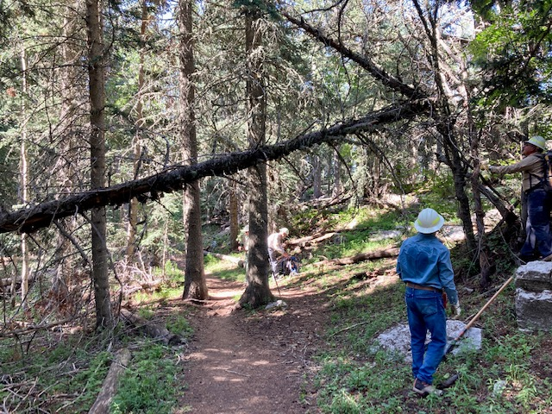

This is a photo of the same tree as in the previous photo. It shows the broken-back top of the tree. This photo looking south.

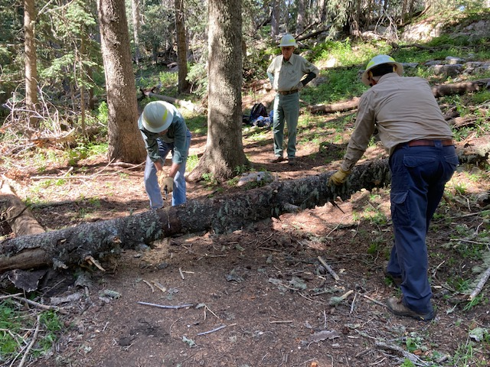

After getting the hung-up tree safely on the ground, it is being cut so that it can be removed from the trail.

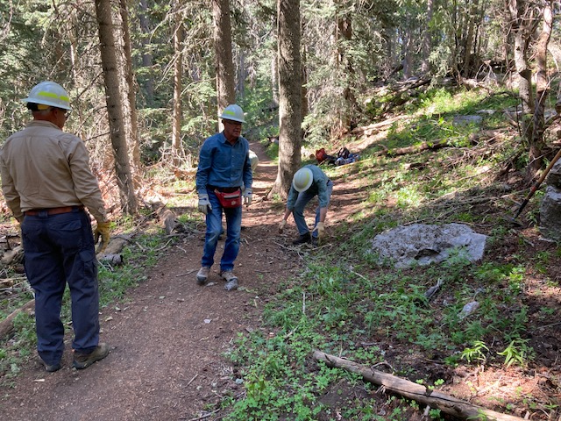

The tree has been removed and Crest Trail 130 north is clear at this point.

These small tree sections were protruding into Crest Trail 130 North about

two miles north of the highway. They were cut back.

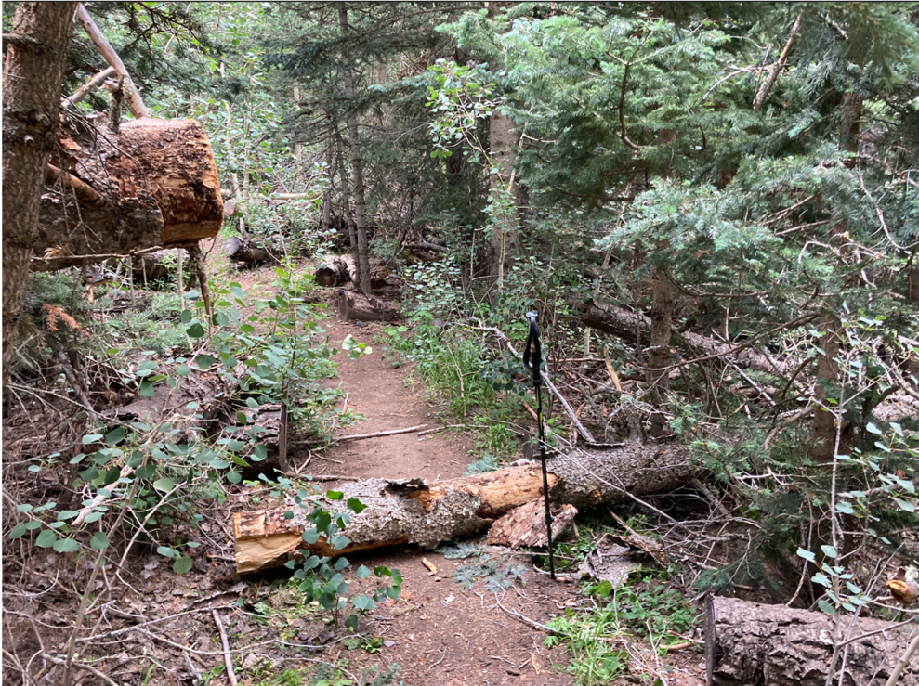

This 10-inch diameter tree had been suspended over 10K North Trail about 100 feet downhill from the Survey junction. It was cut and limbed earlier by another volunteer. The crew removed the tree from the trail and cut back the cut end shown in the upper left of the photo.

Tree in previous photo has been removed and 10K North Trail is clear at

this point.

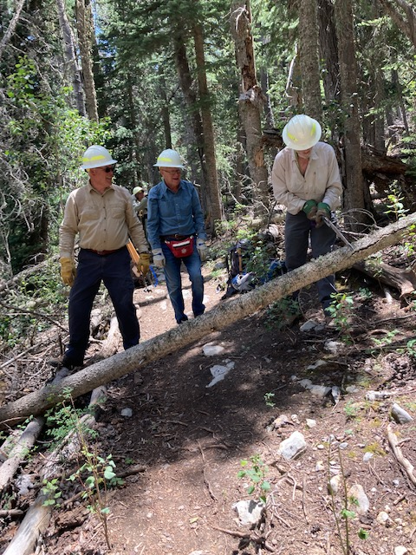

This small fallen tree was one of several removed from Survey Trail south

of the 10K North junction.

This was one of several small protruding logs that were cut back from the

margins of Survey Trail.

This 11-inch diameter green aspen tree had fallen along Survey Trail about

a mile south of the 10K junction. It required two cuts to remove it.

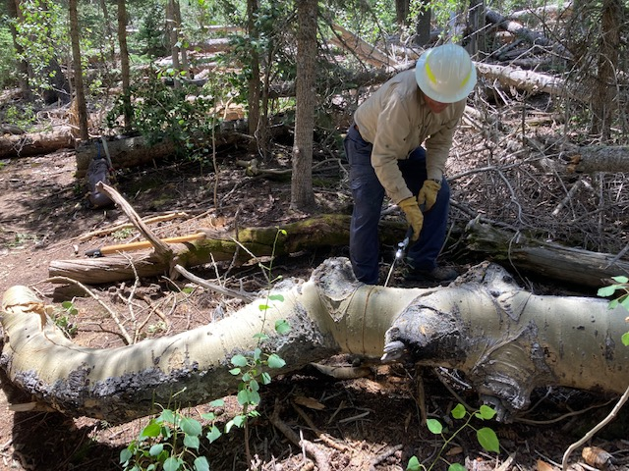

The second cut is being made on the fallen aspen tree.

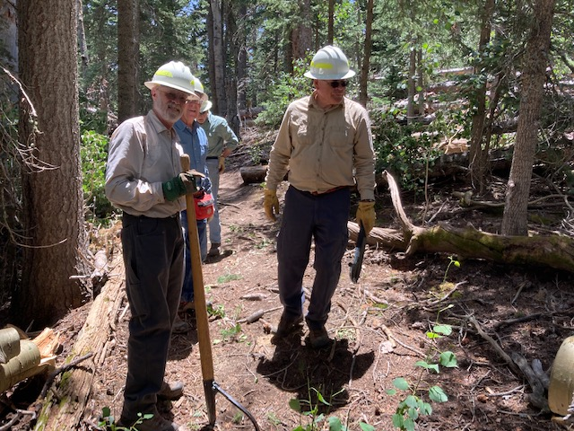

The crew looks over the scene after the big aspen has been cleared from the trail.

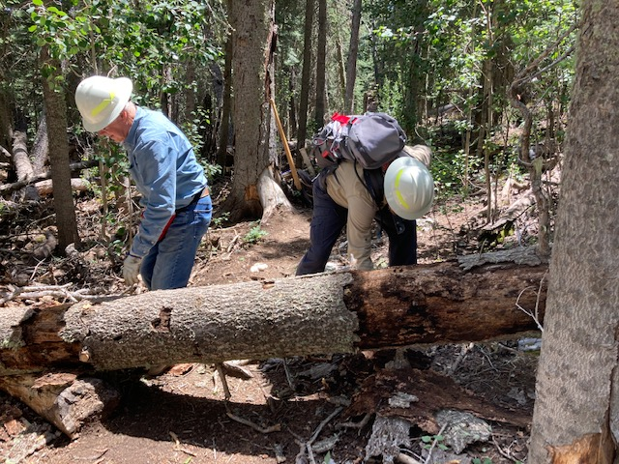

Now for some serious business… This 17-inch diameter fallen fir was blocking Survey Trail about 1000 feet north of the power lines.

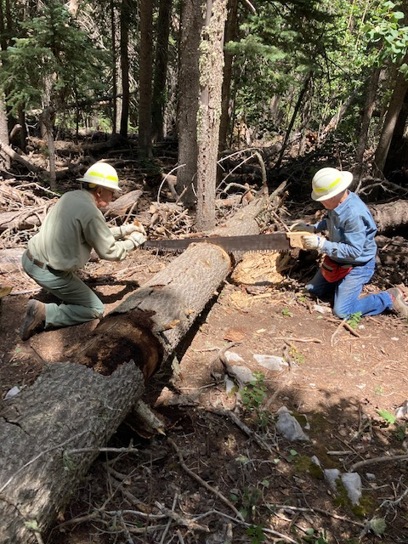

Time for the big saw. The first cut is being made on the 17-inch tree.

The big tree has been cut and moved off the trail.

This very tall 7-inch diameter aspen had fallen away from the trail. It root ball

(Which can’t be seen in this picture) has popped up exposing ragged roots which

produced a tripping hazard. The top of the tree is some thirty or so feet up to

the right and is resting on the branches of another tree. The slope drops off

steeply to the right. The plan was to cut the trunk so the tree would fall off

to the right, away from the trail. David starts the cut.

As David cut the tree, it began to sag very slowly. He moved swiftly away.

The tree very slowly continued to sag and finally broke and fell downhill

into the forest below. Even the ragged base of the tree fell off the trail thereby

finishing the job of clearing the trail.

Sometimes removing protruding trees is a little more complicated than usual.

Unfortunately, there were no ripe raspberries to be found.

The crew discovered this hazardous widow maker about 900 feet north of

power lines. This area has been flagged. Please see separate CTR report for details.