**Report of FOSM Project to Clear the Corridor for the South Crest Trail**

**Reroute near North Gravel Pit Trailhead on Wednesday, July 20, 2022**

Sam Beard

On Wednesday, July 20, FOSM volunteers cleared most of the corridor for the South Crest Trail reroute located near the north Gravel Pit Trailhead. This reroute will eliminate a steep rough segment of the present Crest Tral that follows the old buried cable right of way. Slash will be used to close all of the bypassed trail segment and more of the buried cable ROW extending to the Kiwanis Meadow Trail.

One 12-inch diameter hang-up and one 6-inch fir tree remain to be removed.

The volunteers working on Wednesday were Steve Roholt, Dennis Crowther, Dan Benton, Cliff Giles, Eddie Moore (ABQ Journal photographer), Sim Cook, Jerry Carroll, Byron Garner, Lorna Morrow, Andre Biane, and Sam Beard.

Project photos are presented below.

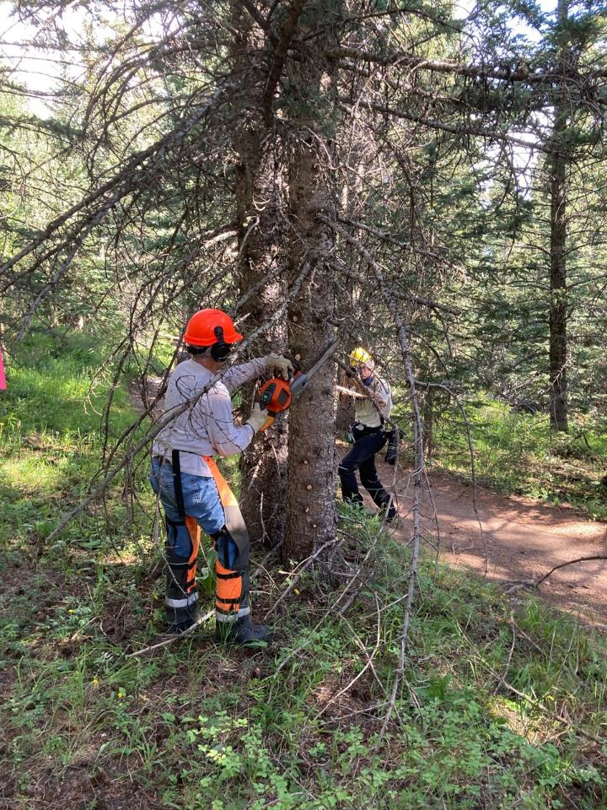

Steve Roholt limbing a tree at the south end of the reroute. He is using the FOSM battery-powered.

chain saw. Note the original trail to the right of the tree. Eddie Moore, Albuquerque Journal, is taking

a picture in the background. All photos by Cliff Giles

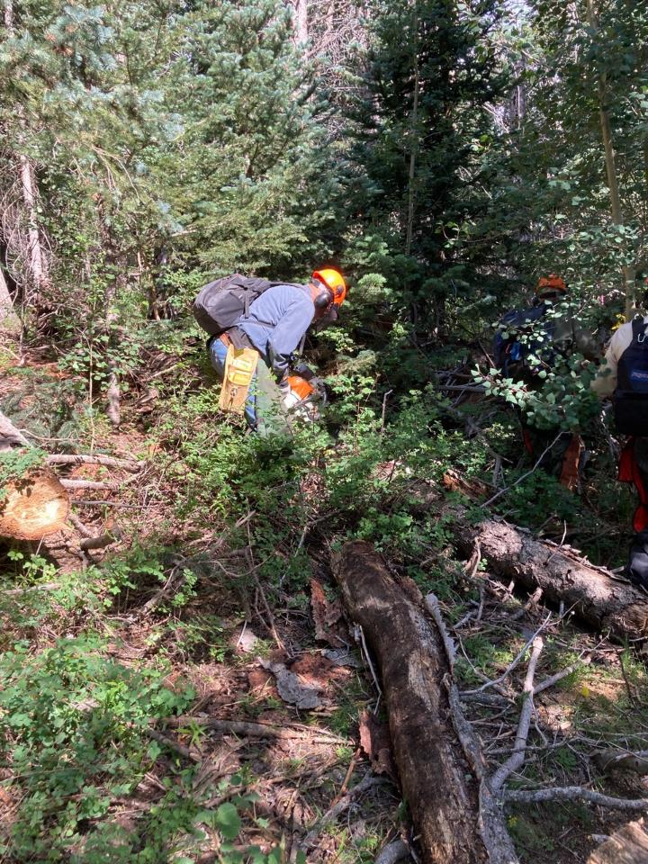

Jerry Carroll is bucking a log to begin clearing the corridor at this location.

Note the dense forest.

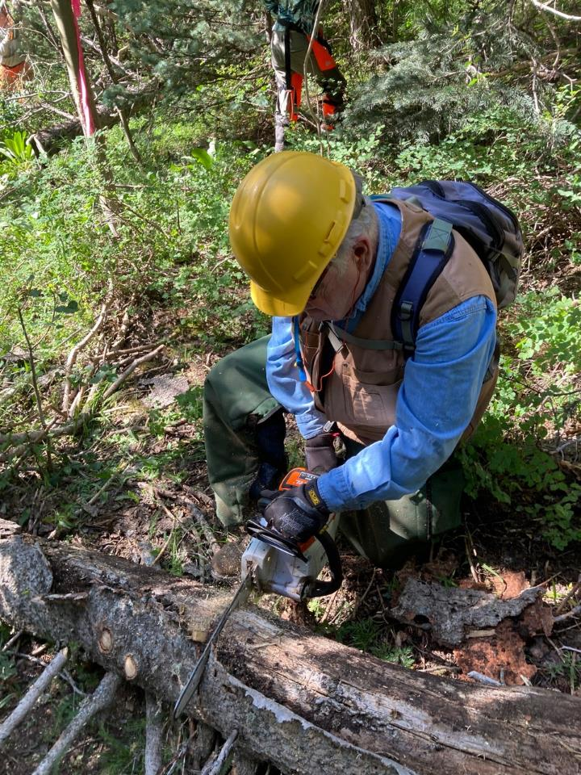

Dennis Crowther cutting a log with his battery-powered chain saw.

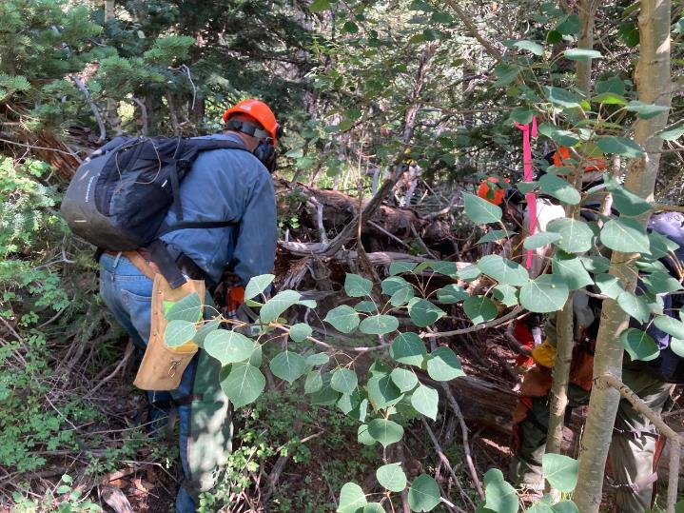

Jerry bucking a log. Note the pink flag marking the trail route.

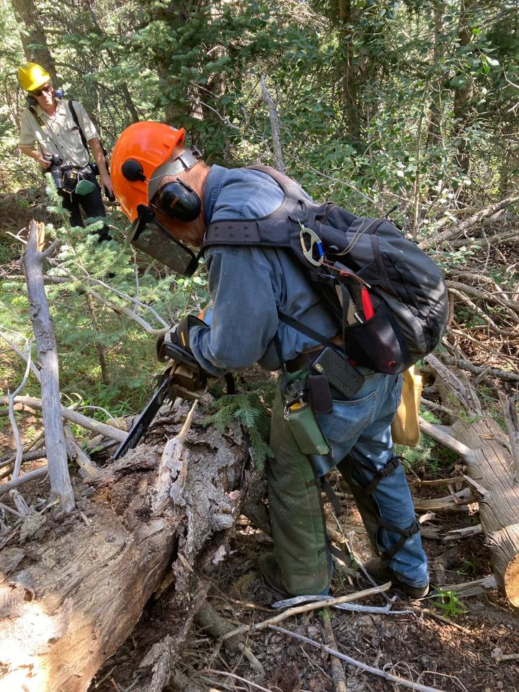

Jerry limbing a log. Note Eddie in the background.

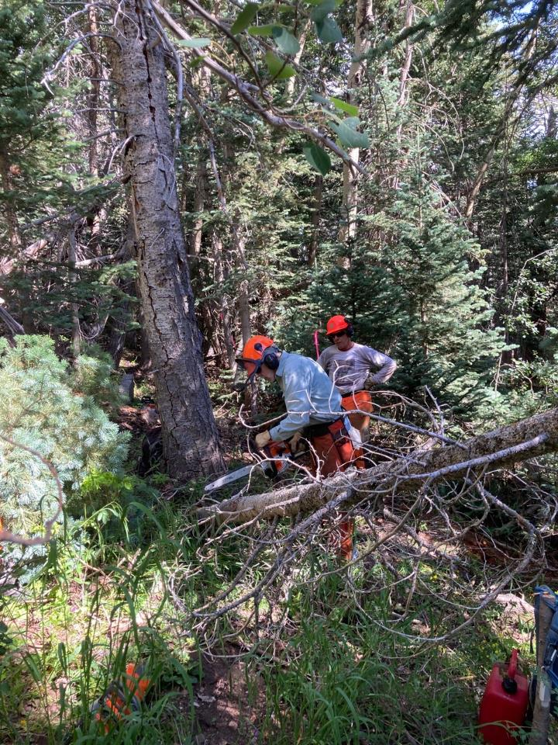

Byron Garner cutting a small tree while Steve observes.

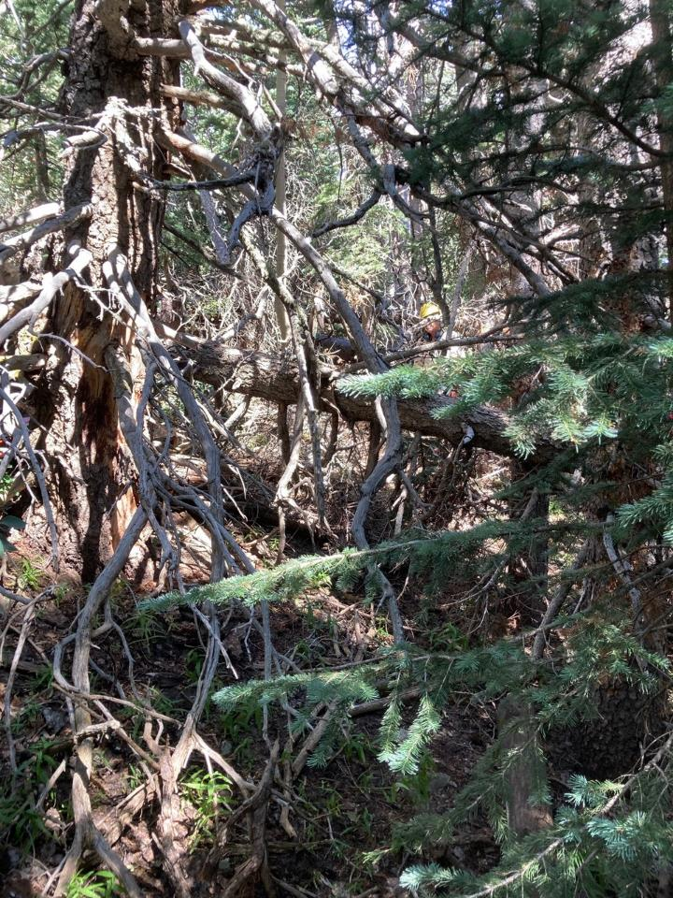

This picture shows how dense the trees and brush were along the route. Note the person with the yellow hard

hat near the center of the photo. The large dead tree on the left was later felled.

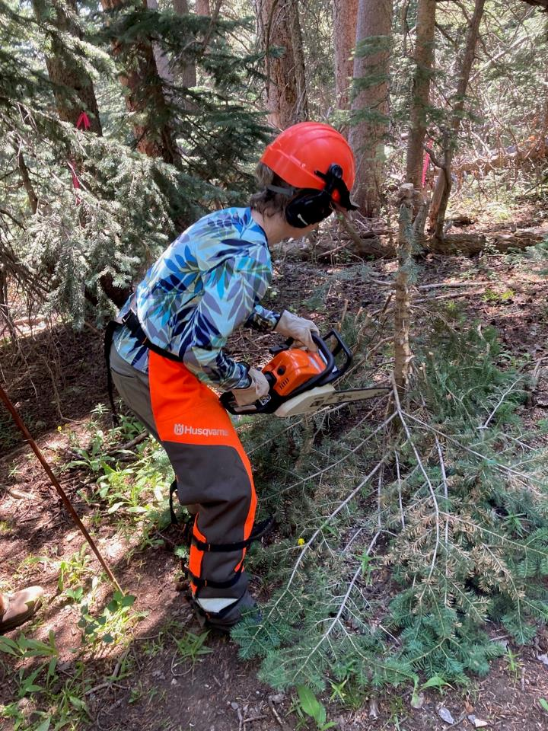

Lorna Morrow limbing a small white fir with her chain saw.

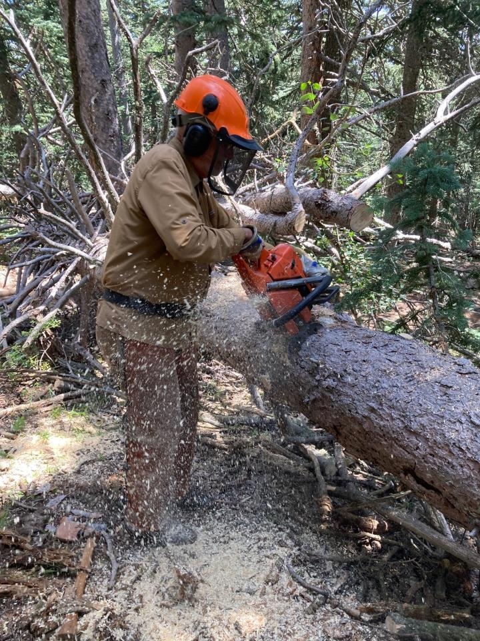

Dan Benton bucking a large spruce log. Dan and Jerry made most of the initial cuts in clearing the route.

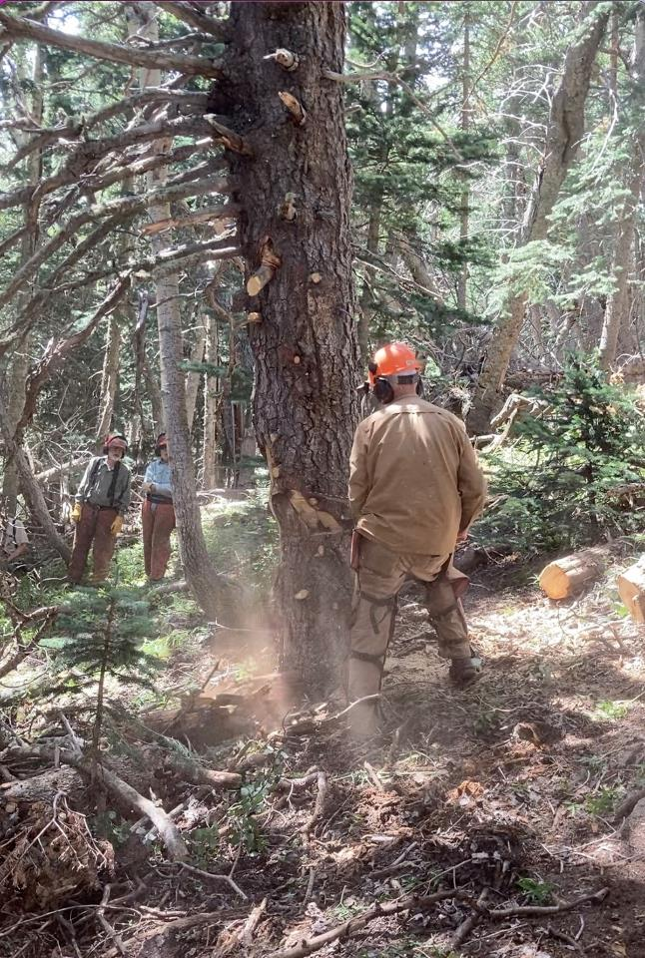

Dan making the face cut in this large dead cigar butt tree.

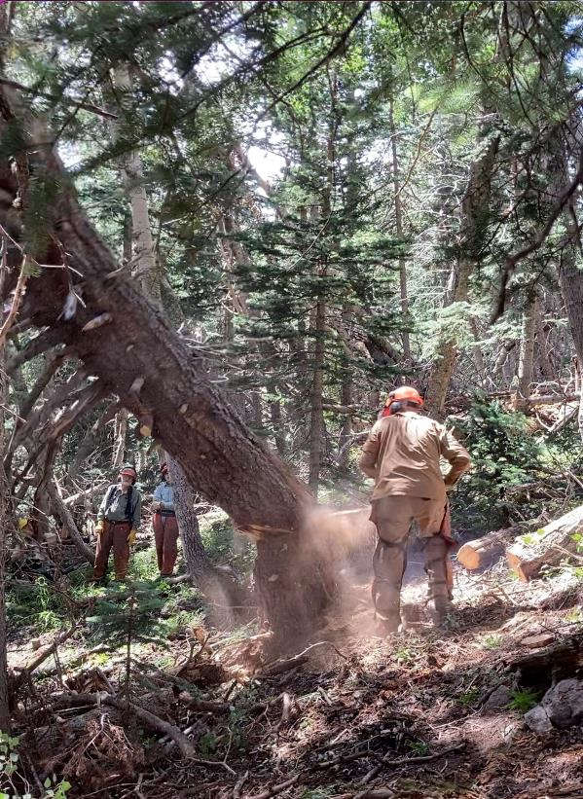

Dan running away from the tree as it falls.

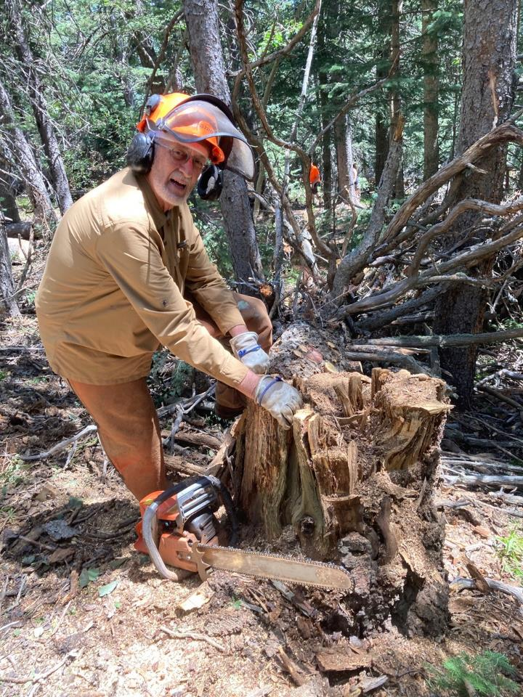

Dan and the chain saw at the stump after he felled the large tree. It was important to fell this hazard tree,

because it was so rotten that it could be moved manually before it was felled.

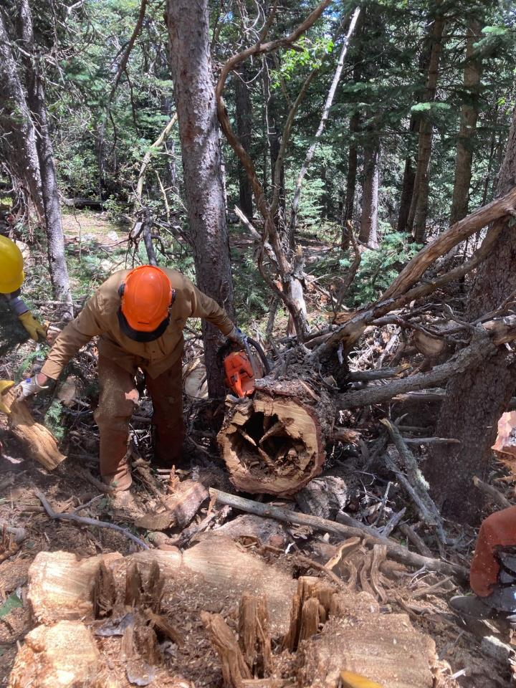

This large dead tree was mostly hollow.

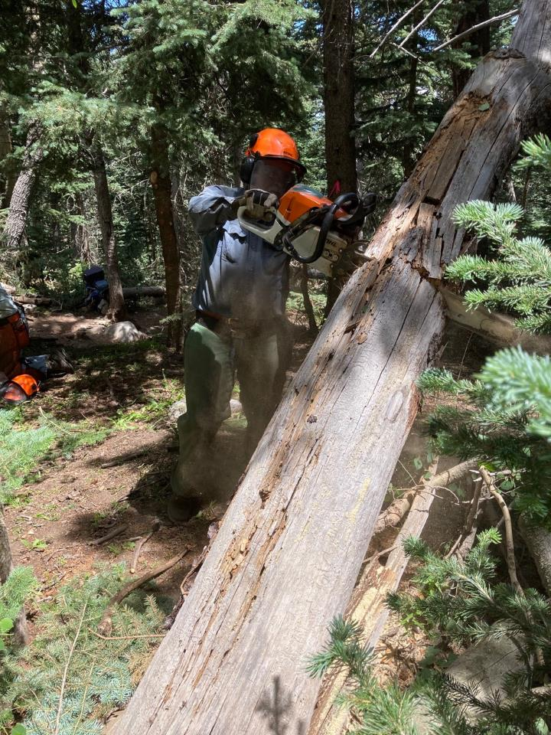

Jerry bucking a low hang-up.

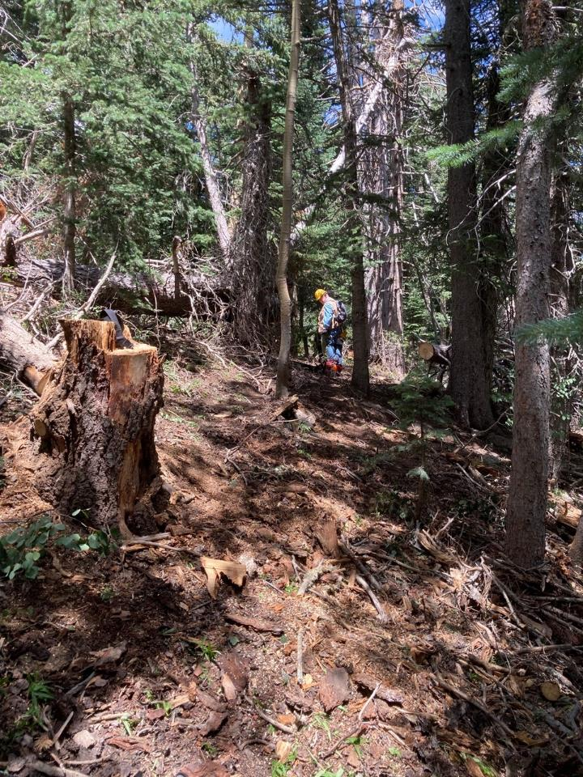

The corridor was mostly clear at this location. Dennis is in the background.

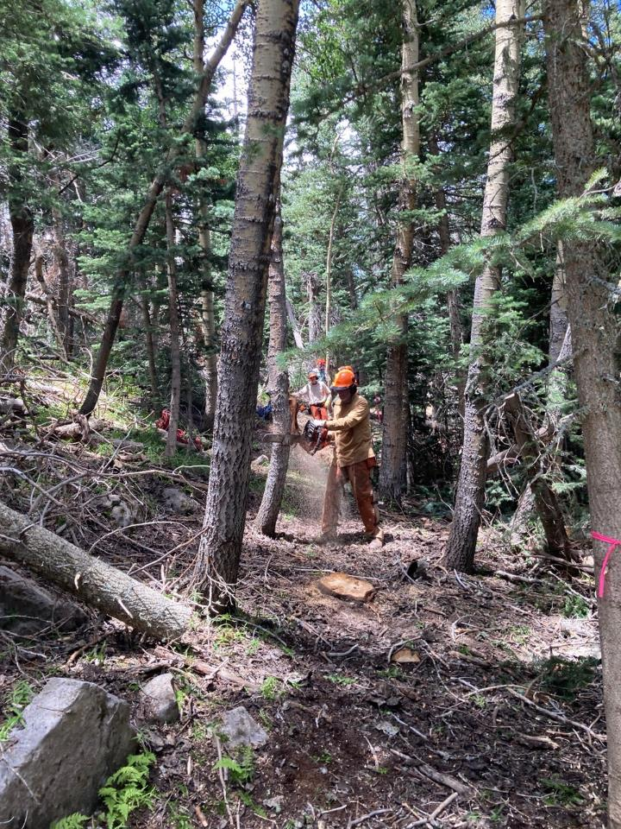

After brush and small trees were cleared along the corridor, sawyers like Dan went back

and felled small trees.

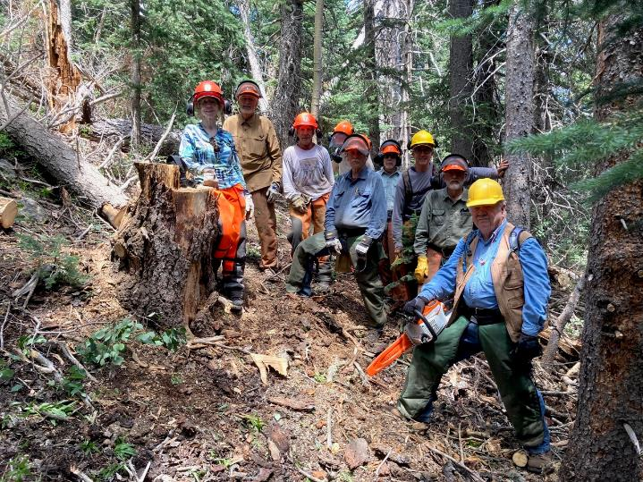

The trail clearing crew. L to R: Lorna Morrow, Dan Benton, Steve Roholt, Sim Cook, Jerry Carroll, Byron Garner,

Andre Biane, Sam Beard, and Dennis Crowther.

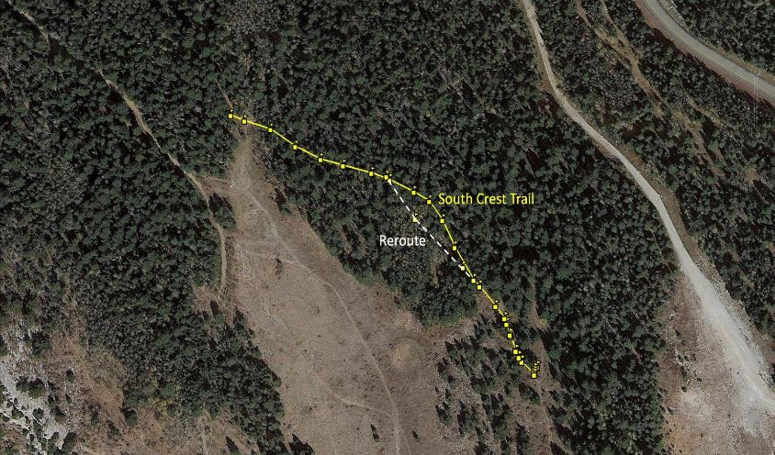

The original route of the South Crest Trail here is shown in yellow. The rerouted segment

is shown in white. The Service Road to the Upper Tram Terminal and the Crest Highway

are south of the rerouted trail. Map by Cliff Giles