Jamey starts the cut on the end of fallen tree that was protruding just a bit too close for comfort at the tread margin of 10K South trail.

Rav finishes the cut on the tree in the previous photo.

Jerry and John work on another protruding log. John is our newest crew member and sawyer apprentice. This was his first experience with a crosscut saw.

Jerry finishes the cut on the log in the previous photo.

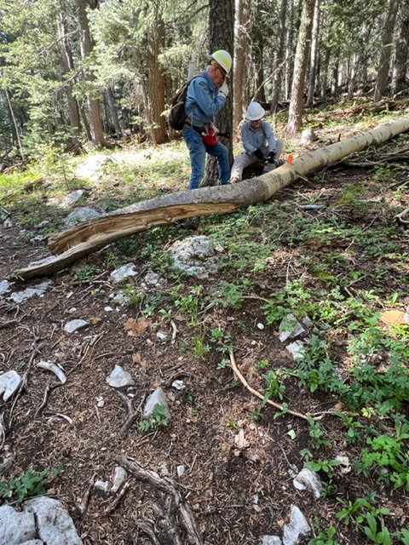

Jerry and Jamey work on a recently fallen aspen whose base

was protruding into the tread on 10K South.

Rav and Ken work on yet another log being cut back to assure

safe passage of users particularly during the ski season.

This newly discovered nasty looking hangup was looming

over the upper margin of 10K South.

Photo by Rav Nicholson from a previous AAT outing.

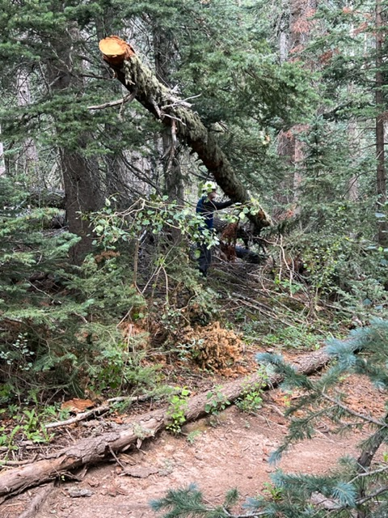

It is unlikely that anyone cut the top of this hangup

while it was suspended some ten feet above the ground.

The trunk of the tree extends well beyond where Cleve is

standing in the background. It fell across another fallen tree which is holding it up. It appears that when it first fell,

the top end was on the ground across the trail. When

someone unknown cut the top away, the remaining trunk did a “teeter-totter” and flew up to its present location. It was certainly an unusual situation.

The big hangup is safely on the ground. It is being cut

in half to make it easier to roll off the trail.

The crew is rolling the cut log sections off the downhill

side of the trail.

The jagged end of this old log was a bit too close to the trail. The crew attempted to roll it back, but the large tree in the back prevented that. The log was too heavy to move away so cutting it was necessary. The “easy job” optimism of hacking away the rotten outer wood quickly subsided when it became apparent that the remaining core wood displayed a hardness similar to an axle on a US Army tank. After considerable effort the cut was finished, and the log was rolled away.