Report of FOSM Volunteers Removing Five Trees from a Sandia Nordic Ski Club Reroute of a Segment of Klaus Trail on Sunday, July 24, 2022

Sam Beard and Scott Dietrich

On Sunday, July 24, five FOSM volunteers including Scott Dietrich, President of the Sandia Nordic Ski Club, felled five trees to complete clearing the corridor of a reroute of Klaus Trail a short distance below the Service Road. The diameters of the trees ranged from 4 inches to 12 inches.

Cliff Giles created a short movie showing the felling of the two-tree combination, and you can access it on YouTube at

[**https://youtu.be/WV2D24SUtDQ**](https://youtu.be/WV2D24SUtDQ)

The volunteers were Michael Arndt, Scott Dietrich, Sim Cook, Cliff Giles, and Sam Beard.

Project photos and more narrative are presented below.

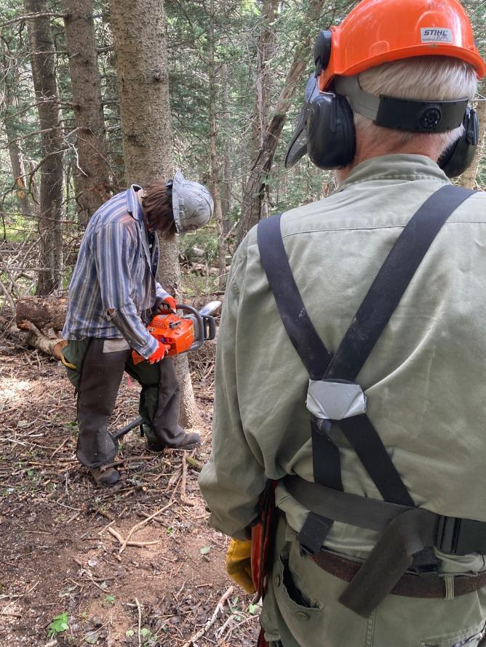

Michael Arndt making a face cut in a cork bark fir on reroute of Klaus Trail to eliminate a steep segment.

All photos by Cliff Giles unless noted otherwise.

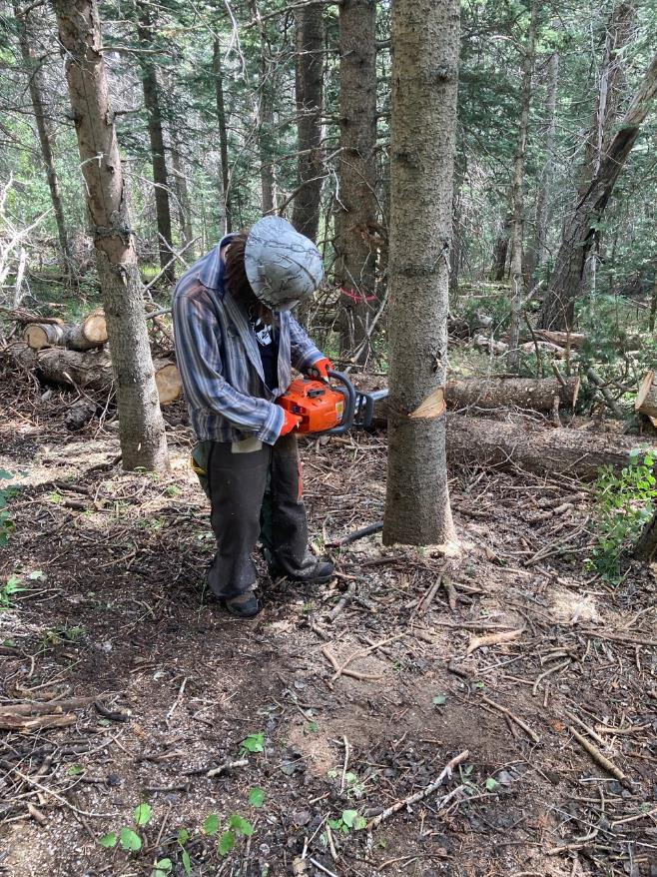

Michael beginning back cut.

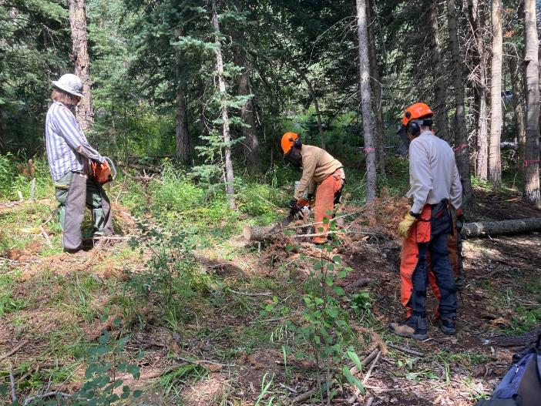

Scott Dietrich limbing felled tree while Michael and Sim Cook observe.

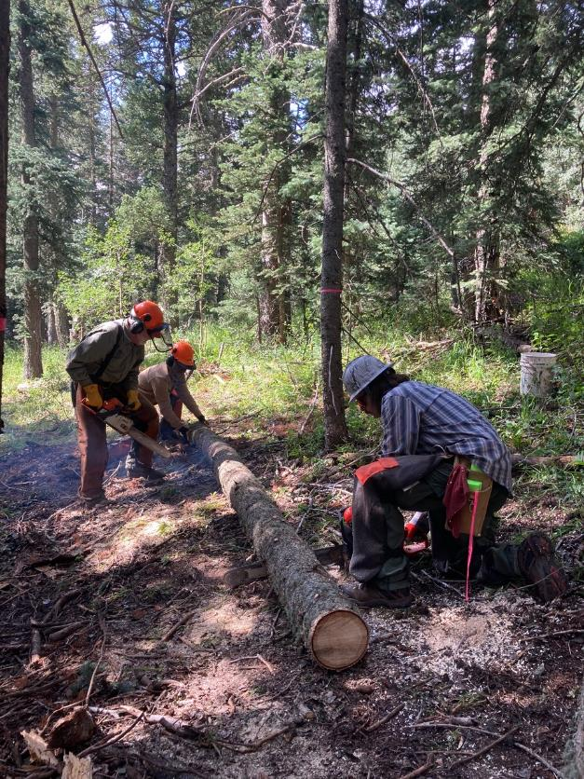

Sam and Michael bucking felled tree.

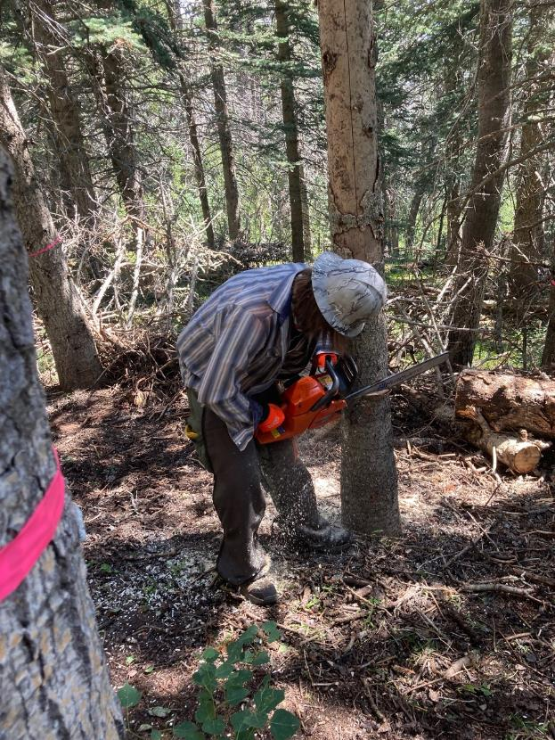

Michael making face cut in second cork bark fir.

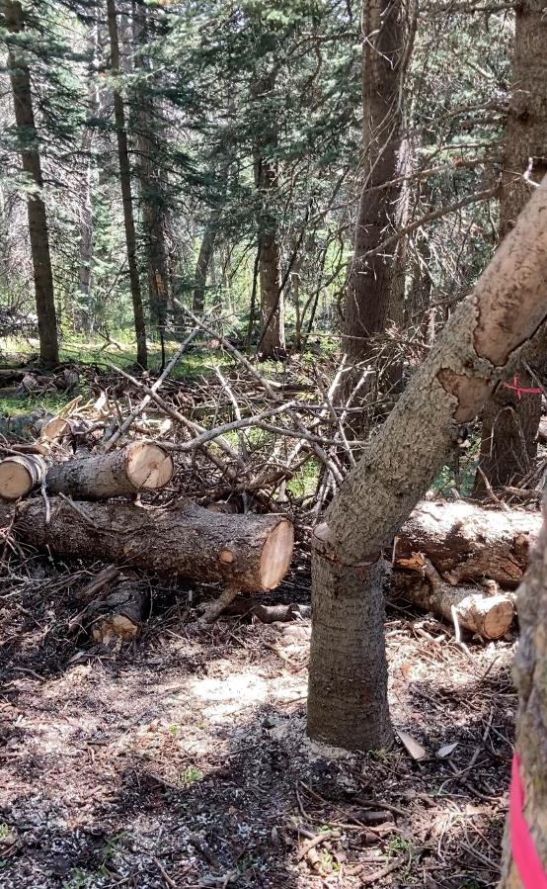

Tree is falling after Michael ran away.

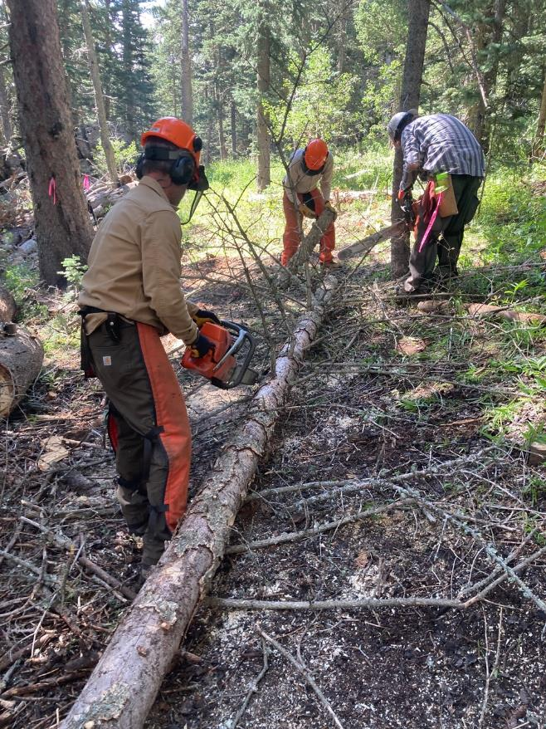

Scott is limbing the tree and Michael is bucking it.

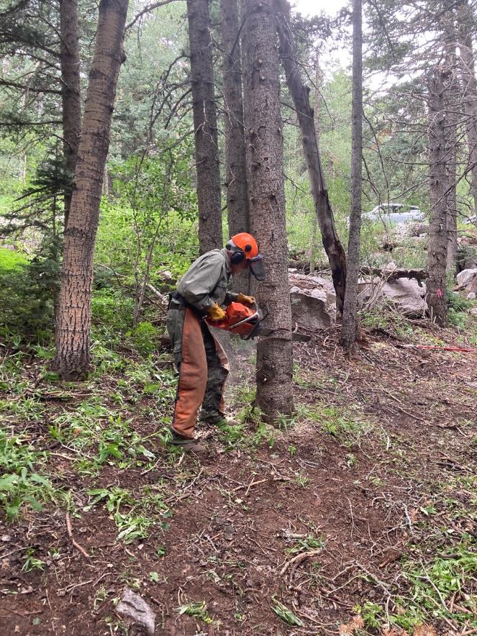

Sam in making the face cut on this fir. The car in the background is on the Service Road.

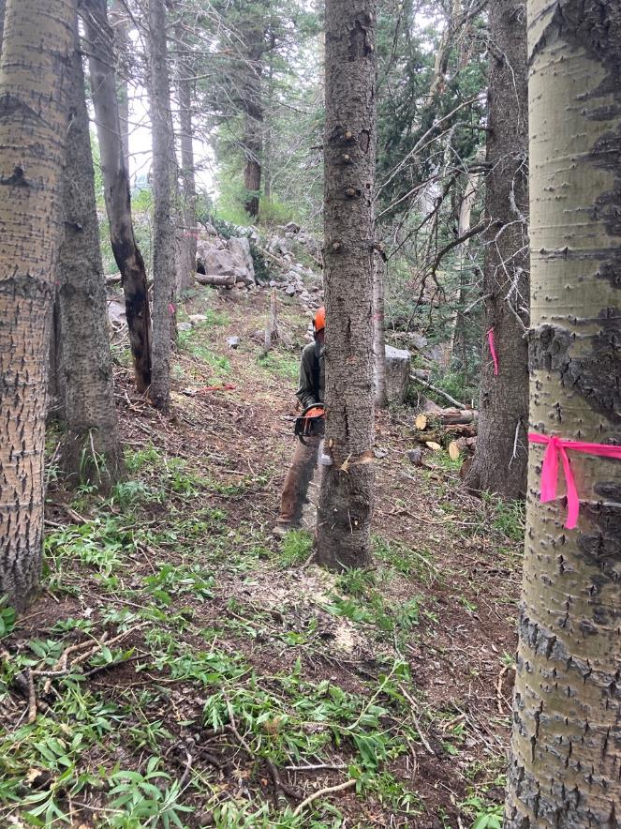

Sam is making the back cut on this fir.

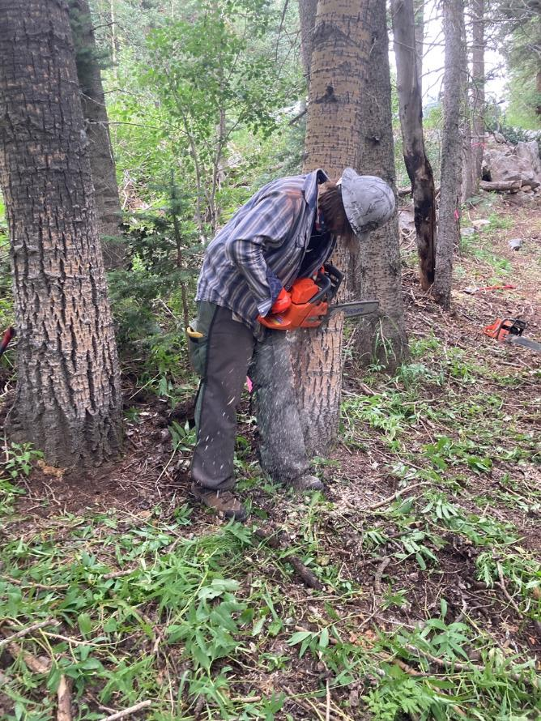

Michael is making the face cut on this aspen.

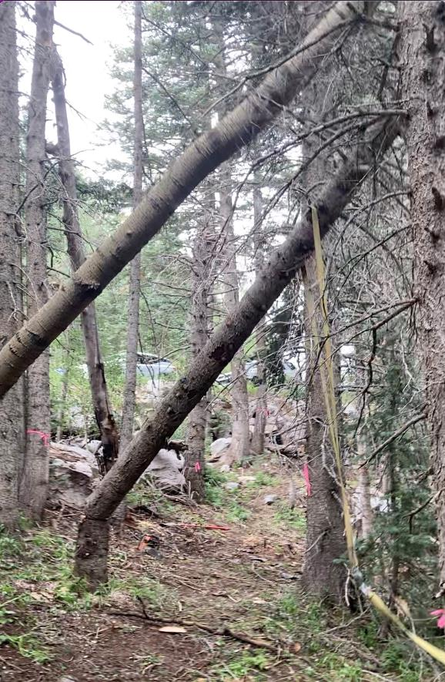

Both trees fall after Michael completes the back cut on the aspen that was hung-up on the fir.

A fork high on the aspen was around the fir trunk, and there was no safe way to separate the two trees.

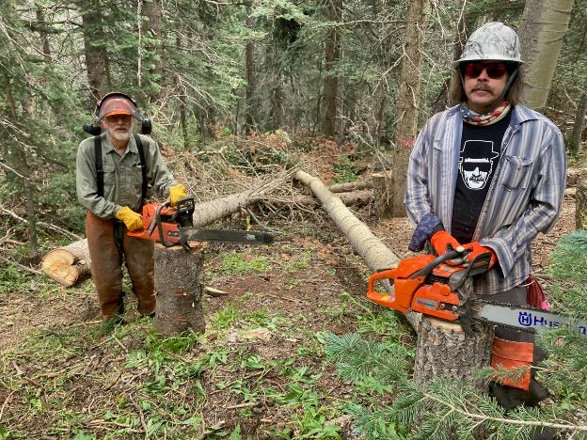

Sam and Michael with their saws and the two safely felled trees.

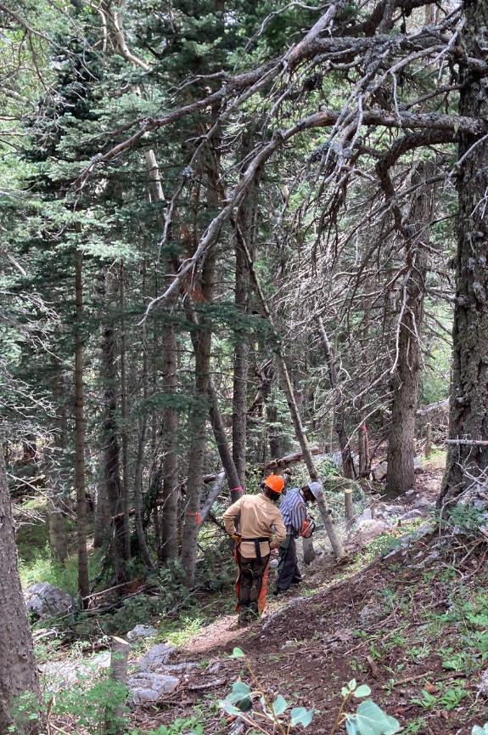

Michael cutting a hung-up small aspen that came off of the nearby stump. Scott is observing.

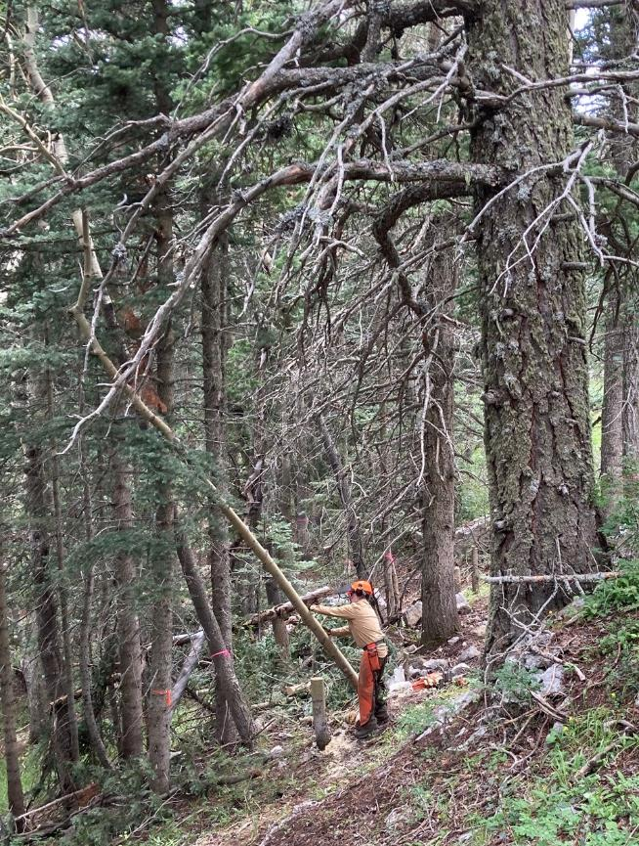

Scott taking the small aspen to the ground.by moving it off the branches in the upper left corner of the photo.

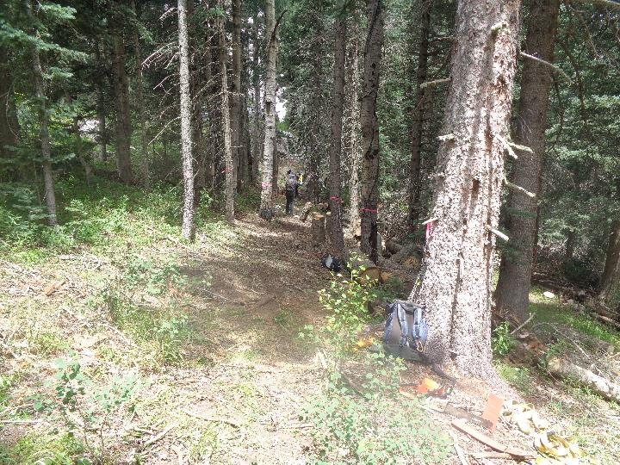

The cleared trail corridor for the reroute of a segment of Klaus Trail. The original route was down the hill to the right, and there was a steep segment leading up onto a ridge. Photo by Sam Beard

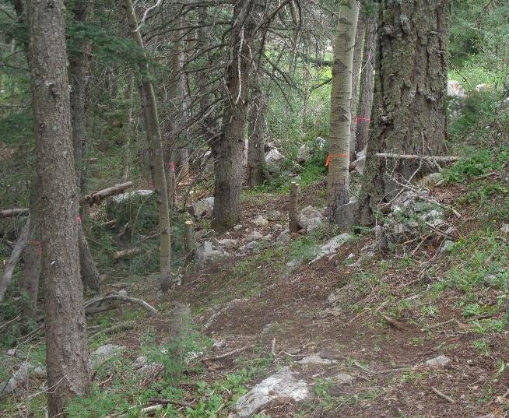

The end of the rerouted segment where it traverses a slope to the top of a low ridge.

The Service Road is in the background in the upper right corner of the photo.

Photo by Sam Beard

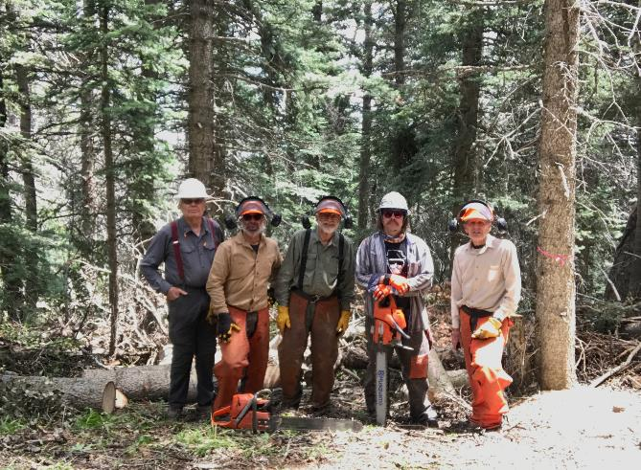

The crew who worked on this project. L to R – Cliff Giles, Scott Dietrich, Sam Beard, Michael Arndt, and Sim Cook.

Photo by Scott Dietrich