**Report of the FOSM Projects to Complete Clearing Corridors**

**for Reroutes of the South Crest Trail and Switchback Trail**

**on Wednesday, July 27, 2022**

Sam Beard

On Wednesday, July 27, seven FOSM volunteers completed two tasks related to trail reroutes near Kiwanis Meadow and Ellis Trailhead. The team of Jerry Carroll, Cliff Giles, and Sam Beard removed a hang-up and small tree from the north end of the South Crest Trail reroute near the Gravel Pit North Trailhead. The trail corridor for the reroute of the Switchback Trail near the north end of the Service Road was completed. By the time Sam’s team arrived at the Switchback Trail Reroute, the other two teams (1. Dan Benton and Don Carnicom and 2. Eric Russell and Andre Biane) had almost finished clearing that corridor.

The FOSM Trails Construction Crew led by Jenny Blackmore will construct trail tread along these corridors later.

Project photos and additional narrative are presented below.

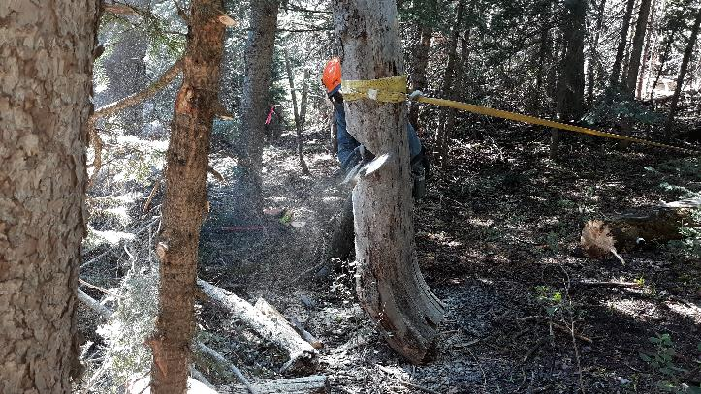

Preparing to use a double hinge technique to remove the bottom 3 feet of a near-vertical hang-up at the north

end of the South Crest Trail Reroute. The lower end of the hang-up is resting on the ground and will be the lower

hinge. The upper hinge is at the notch and back cut (that Jerry Carroll has not yet made). When the strap is pulled

with a cable hoist, the trunk where the strap is will be moved to the right, the trunk part below the notch

will turn clockwise with the second hinge at the ground. The new lower end of the trunk will be pulled to the

right, and the upper part of the hang-up will move lower.

All photos by Cliff Giles unless noter otherwise. Photo by Sam Beard

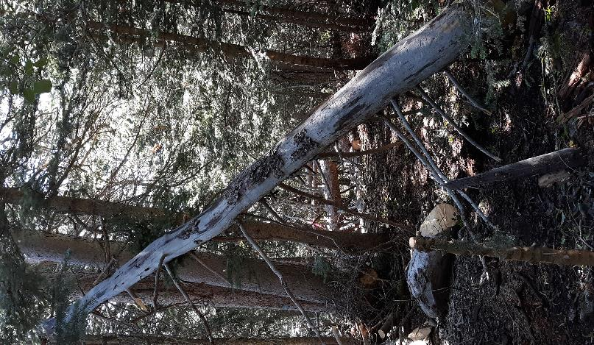

The lower end of the hang-up has broken off and is lying under the trunk

that has been pulled to the right to begin the process of continuing to pull the lower

end to the right so that the upper end of the hang-up is gradually lowered safely.

Photo by Sam Beard

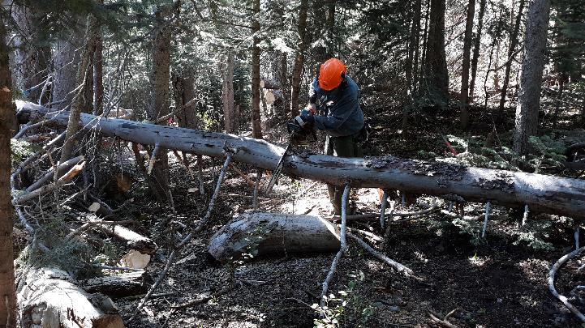

The hang-up has been lowered almost to the ground and Jerry is bucking it

to create a corridor for the new rerouted trail. Photo by Sam Beard

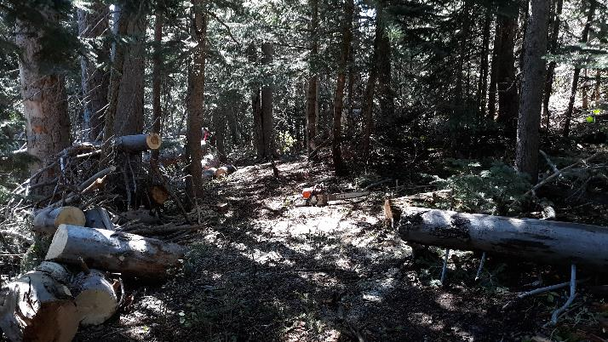

The hang-up is safely on the ground, and the trail corridor has been cleared at this location.

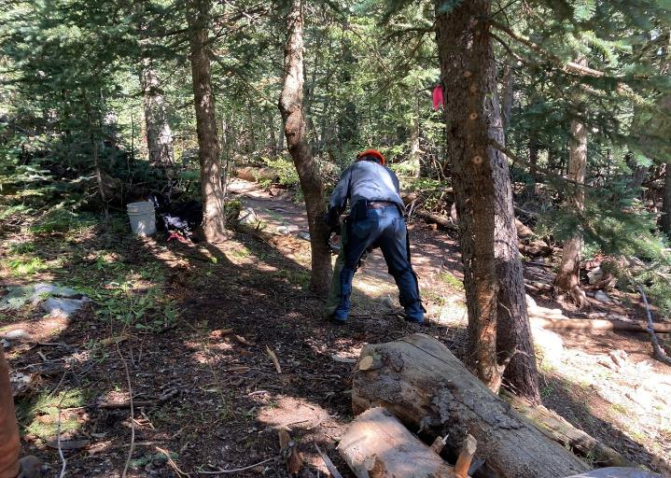

Jerry is felling a small tree in the center of the new trail corridor where it leaves the present South Crest Trail

located just to the right of Jerry.

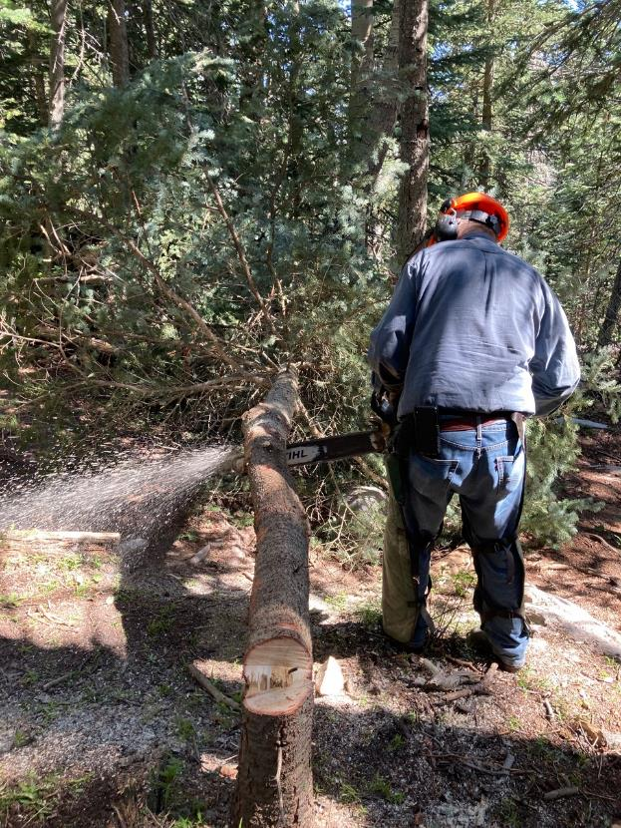

Jerry is bucking the small tree he has just felled.

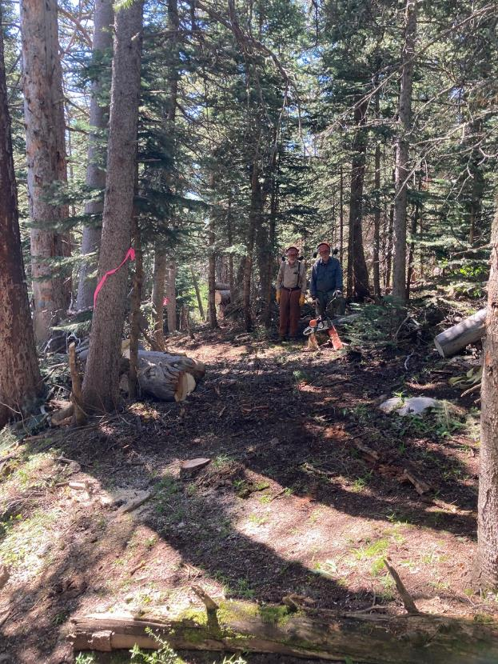

The photographer was standing on the present South Crest Trail. The photo shows the

new reroute corridor located to left of Sam and Jerry. Both the hang-up and the small tree

have been safely removed to clear the corridor here.

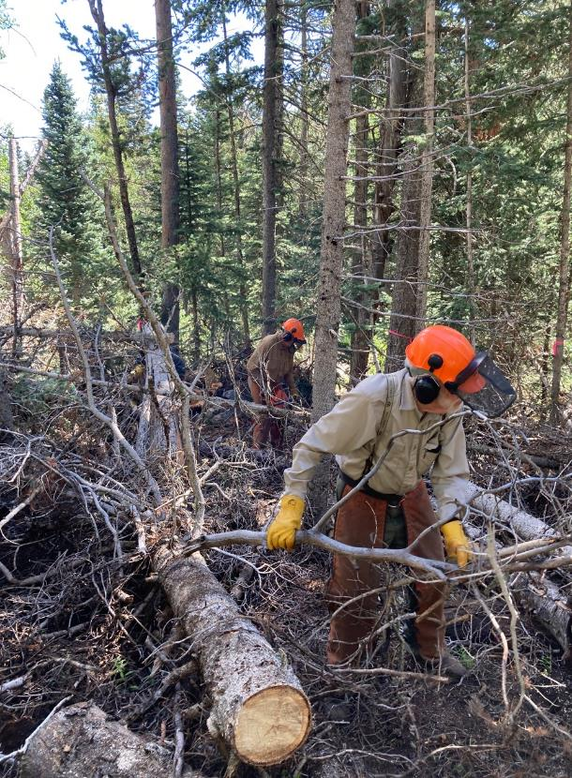

Sam is moving slash to clear the reroute corridor at the west end of the Switchback Trail Reroute

that will move the Switchback Trailhead to Ellis Trailhead at the large red gate on the Service Road.

Dan Benton is using a chain saw to clear the corridor in the background.

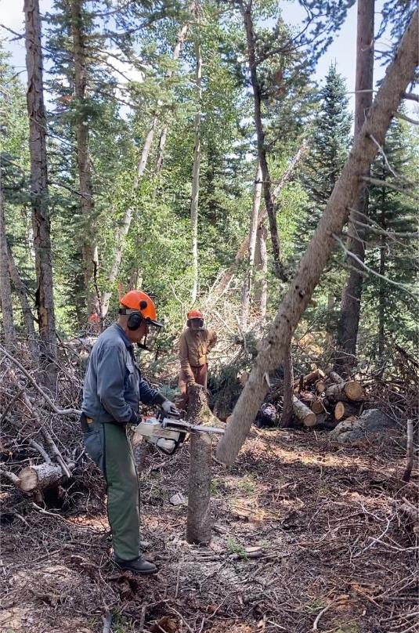

Jerry is felling a small tree to complete the clearing of the corridor near the intersection of the

reroute with the current Switchback Trail.

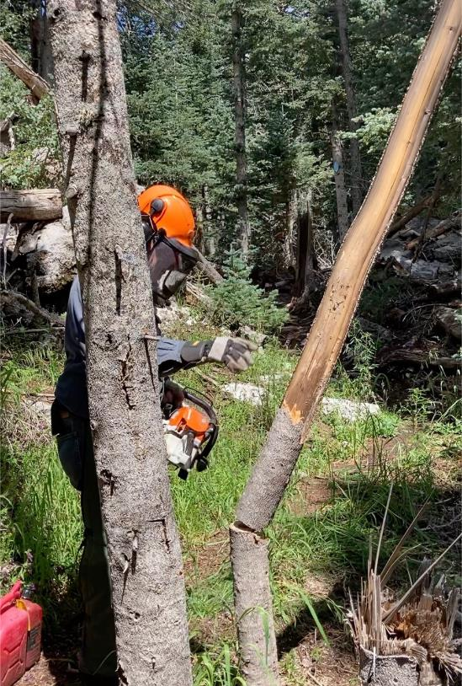

Jerry has felled another small dead tree at the intersection of the present trail with the

west end of the reroute. The red fuel container is resting of the present

Switchback Trail tread.

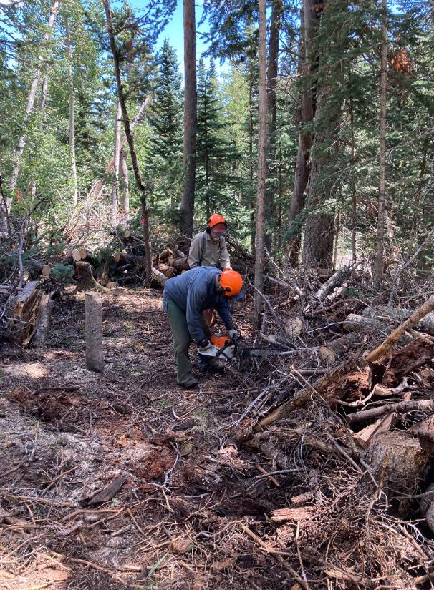

Jerry is cutting the end off of a log protruding into the trail corridor

where he and Sam are standing.

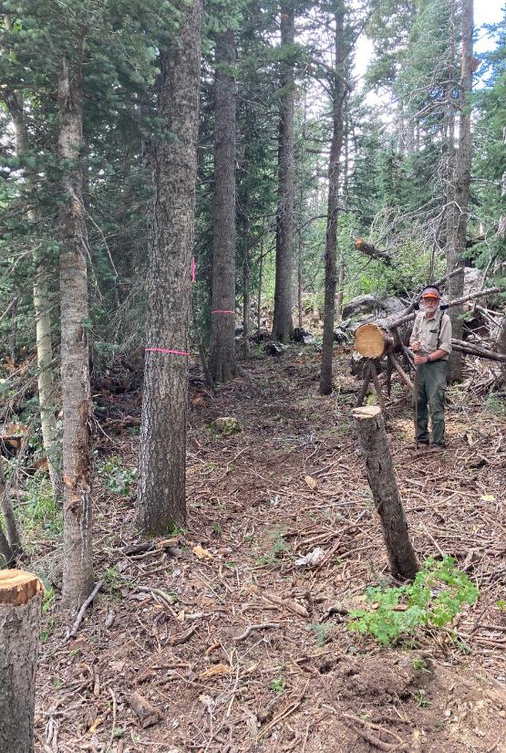

Sam standing beside the cleared corridor near the east end of the reroute

just west of the red gate on the Service Road.

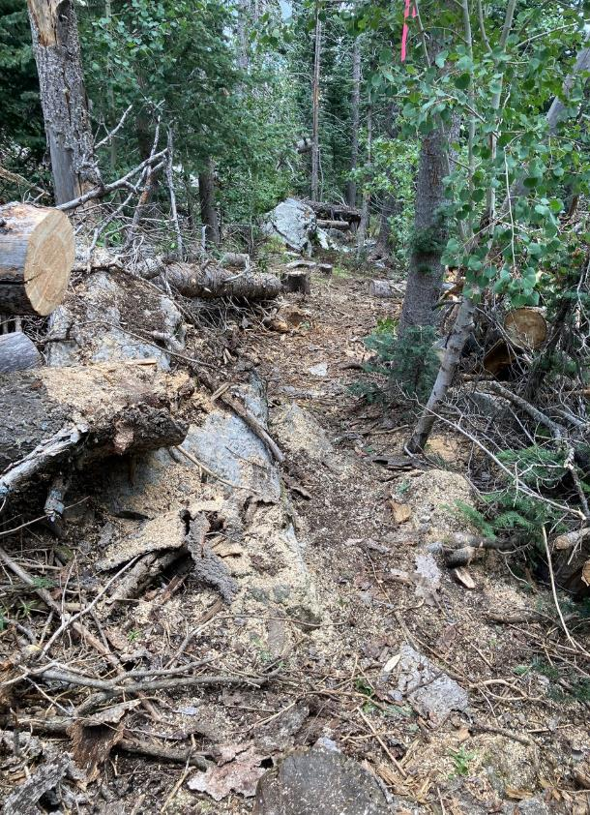

The trail corridor passing some large rocks in the foreground and in the background.